Achievement Standard Geography 91241 (2.2 v2): Demonstrate geographic understanding of an urban pattern
Credits: 3

Seoul - International Tourism
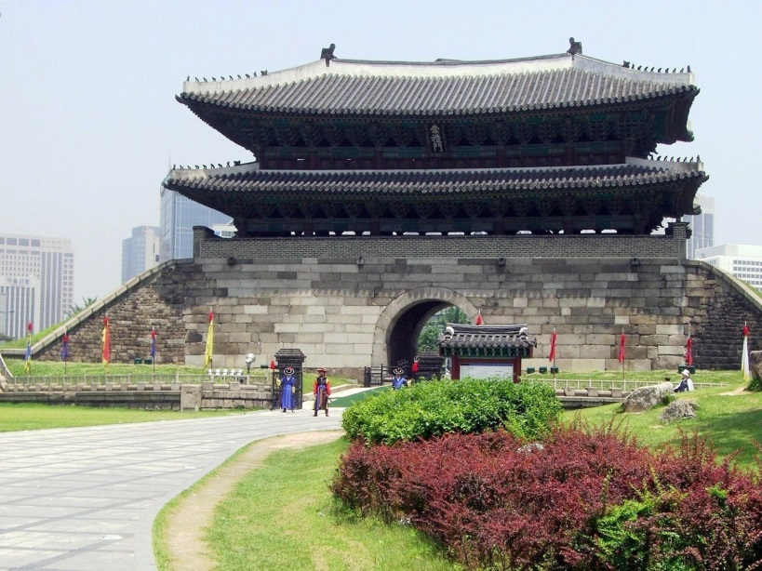
Achievement | Achievement with Merit | Achievement with Excellence
Demonstrate geographic understanding of an urban pattern. | Demonstrate in-depth geographic understanding of an urban pattern. | Demonstrate comprehensive geographic understanding of an urban pattern.
This assessment activity requires you to demonstrate geographic understanding of temporal and spatial patterns related to international tourism in Seoul, South Korea. You are able to use all the class notes, resources and learning done in class. You can also bring into the assessment additional resources you may have collected.
You have three hours to complete this task.
There are two tasks to this assessment. In each task you must include:
- specific detailed case study information about Seoul tourism patterns using geographic terminology, and
- integrate a relevant geographic concept (e.g. accessibility, location, interaction etc.) to Seoul tourism patterns.
It is recommended that you use visual information such as maps, graphs, diagrams to develop your answers.

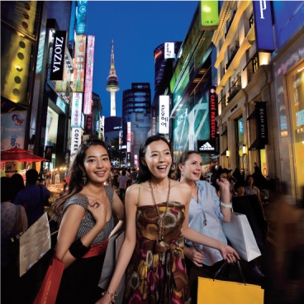
Task One
Fully explain the temporal and/or spatial variation of a tourism pattern in Seoul, South Korea.
_______________________________________________________________________________________________________________________________________________________________________________________________________________________________________________________________________________________________________________________________________________________________________________________________________________________________________________________________________________________________________________________________________________________________________________________________________________________________________________________________________________________________________________________________________________________________________________________________________________________________________________________________________________________________________________________________________________________________________________________________________________________________________________________________________________________________________________________________________________________________________________________________________________________________________________________________________________________________________________________________________________________________________________________________________________________________________________________________________________________________________________________________________________________________________________________________________________________________________________________________________________________________________________________________________________________________________________________________________________________________________________________________________________________________________________________________________________________________________________________________________________________________________________________________________________________________________________________________________________________________________________________________________________________________________________
Task Two
Fully explain the factors and/or circumstances that have contributed to the temporal and/or spatial patterns you identified in task one.
Factors and/or circumstances could include: elements, processes, events, and perceptions that have contributed to the pattern.
Make sure you include:
- a relevant geographic concept e.g. accessibility, location, interaction, change, that helps to clarify your understanding of the pattern.
- detailed, specific case study evidence of Seoul and specific tourism features and elements.
_________________________________________________________________________________________________________________________________________________________________________________________________________________________________________________________________________________________________________________________________________________________________________________________________________________________________________________________________________________________________________________________________________________________________________________________________________________________________________________________________________________________________________________________________________________________________________________________________________________________________________________________________________________________________________________________________________________________________________________________________________________________________________________________________________________________________________________________________________________________________________________________________________________________________________________________________________________________________________________________________________________________________________________________________________________________________________________________________________________________________________________________________________________________________________________________________________________________________________________________________________________________________________________________________________________________________________________________________________________________________________________________________________________________________________________________________________________________________________________________________________________________________________________________________________________________________________________________________________________________________________________________________________________________________________________________________________________________________________________________________________________________________________________________________________________________________________________________________________________________________________________________________________________________________________________________________________________________________________________________________________________________________________________________________________________________________________________________________________________________________________________________________________________________________________________________________________________________________________________________________________________________________________________________________________________________________________________________________________________________________________________________________________________________________________________________________________________________________________________________________________________________________________________________________________________________________________________________________________________________________________________________________________________________________________________________________________________________________________________________________________________________________________________________________________________________________________________________________________________________________________________________

