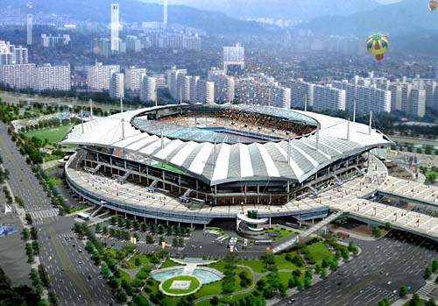
Elements important to the development of tourism
The source market is the place tourists come from. Source markets can be analysed in different ways to get a better understanding of the market. The market are the buyers of the tourist products. The buyers can be sorted into different categories that include: the source country and region, age, gender, whether they are independent travellers, families or groups, high spenders or low spenders. Source markets are able to influence the development of a tourism destination as they demand particular services and products such as different forms of infrastructure, accommodation and activities.
Attractions and activities can also be sorted into categories, for example man-made, natural, historical, adventure, sports, retail, and events. Some destinations have a particular attraction that is the main reason for peoples travel to that destination and other attractions and activities have developed because of this. Location is an important feature of attractions and activities. An attraction or activity may be in a fixed location, others may be found in several locations within a destination.
Operators provide products and services to tourists. These are usually businesses and organisations such as hotels, travel agents and restaurants.
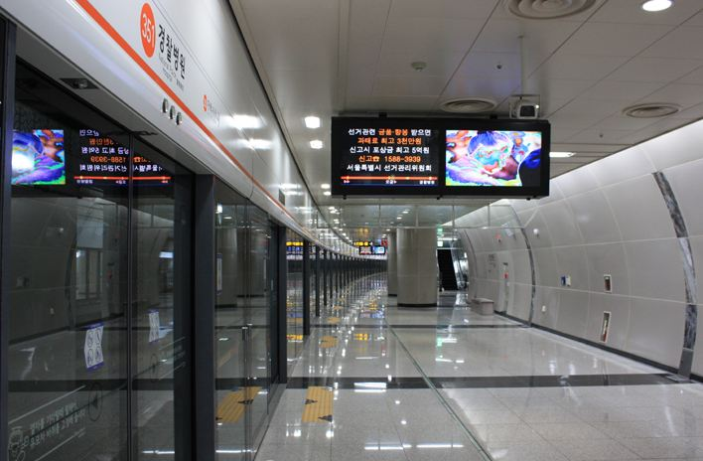
Regulators are the organisations and groups that are able to control the development of a tourism destination. These are usually government or industry groups who make decisions, policy and enforce rules that tourist operators follow.
Facilities and infrastructure are the services and products that support tourism within a destination. This can include public transport networks, communications, financial services and accommodation.

The diagram below shows how each element of tourism interacts with another.

Just as the source market can influence tourism elements, tourism elements can also influence the source market by being attractive to and enticing a wider range and quantity of buyers.

