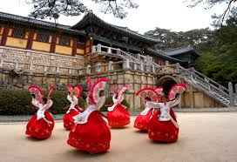
You are a travel agent working for GlobalTravel, a global travel agency.
Several clients have approached GlobalTravel for packages to Seoul, South Korea. You are required to select one of the clients below and prepare their travel package.

Your package should provide:
- A description of appropriate attractions and activities
- Accommodation for the duration of their stay
- A description of subway routes that are taken to move between attractions, activities and accommodation. A map of the subway would help to illustrate this.
- A map that identifies the location of the attractions, activities and accommodation you have recommended.

GlobalTravel - reflection
- How would you describe the spatial organisation of the attractions and activities you selected for your clients?

- Are your clients able to use the subway to travel between accommodation, attractions and activities?

- Did you have to reconsider your choice of accommodation, attractions or activities so that the subway could be used? If so, what did you change?

- When you were putting the itinerary together what factors did you consider? ie. distance, proximity, interest, cost, type of attraction or activity, time.

- Explain how the geographic concepts of distance, location and accessibility are relevant to this task.

- Look back at the paragraph you wrote when you complete the task ‘Seven clusters in Seoul’.

- What would you add to this paragraph to explain in more depth the tourism patterns in Seoul?
- Could you better integrate geographic concepts?

