Seven clusters in Seoul, South Korea
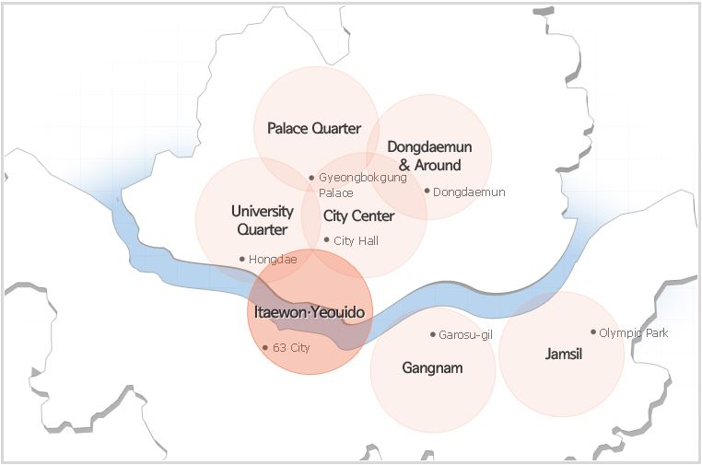
The map above identifies seven areas within Seoul that provide a wide range of tourist attractions, activities as well as related facilities and services.
- Using the website (http://www.visitseoul.net) annotate each cluster to describe the characteristic of that area. Provide examples of attractions and activities that illustrate the characteristics of the area. Characteristics could include: culture and heritage, shopping, nightlife, entertainment, recreation.
Go to the tab See and do, then Seoul at a glance.

- Looking at your annotations, what patterns do you notice? Consider:
- The main characteristic of each cluster
- Similarities between the clusters
- Proximity of the clusters to each other
- The proximity of attractions and activities within each cluster
- The complementary or contrasting nature of the clusters

- Write a paragraph to explain how tourism varies within Seoul. Include geographic concepts and examples and evidence from tasks 1 and 2.

