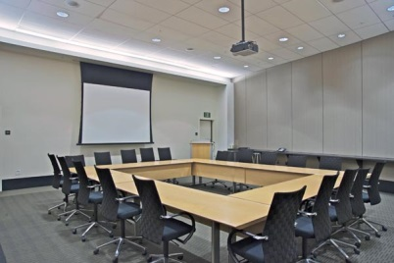
Government and Industry partnerships
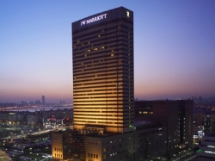
- What did South Korea achieve in 2014?
- What are some examples of significant business events that have been held in Seoul? Why do you think these events are significant?
- When you look back at the temporal patterns for tourism in Seoul and South Korea can you see the influence of Government and industry partnerships?
- How does the IT sector support Seoul to function as a successful business event tourism destination?
- How is the transport network in Seoul an advantage for tourism?
- What is the role of Seoul MICE?

- How significant is the Seoul metropolitan government’s role in supporting business event tourism? What incentives are there for people to hold their business event in Seoul?

- Construct a diagram to show the interaction between different groups and organisations in the context of business tourism. Your groups could include:
Seoul Mice | Seoul Metropolitan Government
Hotels | Transport providers
Retailers | IT providers
Specialist groups eg. linguists | Entertainment providers

- What factors have had a bigger influence on business event tourism in Seoul?
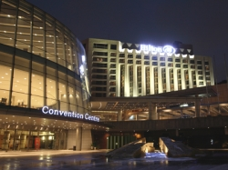
- Transport networks
- IT industry
- Government and industry partnerships

