Medical Tourism
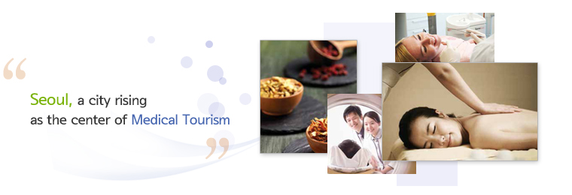
Medical Tourism in Seoul, South Korea
Seoul, which is the capital of South Korea, is a large metropolitan city that is thronged by millions of tourists every year. The city is an eclectic mix of natural beauty and modern urban life. Nowadays, a large number of tourists are visiting Seoul to obtain the best health care services. High-class medical facilities available at unbelievably low prices are the main reasons that propel the growth of Seoul medical tourism. Reaching Seoul is very easy as it is well connected to all the major cities of the world by air.
Why Health Tourism in Seoul?
In order to promote Seoul medical tourism the government has collaborated with many leading medical institutes in the place. The staff at these medical facilities is well-versed in English and so foreign visitors will not face many communication problems. In Seoul, you can undergo cosmetic surgeries and many other health care treatments, without having to worry about the hassles of insurance or long waiting queues.
Apart from conventional treatment, Seoul medical tourism offers its visitors with the goodness of Oriental medicine treatments that can be used to treat bone, joint, and spinal disorders. On a visit to Seoul, you can enjoy some of the beautiful tourist spots and experience the wonderful local cuisine. You can also take a break from your medical tourism regime and visit many historical sites, palaces and mountain ranges that surround the city. The warm and welcoming population of Seoul will definitely make your stay a memorable one.
http://www.mymedholiday.com/country/south-korea/seoul

Seoul benefits from medical tourism

07 January 2015
http://www.imtj.com/news/seoul-benefits-medical-tourism/

The revenue that Seoul hospitals and clinics earned from treating foreign patients has risen sevenfold over the past four years. Seoul is the cornerstone of Korea's medical tourism.
According to the Seoul Metropolitan Government, 178,519 patients from abroad visited Seoul and spent $260 million on treatment in 2013. This is a dramatic increase from 2009 of 40,607 foreign patients.
40,100 went for surgery, while 21,364 went for cosmetic surgery. Third was dermatology with 19,949 patients.
Most of the revenue came from 39,257 Chinese nationals, followed by 14,446 Russians, 19,158 Americans), Mongolians and people from the United Arab Emirates.
The top average spend was by people from the United Arab Emirates, with Kazakhstan second. The UAE spend was 370% up on 2013.
- See more at: http://www.imtj.com/news/seoul-benefits-medical-tourism/#sthash.fsosJtm2.dpuf
Tourists ride 'Korean medical wave'
ANNA FIFIELD August 2014
All around the southern Seoul district of Gangnam - the area of conspicuous consumption made famous by the hit song "Gangnam Style" - Chinese women walk down the street with bandages over their faces and around their heads.
Some, despite hoodies pulled up and parasols pulled down, are so badly bruised and swollen that they look as if they've just survived a car accident - if only barely. They're riding the latest crest of the Korean Wave: plastic surgery.
Korean cultural exports - especially the manufactured "K-Pop" music and schmaltzy soap operas - have become a phenomenon across Asia. There's a huge following in China, in particular, and now an increasing number of fans are coming to South Korea not just for shopping and sightseeing, but also for nips and tucks - and more.
"Naturally, Korean dramas and K-Pop has a lot to do with it," said Hong Sung-bum, a plastic surgeon and the director of the BK Hospital, a 15-story building in Gangnam devoted to various kinds of cosmetic additions or subtractions, which employs 30 Chinese-speaking staff. "There are lots of Chinese patients who come here asking to look like a certain Korean Wave star," he said in his office, still wearing his blue scrubs and rubber clogs. On the desk sat a skull wearing a Burberry-pattern headband.
Right now, the hottest look is Jun Ji-hyun, the star of "My Love from the Star", a soap opera with an unlikely story line: An alien accidentally arrives on Earth 400 years ago, meets an arrogant female pop star and falls in love. Women covet not just Jun's wardrobe and her lifestyle, but her face, too.
As the Korean government promotes ever-closer economic relations with China, it is busily promoting a "Korean medical wave". The Korean Tourism Organisation regularly organises plastic surgery expos in Beijing and Shanghai, where K-Pop singers and dancers perform and women learn how to do their makeup like Korean Wave stars. Groups of doctors offer advice to prospective patients. "We tell them that these people are not just doctors, they're beauty designers," said Kim Su-jin, an official at the KTO's medical tourism division.
The Korean surgery craze is part of a broader boom in tourism from China and comes as arrivals from Japan have fallen sharply amid worsening geopolitical tensions.
While the most common procedures are operations to make Caucasian-style double-eyelids (with clinics charging $700 to $1,500) and nose jobs ($1,500-$4,500), a sizable proportion of patients, like Xu, want "facial contouring" - invasive surgery that involves shaving or chopping away bones.
The Korean plastic surgery craze creates big business in China, too. Chinese travel agencies offer tour packages that combine several days of sightseeing with longer periods of plastic surgery. Ocean International Travel Service offers a typical five-day tour for about US$1000, surgeries not included.
The plastic surgery industry has become so dominant in Gangnam that some intersections feature clinics on all four corners. The underpasses to the subway station are wallpapered with ads for cosmetic enhancements.
The Washington Post
Adapted http://www.stuff.co.nz/travel/destinations/asia/60886731/Tourists-ride-Korean-medical-wave

Korea is taking its place in the world tourism stage by warmly welcoming visitors from around the world through the Visit Korea Year Campaign, held from 2010 through to the end of 2012. Korea has become a destination of choice for people worldwide who wish to indulge in its rich culinary culture, dream of meeting their favorite Korean stars, and even those who desire a peaceful escape in a temple or a spa. And of course, there is the world class shopping.

The Visit Korea Year Campaign aims to make all of the delightful elements of Korea even more accessible and exciting, and to make sure you get the reception you deserve upon arrival. An extensive variety of special events and promotions have been put in place to ensure that vacationing in Korea exceeds your expectations. Highlights include a Korea wide shopping extravaganza called the Korea Grand Sale, a 3+1/4+1 sale on select hotel rooms called the One More Night Promotion, and even a free shuttle service to such great destinations as Busan, Gyeongju, and Jeonju. There will also be fun filled events announced throughout the Visit Korea Year period.

Our aim is to establish Korea as one of the most popular tourist destinations in the world.
One of the most recent global developments has been the recognition of the tourism industry as a valuable national resource. Because of its potential to incur positive economic, social and cultural effects, including promotion of the national culture, vitalization of the local economy, and increased employment opportunities and income, the tourism industry has been recognized as a new driving force of growth.
It can be said that the Visit Korea Year is a culmination of such a trend and efforts. Led by the private sector, the Visit Korea Committee aims to attract 10 million foreign tourists, generate $13 billion in income, and establish Korea as one of the top 20 tourist destinations in the world in the year of 2012.

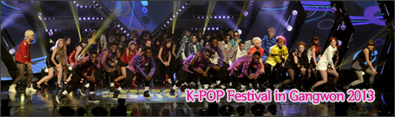
During the campaign period of the 2010-2012 Visit Korea Year, the Visit Korea Committee held the K-POP Cover Dance Festival in Celebration of the Visit Korea Year using the globally popular K-POP and invited Hallyu fans from all over the world to Korea, the home of K-POP.
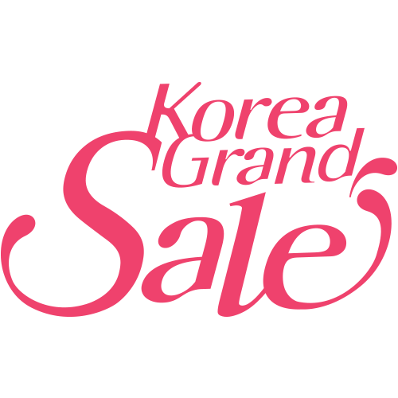
The Korea Grand Sale, the largest shopping/tourism festival for Overseas visitors ever held in this country, will run for 79 days from August 14, 2015 to October 31, 2015.
Korea Grand Sale is a shopping-tourism festival to make foreign visitors spend quality time in Korea through harmony among shopping, the Korean Wave, and tourism.
Korea Grand Sale which celebrates its 6th anniversary this year provides with introduction of quality products from Korea, expansion of cultural experience, and other various benefits for shopping, attractions, accommodations, transportations, food & beverages, and entertainment to attract foreign tourists and to boost consumption during the off-season.
The Korea Grand Sale is a great way of doing trendy but thrifty shopping in Korea!
It’s also the time of year when you can take advantage of the biggest possible discounts on air tickets and hotel guestroom rates. Come and have a great time shopping and enjoying Korean culture.

Korea Visit Committee, the host and supervisor of Korea Grand Sale, has been promoting various projects to lead the “2016-2018 Visit Korea Years” for the 2018 Winter Olympics in Pyeongchang to success.
First of all, the Committee is discovering and invigorating tourist attractions gracious enough to satisfy the increasing demand of various visitors to Korea. It designs and promotes not only the ‘Must-See Routes’, a luxury tour course to introduce selected hidden tourist attractions in each area, the ‘K-shuttle’, a free bus tour package to help tourists make an easy and luxury journey to the rural areas, and Korea Grand Sale, a shopping festival for tourists, but also online discount coupons and the priority card for visit to Korea to transform Korea into a happy shopping and tourist destination. The invigoration of the Korean Wave tour through K-POP festivals is another project the Committee has been focused on to provide with more spectacles and entertainment for tourists. The Committee also established the ‘Tourist Service Center’, a portable tourist information center, at where foreign tourists gather to provide with various services for tourist convenience including interpretation service. Moreover, the Committee is promoting a campaign for Koreans to show foreign tourists a warm welcome. The ‘K-Smile’, a campaign to continue a long-held Korean tradition of welcoming a guest from a far away land, sends a message not to be shy and to give strange foreign visitors a friendly smile. The National Smile Team consisting of university students, teenagers, and tourism workers is working on promotions as a private promotion unit.

K-pop Lessons, Another ‘Must Do’ for Tourists
Posted on August 31, 2015 by Korea Bizwire in Culture & Society, Top News with 0 Comments

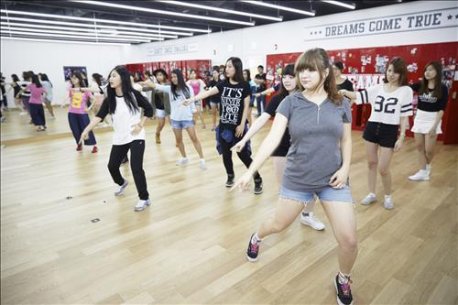
The Seoul Metropolitan Government has announced that they will manage a program where foreign visitors can learn the latest K-pop dances. (Image : Yonhap)
SEOUL, Aug. 31 (Korea Bizwire) – The Seoul Metropolitan Government has announced that they will manage a program where foreign visitors can learn the latest K-pop dances.
Participants will tour the SM Town studio in Samseong-dong for 30 minutes, and learn the latest K-pop moves from a professional choreographer for 60 minutes.
According to a survey conducted on foreigners that plan to visit Korea, 50.2 percent of the respondents answered that Hallyu was the first thing that they picture when they thought of Korea.
However, respondents also pointed out that the chances of experiencing Hallyu during their visit were scarce.
The Seoul Metropolitan Government planned the program to meet the wants of tourists. The program will be expanded to other regions after the test run this year.
http://koreabizwire.com/k-pop-lessons-another-must-do-for-tourists/41354

MBC Gives K-Pop Fans The Chance To Experience Hallyu In Person With Korean Wave Theme Park
By Samantha Marie Lifson | September 01, 2015

Korean broadcaster MBC will be treating fans of Korean pop culture to an exciting new attraction this September.
On August 30, MBC (Munhwa Broadcasting Corporation) announced the opening of their new Hallyu (Korean wave) based theme park, MBC World. The theme park will include photo booths, virtual reality drama sets, and various events through hologram
Fans can experience how it feels to appear in Korean period dramas by visiting recreated sets or submerse themselves into popular MBC variety shows like "Infinite Challenge," "Radio Star," and "Real Men" in the 360-virtual reality theater.
More excitingly for many fans, MBC World will include a hologram theater that will put on different K-pop concerts as if being viewed only a few steps away from the stage. The hologram theater also allows fans the experience of being on stage with their favorite K-pop idols, like G-Dragon or Psy, and even has a feature where attendees can learn dance moves from Korean stars as well.
"Many tourists come to [Korea] pursuing their love for Hallyu content, but find that few Hallyu-related activities are available and simply end up shopping instead," an MBC rep lamented according to Korea Herald. As a result, the company created MBC World for fans that want an immersive Hallyu experience.
MBC World is located at MBC Headquarters in northern Seoul and will open on September 5. MBC projects that the park will attract more than 130,000 visitors per year and requires visits to be reserved in advance.
http://www.kpopstarz.com/articles/236476/20150901/mbc-world-hallyu-theme-park.htm

