Geographic inquiry
How have different factors contributed to patterns of tourism in Seoul, South Korea?
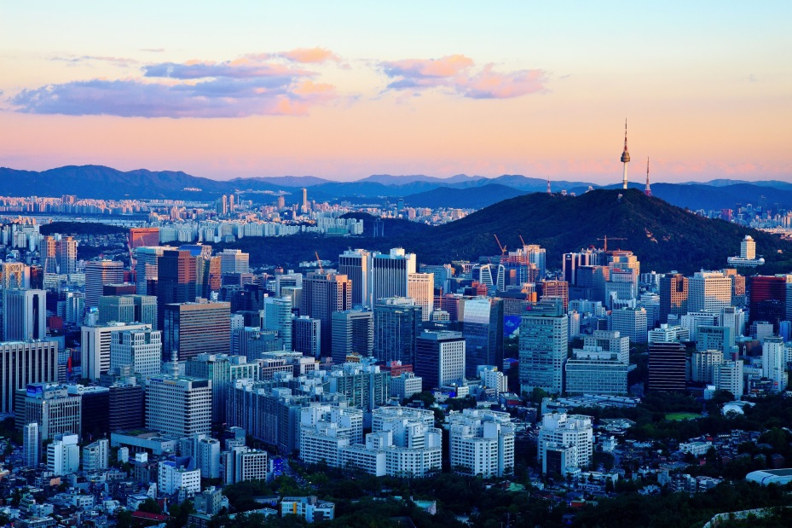
Planning – consider these questions carefully before you start collecting information
- What do you need to know in order to answer the inquiry question?

- Where can you source this information from? (be specific)

- What geographic ideas do you think are relevant?

- Based on what you know about tourism in Seoul already, what do you think are some factors that have contributed to tourism patterns in Seoul?

Use the information you collect to form an insightful conclusion that answers the inquiry question ‘How have different factors contributed to patterns of tourism in Seoul, South Korea?’
Your conclusion should include: geographic terms and concepts as well as evidence and examples to support your explanation.

