Factors that contribute to tourism patterns in Seoul, South Korea
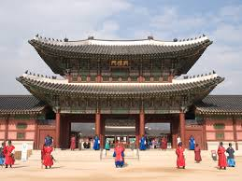
Factor | What is this factor? | What patterns has the factor contributed to? | What is another factor it connects to?
Diplomatic relations
Technology & communications
Transport networks
Government policy
Industry associations | Stakeholders in the tourism industry have formed associations such as MICE to improve the potential for increased tourism. | Temporal patterns with an increase in tourist numbers more recently. Also spatial patterns with the development of infrastructure in particular locations | Government initiatives
Government and industry partnerships
Location of sites of significance
Promotion
Government initiatives

