HALLYU - THE KOREAN WAVE
How Korean Cool took over the world!
OBJECTIVES
Year Level: 7 - 10  The Arts  Dance  Music  Drama  Curriculum Level: 4 & 5  Unit Duration: 10 weeks | Achievement Objectives:  Students will:  - identify and describe the characteristics of music in relation to historical, social, and cultural contexts  - explore and describe how dance is used for different purposes in a variety of cultures and contexts  - investigate the functions, purposes, and technologies of drama in cultural and historical settings
OTHER LEARNING AREA LINKS/OPPORTUNITIES
Literacy
Speaking, writing and presenting - Processes and strategies
Students will integrate sources of information, processes, and strategies with developing confidence to identify, form, and express ideas.

Listening, reading and viewing - Processes and strategies
Students will integrate sources of information and prior knowledge confidently and make sense of increasingly varied and complex texts.

Mathematics - Statistics
Students will communicate findings, using appropriate displays.

Physical Education - Challenges and social and cultural factors
Students will participate in and demonstrate an understanding of how social and cultural practices are expressed through movement.

Learning Languages - Communication
Students can understand and use familiar expressions and everyday vocabulary. Students can interact in a simple way in supported situations.

Note - Some Korean language is developed throughout the unit but additional, level 1 Korean language lessons are added separately under ‘Additional Resources’ at the end of this plan. These can be utilised by teachers as a supplement to the unit.

Values  Excellence  Innovation, inquiry, and curiosity  Diversity  Equity  Community and participation  Ecological sustainability  Integrity  Respect | Key Competencies  Thinking  Using language, symbols, and texts  Managing self  Relating to others  Participating and contributing | Principles  High expectations  Treaty of Waitangi  Cultural diversity  Inclusion  Learning to learn  Community engagement  Coherence  Future Focus

Unit Focus  How ‘Korean Cool’ took over the world!  An inquiry into Korean entertainment and its globalisation.  To explore how music, dance and drama in Korea display different characteristics and serve different purposes in historical, social and cultural contexts.  Throughout this unit there are lessons designed to explore the different art forms encompassed in the Hallyu - The Korean Wave, such as Korean Pop Music and Korean Drama. Students will make connections with own cultures and arts, as well as how these art forms have had social, historical, economical, and cultural impacts.  Lessons are planned in an inquiry sequence, using the Ontario Inquiry Model, as below. Some lessons may run over several learning sessions, particularly when the students are participating in their own research. | Context  The unit begins with students activating their prior knowledge of different forms of entertainment around the world. Students identify characteristics and attributes of entertainment forms and consider similarities and differences.  Through front-loading lessons students will develop their understanding of how what K-Pop and K-Drama are and how they have influenced change in Korea. Lessons include critical thinking and connection to other cultures and countries.  The unit concludes with students creating an advertisement for their own form of entertainment in the context of Hallyu - the Korean Wave. The presentation will display students’ knowledge and understanding of the characteristics of their chosen art form, as well as their understanding of its impacts. Summative tasks may be in the form of a live presentation, or created through a chosen digital media.
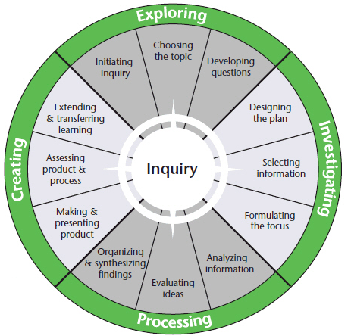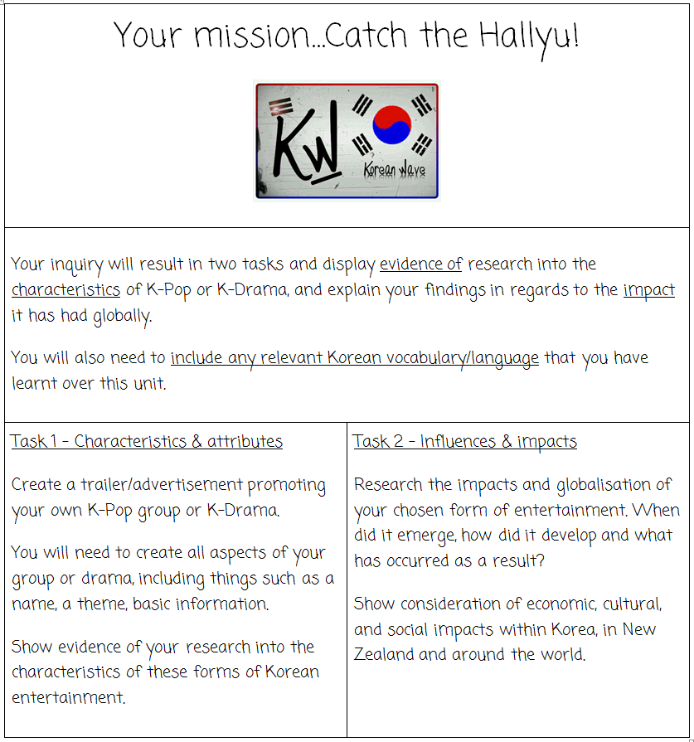

Achievement Objectives | Identify and describe the characteristics of music in relation to historical, social, and cultural contexts
Learning Focus | Music and dance can have different characteristics and attributes depending on cultures and contexts.
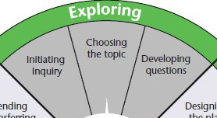

Activating Prior Knowledge

Introduce the lesson by discussing the learning focus. Divide the class into six groups and distribute Copy Master 2 - Bus-stop to each group. Ask students to brainstorm prior knowledge about music and dance in different countries i.e. New Zealand, Korea, India, America, Britain, and China. Discuss things such as artists/groups they know, music styles, dance moves, and genres that relate to each country. Give each group a few minutes at each bus-stop and then rotate groups through different countries until complete, reminding them not to repeat ideas.

Discuss as a class:
Which country do we know the most about?
Which country do we know the least about?
Why? Are there similarities and/or differences?

Introduce the Unit Focus. Add this to student books as a reference. Alternatively students could create individual Google folders to record their inquiries.

Unit Focus
How ‘Korean Cool’ took over the world - An inquiry into Korean entertainment and its globalisation.

To explore how music, dance and drama in Korea display different characteristics and serve different purposes in historical, social and cultural contexts.

Identify and discuss key words such as globalisation, characteristics, or context.

K-Pop Provocation

Write the question ‘What are characteristics and attributes?’ on the board. Ask students to discuss and define what a characteristic is and what an attribute is. Use dictionary terms to refine.

Using Copy Master 3 - What do you notice template and music links below, play examples of pop music from New Zealand, India, America and Korea and have students record what characteristics and attributes they see, hear, or notice. Encourage students to record things they see such as how many singers there are, clothing, background, dance, colour, hair, genre, or
what they hear such as repetition, storytelling, instruments.

Watch ‘New Zealand’ examples first as a class and complete the ‘What do you notice’ NZ section of the template together. Discuss as a class the characteristics that stood out through all three New Zealand examples and select three main characteristics.

New Zealand
Six60 - Forever
David Dallas - Runnin'
Jamie McDell - Crash

Allow students time to watch the examples from other countries, adding what they notice to the template as they go. This may be done more than once if students require more time.

India
Shahrukh Khan - Marjaani Marjaani
Ek Tha Tiger - Banjaara
Dil Bole Hadippa - Disco Wale Hisko

America
Taylor Swift - Style
Pharrell Williams - Freedom
Echosmith - Cool Kids

Korea
Super Junior - Mr. Simple
Girls' Generation - Gee
EXO - Overdose

Discuss main characteristics. What did you notice about K-Pop?

Ask students to individually write a brief reflection using Copy Master 4 - Reflection Key + - :) ?. A copy of this key can be kept as a reference in books or Google folders also.

K-Pop - What is K-pop? Let’s find out.

In this session students will use a Blendspace of resources to research and learn more about the K-Pop phenomenon. Questions and answers can be recorded in books or added to students Google folder.

Students will research to answer the following questions in Copy Master 5 – What is K-Pop?. Once complete group students in small groups to discuss findings.

Reflect using the Reflection Key + - :) ?
K-Pop - NZ Meets Korea

Discuss as a class the popularity of K-Pop in New Zealand. K-Pop has a large fan-base here in NZ. Discuss why this is, encouraging students to think about the ever-growing diversity in NZ.

Pose the question of how might NZ influence K-Pop? Think, pair, share and discuss possibilities.

Watch - Korean hip hop's Kiwi contingent

Ask students to discuss their thoughts about this clip with a buddy. Students will then complete Copy Master 6 - Plus, Minus, Interesting and formulate own perspective. Share thoughts as a class.

Reflect using the Reflection Key + - :) ?

K-Pop - Let’s Dance!
Discuss with the class what they know about how K-Pop groups are manufactured (as explored in previous lessons). Encourage discussion around the fact that image and video clips etc. are organised by the entertainment company they work for. This means that dance moves are specific and somewhat dictated to the group.

Break class into six small groups and provide a device for each group. Students will view the dance tutorial on the link below.

K-Pop Dance Tutorial - K-Pop for Beginners

Each group will be assigned a dance move to learn, perform and then teach the class.

These moves might be useful for students own inquiries later.

Reflect using the Reflection Key + - :) ?
K-Pop - Dance - Old or New
Pose the question to the class - Is dance different across cultures? Discuss examples considering the purpose of different dances. Ask the class - Does dance change over time? Discuss examples. Think about how the Haka has changed over the years. How has its purpose changed? Has is become more or less important?

Introduce Copy Master 7 - Matching Activity where students will read about examples
of traditional Korean dance and their functions culturally. Students cut and match images and descriptions.

As a class discuss the beliefs represented in these examples. Are these things reflected in modern day Korean music? Why might these changed over time?

Reflect using the Reflection Key + - :) ?

Achievement Objective | Investigate the functions, purposes, and technologies of drama in cultural and historical settings.
Learning Focus | Drama can serve a range of functions and influence people over time.
K-Drama Provocation

Introduce the lesson by discussing the learning focus, elaborating on ‘functions’ and ‘influences’. Using Copy Master 8 - What do you notice, students will watch the video link below of different television dramas from New Zealand, India and Korea and record what they see, hear, or notice, as in previous lesson with pop music.

Link - What do you notice? Drama

Once complete, move students into groups of three or four to discuss and identify what they consider to be the main characteristics of each country’s examples. Share as a class. In particular, what did you notice about K-Drama? Discuss main characteristics.

Reflect using the Reflection Key + - :) ?
K-Drama 101

In this lesson the class will split into three groups. Assign one of the links below to each group. They will watch the tutorial and report back to the class the main ideas in the tutorial. Focus the class on how each video can link to the achievement objectives around characteristics, attributes, function and purpose.

What is K-Drama 101
Who is K-Drama for
K-Drama acting styles

Each group will share their findings.

Reflect using the Reflection Key + - :) ?
K-Drama - Knowing the lingo

Another characteristic of K-Drama is the language and vocabulary that has developed over time. Discuss how entertainment can influence and develop new language. Korean Drama has a long list of vocabulary that is specific to K-Drama, some Korean and some English. Storylines are also often set around a family or families, therefore familial terms are common.

Using the Blendspace - K-Drama Glossary students will find the meanings of some of the well-known K-Drama vocabulary/terms, as in Copy Master 9 – K-Drama Glossary.

Reflect using the Reflection Key + - :) ?
K-Drama – Influences and impacts

Provide envelopes with cut-out cards of Copy Master 10 - Influences and impacts to pairs. Students will read each card and identify how K-Drama has influenced a change, what effect it has had, and where K-Drama has spread around the world.

Students will then note these influences and impacts on the World Map.

Reflect using the Reflection Key + - :) ?

Choosing a topic and developing questions

Students will now decide on the area of interest they wish to inquire into further, K-Pop or K-Drama. Ask students to look back over their reflections and any questions they had.

Ask students to put together a Questions Page where they record any questions they have about their area of interest. Encourage students to include questions around CHARACTERISTICS and INFLUENCE/IMPACT, in order to keep clear links to the achievement objectives.

Students will review their individual Questions Page and identify key questions to drive their inquiries. Teacher will ask the class if their questions are Lookers, Drivers, Snoozers or Keepers.

Project Copy Master 11 - Sorting Key Questions onto the whiteboard and explain each category, as below.

KEY

Drivers - Questions that are both generative and genuine to drive my inquiry
Lookers - Questions that are genuine but quick to look up
Snoozers - Questions that are not compelling nor overly useful
Keepers - Questions that are generative but low interest which may be kept for later

Generative - How likely is my question going to generate insight, creative action, deeper understanding, and new possibilities?
Genuine - How much do I care about investigating this question?

Students will then assess and group their questions accordingly and sort own key questions using the template.

Inquiry lessons to support student research and presentation. Students will conference with their teacher and peers throughout these stages.
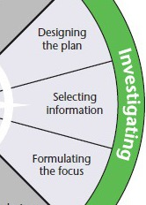

Designing the plan

Introduce Copy Master 12 - Summative Task and Copy Master 13 – Summative Task Rubric.

Create a plan using Copy Master 14 – Planning Page to organise a starting point for students’ inquiry.

At this point students will also decide if they want to inquire individually or in small groups.

Selecting Information & Formulating the focus

Ask students:
How do you find something online?
What kinds of things do you search for?

Discuss as a class what a ‘search strategy’ is when researching on the internet. Teacher can note known strategies on the board. Read through Copy Master 15 - Strategic Searching Tips.

Define what effective and efficient searching might look like. Explain to students that an effective online search is one that yields the precise results they are looking for. An efficient search does so without a lot of wasted time or energy – for example, having to scroll through a lot of search results that don’t relate to their desired topic.

Write the following steps on the board, or project it from your computer screen. This mnemonic device lays out the five steps in a search plan, and the steps spell out SEARCH. Share the explanation of what each step means.

SELECT - research questions and search tools.
(Explain to students that they should have one or more questions that get to the core of what they want to find out in their search. They should also choose search engines and tools that are most relevant to what they are looking for.)
EXTRACT keywords and terms. (Students should understand that they can find effective keywords by highlighting the key terms from their research questions.)
APPLY search strategies. (Students should apply some of the search strategies they learned – for example, adding quotation marks or a minus sign, or specifying what type of information they need.)
RUN your search. (Students should run a search on the terms they have chosen and review the results. Remind students that they should check out multiple sources.)
CHART your search. (Students can avoid repeating work they have already done by jotting down what they’ve searched for and where they’ve searched for it.)

Reflect +-:)?

At this point students will conduct research.

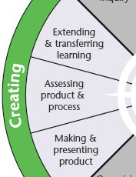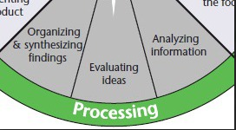

Throughout their research process students will conference with the teacher and organise, sort and analyse findings. Students will consider what information is most relevant and necessary.

Making and presenting product

Students will have a choice of how they present both parts of their summative task. Task 1 will be a visual presentation and Task 2 will be a written explanation. Provide some possible methods for each task by exploring some of the digital media available. Presentations might be made through iMovie or other animation tools. Share the tutorial video below. Task 2 may be written or shared through Google docs or presentations.

How to create a movie trailer in iMovie

Assessing product and process

Once students have presented their inquiries, they will need to assess themselves in relation to the success criteria Summative Task Rubric and complete a self-assessment reflection. They will also need to collect feedback from a peer and their teacher.

Extending and transferring learning

Discuss the importance of reflection and why it is helpful in our learning. Remind students that reflective responses require explanation and examples for clarity. Reflect on the end of unit by completing Copy Master 16 - Hallyu Reflection.

Ask students who want to share what some of the interesting things about this unit were and what their ‘So what?’ next steps might be.

Copy Master 1: Ontario Inquiry Model

Copy Master 2: Bus-stop

Copy Master 3: What do you notice?

What do you notice?
 |  | I see… I hear… I notice... | Main characteristics
NEW ZEALAND | 1  2  3
INDIA | 1  2  3
AMERICA | 1  2  3
KOREA | 1  2  3

Copy Master 4: Reflection Key

Reflection Key
+ | PLUS  What were the positives? What worked well and why? What did I like and why?
- | MINUS  What were the negatives? What didn’t work well and why? What didn’t I like and why? What didn’t I understand?
:) | INTERESTING  What did I find interesting or different? What was new to me?
? | QUESTIONS  What questions do I now have? I wonder….

Copy Master 5: What is K-pop?

What is K-pop?

Your task is to find out a bit more about K-pop, what it is and how it works. Find information from the resources provided and answer the questions below.

Use information from the resources and provide examples/evidence to support your response.

____________________________________________________________

- When did K-pop first emerge?

- How many people auditioned to be a K-Pop star in 2012?

- How many views did Psy’s Gangnam Style music video (official) hit in 2012?

- What about today? How many views does it have at today’s date?

- How is the Korean Government linked to K-Pop?

- What is the ‘full package’ a K-Pop star is required to have?

- Which two countries had the highest number of K-Pop views in 2011?

- In your own words, what are the five stages of becoming a K-Pop star? Explain.

- Why are social networking systems so important to K-Pop?

- Is K-Pop popular here in New Zealand? Explain.

- Approximately how much money did Korea’s pop-culture exports account for in 2014?

Copy Master 6: PMI Chart - NZ Meets Korea

PMI Chart

Consider the positive and negative aspects to the inclusion of the Haka in EXO’s performance, and what you find interesting about it.

Then summarise your perspective below.
Plus | Minus | Interesting
My perspective is….

Copy Master 7: Dance over time

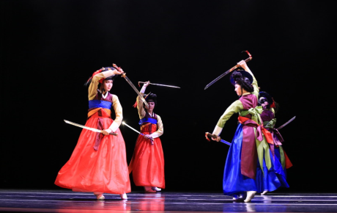 | Keummu, or sword dance, is performed by a group of female dancers holding a sword in each hand. The swords’ blades are connected by short wires to the handles, which produce a rattling noise as the dancers brandish them.
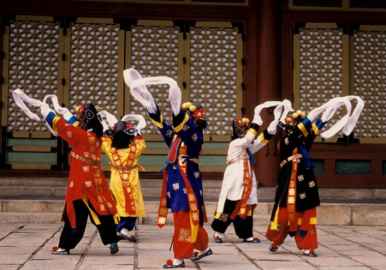 | Ch’oyongmu is a dance of exorcism where male dancers wear masks and costumes with blue, white, red, black and yellow to symbolize the east, west, south, north and the centre of the universe. Dancers occasionally alter their positions while flapping their sleeves and making full turns.
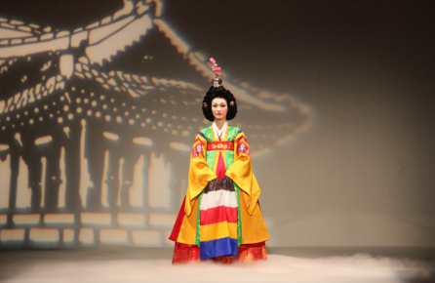 | Chunaengmu, or nightingale dance, is a solo performed by a female dancer. The dancer is clothed in a brilliant yellow dress with sleeves of multi–coloured stripes and a flower crown adorning her head. She stands on a flower mattress and sings a song, revealing exhilarating elegance and beauty through graceful and gentle movements with her hands and feet while exhibiting her front, side and back.

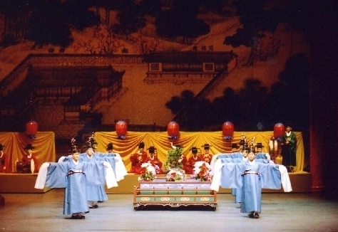 | Court dances, influenced by Confucianism, were traditionally performed at banquets hosted by the royal court for the privileged and take on two varying forms: Hyang–ak and Tang–ak. The first is indigenous Korean dance dating from ancient times where dancers recite an oral preface in the format of a classical song, and the latter differs by having a leader recite an oral preface on the side.
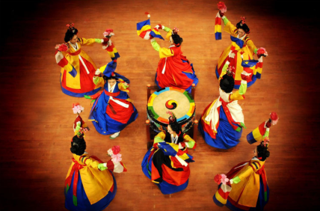 | Mugo is performed by dancers before a large drum. Main dancers use sticks to beat the drum and secondary performers hold lotus flowers. All performers dance around the drum to depict butterflies flying around a central flower.
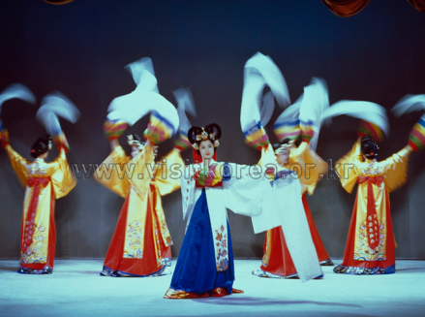 | Hwagwanmu, or flower crane dance, consists of dancers wearing crane masks and costumes while executing movements that mimic a crane. The choreography usually depicts a group of cranes approaching a large lotus flower, and to their surprise, find a little fairy girl inside the flower.

Copy Master 8: What do you notice? Drama

What do you notice?
 |  | I see… I hear… I notice... | Main characteristics
NEW ZEALAND

INDIA

AMERICA

KOREA

Copy Master 9: K-Drama Glossary

K-Drama Glossary
Korean terms | English terms
Noona  Oppa  Sageuk  Ulzzang  Aegyo  Makjang  Banjun | Raws  Second Lead Syndrome  Passing Shot  Melo  Fancruft  Kitchen Sink

Copy Master 10: Influences and impacts

South Korean television dramas (K-dramas, typically served up as mini-series) enjoy huge audiences in the unlikeliest regions. The Korean historical cuisine drama The Jewel in the Palace is so popular that Iranians reportedly organise their mealtimes around the show, Ms Hong writes.

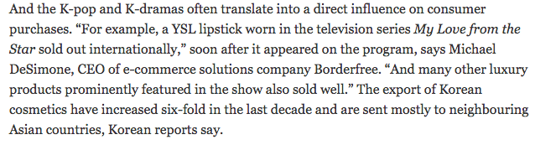
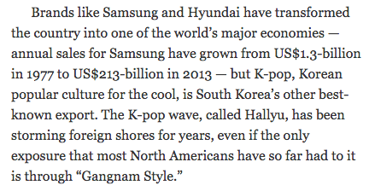
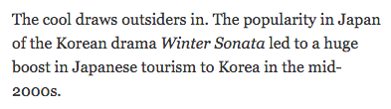
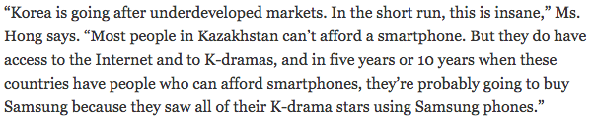
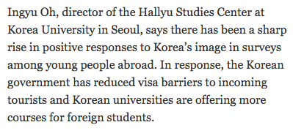

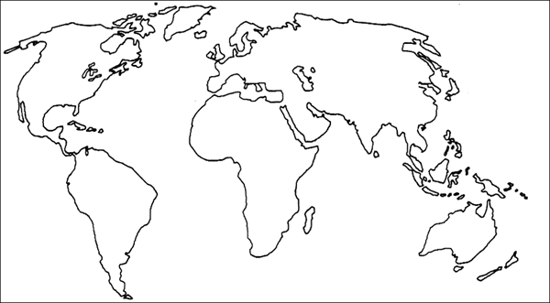

Copy Master 11: Sorting Key Questions

Sorting my inquiry questions

Are they Lookers, Drivers, Snoozers or Keepers

KEY
Drivers - Questions that are both generative and genuine to drive my inquiry
Lookers - Questions that are genuine but quick to look up
Snoozers - Questions that are not compelling nor overly useful
Keepers - Questions that are generative but low interest which may be kept for later

Drivers | Lookers
Generative - How likely is my question going to generate insight, creative action, deeper understanding, and new possibilities?
←--------------------------------------------------------------------------------------------------------------------------------------------->
Snoozers | Keepers

Copy Master 12: Summative Task

Your mission…Catch the Hallyu!

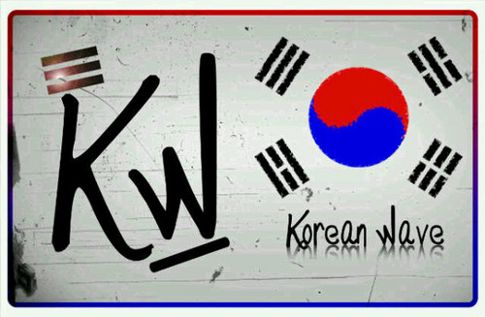

Your inquiry will result in two tasks and display evidence of research into the characteristics of K-Pop or K-Drama, and explain your findings in regards to the impact it has had globally.

You will also need to include any relevant Korean vocabulary/language that you have learnt over this unit.

Task 1 - Characteristics & attributes  Create a trailer/advertisement promoting your own K-Pop group or K-Drama.  You will need to create all aspects of your group or drama, including things such as a name, a theme, basic information.  Show evidence of your research into the characteristics of these forms of Korean entertainment. | Task 2 - Influences & impacts  Research the impacts and globalisation of your chosen form of entertainment. When did it emerge, how did it develop and what has occurred as a result?  Show consideration of economic, cultural, and social impacts within Korea, in New Zealand and around the world.

Copy Master 13: Summative Task Rubric

Summative Task Rubric - Success Criteria
 | Needs Development | Developing | Achieved | Exceeded
Characteristics & attributes | Further research of chosen entertainment form would have provided more understanding of characteristics. | Evidence of some characteristics of chosen entertainment form were recognised. | Evidence of research and understanding of the characteristics of chosen entertainment form. | Clear and relevant evidence of research and understanding of the characteristics in chosen entertainment form.
Influences & impacts | Impacts of Hallyu, in relation to chosen entertainment form, were identified. | Impacts of Hallyu, in relation to chosen entertainment form, were identified and explained. | Impacts of Hallyu, in relation to chosen entertainment form, were identified, explained and linked globally and locally. | Main impacts of Hallyu, in relation to chosen entertainment form, were identified, explained and linked globally and locally.
Presentation | Aspects of the presentation were not sufficiently complete. | New understandings were presented with some clarity. | New understandings were presented clearly, with audience consideration. | New understandings were presented clearly and creatively, with excellent audience consideration.
Language | No Korean vocabulary/phrases were included. | Some Korean vocabulary/phrases were included. | Relevant Korean vocabulary/phrases were included where possible. | Relevant Korean vocabulary/phrases were included effectively.
Peer feedback:

Self-assessment:

Teacher feedback:

Copy Master 14: Planning Page

Planning my inquiry…

Chosen form of Hallyu entertainment and why.

Key Questions developed to drive my inquiry.

Where will I look for information?

To do list…

Copy Master 15: Strategic Searching Tips

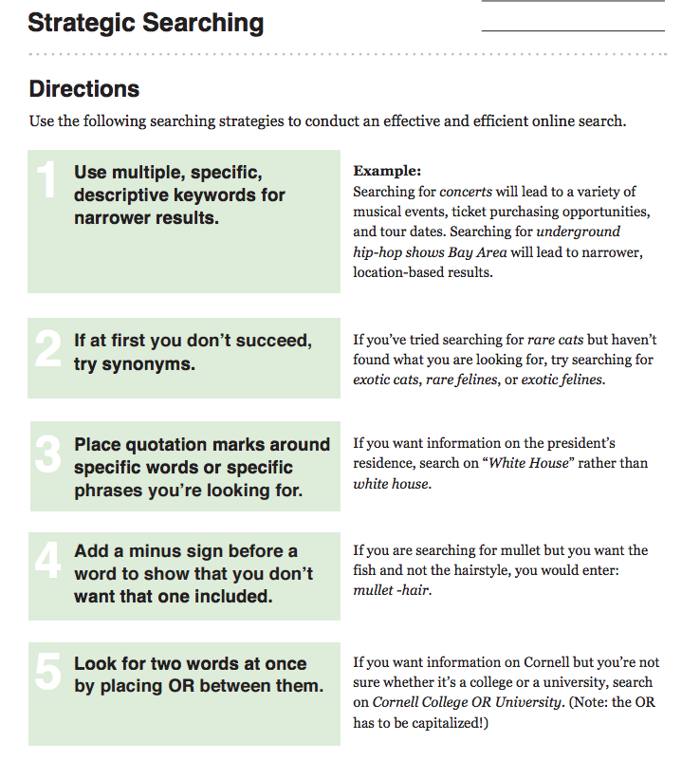

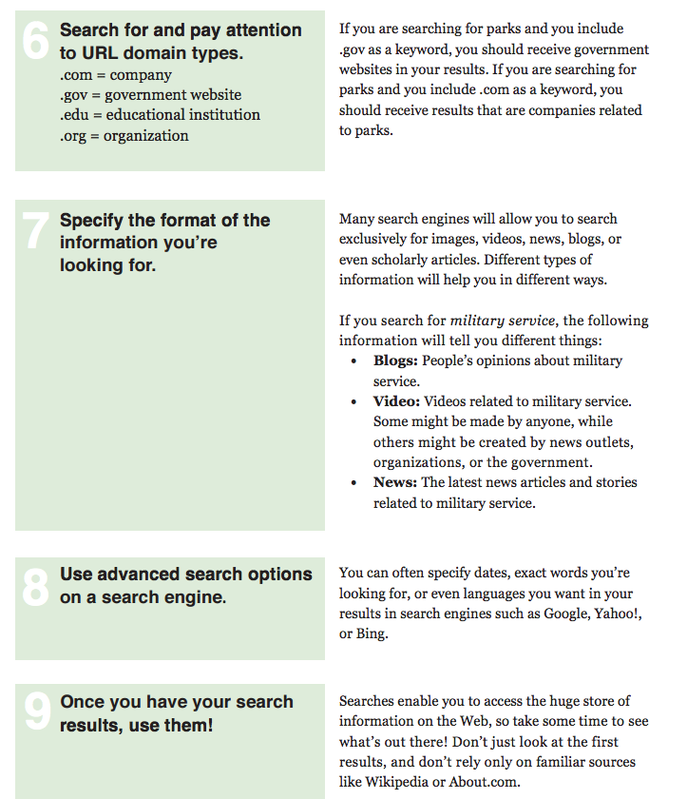

Copy Master 16: Hallyu Reflection

Unit Reflection
Characteristics and attributes?
Explain what you know about the characteristics of K-Pop and K-Drama. Provide examples.
Influences and impacts?
Explain the globalisation of Hallyu and how it has impacted on Korea and the world. Provide examples of different social, economic, political, and/or cultural impacts.
What questions do you still have?

What surprised or interested you during this unit of inquiry?

So what? How could you or how did you use your new knowledge and understanding of Hallyu?

Additional Resources:
Reading Material

Hallyu 2.0: The New Korean Wave in the Creative Industry - Hallyu 2.0

Korean Language

Talk to me in Korean - Lesson 1 - Hello/Thank you
- Lesson 1 pdf
- Audio Lesson 1

Talk to me in Korean - Lesson 2 - Yes/No/What
- Lesson 2 pdf
- Audio Lesson 2

Talk to me in Korean - Lesson 3 - Goodbye/See you
- Lesson 3 pdf
- Audio Lesson 3

Talk to me in Korean - Lesson 4 - I’m sorry/Excuse me
- Lesson 4 pdf
- Audio Lesson 4

Further lessons available through the ‘Talk to me in Korean’ website listed below.

Websites

Korean Updates Website - http://koreanupdates.com/
Learn Korean with Talk to me in Korean - http://www.talktomeinkorean.com/about/
Lesson requests & questions - http://www.talktomeinkorean.com/questions/

References

Student Keys to Driving an Inquiry. Retrieved October 7, 2015, from http://www.prodivame.com/pd-bites/category/tools

Court Dances. Retrieved October 7, 2015, from http://www.koreandance.net/court_dances.html#parrent

Teach digital citizenship and discover the best apps, games, and websites rated for learning | Common Sense Media. Retrieved October 7, 2015, from https://www.commonsensemedia.org/educators

Queen's University - Utility Bar. Ontario Inquiry Model. Retrieved October 1, 2015, from http://library.queensu.ca/research/guide/education-inquiry/model

