Brand and Packaging
Packaging is just as important as the product. It communicates a lot about a brand such as its values, benefits to consumers and the function of the product.
- Function: packaging needs to protect the product from damage that might occur while in transit or on the shelf.
- Differentiation: packaging helps the product stand out from its competitors. Logos, images, colour, size and shape can all do this.
- Informative: Packaging can communicate information to the consumer such as ingredients and nutritional information and values held by the producer.
Investigate the packaging that CHIA + Awaka and Pic’s peanut butter use.
Features of packaging |  | 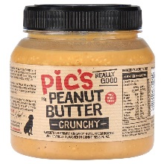
Packaging description
- Labelling
- Images
- Functionality
- Information

What does this tell you about the brand?

