Kiwi brands working together
New Zealand Producer | What is their mission or vision? | What is important to this producer (values)? | What products does the producer make and what are the features of the products? | What are the benefits of the products? | What are 4 interesting features about this producer?
Chia + Awaka

http://chia.co.nz/
Pic’s Peanut Butter

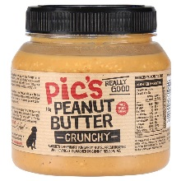

https://www.picspeanutbutter.com/nz/

