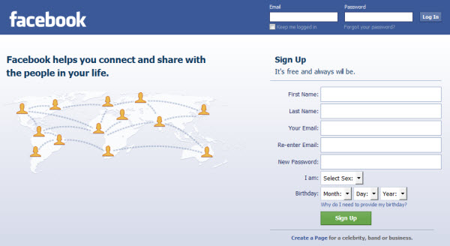
Top 3 reasons for small and medium business to use social media
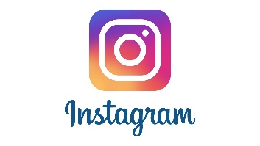
- It will increase brand recognition.
Using social media will increase people’s accessibility to your brand so it becomes more familiar. This could lead to more hits on your website and potential for more customers.

- It increases brand loyalty.
Using social media means the business will be able to better connect with people. The better it does this the more likely that people will become loyal and purchase from the brand again.

- There is potential to convert customers.
Using social media gives the brand access to new, recent and older customers. By interacting with them through social media it can increase the likelihood of these people becoming customers again. People might even switch from another brand because your business has had greater interactions.

Other reasons include:

- It costs less than other forms of marketing and promotion. Large businesses have more money to be able to use other more costly forms of marketing. Small and medium sized business have less so this is a good option for them.
- Businesses are able to keep an eye on their competition. This means they can be better informed of what their competitors are doing and respond to it.

