CHINESE LANTERN FESTIVAL

OBJECTIVES
Achievement Objectives:  Students will gain knowledge, skills and experience to:  - Understand how belonging to groups is important for people.  - Understand how the past is important to people.  - Understand how the cultures of people in New Zealand are expressed in their daily lives. | Year Level: Year 1 and 2  Curriculum level: Level 1  Unit Duration: 5 weeks
INTEGRATION INTO OTHER LEARNING AREA
MATHS
Statistical Investigation
- Conduct investigations using the statistical enquiry cycle:
- posing and answering questions;
- gathering, sorting and counting, and displaying category data;
- discussing the results.

ENGLISH – SPEAKING, WRITING, PRESENTING
Purposes and audiences
- Recognise how to shape texts for a purpose and an audience.

HEALTH & PE
Relationships
- Explore and share ideas about relationships with other people.
Identity, sensitivity, and respect
- Demonstrate respect through sharing and co-operation in groups.
Interpersonal skills
- Express their own ideas, needs, wants, and feelings clearly and listen to those of other people.

VISUAL ART
- Share ideas about how and why their own and others’ works are made and their purpose, value, and context.

DANCE
- Demonstrate an awareness of dance in their lives and in their communities.

MUSIC
- Explore and share ideas about music from a range of sound environments and recognise that music serves a variety of purposes and functions in their lives and in their communities.

Values:  Excellence  Innovation, inquiry, and curiosity  Diversity  Equity  Community and participation  Ecological sustainability  Integrity  Respect | Key Competencies:  Thinking  Using language, symbols, and texts  Managing self  Relating to others  Participating and contributing |  | Principles:  High expectations  Treaty of Waitangi  Cultural diversity  Inclusion  Learning to learn  Community engagement  Coherence  Future focus
Assessment Opportunities:
The inquiry booklet can be used as both formative and summative assessment.
There is an Assessment Checklist included which is intended to be used when necessary throughout the unit.

Unit Focus:  The unit is intended to be completed over a five week period. There are two lessons per week that are included in the unit however, it is intended that learning will be integrated into other areas of the curriculum.  Each lesson begins with developing knowledge about China. This is intended to answer any questions that students may have about China and will vary as necessary according to the needs and experiences of the students.  The majority of each lesson consists of students following an inquiry based on the Lantern Festival. Students will be supported throughout the inquiry process to answer their own questions.  Each lesson also includes a ‘learning the language’ component. This is included because Mandarin is an important language to learn as more people in the world speak Mandarin than English. Students will learn simple words and phrases in Mandarin. These will need to be revisited throughout the unit and throughout the year. |  | Context:  The unit begins with discussion about celebrations and how they are an important part of who we are.  The focus of the unit is on the Chinese Lantern Festival and concludes with students hosting a Lantern Festival celebration.  It is expected that the theme of China and celebrations will be integrated into other curriculum areas particularly in maths and literacy as this will make the learning more authentic for students.

LESSON 1
Curriculum achievement objectives | Understand how the cultures of people in New Zealand are expressed in their daily lives.
Learning Intention | We are learning how to identify festivals that we celebrate.  We are learning that different people celebrate different festivals.
HOOK INTO LEARNING
Students are given Copy Master 1 to mix and match celebrations and festivals. In small groups students match the three celebrations correctly. When completed they name other festivals that they celebrate with their family. Share back with the class and discuss that different families celebrate different festivals.
Explain that in this unit we will focus on one festival that is important to some New Zealanders and is celebrated in China. Tell students to pay careful attention to what the movie tells us about the Lantern Festival.

Watch Sagwa the Siamese Cat - Ba-Do and the Lantern Festival
https://www.youtube.com/watch?v=hDL-R5vxGQk
Discuss with a buddy what information the movie gave us about lantern festival.
Student may discuss …,
- Fireworks
- Last night of the new year’s festival
- Food
- Plays for children to watch
- Fire dragon
- Riddles on lanterns
Other movies that could be used that have basic information about lantern festival
https://www.youtube.com/watch?v=xrhHvbHLbMc
https://www.youtube.com/watch?v=Pv4x2Z7VlKI

LESSON 2
Curriculum achievement objectives | Understand how belonging to groups is important for people.
Learning Intention | We are learning how to find China on a map.  We are learning how to discuss what we already know about China.
PRIOR KNOWLEDGE – What do I know? How do I know?
Use Copy Master 2 to find China on a map and compare to New Zealand. Identify students who are from China either within the class or within the school. Which part of China are they from? Include the names of these cities on the map. Has anyone been to China? Where? Also include these cities on the map. If appropriate you could also attach photos of the students.
Locate 5 major Chinese cities and discuss where Chinese is spoken.
Complete a class brainstorm to find out what students already know about China. Ask students what they would like to learn about China. Students write out these questions and these may also be investigated throughout the unit.
LEARNING THE LANGUAGE
WALHT speak some basic Chinese
Nǐ hăo – Hello
Nǐ hăo ma? – How are you?
Wŏ hĕn hăo – I’m very good
Xiè xiè – Thank you
Zài jiàn – Goodbye
This video could be used as a support for the teacher and as a follow up for the students after the lesson. https://www.youtube.com/watch?v=m1LWu81kWqE

LESSON 3
Curriculum achievement objectives | Understand how the cultures of people in New Zealand are expressed in their daily lives.
Learning Intention | We are learning how to ask good questions.
DESIGNING QUESTIONS
Tell students that we will be having our own lantern festival and ask what there needs to be at our festival. Lead students to come up with three ideas
- Lanterns with riddles
- Food
- Lion dance
Divide students into three groups according to which area of the Lantern Festival they would like inquire into.
Within their groups, students record questions they need to find out so that they can make their chosen aspect of the lantern festival genuine.

Print out appropriate Copy Master 3 and Copy Master 4 for each group to support them with their questions. Support students to produce a variety of questions. Rate the questions from those that are the most important to find out to those that may not be as important to find out.

Share back with the class and encourage students to come up with any new questions that the groups have not thought of.

Display these questions on the wall.
Students complete their inquiry booklet and record their questions.

LEARNING THE LANGUAGE
WALHT say some colours in Chinese
Hóng sè – red
Lu sè – green
Huáng sè – yellow
Lán sè – blue
Bái sè – white
Heī sè – black
Chéng sè – orange
Zĭ sè - purple

A song to reinforce Chinese colours
https://www.youtube.com/watch?v=tHmkDmZVZt8

LESSON 4
Curriculum achievement objectives | Understand how the past is important to people.
Learning Intention | We are learning how to talk about why myths and legends are written.  We are learning how to find information.
KNOWLEDGE ABOUT CHINA
Read the legend of the Chinese Lantern Festival, Copy Master 5.
Discuss
- Why do you think someone wrote this?
- Do you think this really happened?
- Can you think of other legends that have been written to explain happenings?

INQUIRY RESEARCH
Students establish a buddy to work with from within their group.
In their pairs they begin research
- Lanterns with riddles - research using books from library and internet why people have lanterns and what they look like.
- Food – research using books from library and internet what types of food is eaten during the Lantern Festival.
- Lion dance - research using books from library and internet about the Lion Dance during the Lantern Festival.

LEARNING THE LANGUAGE

This learning the language lesson is intended to reinforce the colours that were introduced in the previous lesson.

Students can independently listen to the colours
http://free.lessons.l-ceps.com/learn-chinese-mandarin-free-lesson-4.html

WALHT say some colours in Chinese
Hóng sè – red
Lu sè – green
Huáng sè – yellow
Lán sè – blue
Bái sè – white
Heī sè – black
Chéng sè – orange
Zĭ sè - purple

Students can go together in pairs on in threes. Give each group a colour. They need to take photos of items that are that colour and create a colour sign so that the sign and photos can be a class display.

Use Unit 8 of Hăo (Free resource that is available to all New Zealand Schools) Pages 217- 233 for ways that numbers can be reinforced

LESSON 5
Curriculum achievement objectives | Understand how the past is important to people.
Learning Intention | We are learning how to compare and contrast.  We are learning how to find specific information.
KNOWLEDGE ABOUT CHINA
The Lantern Festival was traditional also known as Chinese Valentine’s day. Explain to students why the Lantern Festival was traditionally known as Valentine’s day.
Ladies (especially unmarried girls from respectable families or humble families) were forbidden to go out in ancient China. Only during the Lantern Festival could they go out to appreciate the colourful lantern exhibitions, and possibly for a date. So, the Lantern Festival was like a Chinese Valentine’s Day in ancient China.
Nowadays, people still go out for date on the evening of the Lantern Festival (including appreciating lantern exhibitions and fireworks shows together, and attending other celebration activities).
Discuss how Valentine’s day was traditionally celebrated in China and how it is celebrated in New Zealand today. Discuss why they think that this has changed?
INQUIRY RESEARCH
In their pairs student continue to research
- Lanterns with riddles – Find and record two different ways to make a lantern
- Food – Find and record two different recipes
- Lion dance – Find out and record about the roles in the lion dance.
LEARNING THE LANGUAGE
WALHT say the numbers from 1 to 10
yi - 1
èr - 2
san - 3
sì - 4
wu - 5
liù - 6
qi - 7
ba - 8
jiu - 9
shí - 10
Video could be used as a support for teacher and as a follow up for students after the lesson.
https://www.youtube.com/watch?v=ujiqoDARvbg

LESSON 6
Curriculum achievement objectives | Understand how belonging to groups is important for people.
Learning Intention | We are learning about Chinese script.  We are learning how to plan our research.
KNOWLEDGE ABOUT CHINA

Invite someone who is Chinese in from the community. This could be a parent of a student within the class. Ask the person to talk to the students about the Chinese script. Ask the students which words they would like to see written and students can try to copy words.

INQUIRY RESEARCH

In their pairs student continue to research
- Lanterns with riddles – Investigate riddles. What are they? Choose one that can be used in their own lantern
- Food – Plan what is needed for their chosen recipe. Re-write the recipe that is the most appropriate. Discuss reasons why they selected the recipe.
- Lion dance – Find and record different ways to create a lion

LEARNING THE LANGUAGE

WALHT say the numbers from 10 to 20
shí yi - 11
shí èr - 12
shí san - 13
shí sì - 14
shí wu - 15
shí liù - 16
shí qi - 17
shí ba - 18
shí jiu - 19
èr shí – 20

Video could be used as a support for teacher and as a follow up for students after the lesson. https://www.youtube.com/watch?v=ujiqoDARvbg

LESSON 7
Curriculum achievement objectives | Understand how the cultures of people in New Zealand are expressed in their daily lives.
Learning Intention | We are learning how to talk about the Chinese zodiac.  We are learning how to record our research.
KNOWLEDGE ABOUT CHINA
The Chinese Zodiac has 12 signs that are determined by the Chinese Lunar Calendar based on the cycles of the moon. The moon’s cycle repeats itself every 12 years and so there are 12 animals one for each year.

Buddha called the animals to earth but only 12 came. The rat, the ox, the tiger, the rabbit, the dragon, the snake, the horse, the goat or sheet, the monkey, the rooster, the dog and the pig. Look at Copy Master 6: Chinese Zodiac and watch this video of the story of the Chinese Zodiac - https://www.youtube.com/watch?v=Iw0adpGLIdk
Ask students which year they were born in and record names under animal. Read descriptors and students identify if they are similar of different to the description. Find one other student at school (it could be a student from a buddy class) and identify which animal they are and the descriptors that match.
Unit 6 of Hăo (Free resource that is available to all New Zealand Schools) Page 172-126189 also has information and activities that can be used to further explore the Chinese Zodiac.
INQUIRY RESEARCH
In their pairs student continue to research
- Lanterns with riddles – Design what the lantern will look like. Justify the decisions made.
- Food – Research and record how the food will be presented to guests. What is needed?
- Lion dance – Record the steps of how to create the lion and the materials that will be needed.
LEARNING THE LANGUAGE
This learning the language lesson is intended to reinforce the numbers that were introduced in the previous two lessons.

WALHT say the numbers from 1 to 20
yi - 1
èr - 2
san - 3
sì - 4
wu - 5
liù - 6
qi - 7
ba - 8
jiu - 9
shí - 10
shí yi - 11
shí èr - 12
shí san - 13
shí sì - 14
shí wu - 15
shí liù - 16
shí qi - 17
shí ba - 18
shí jiu - 19
èr shí – 20

Use Unit 3 of Hăo (Free resource that is available to all New Zealand Schools) Page 109-126 for ways that numbers can be reinforced
- Drawing lines between the numeral, written number and character
- Singing ‘10 Little Indians’ song
- Listening to and recording phone numbers

LESSON 8
Curriculum achievement objectives | Understand how belonging to groups is important for people.
Learning Intention | We are learning how to talk about why pandas are important.  We are learning how to create using what we have found.
KNOWLEDGE ABOUT CHINA
Look at Panda cam http://zoo.sandiegozoo.org/cams/panda-cam
Read about Pandas http://animals.sandiegozoo.org/animals/giant-panda
Look at a map of China and look at where Pandas can be found.

INQUIRY RESEARCH
In their pairs student continue to research
- Lanterns with riddles – Create lantern
- Food – Prepare food
- Lion dance – Make lion and design dance

LEARNING THE LANGUAGE

WALHT say the days of the week
xīngqī yī - Monday
xīngqī èr - Tuesday
xīngqī sān - Wednesday
xīngqī sì - Thursday
xīngqī wŭ - Friday
xīngqī liù - Saturday
xīngqī rì - Sunday

Discuss the pattern in the words. How does this compare to English?

Video could be used as a support for the teacher and as a follow up for the students after the lesson. https://www.youtube.com/watch?v=HFUtz-VIGbw

Complete necessary organisation in preparation for Chinese Lantern Day celebration

LANTERN DAY CELEBRATION

LESSON 9
Curriculum achievement objectives | Understand how the cultures of people in New Zealand are expressed in their daily lives.
Learning Intention | We are learning how to reflect on our learning.
INQUIRY RESEARCH

Reflect on the process and ensure that the research questions have been answered.

- What things went really well for you in your learning?
- What things do I need to work on for next time? Is there anything I would change?
- What did I enjoy most about my learning?

LEARNING THE LANGUAGE

WALHT revise what we already know.

ADDITIONAL RESOURCES
School Journals
Part 2 Number 3 1991

Guest speakers
Invite parents or members of the community in to discuss their knowledge and experiences.

Hăo! An introduction to Chinese

Copy Masters 1-6

Copy Master 1: Mix and match celebrations and festivals

Name | Christmas | Lantern Festival | Valentine’s Day
Picture |  | 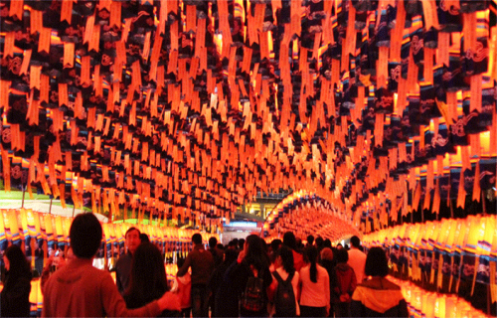
Date | 25th December | 15th day of the first month of the lunar calendar | 14th February
Food | Roast turkey | Ball dumplings in soup | Chocolate
Celebrates | Birth of Jesus | End of Chinese new year | Love

Copy Master 2: Map of the world

Copy Master 3: Questions
who
where

when
why

how
what

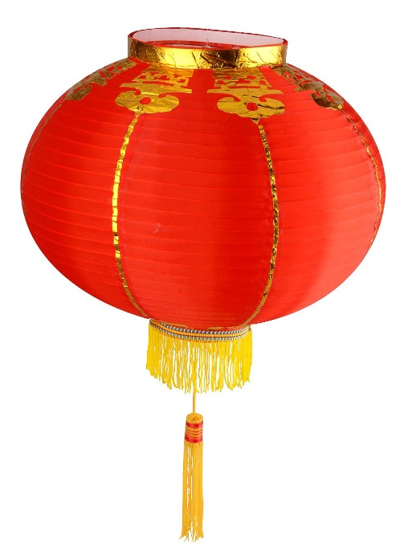
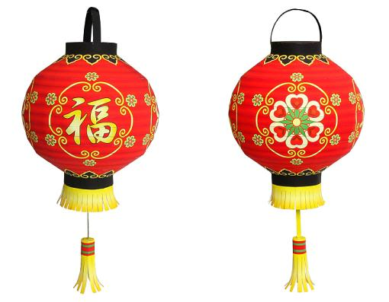
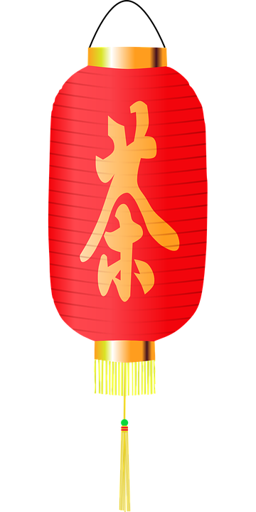
Copy Master 4: Lanterns

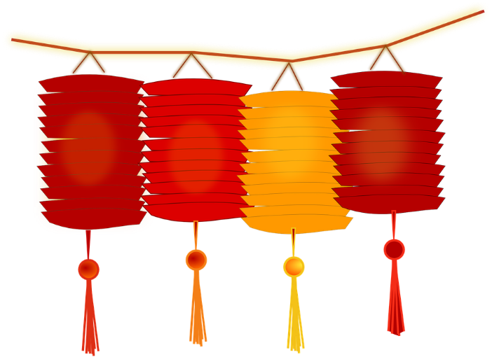

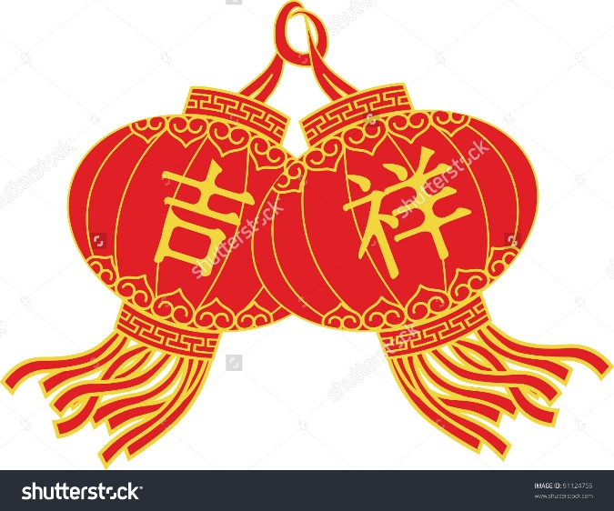
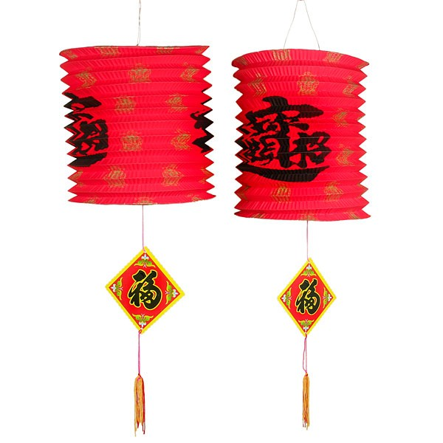

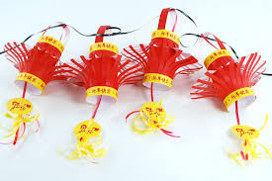

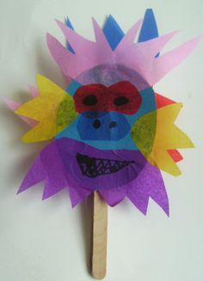
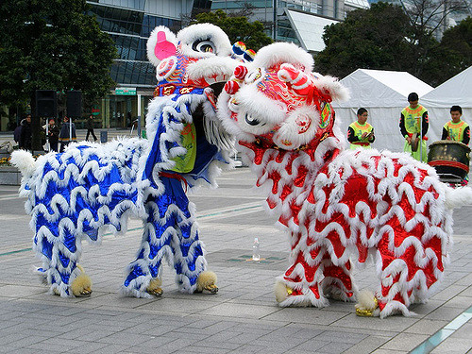
Copy Master 4: Lion
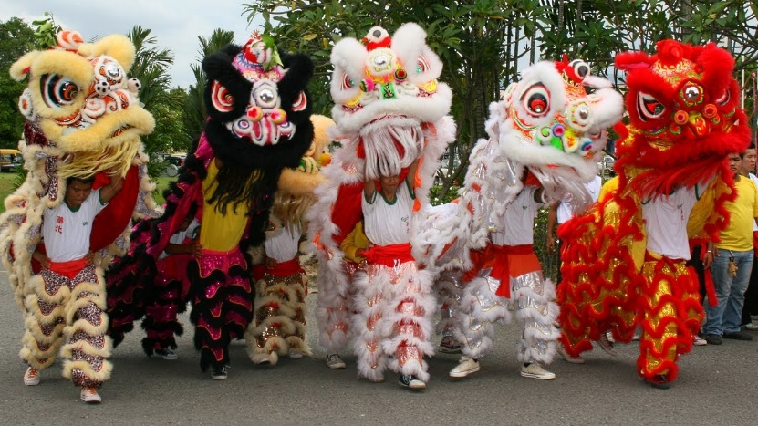

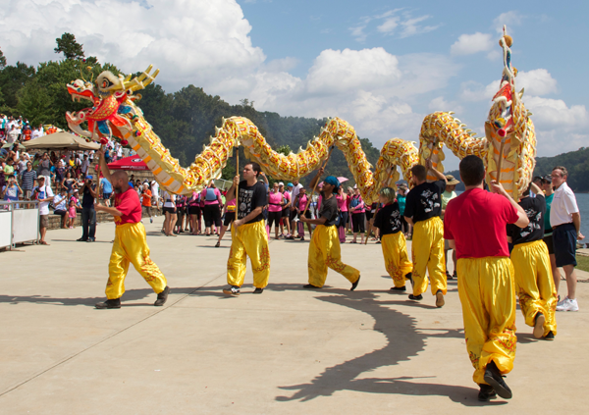

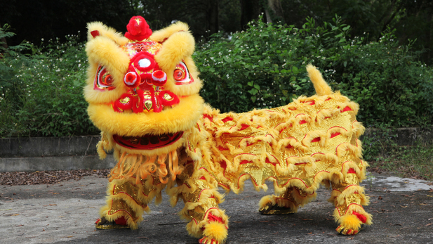
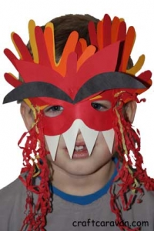

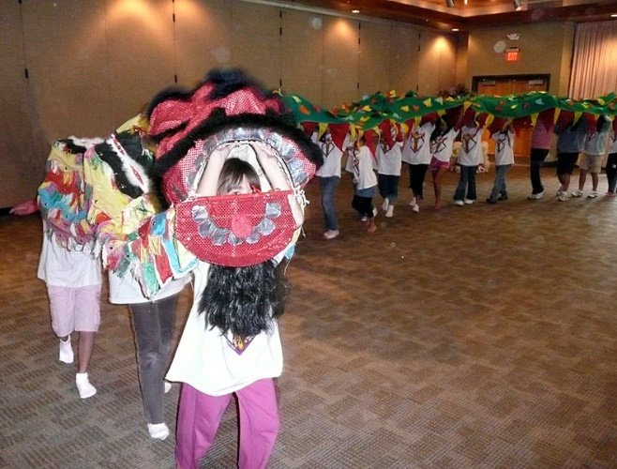
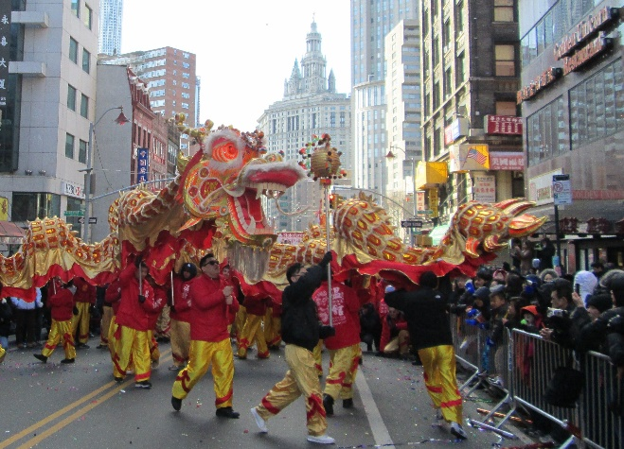
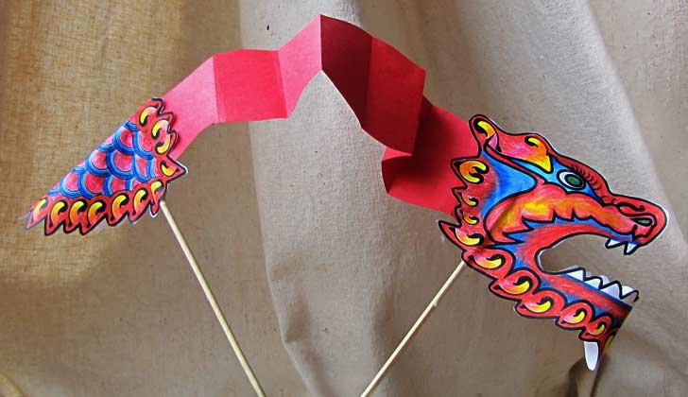

Copy Master 4: Food
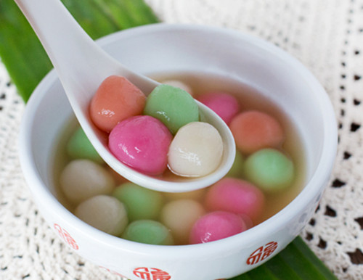
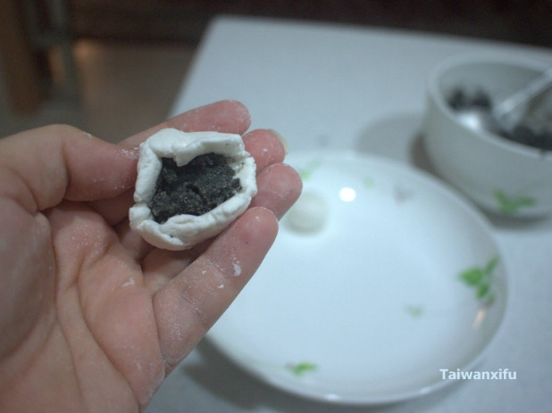
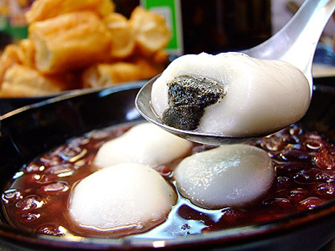
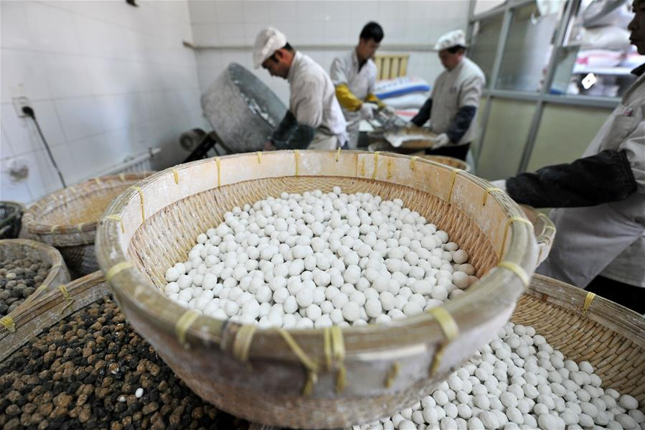
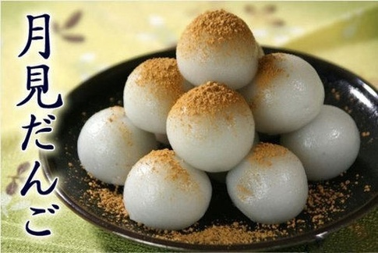
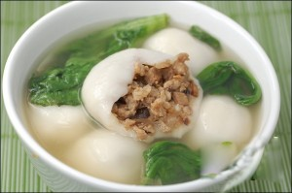
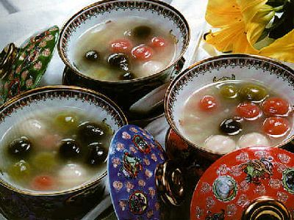
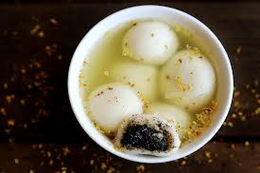
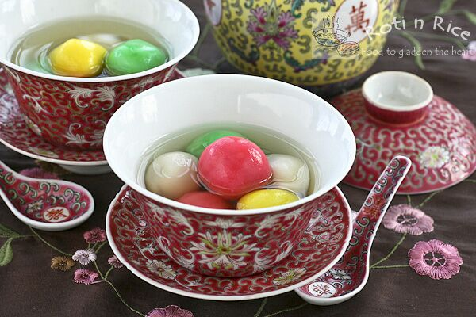

Copy Master 5: Legend about the festival
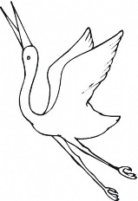
Once upon a time a beautiful crane that flew down to earth from heaven. After it landed on earth it was hunted and killed by some villagers. This made the Jade Emperor in Heaven angry because the crane was his favourite one.

So, he planned a fire to destroy the village on the fifteenth lunar day. The Jade Emperor's daughter warned the people who lived in the village of her father’s plan to destroy their village. The village was in chaos because nobody knew how they could escape.

A wise man from another village suggested that every family should hang red lanterns around their houses, set up bonfires on the streets, and explode firecrackers on the fourteenth, fifteenth, and sixteenth lunar days. This would make the Jade Emperor think that the village was on fire. On the fifteenth lunar day, troops sent down from heaven whose mission was to destroy the village. But when they reached the village they saw that it was already ablaze so they returned to heaven to report to the Jade Emperor. Satisfied, the Jade Emperor decided not to burn down the village.

From that day on, people celebrate the anniversary on the fifteenth lunar day every year by carrying lanterns on the streets and exploding firecrackers and fireworks.

Retrieved from http://www.chinatraveldesigner.com/travel-guide/culture/chinese-festivals/lantern-festival-origin.htm

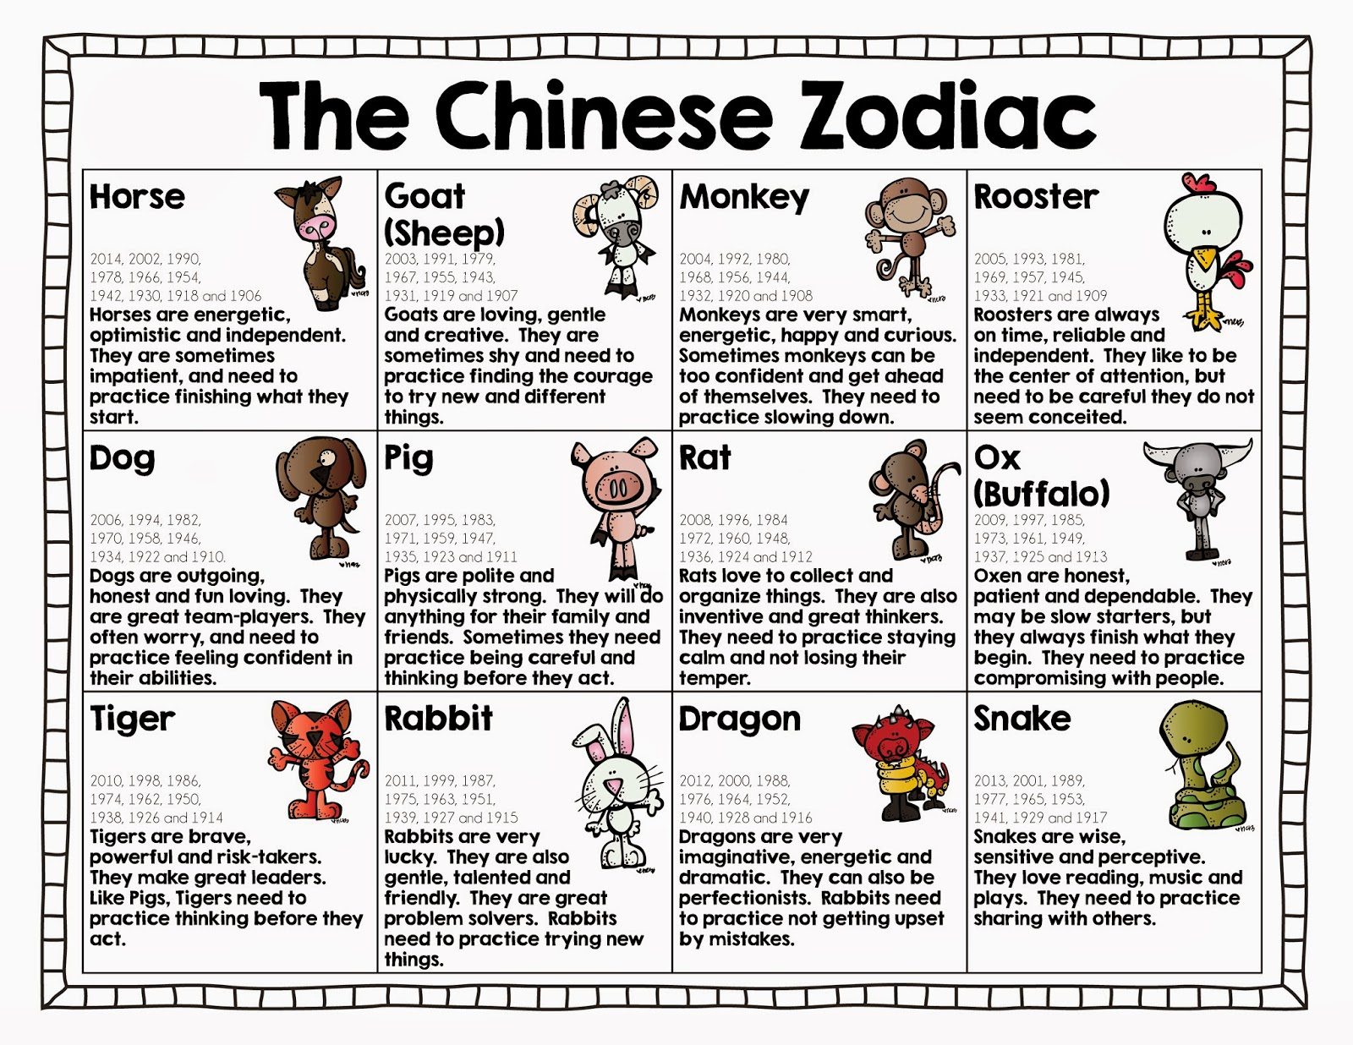
Copy Master 6: Chinese Zodiac

