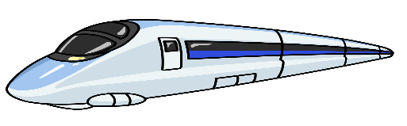**Equations of Motion Practice**

**Mechanics:**

**Japanese Rail & the Shinkansen**



$v_{f}$ $= v_{i}+at$

**d = $v_{i}t+\frac{1}{2}at^{2}$**

${v_{f}}^{2}$ $={v_{i}}^{2}+2ad$

1. Japan’s Shinkansen system includes several different versions of bullet train. The 100-series trains were in service from 1984 until 2012 and accelerated at 1.6 km/h/s (0.44 ms-2). The top speed of a regular 100-series train was 220 km/h (61 ms-1). Assuming constant acceleration from rest, how long would it take one of these trains to reach its top speed? How far would the train travel while accelerating to its top speed?
2. The N700 Shinkansen bullet train is one of the more recent models. Amongst other things it has greater acceleration than previous models and, from rest, it can reach 270 km/h (75 ms-1) in 3 minutes (180s). Calculate the acceleration of a N700 Shinkansen.
3. A passenger is trying to get to a platform in Tokyo Station but is running late. They are running at 4 ms-1 when the speed up to try and make the train. They cover the remaining 80 metres to the train arriving to the train travelling at 6 ms-1. How long did it take for the passenger to cover the 80 metres?
4. Japan, like New Zealand, is on the Pacific Ring of Fire. This leaves it susceptible to large earthquakes at any time. For safety the Shinkansen has an emergency braking system that can bring a train from 270 km/h (75 ms-1) to a complete stop over a distance of 4km. Calculate the acceleration of the train.
5. Shinjuku station is the world’s busiest train station, handling over 3.6 million passengers a day. A train leaves the station bound for Harajuku station on the Yamanote line which is a 34.5 km loop and considered to be Tokyo’s most important. This is a short distance of 2.5km and the train takes 4 minutes for this trip. If the train is travelling at 72km/h (20 ms-1) and has a maximum deceleration of 4.2km/h/s (1.17ms-2) calculate:
   * 1. The distance covered during it’s deceleration into Harajuku station
     2. The time taken for the deceleration into Harajuku station