CHINESE CULTURE: THEN AND NOW

OBJECTIVES
Achievement Objectives:  Students will:  - Explore and describe how dance is used for different purposes in a variety of cultures and context.  - Investigate the functions, purposes, and technologies of drama in cultural and historical settings.  - Identify and describe the characteristics of music associated with a range of sound environments, in relation to historical, social, and cultural contexts.  - Explore ideas about how music serves a variety of purposes and functions in their lives and their communities.  - Apply knowledge of a range of conventions from established practice, using appropriate processes and procedures. |  | Year Level: Year 7 - 9  Curriculum level: Level 4  Unit Duration: 10 weeks  Learning Area: The Arts  - Music  - Visual Arts  - Dance and Drama
INTEGRATION INTO OTHER LEARNING AREA
English - Speaking, writing, presenting - Processes and strategies
Students will integrate sources of information, processes, and strategies with developing confidence to identify, form, and express ideas.

English - Listening, reading and viewing - Processes and strategies
Students will integrate sources of information and prior knowledge confidently and make sense of increasingly varied and complex texts.

Mathematics - Statistics
Students will communicate findings, using appropriate displays.

Physical Education - Challenges and social and cultural factors
Students will participate in and demonstrate an understanding of how social and cultural practices are expressed through movement.

Learning Languages - Communication
Students can understand and use familiar expressions and everyday vocabulary. Students can interact in a simple way in supported situations.

Note - Some Chinese language is developed throughout the unit, but additional Level 1 Chinese language lessons are added separately under ‘Additional Resources’ at the end of this plan. These can be utilized by teachers as a supplement to the unit.
Values:  Excellence  Innovation, inquiry, and curiosity  Diversity  Equity  Community and participation  Ecological sustainability  Integrity  Respect | Key Competencies:  Thinking  Using language, symbols, and texts  Managing self  Relating to others  Participating and contributing |  | Principles:  High expectations  Treaty of Waitangi  Cultural diversity  Inclusion  Learning to learn  Community engagement  Coherence  Future Focus
Unit Focus:  An inquiry into Chinese Arts and how they have changed over time.  To explore how music, dance, drama and visual art in China has been influenced and changed over time.  Throughout this unit there are lessons designed to explore the different Chinese Arts. Students will develop understandings of the traditions behind the arts in relation to historical, social, and cultural contexts.  Lessons are planned in an inquiry sequence, using the Ontario Inquiry Model – see below. Some lessons may run over several learning sessions, particularly when the students are participating in their own research. |  | Context:  The unit context is set through exploring rituals and celebrations. These encompass all areas of the Arts, both traditionally and in modern times.  Students’ will explore the dance, drama, music and visual arts involved in historical rituals and celebrations, and investigate how and why these have changed in a more modern context today.
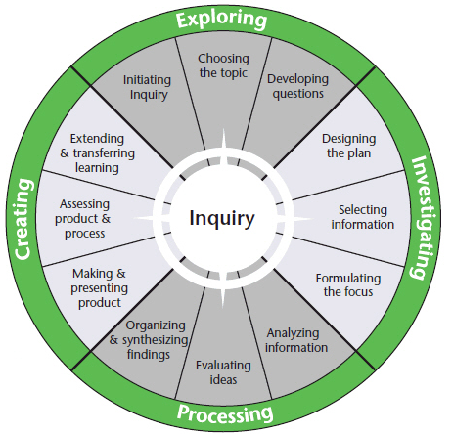

EXPLORING
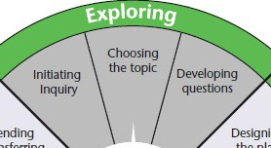

LESSON 1 – Why China?
Initiate class discussion around why it is important to learn about other countries/cultures. Focus class on learning about China. Brainstorm, as a class, reasons why it might be important within a New Zealand context.

Play the videos (linked below). Discuss and add new thoughts to the class brainstorm.

Link - https://vimeo.com/147053421 - Equipping your child to thrive in the Asian Century.

Link - Open Door - Chinese New Zealand - NZ On Screen - Chinese NZ - Maintaining culture?

Introduce the Unit Focus to the class. Add this to student books as a reference. Alternatively students could create individual Google folders to record their inquiries.

Unit Focus: Chinese Culture: Then and Now. An inquiry into Chinese Arts and how they have changed over time.

We will explore how music, dance, drama and visual art in China has been influenced and changed over time.

LESSON 2 – Prior Knowledge
Discuss the unit focus as a class. Ask students to create a visual page of their prior knowledge of Chinese culture, in particular the Arts. Students’ may draw, write or collate digital images to represent their knowledge.

Focus their thinking by questioning - What do you know or think about when you think of Chinese dance, music, drama, or art?

Ask students to individually write a brief reflection using the Copy Master 2: Reflection Key + - :) ?
A copy of this key can be kept as a reference in books or Google folders also.

LESSON 3 – Provocation
Distribute images - Copy Master 3: Images - of different Chinese rituals/celebrations around the room. Split class into small groups of 3-4. Start each group at a different image.

Give each group a copy of the card template sheet - Copy Master 4: Card Template Groups will rotate around images, adding things that they notice into boxes on the template. Provide an example of adding ‘masks’ or ‘dancing’.

Once groups have rotated through the images, ask groups to cut up their cards. Students’ will then try and classify their cards under the headings of DANCE, DRAMA, MUSIC, VISUAL ART.

Discuss what they notice. Are all of the Arts used in these rituals/celebrations? Question WHY? Do we do similar things in our cultures?

Reflect using the Reflection Key + - :) ?

MUSIC
Achievement Objectives | Identify and describe the characteristics of music in relation to historical, social, and cultural contexts
Learning Focus | Music can have different characteristics and attributes depending on cultures and contexts.
LESSON 4 – Traditional Chinese Music
Read as a class, or individually - Copy Master 5: Traditional Chinese Music.

Draw information from the text by identifying the WHO, WHAT, WHEN, WHY, HOW of traditional Chinese music and discuss how it is influenced through the dynasties.

Distribute Copy Master 6: Traditional Chinese Instruments to students.

Ask students to cut out instrument explanations and images and try and match the images to the correct description.

Listen to the samples of each instrument on the links below.

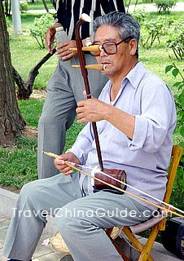
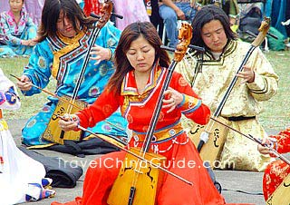
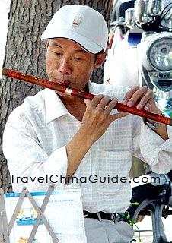
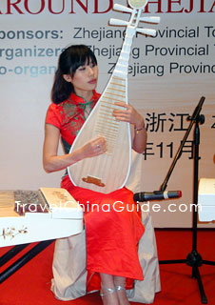

Lute (Pipa) Erhu Flute Horse-Headed Fiddle

Reflect using the Reflection Key + - :) ?
LESSON 5 – Modern Chinese Music
Ask students to read through Copy Master 7: An Introduction to Modern Chinese Music. Based on the text, discuss how the traditional and modern merge. Question the students on whether this is the case with modern Western music. Is this the case with music we listen to today?

Listen/watch the examples of modern Chinese music on this link - Modern Chinese Music. In books, asked students to listen/watch and note what traditional and modern elements they see or hear, as below:

Traditional | Modern

Reflect using the Reflection Key + - :) ?

VISUAL ART
Achievement Objectives | Apply knowledge of a range of conventions from established practice, using appropriate processes and procedures.
Learning Focus | Visual Art can be used to bring music to life
LESSON 6 – Visualising Chinese Music
Discuss as a class how music can evoke imagery. Introduce the idea of programmatic music.

Programmatic music is a typical manner and form of Chinese music. It is music that narrates a story or refers to something concrete in reality, such as scenery, nature, a flowing stream, and high mountains. It can also be poetic in tone and can depict historical events, human emotions, or states of mind. This can be recorded in books for reference.

Play the introduction of Moonlight on the Ching Yang River and ask: What kind of landscape do you imagine when you hear this music? Brainstorm in books, using either words or sketches.

Tell students that this music is considered programmatic music, and each section of music can be identified visually with a picture. As is mentioned in the album details of Cheng Yu (2007), the introduction gives us the image of the sound of a bell and a temple drum along the river. Compare this picture with descriptive comments from the students.

Explain to students that programmatic musical pieces contain poetic titles that help to conjure up particular images. In essence, the music functions as a narration or ‘sound-painting’ of stories that the composer has in mind. Let students understand that music can be a powerful resource for describing and portraying many stories. Listen again and see if they can imagine the scene of moonlight on a river at night.

LESSON 7 – Create a Programmatic Music Art
Discuss what a ‘landscape’ is and entails. Revise what programmatic music is, noting that it evokes imagery and contain a poetic title to help develop imagery.

Explain to the class that they will create their own visual piece based on an example of programmatic Chinese music. They will consider both the title of the piece and the emotion within the music.

Watch Ways to create the illusion of space and leave the final examples on the whiteboard for students to view. Ask students to try and include at least two of the techniques shown in their landscape.

Introduce the title of Blossoms on a Moonlit River in Spring. Discuss what the title implies and what you might see in this landscape. Play Blossoms on a Moonlit River in Spring to the class and discuss how the music might match the title. Think about how different colours might be used to represent spring etc.

Model a draft with students and let them be creative whilst listening to the music again. Different media such as coloured pencils or pastels work with landscape art.

Art may take longer than one lesson and can be worked on over time. Ask students to peer-assess each other’s work, commenting on the criteria of using at least two of the techniques seen, and by considering if the art effectively represents the piece of music.

Reflect using the Reflection Key + - :) ?

DANCE AND DRAMA
Achievement Objectives | Explore and describe how dance is used for different purposes in a variety of cultures and context.  Investigate the functions, purposes, and technologies of drama in cultural and historical settings.
Learning Focus | Dance and drama can serve a range of functions and influence people over time.
LESSON 8 – Traditional influences on Modern Dance and Drama
Discuss as a class how and when the Arts (music, art, dance, drama) mix and merge, often overlapping and complementing each other. Discuss this within a local context, making links to western music video clips often telling a story and using digital visual arts.

Share Copy Master 8: Dance and Drama Combine and ask students to glue this into books.

Discuss how traditional stories are often passed through time with dance and drama. Add to books any connections students can make with their own prior knowledge. Make links to Maori waiata, myths and legends, and Kapa Haka.

Watch - Dance drama 'Confucius' popular during National Day holidays

Reflect using the Reflection Key + - :) ?

LESSON 9 – Lion Dance Traditions Continued
Watch Chinese Youth Club Lion Dancers and respond to the questions in Copy Master 9: Lion Dancers.

Have students examine the images in Copy Master 10: Lion Masks. Discuss that the masks are made from strong but light materials, such as papier-mache and bamboo, and fit over a dancer's shoulders. The dancer can move the lion's eyes, mouth and ears with their hands. The lion's body, which is attached to the head, consists of a long piece of cloth. It is often decorated with sequins and mock fur.

Have a look at the process of making a Lion head here - How to make a lion head.

Should you wish to take this lesson further you could even attempt to make a class lion head. Try and make connections with the local community and see if you can even get someone in to run a lesson.

Reflect using the Reflection Key + - :) ?

LESSON 10 – Choosing a topic and developing questions
Students will now decide on the area of interest they wish to inquire into further.

Ask students to look back over their reflections and any questions they had. Use lessons as a guide to students interests. What stood out? Traditional Chinese instruments, modern Chinese music, visualising Chinese music, Dance Drama, traditional Chinese rituals through the Arts?

Ask students to put together a Questions Page where they record any questions they have about their area of interest. Encourage students to include a CHARACTERISTICS of their chosen area question, and a CHANGE question that focuses on the change over time, in order to keep clear links to the achievement objectives.

Students will review their individual Questions Page and identify key questions to drive their inquiries. Teacher will ask the class if their questions are Lookers, Drivers, Snoozers or Keepers.

Project Copy Master 11: Sorting Key Questions onto the whiteboard and explain each category, as below.

KEY
Drivers - Questions that are both generative and genuine to drive my inquiry
Lookers - Questions that are genuine but quick to look up
Snoozers - Questions that are not compelling nor overly useful
Keepers - Questions that are generative but low interest which may be kept for later

Generative - How likely is my question going to generate insight, creative action, deeper understanding, and new possibilities?

Genuine - How much do I care about investigating this question?

Reflect using the Reflection Key + - :) ?

INVESTIGATING
Inquiry lessons to support student research and presentation.
Students will conference with their teacher and peers throughout these stages.
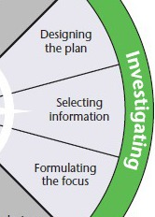

LESSON 11 – Designing the Plan
Introduce Copy Master 12: Summative Task and Copy Master 13: Task Rubric and Success Criteria.

At this point students will also decide if they want to inquire individually or in small groups. Groups will decide on an area of the Arts to research.

They will EXPLAIN their art form and its characteristics, DESCRIBE how it has changed over time and become what it is today, and CREATE a visual representation of how it has changed.

Discuss examples of like how the Lion dance was traditionally and how it may have changed over time to suit modern contexts. Or how the materials may have changed over time because of development.

LESSON 12 – Selecting Information and formulating the focus
Ask students: How do you find something online? What kinds of things do you search for?

Discuss as a class what a ‘search strategy’ is when researching on the internet. Teacher can note known strategies on the board.

Define what effective and efficient searching might look like. Explain to students that an effective online search is one that yields the precise results they are looking for. An efficient search does so without a lot of wasted time or energy – for example, having to scroll through a lot of search results that don’t relate to their desired topic.

Write the following steps on the board, or project it from your computer screen. This mnemonic device lays out the five steps in a search plan, and the steps spell out SEARCH. Share the explanation of what each step means.

SELECT - research questions and search tools
(Explain to students that they should have one or more questions that get to the core of what they want to find out in their search. They should also choose search engines and tools that are most relevant to what they are looking for.)

EXTRACT keywords and terms
(Students should understand that they can find effective keywords by highlighting the key terms from their research questions.)

APPLY search strategies
(Students should apply some of the search strategies they learned – for example, adding quotation marks or a minus sign, or specifying what type of information they need.)

RUN your search
(Students should run a search on the terms they have chosen and review the results. Remind students that they should check out multiple sources.)

CHART your search
(Students can avoid repeating work they have already done by jotting down what they’ve searched for and where they’ve searched for it.)

Reflect using the Reflection Key + - :) ?

LESSON 13 – Strategic Searching
Students will now spend time researching their chosen inquiry questions, note-taking and summarising in their own words. Research time may vary and regular conferencing with the Teacher and peers is required throughout the research stage.

To begin the research process, discuss effective search skills for internet based research. Discuss the use of effective key-words through the lesson set out in Copy Master 14: Strategic Searching.

PROCESSING
LESSON 14 – Note-taking/note-making to analysing information
Discuss the difference between researching by taking notes and researching by taking notes from a range of sources and then making notes of your new understandings.

Walk students through Copy Master 15: Research organiser.

Model with students the process of taking bullet-point notes and selecting one or two important direct quotes. Then show them how to summarise these findings into their own words. Stress the importance of bullet point note-taking so that they are not in danger of copying information word for word. Students may utilise this organiser a number of times for different sources and then collate summaries.

LESSON 15 – Organising information and findings
Once students have completed their research and note-taking, they will need to gather their summarised information and analyse what information is the most relevant and which information needs to be discarded.

Ask students to consider what information best shows their new understandings of their chosen art form. Do some of their findings overlap? Can summaries be merged or filtered?

Students could use Copy Master 16: WWWWH & So what? to help sort their findings. Have they covered the who, what, when, why, and how? Ask students to also consider the ‘So What?’ aspect of their findings at this stage. Why is this information useful/interesting? Why is it important or reflective?

CREATING
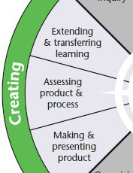

LESSON 16 - Making and presenting product
Students will consider a range of different medium to create a visual or audible representation of an aspect of their art form. Things such as papier mache, dioramas and digital media may be suitable for presentations. Encourage students’ to consider the BEST way to present the CREATE aspect of their inquiry, through research. They may need help with resources.

LESSON 17 - Assessing product and process
Once students have presented their inquiries, they will need to assess themselves in relation to the success criteria in the Summative Task Rubric.

Did their presentation EXPLAIN the art forms characteristics, DESCRIBE the change from traditional to modern, and did they CREATE a suitable representation of this visually (or audibly if music was chosen).

LESSON 18 – Extending and transferring learning
Discuss the importance of reflection and why it is helpful in our learning. Remind students that reflective responses require explanation and examples, for clarity of new understandings gained. Complete the end of unit reflection using Copy Master 17: Chinese Culture: Then and Now Unit Reflection.

Ask students to share what some of the interesting things about this unit were and what their ‘So what?’ next steps might be.

