Sichuan Province, China
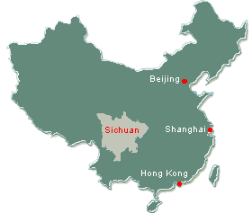
Sichuan province is situated in the southwest of China near the upper reaches of the Yangtze River. It is within a highly active seismic zone.
There are 21 cities and 183 counties in Sichuan Province. The capital city is Chengdu. It has the largest economy in the province and is the hub of culture, technology, education, transport and communicate services. Most of the population is located in the east however there is a large rural population.
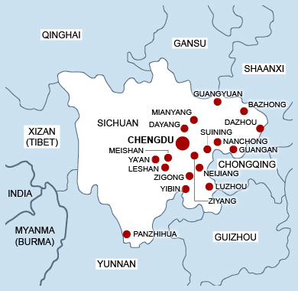
Area: 485,000 km2
Population: 80418200
Population density: 180 people/km2
Gross domestic product: 1718.5 billion RMB
GDP per capital: 21182 RMB
GDP growth: 15.10%
There is a region of high mountains in the southwest, a high plateau in the northwest, and a lowland region in the eastern part of the province. The Sichuan Basin is a key natural feature. Land within the basin varies greatly. There are many low, rolling hills, high ridges, floodplains and valley flats. There is an abundance of water resources within the province. The Yangtze River runs through the mountains of western Sichuan and the Sichuan Basin. Many tributaries flow from the Yangtze. All areas within the province are affected by the monsoon climates however the varying natural features mean there are differences within the province.
The Sichuan Basin is one of China major agricultural production bases. Products produced include rice, wheat and port. It is also an industrial centre producing coal, hydro power and iron. Most of the growth has occurred in Chengdu.
The province contains a large amount of cultural treasures. There are 5 world heritage sites and 62 natural key cultural relic protection units. Tourism is a growing industry within the province.
Sources:www.thechinaperspective.com www.sc.gov.nz www.britannica.com/place/Sichuan

