The relationship between values and actions
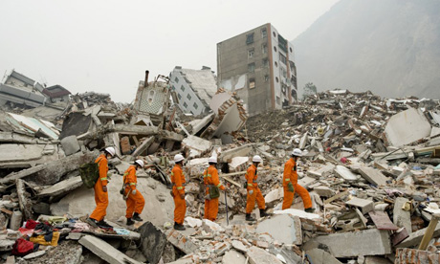

Group or organisation | The values held by this group or organisation are… | These values motivated the group or organisation to (action)…
Chinese Government

International group

Name the group

