Material Master 1
Where in the world would you find these fridges?
How do you know?

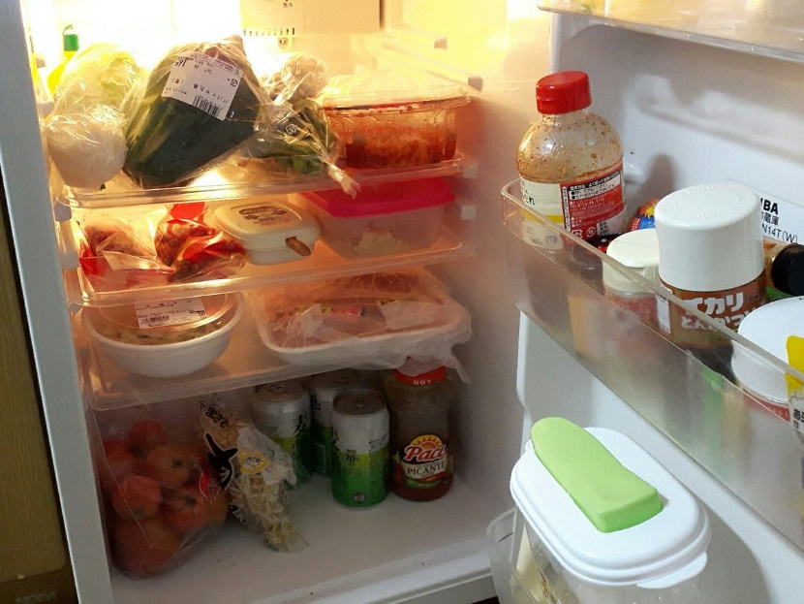
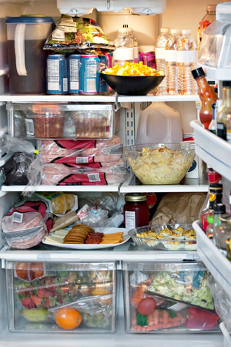
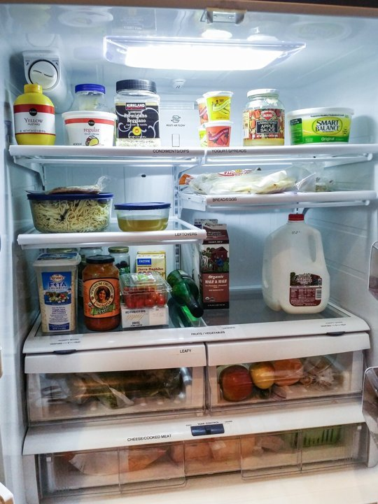
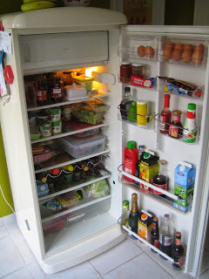

Material Master 2
Where in the world would you find these food markets?
How do you know?

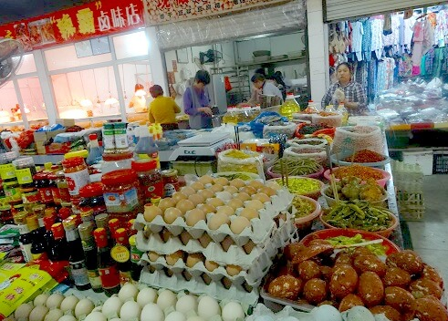
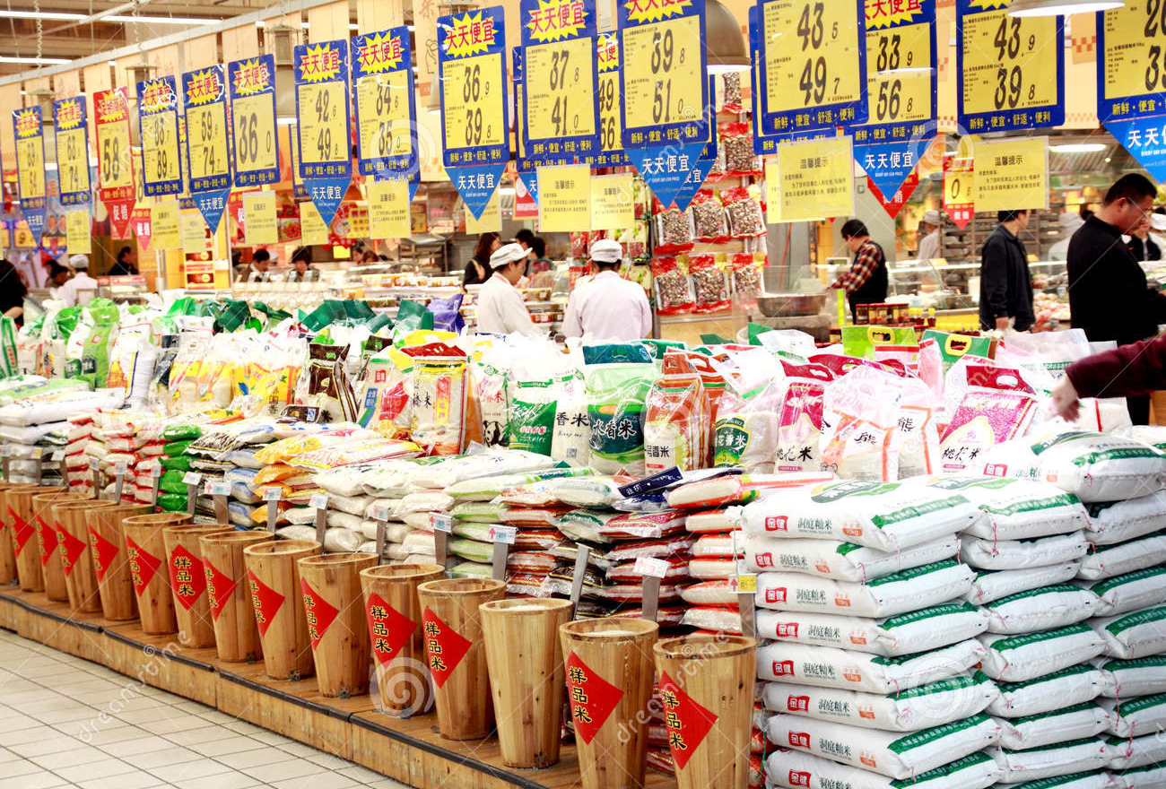
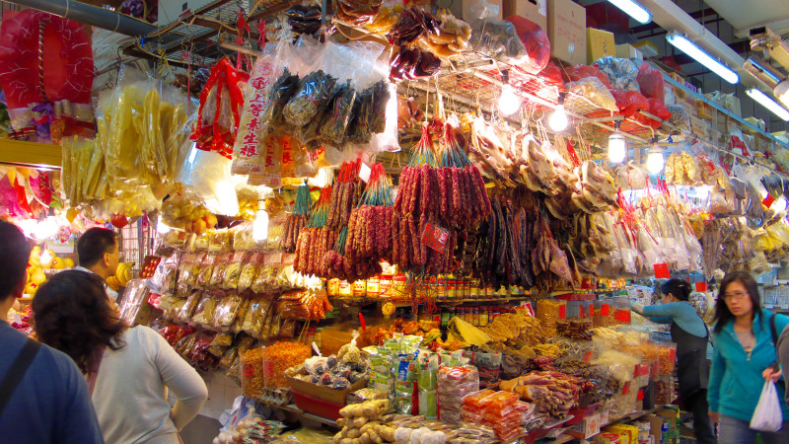
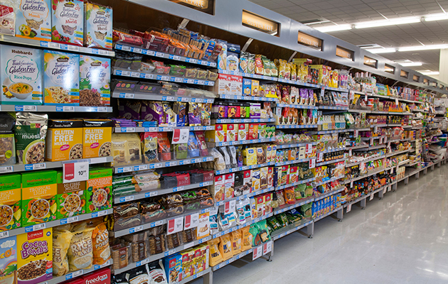
Material Master 3
What are these people doing?
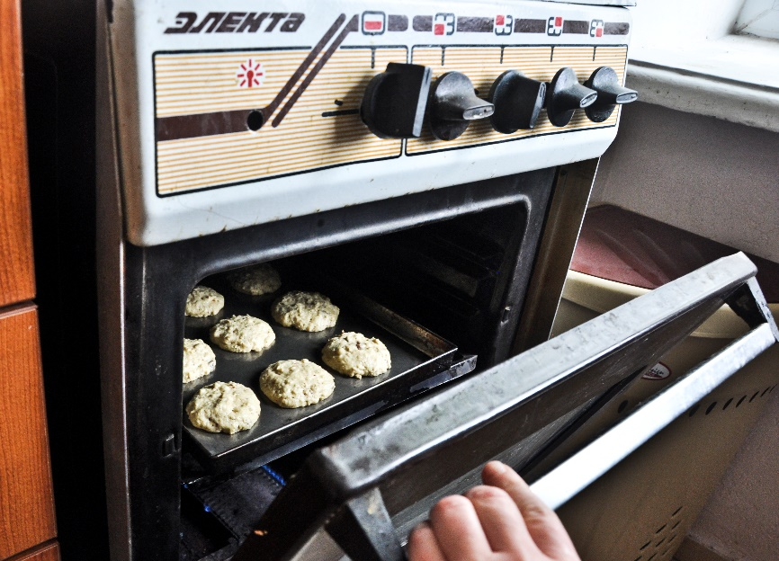
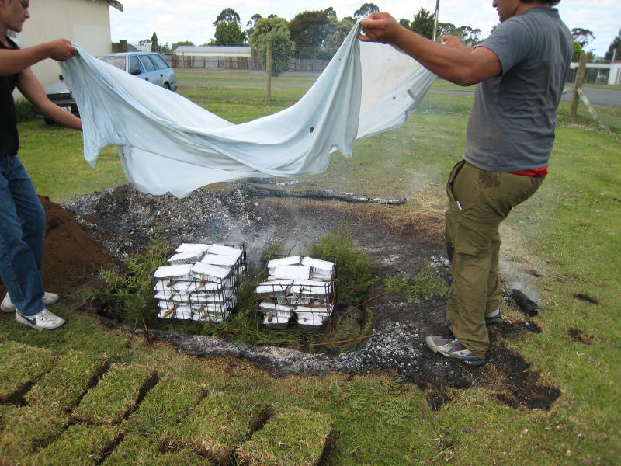

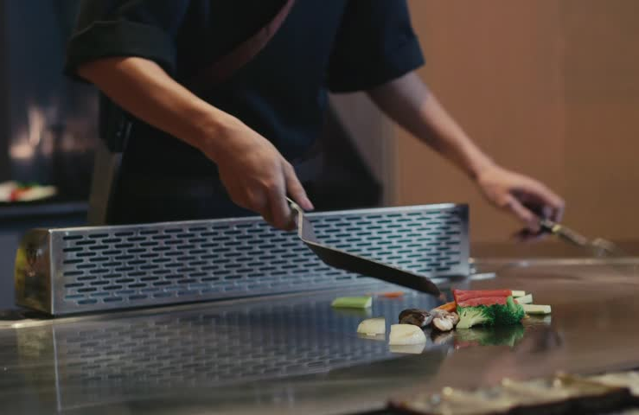
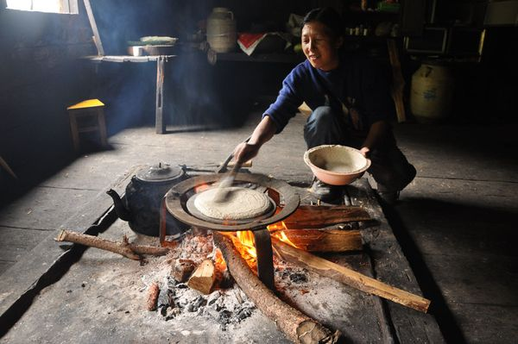
Material Master 4
Different foods from different countries
Kazakhstan cuisine
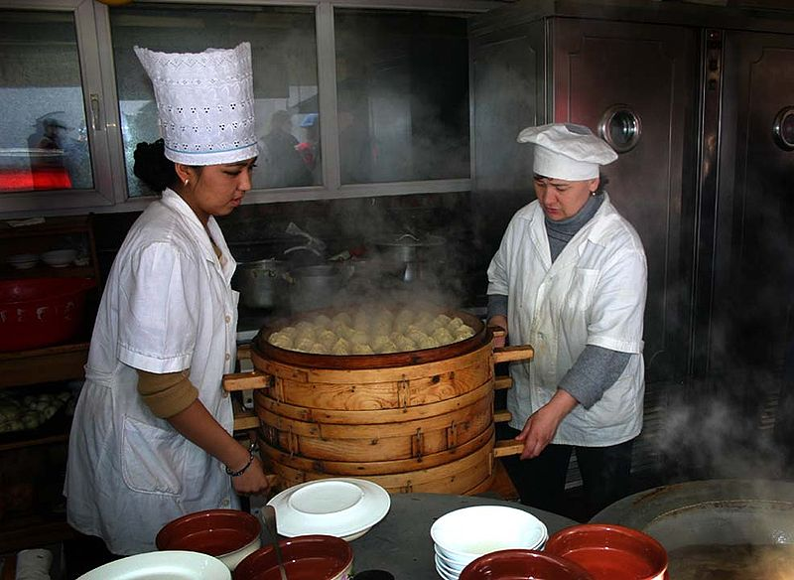 | 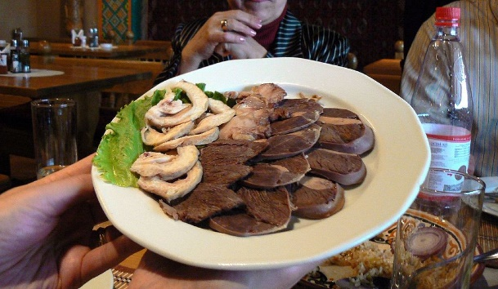
Preparation of a meal in Kazakhstan | Horse meat

Japanese cuisine
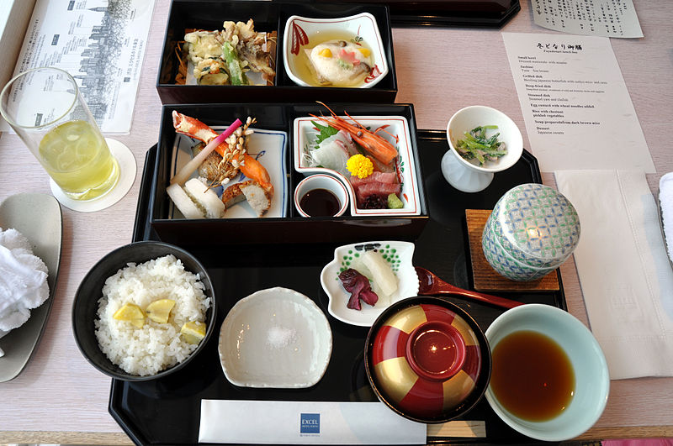 | 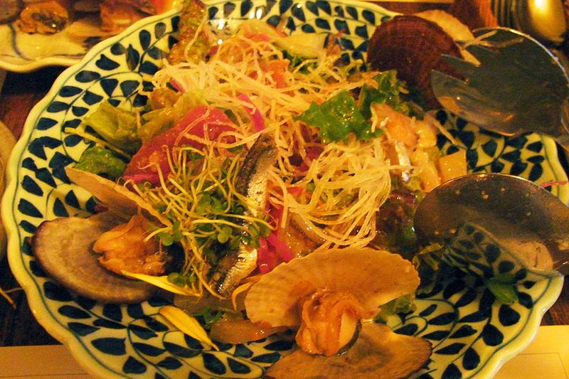
A meal including tempura, sashimi and miso soup. | Japanese vegetables

Burmese cuisine from Myanmar
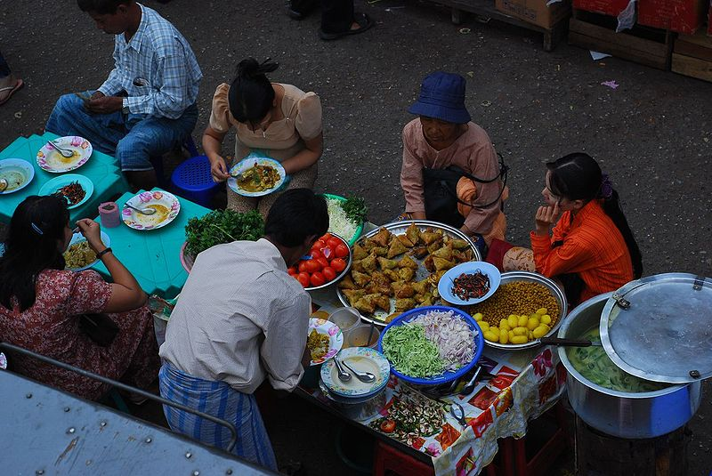 | 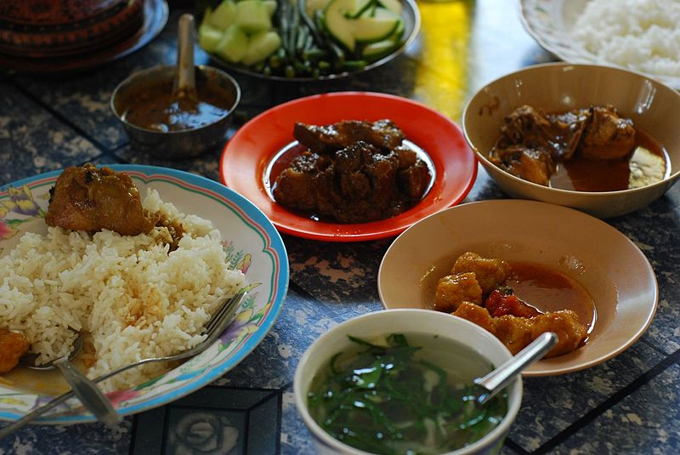
People eating in the outdoors | A bowl of soup, rice, curries and vegetables for dipping

Material Master 5

Questions to encourage picture discussion in Material Master 2

How are the foods in the pictures different from the foods you eat?

Why do we eat the foods we eat?

How does our culture or ethnic background affect the way we eat?

What do you think these foods are? Would you like to eat them?

When do you think people would eat this food?

Which country do you think these people are from? What makes you think this?

Material Master 6
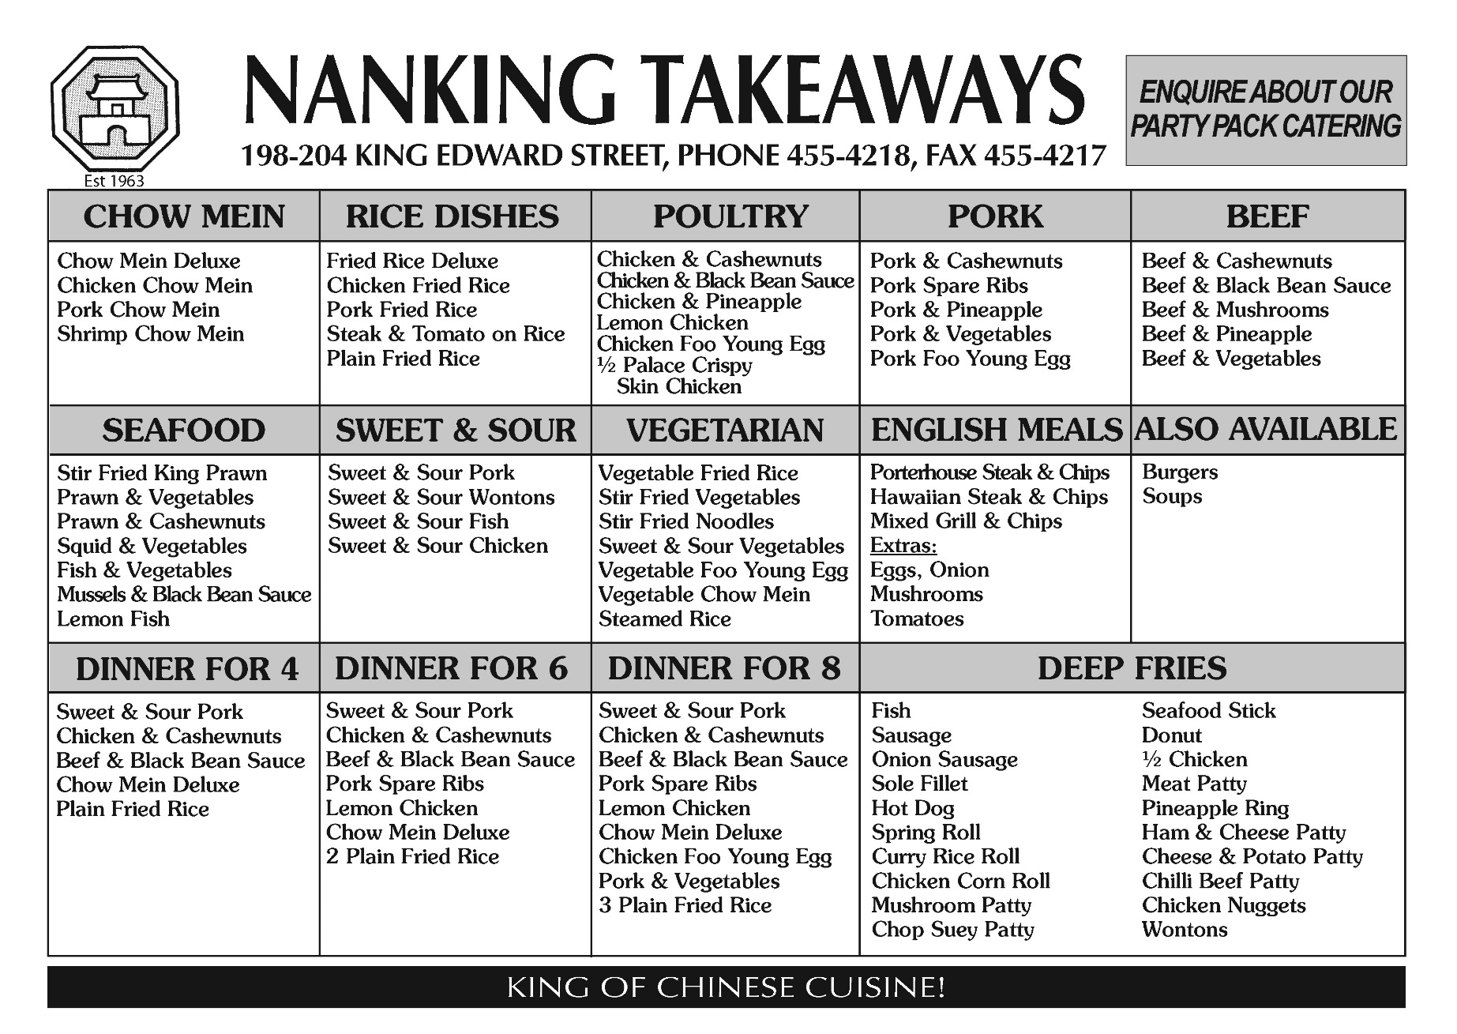

A
Afghanistan
Armenia
Azerbaijan

B
Bahrain
Bangladesh
Bhutan
Brunei

C
Cambodia
China
Cyprus

G
Georgia

I
India
Indonesia
Iran
Iraq
Israel

J
Japan
Jordan

K
Kazakhstan
Kuwait
Kyrgyzstan

L
Laos
Lebanon

M
Malaysia
Maldives
Mongolia
Myanmar (Burma)

N
Nepal
North Korea

O
Oman

P
Pakistan
Palestine
Philippines

Q
Qatar

Material Master 7
R
Russia

S
Saudi Arabia
Singapore
South Korea
Sri Lanka
Syria

T
Taiwan
Tajikistan
Thailand
Timor-Leste
Turkey
Turkmenistan

U
United Arab Emirates (UAE)
Uzbekistan

V
Vietnam

Y
Yemen

Material Master 8
Researching a Country
Name of country ______________________
Capital City:
__________________
Population:
__________________
Official language(s) spoken:
__________________
__________________
This is how you say…
Hello
__________________
Goodbye
__________________

Interesting fact:
_______________
_______________
_______________

Interesting fact:
_______________
_______________
_______________

Famous Landmarks:
____________________
____________________
____________________
____________________
____________________
____________________
____________________
____________________

Holidays celebrated:
____________________
____________________
____________________
____________________
____________________
____________________
____________________
____________________

Flag:
Map:
Material Master 9
The country I am investigating is __________________________________

What is the traditional dish of this country? | Here is a picture of the traditional dish.
What foods do they eat most days? | Here is a picture of the foods they eat most days
What celebrations are there when they have special food?

Other interesting facts about food

Material Master 10
Here is some of the packaging I use at my house
Type of packaging | In my house we use .. | It looks like this.
Foil wrapped
Tins
Glass jars
Cardboard
Aluminium cans
Steel

Material Master 11
Snacks that people enjoy

Material Master 12
The snack we have decided on is __________________________

To make our snack we need these ingredients:

To prepare our snack we to:

Some possible names for our snack could be:
____________________________________
____________________________________
____________________________________
____________________________________
____________________________________

Material Master 13
Possible designs for our package
This is how I rate this design | This is how I rate this design

Material Master 14
Self evaluation
What worked well? | What didn’t work well? | What could I do next time to make my snack or package better?
This is how well I worked on this project

