Material Master 1
Getting to know you character sheet
Who is the character?
Personality
Look for the characters thoughts and feelings.
Who is the character?

Find evidence in the text
Find evidence in the text
Find evidence in the text

Actions
What is the character doing?
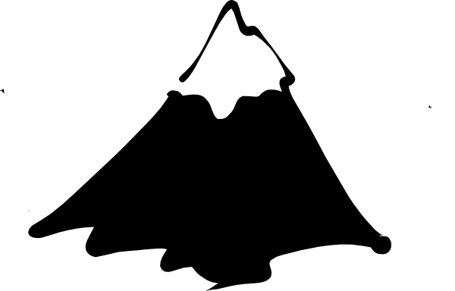
Story Mountain Material Master 2
Problem

Resolution
Build up

Ending
Opening

A
Afghanistan
Armenia
Azerbaijan

B
Bahrain
Bangladesh
Bhutan
Brunei

C
Cambodia
China
Cyprus

G
Georgia

I
India
Indonesia
Iran
Iraq
Israel

J
Japan
Jordan

K
Kazakhstan
Kuwait
Kyrgyzstan

L
Laos
Lebanon

M
Malaysia
Maldives
Mongolia
Myanmar (Burma)

N
Nepal
North Korea

O
Oman

P
Pakistan
Palestine
Philippines

Q
Qatar

Material Master 3
R
Russia

S
Saudi Arabia
Singapore
South Korea
Sri Lanka
Syria

T
Taiwan
Tajikistan
Thailand
Timor-Leste
Turkey
Turkmenistan

U
United Arab Emirates (UAE)
Uzbekistan

V
Vietnam

Y
Yemen

Clothing:
Foods:
______________
______________
______________
______________
Interesting facts:
1______________________________________________________________________________________
2______________________________________________________________________________________
3_______________________________________________________________________________________________

The best things to see in this country are …
____________________
____________________

Holidays:
___________________
This is how you say…
Hello ___________
Goodbye ___________

Country:
________________________
Capital:
________________________
Language:
___________________
This is how you say…
Hello ___________
Goodbye ___________

This is the flag:

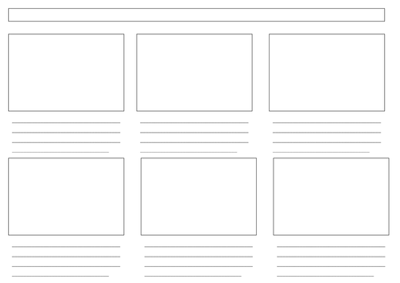
Material Master 5

Material Master 6
Roll and Retell

What is the story about?

Who are the main characters?
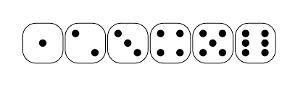

Where does the story take place?

What was the problem in the story?

How was the problem in the story resolved?

Is there any questions you have about the story?

Material Master 7
Planning a story template
Who? | What?
Where? | When?
How? | Why?

Material Master 8
Reflect on your learning this term

This term I learnt…

My story was about ….

I think that the best part was …

I think this because…

My next steps might be to…

Material Master 9
Assessment Checklist
Name of student | I can name some countries that are in Asia. (Lesson 1) | I can talk about a story from another culture.  (Lesson 3) | I can summarise a story.  (Lesson 4) | I can describe a character in a story. (Lesson 5) | I can act out a story. (Lesson 6) | I can talk about the parts of a story. (Lesson 7) | I can find information about an Asian country. (Lesson 9)

Writing Checklist
I can use paragraphs
I can describe the setting in my story
I can use connectives
I can use descriptive words in my writing
I can make changes to improve my work.

