Material Master 1
Answers to finding out facts about Japan

- None. Japan is surrounded by sea.
- 8
- Tokyo
- 126.92 million
- 70-75% (On the Nature and Climate page it states that 75% of the country is mountainous, while on the Regions of Japan page it says that Mountainous areas account for more than 70% of Japan’s land)
- 3 years
- 30-40 in a typical elementary class
- Kanji
- Sumo

Material Master 2
Map of Japan
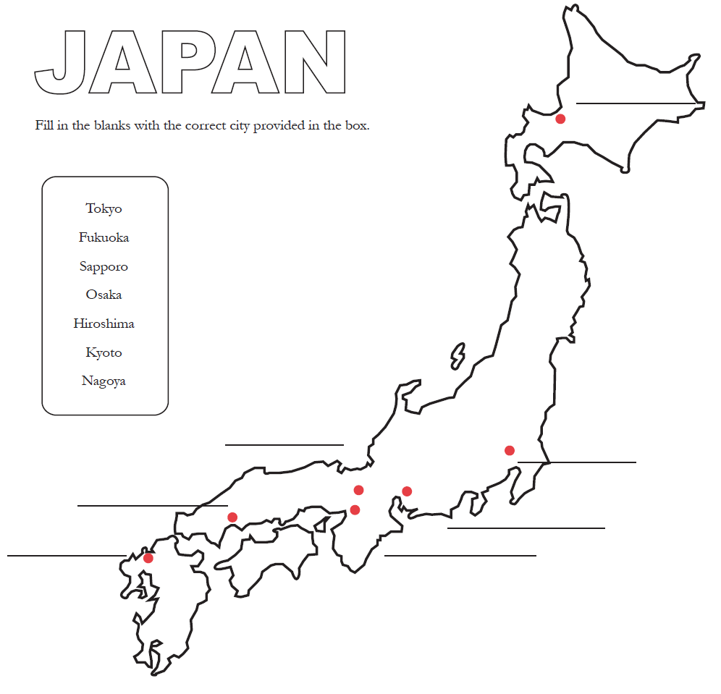

*Map sourced from https://layers-of-learning.com/printable-map-of-japan/

Material Master 3
Cities of Japan

Match the city with the correct statement.

Tokyo | This city is close to Seoul (in Korea) and is known as an important harbour city.
Fukuoka | This city was hit by an atomic bomb in World War II
Sapporo | Two popular sites in this city are  - The Atsuta Shrine  - TV Tower
Osaka | This city is the capital of Japan and it is one of the largest cities in the world.
Hiroshima | There are thousands of temples and shrines in this city.
Kyoto | This city is the largest city that is on the island of Hokkaido.
Nagoya | This city is one that is an ancient Japanese city.

Material Master 4
Eating out in Japan
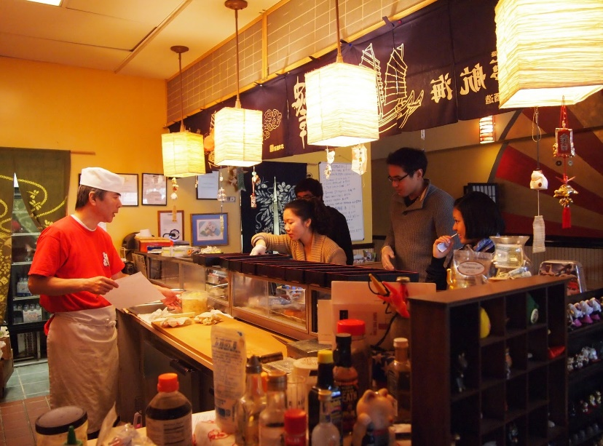
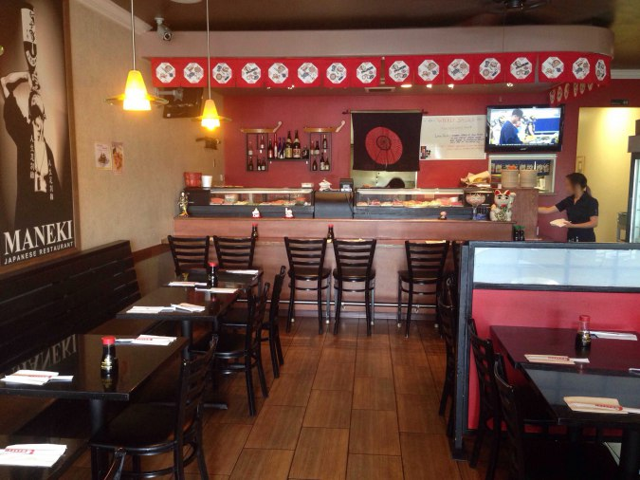
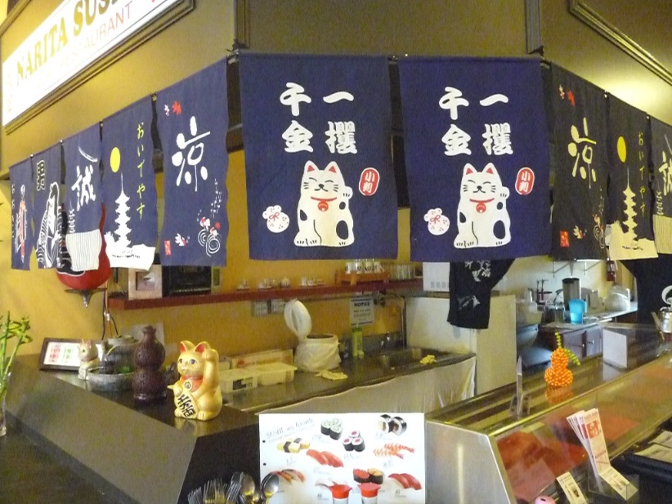
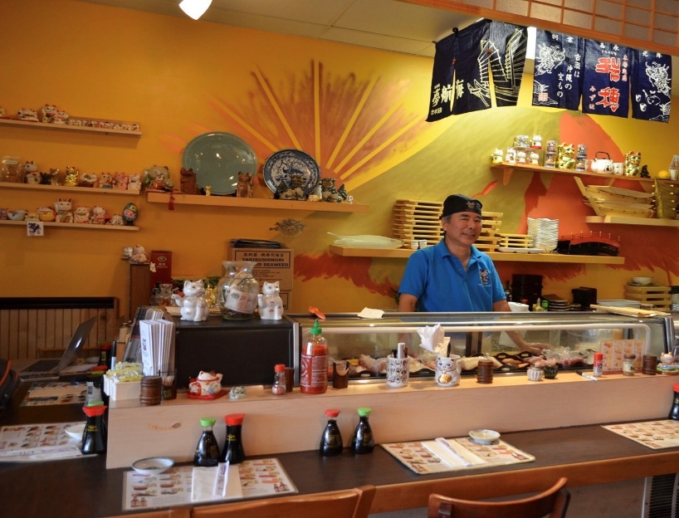
Material Master 5
Answers for finding the Cat in the photo
Material Master 6
Maneki Neko
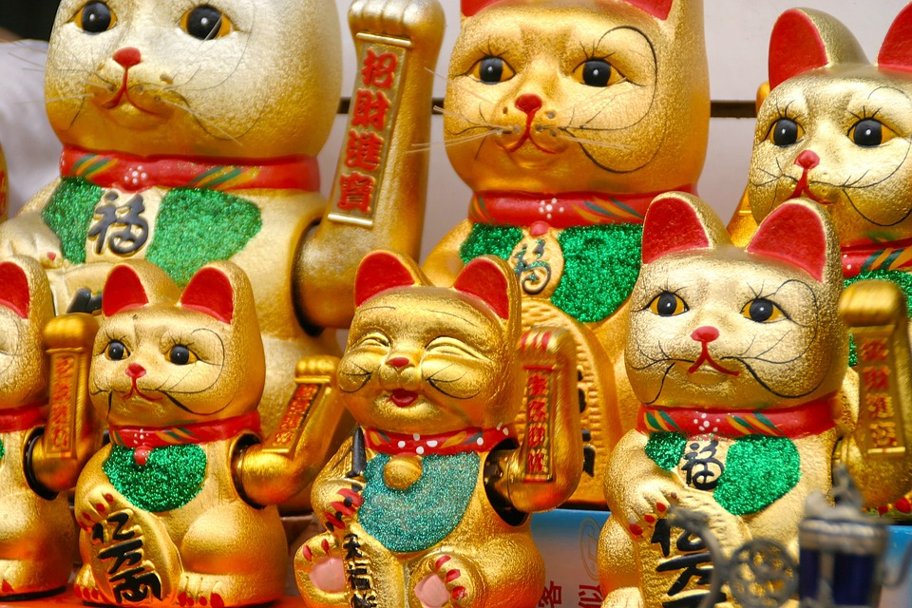

*Photo sourced from https://pxhere.com/no/photo/677947

Material Master 7
Taste testing
English name of ingredient | Japanese name of ingredient | 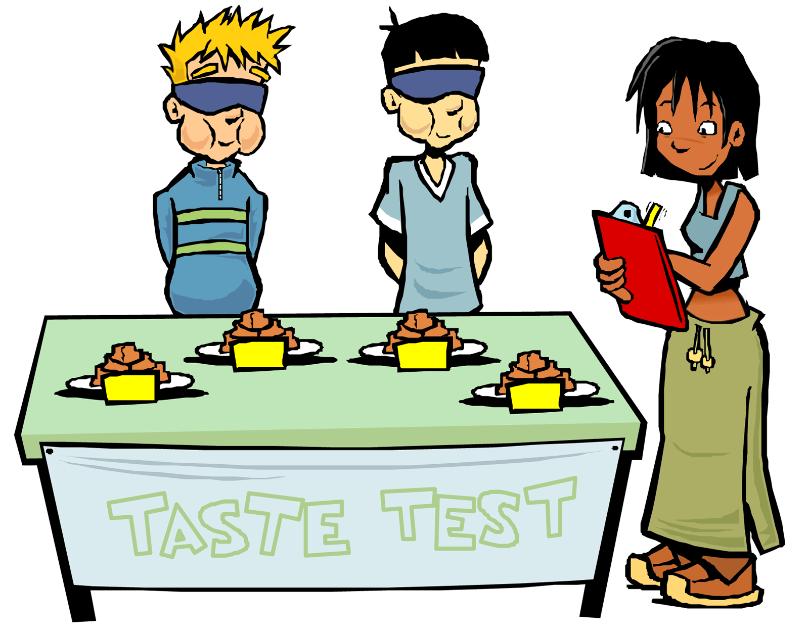  Tastes like | My rating out of 10
Japanese Rice | Gohan
Japanese Soy Sauce
Miso Paste
Bonito Flakes | Katsuoboshi
Rice vinegar | Komezu
Soba noodles
Seaweed sheets | Nori
Dehydrated seaweed | Wakame
Panko Bread Crumbs

Material Master 8
Comparing eating lunch in New Zealand with eating lunch in Japan
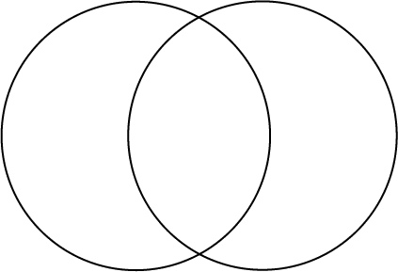
Eating lunch in NZ
Eating lunch in Japan

Material Master 9
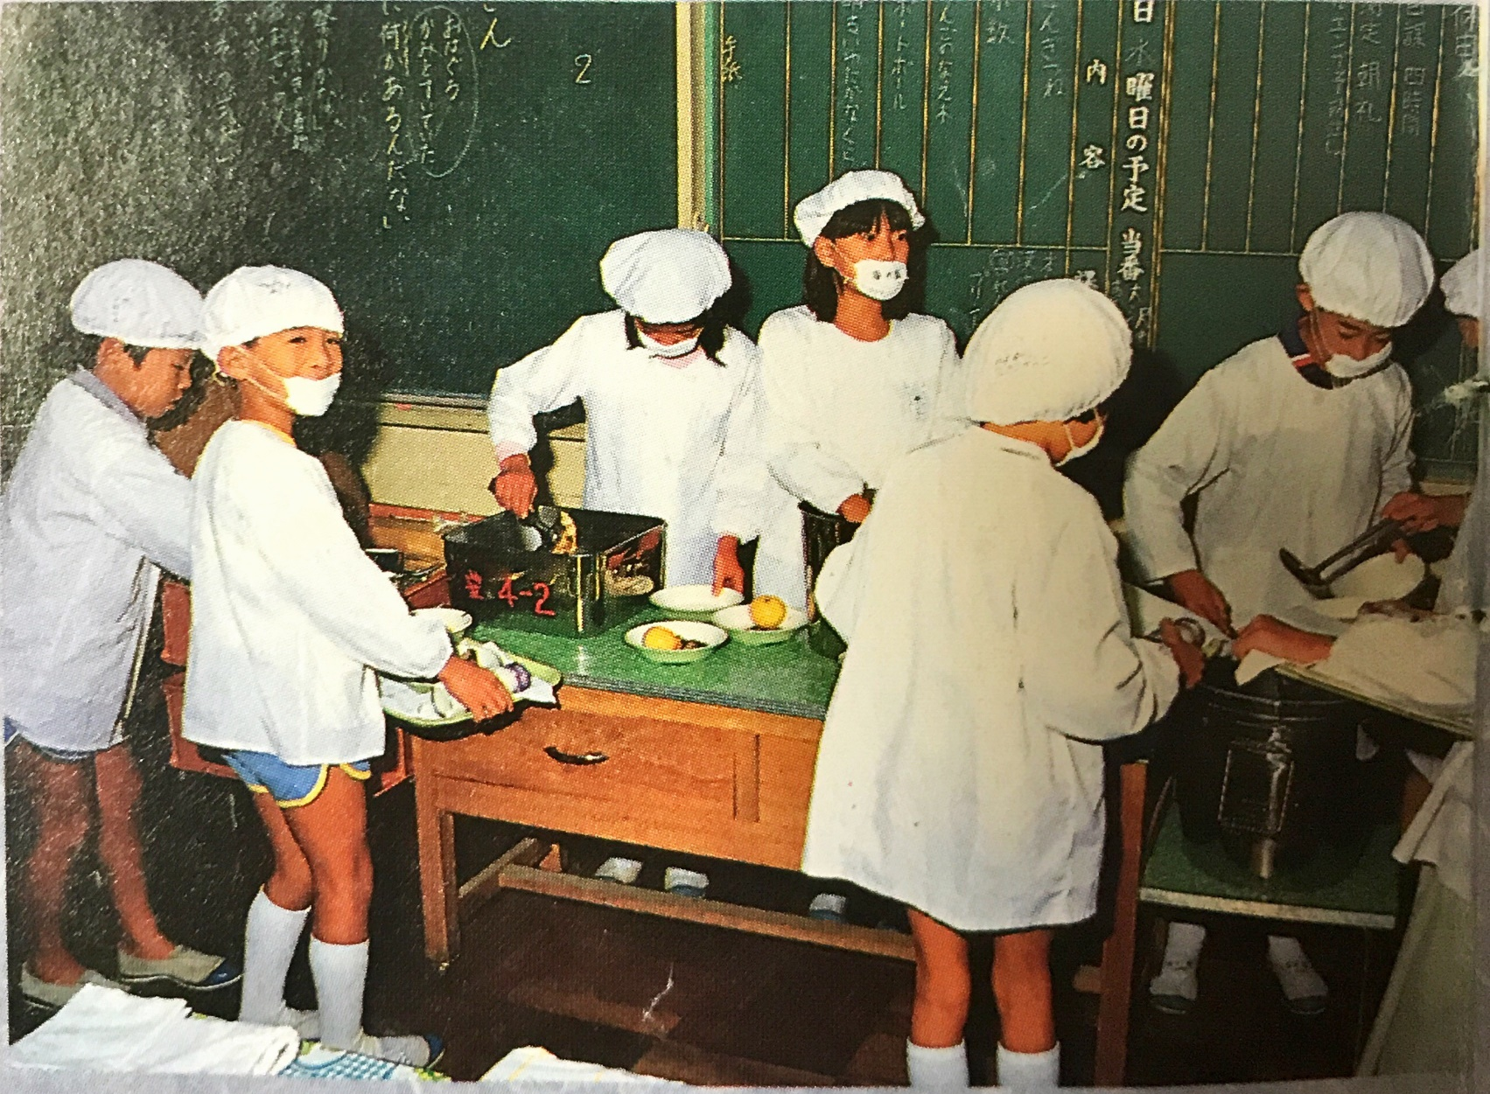
Lunch at a Japanese School

Material Master 10
Food reviews
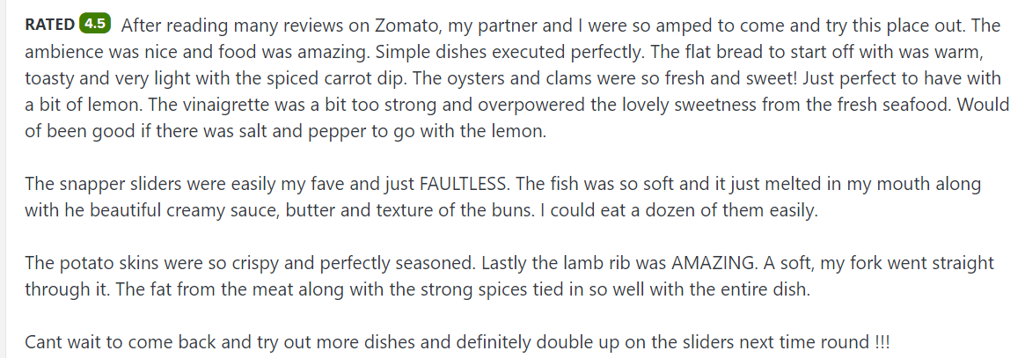
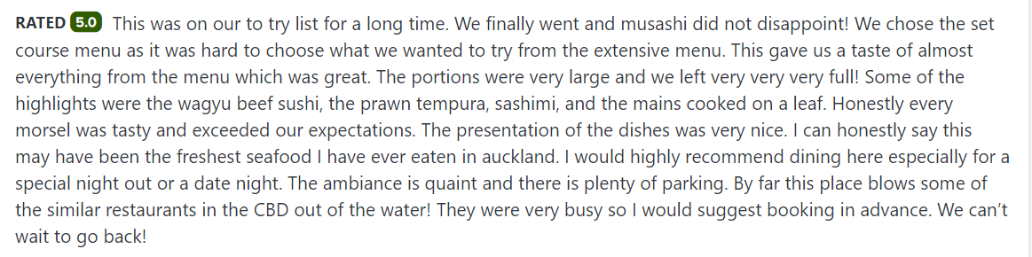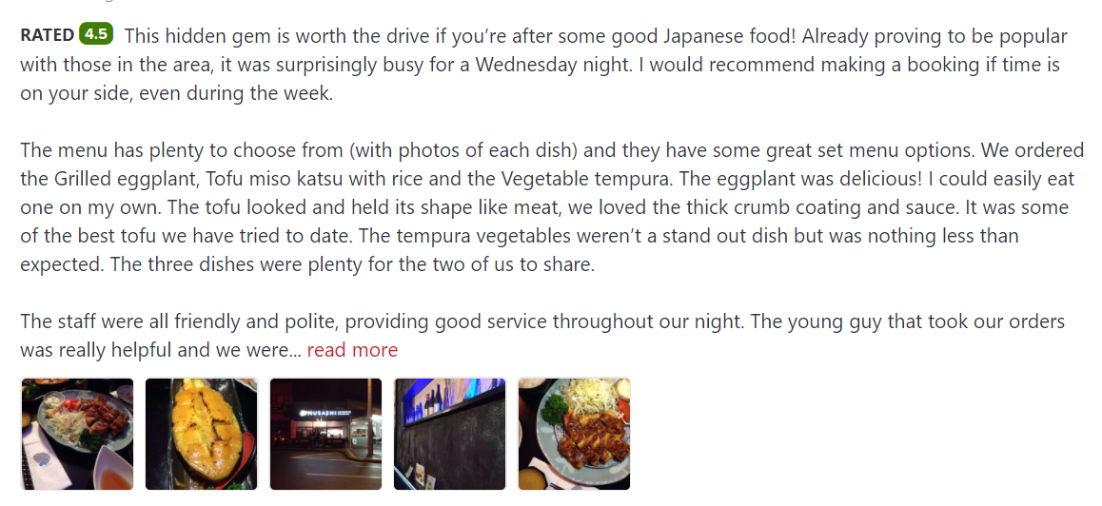

Material Master 11
Sushi reviews

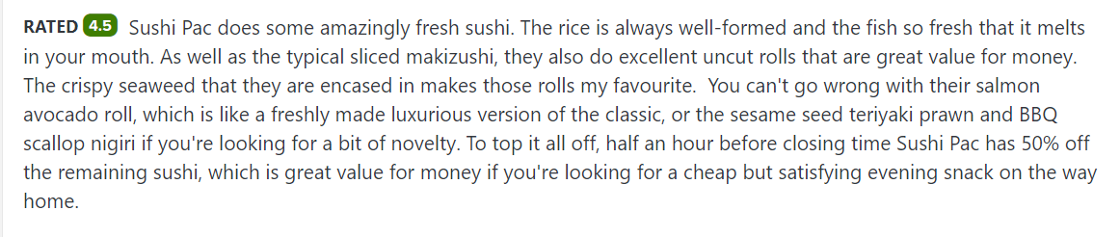
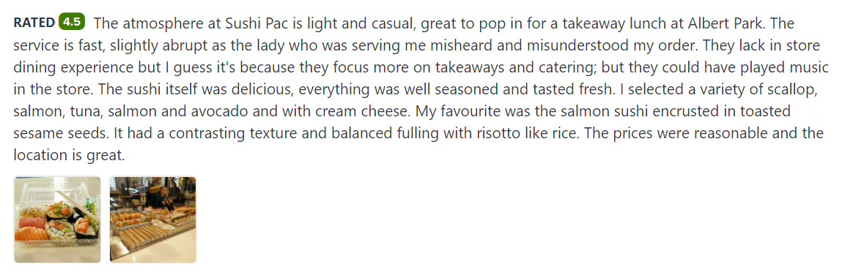

Material Master 12
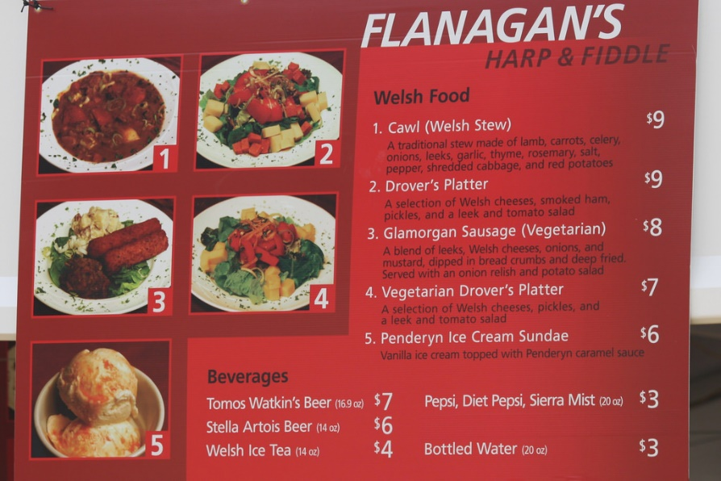
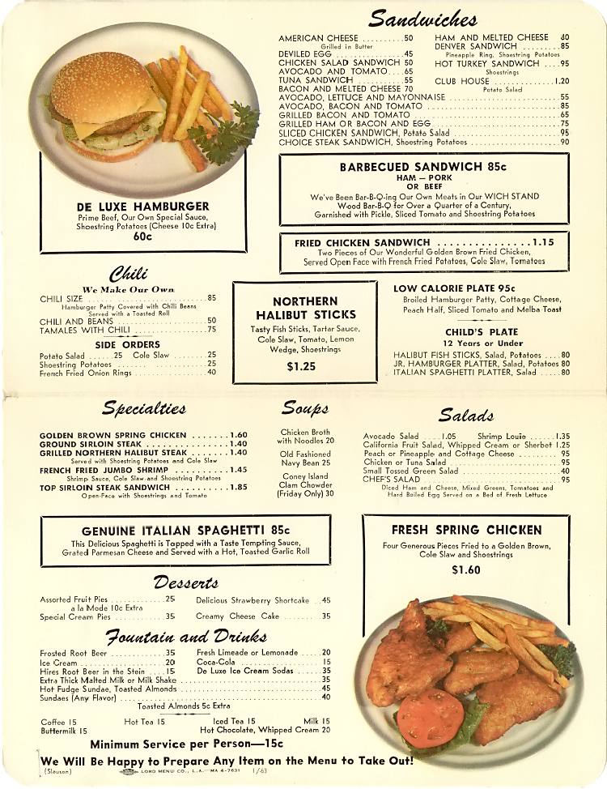
Menus

