Copy master 1 - Pictures
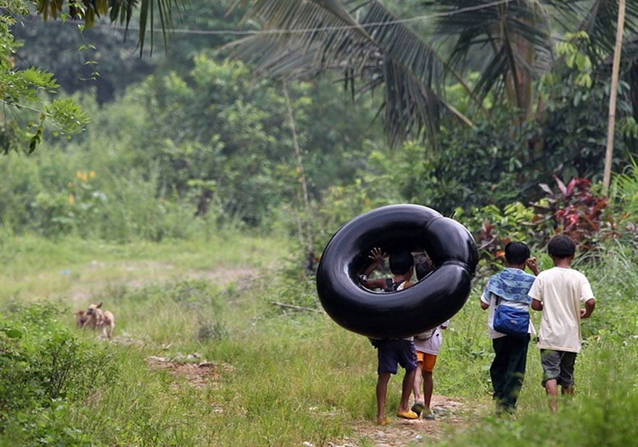

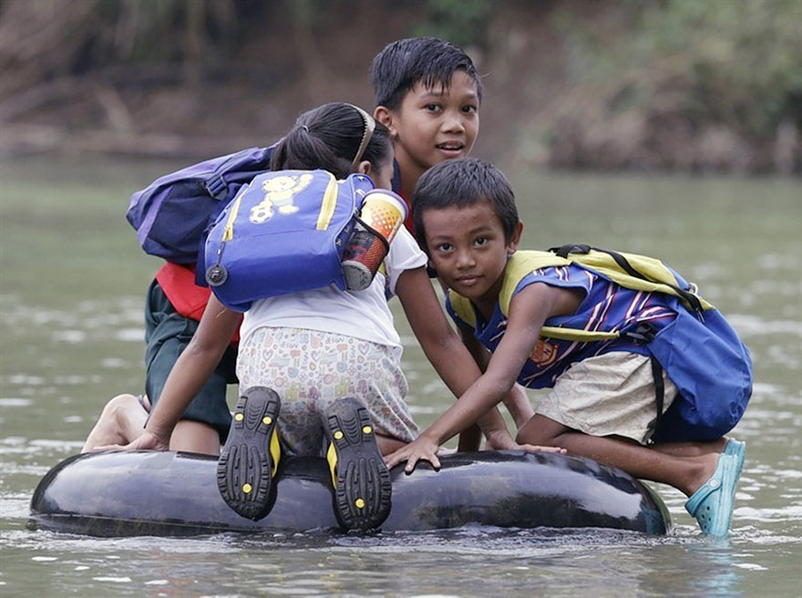
Copy master 2 - See, Think, Wonder
WALHT- Explore what we already know about the Philippines.
See  What do you SEE in the picture? | Think  What do you THINK is happening, what do you THINK about that? | Wonder  What does it make you WONDER?

Copy master 3 - World Map
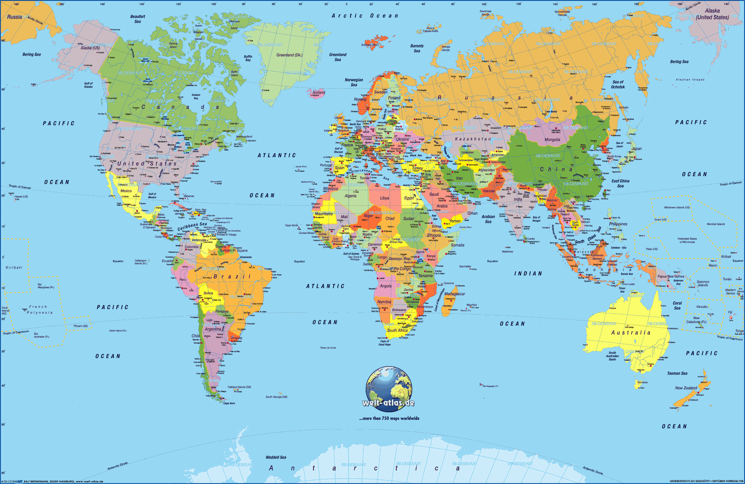
WALHT- Locate Philippines on a map

Copy master 4 - Population density
People per square kilometre
Philippines | New Zealand

Copy master 5 - Map of Philippines
WALHT- Locate Philippines on a map
Label: Papua New Guinea, Indonesia, China, Borneo, Taiwan, Vietnam, Australia, Manila, Colour the land green and the oceans blue except for the Philippines, then colour the islands of Luzon red, Visayas yellow and Mindanao orange.
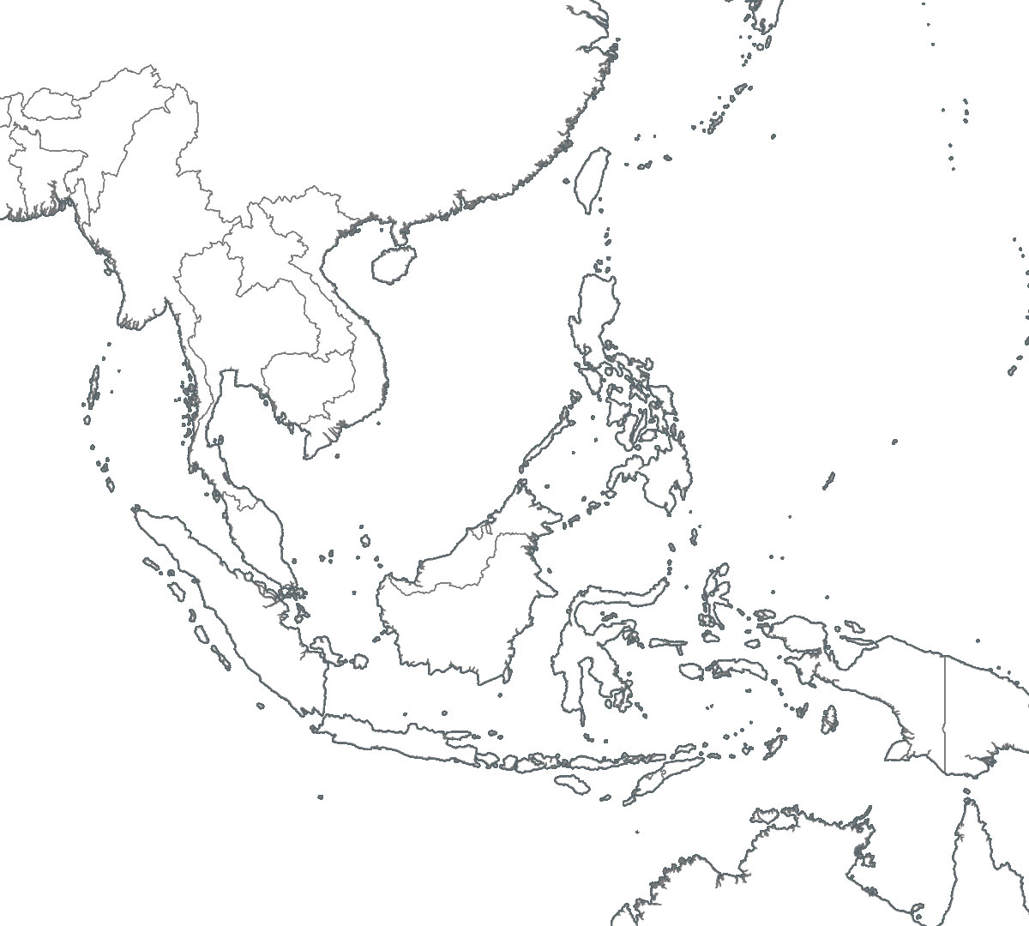

China
Taiwan
Vietnam
Manilla
Papua New Guinea
Indonesia
Borneo
Australia
ANSWERS
Module 1: Languages
WALHT- Conduct a simple conversation in Tagalog.
By the end of this language module you are going to have a choice of two options to present your learning.
- Construct a cartoon strip showing two people meeting each other and using Tagalog to speak.
- Present a play to the class of two people meeting each other. This can also be pre-recorded and then the video shown to the class.
For help with pronunciation type into google - Free Tagalog lessons
Record the words below and how you think they sound when pronounced.
English word | In Tagalog | How to pronounce
Hello | Halo | Ha-low
Good day
Good evening
Goodbye
Please
Thank you
What is your name?
Good to meet you.
How are you?
Excuse me
Do you speak English?
Reflection: WALHT write clear questions to guide my research

I will be successful when I can:
- Speak with confidence using the words I have learnt
Comment:

Module 2: Native Animals
WALHT- Identify common animals found in the Philippines and describe simple facts about common Filipino animals.
Name of animal | Endangered? | Extinct? | Notes about the animal | Are there any NZ animals that are similar?

Presentation:
Choose one animal that is currently endangered and construct a poster informing the people of the Philippines what they can do to help save it. You can choose to either complete on paper or digital, canva or google presentation would be some suitable options. After completion, ask your teacher for some time to present to the class and then put it on display.
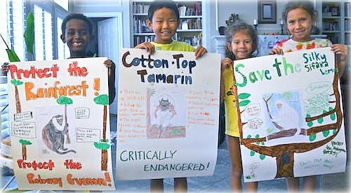
Examples:
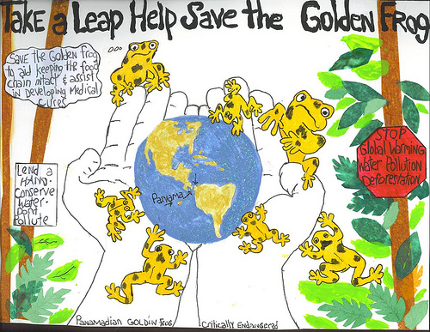
Reflection: WALHT Identify common animals found in the Philippines
WALHT Describe simple facts about common Filipino animals

I will be successful when I can:
- Construct a poster giving clear information about the animal and how we can help it
Comment:

Module 3: Games/Sport
WALHT Explain and teach how to play a traditional Filipino game to our classmates
Type into google Traditional games in the Philippines. Read through all the traditional playground games they have created, these require minimal equipment and just imagination!
What are some games that we also play in New Zealand that are similar? Maybe under a different name?
Filipino game | New Zealand game that’s similar

Choose one game that you are going to teach to your class. Make sure that it will work with the amount of students in your classroom. Once you have made your plan, show it to your teacher and discuss when you have time to play it.
Name of game:
Equipment needed:
Background of game if known:
Brief diagram:
Instructions for the class:

WALHT Demonstrate how to play Tapatan with a friend
Research how to play the traditional Filipino game - Tapatan. Once you have learnt how to play it, teach it to a friend by playing a few rounds with them.

Reflection: WALHT Explain and teach how to play a Filipino game to our classmates
WALHT: Demonstrate how to play Tapatan with a friend.

I will be successful when I can:
- Explain the game clearly, so that the class were able to play our traditional game successfully
- Teach the game of Tapatan to my friend so they were able to play
Comment:

Module 4: Art
WALHT- Describe a Filipino artist and then make a comparison against a New Zealand artist.
Type in Filipino art in google images and scroll through and look at all the art. What do you notice about these images? Are there any common themes?

Write down the names of 3 Filipino artists that you like their art pieces
1.
2.
3.

Choose one Filipino artist and record some information about them and their art, including what sort of art they did, when they were famous, what did they depict in their artworks etc.
Artist name:

Now do the same with New Zealand artists. Look at google images of NZ artists, can you find any pieces that are in some way similar or different to the Filipino artist you looked at? Similar style/colours? Similar objects in pictures?
Ways they are similar to NZ artists | Ways they are different to NZ artists
E.g. Uses similar bright colours to NZ artist Dick Frizzell

Reflection: WALHT Describe a Filipino artist and then make a comparison against a New Zealand artist.

I will be successful when I can:
- Write a paragraph in my own words that include facts about the artist
- Construct a comparison comparing the Filipino artist to NZ artists
Comment:

Module 5: Dance
WALHT- Summarise the brief history of some popular Filipino folk dances and demonstrate the basic steps of the Tinkling dance.
Dancing plays a very important role in Filipino culture, it tells their history and preserves traditions through folk dance and music. The dances are entertaining for audiences and it is very fun to learn and perform! Many of their folk dances represent hardship and daily back breaking tasks that they then turn into a dance. Many of their dances represent daily chores or actual activities they have to do to survive the poor economy.
With the dances listed below look at each one on YouTube, don’t watch the whole clip just enough so you get an idea of what is happening. Using what you learnt above, take a guess about what they are trying to demonstrate in the dances. Once you have watched them all, research the true history of the dance and record this.
Name of Filipino Dance | What I think the dance means (While watching video) | What it actually means (After researching)
Idaw
Banga
Tinkling
Iduidu

The next part of the dance module is to learn some simple steps to the Tinkling folk dance.
Type into YouTube “5th graders Tinkling” and watch this quick video of a class that has learnt how to do it, focus on the rhythm of the feet and also what the people with the sticks do. Stick rhythm-out, out in. Feet-in, in out.

Then type into YouTube Tinkling tutorial: The basics. With chalk or two pieces of string, follow along to the instructions of the teacher in this tutorial. Once you are ready to have a go put on some Tinkling music and do it without the sticks. You can also use some new music that has the right beat e.g. YMCA- village people
Extension:
If you are feeling confident and want to have a go at some more dancing, look up the 5 different steps of Tinkling and learn all the rest of the moves to the folk dance. You could even create your own mash-up of different moves to a song, there are some great ones on YouTube- Uptown funk, Party rock. Perform to class once you have your routine sorted.
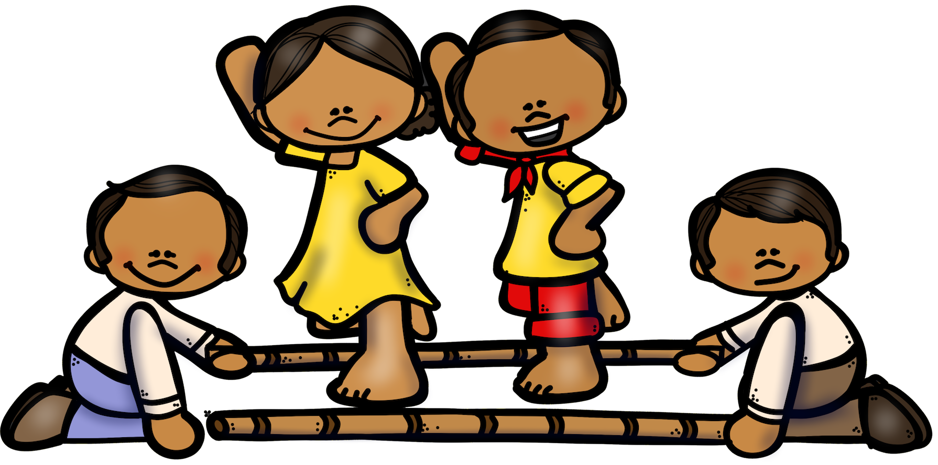

Reflection: WALHT Summarise the brief history of some popular Filipino folk dances
WALHT Demonstrate the basic steps of the Tinkling dance.

I will be successful when I can:
- Think critically about what the dance performance may mean by using what I currently know about the Philippines
- Perform a very basic routine of the Tinkling folk dance to a friend or class
Comment:

Module 6: Famous landmarks
WALT: Describe common landmarks in the Philippines.
Research New Zealand and then the Philippines basic information about the geography of the country.

 | The Philippines | New Zealand
Population:
Land size:
Climate:

Time zone:
Main religion (include percentages)
Main exports:

During your research between the two countries, write 2-3 sentences about similarities you found between them and the differences.

Famous Landmarks in the Philippines
Research the famous landmarks found in the Philippines, look through all the pictures and read about their main attractions. These may include: Malacañan Palace, Banaue Rice Terraces, MacArthur Landing Memorial national park, Taal Lake and Taal volcano, Luneta and Intramuros, Mayon Volcabno, Barasoain church, Chocolate Hills.
Choose 3 famous Filipino landmarks that you would love to see one day. Construct a Google slideshow giving key information about this landmark, how it was created, how long has it been there, why it is an attraction, and include pictures of it. Talk to your teacher once this is complete about showing your research to the class.
The 5 Filipino landmarks I am going to present are:
1.
2.
3.
Now research famous New Zealand landmarks/attractions, can you find any that are similar in some way to ones in the Philippines? https://www.tripadvisor.co.nz/Attractions-g255104-Activities-c47-New_Zealand.html
Name of NZ landmark | Name of Filipino landmark  that is similar | Why is it similar or different? E.g. similar memorial, structure of it etc.
Reflection: WALHT
WALHT:

I will be successful when I can:
- Describe and explain confidently about my 3 chosen Filipino landmarks
- Make a comparison between 3 NZ landmarks and 3 Filipino ones, by either explaining similarities or differences
Comment:

Module 7: School and daily life
WALHT- Compare a Filpino school to a New Zealand school.
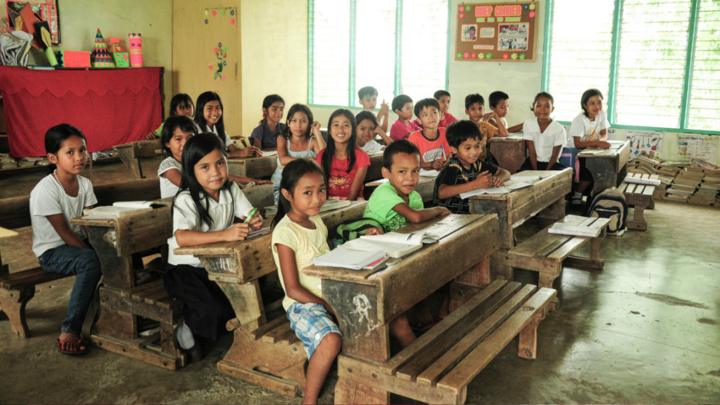
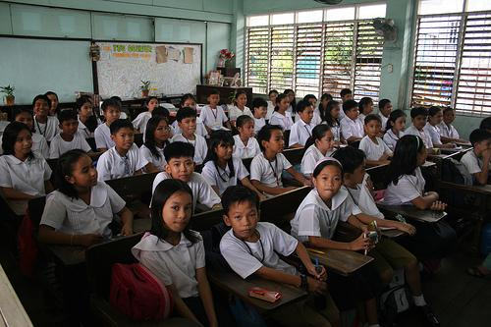
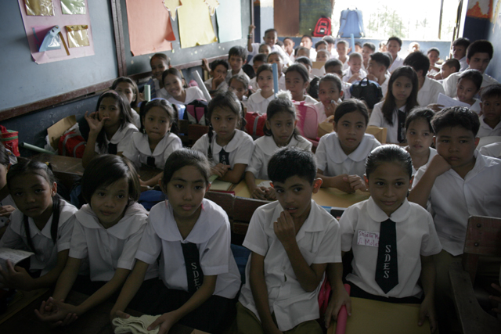
School life: Look closely at these photos of some of the classrooms in the Philippines, then complete a Venn diagram to show the similarities and differences between New Zealand and Filipino classrooms.

Venn Diagram
Looking closely at the pictures, think about all the aspects of the classroom that may be similar or different e.g. Number of students in the room, equipment, uniforms, what is on the walls, furniture, how much space there is etc…
The Philippines
Same
New Zealand

A day in the life of a student your age:

Type into YouTube - A day in the life of 11 year old Jonacel- Philippines. https://www.youtube.com/watch?v=bWqoNY9euGo:

After watching this clip, write a paragraph of what your thoughts are after watching, What surprised you? What was different to what you do? Was their anything similar that you do?

Customs and Etiquette
In the Philippines they are extremely strong family values and 86% of the population is Roman Catholic, compared to only 11% in New Zealand. Research and read about the customs and etiquette in the Philippines. Write down values that are similar and different to what your family does.
Similar | Different

Optional Extension: Make a movie that shows at least two things that you need to do in order to be considered polite in the Philippines.
Reflection: WALHT Compare a Filipino school to a NZ school

I will be successful when I can:
- Describe what makes a school in the Philippines similar/different to us
- Compare how the values and etiquette differ in the Philippines to your family
Comment:

Module 8: Food
WALHT- Describe the types of food Filipino people eat.
Using a suitable computer program e.g. Canva, Microsoft word/publisher, Google docs etc.
Construct a collage of the traditional food from the Philippines, include the name of the dish and a brief description of it.
Once you have completed this, present it to the class, as you are presenting explain what you noticed about the food, how it is different to our food, what cooking methods they use etc.
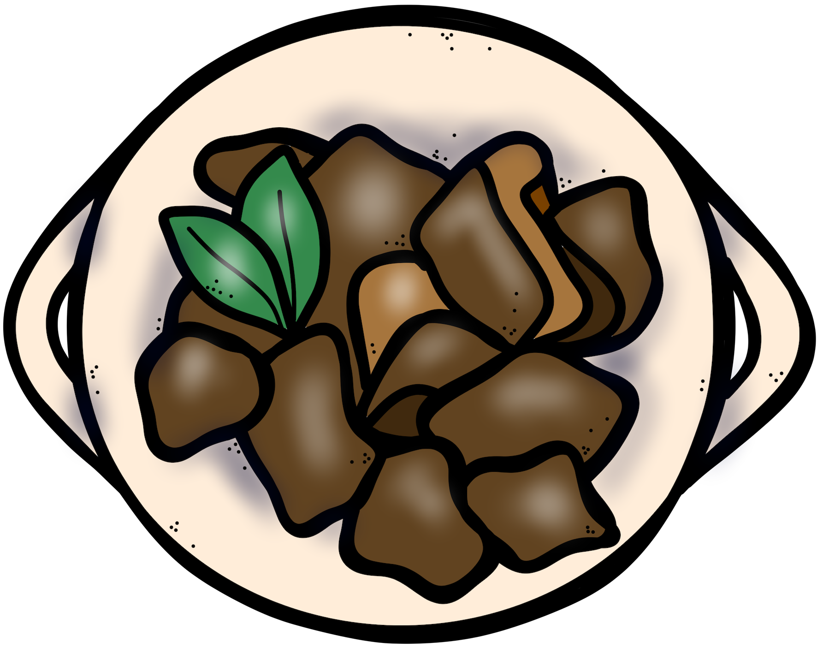

Reflection: WALHT Descirbe the types of food Filipino people eat

I will be successful when I can:
- Explain with confidence some traditional Filipino dishes and how they are made
Comment:

Copy master 6 - Venn diagram for assessment
The Philippines
Same
New Zealand
Copy master 7 - Postcard template for assessment

