UNIQUE KOREA
OBJECTIVES
Achievement Objectives:  Students will gain knowledge, skills, and experience to:  - Understand how the cultures of people in New Zealand are expressed in their daily lives  - Understand how the past is important to people  - Understand how belonging to groups is important for people |  | Year Level: Year 1 and 2  Curriculum level: 1  Unit Duration: 10 weeks
INTEGRATION INTO OTHER LEARNING AREA
MATHS
Statistical Investigation
- Conduct investigations using the statistical enquiry cycle:
- posing and answering questions;
- gathering, sorting and counting, and displaying category data;
- discussing the results.

ENGLISH – SPEAKING, WRITING, PRESENTING
Purposes and audiences
- Recognise how to shape texts for a purpose and an audience.

HEALTH & PE
Relationships
- Explore and share ideas about relationships with other people.
Identity, sensitivity, and respect
- Demonstrate respect through sharing and co-operation in groups.
Interpersonal skills
- Express their own ideas, needs, wants, and feelings clearly and listen to those of other people.

VISUAL ART
- Share ideas about how and why their own and others’ works are made and their purpose, value, and context.

DANCE
- Demonstrate an awareness of dance in their lives and in their communities.

MUSIC
- Explore and share ideas about music from a range of sound environments and recognise that music serves a variety of purposes and functions in their lives and in their communities.

Values:  Excellence  Innovation, inquiry, and curiosity  Diversity  Equity  Community and participation  Ecological sustainability  Integrity  Respect | Key Competencies:  Thinking  Using language, symbols, and texts  Managing self  Relating to others  Participating and contributing |  | Principles:  High expectations  Treaty of Waitangi  Cultural diversity  Inclusion  Learning to learn\  Community engagement  Coherence  Future focus
Assessment Opportunities:

The inquiry booklet can be used as both formative and summative assessment.
There is an Assessment Checklist included which is intended to be used when necessary throughout the unit.
Unit Focus:  In this unit the students work together in groups to research one area involved in a Korean celebration.  Throughout the unit there are lessons designed that intend to provide students with a better understanding of Korea and to develop an awareness of what makes Korea Unique.  There are also Inquiry Learning lessons, where the students are supported to conduct their own inquiry about an aspect of a Korean celebration. Some of the lessons may run over several learning sessions, particularly when the students are participating in their own research. |  | Context:  The unit begins with discussion about celebrations and how they are an important part of who we are. Students discuss what makes celebrations important. This theme needs to be constantly revisited throughout the unit to remind students about the purpose.  The unit concludes with students hosting a Korean Children’s Day celebration. When the students are researching their inquiry they need to be continually reminded about the purpose and audience.  It is expected that the theme of Korea and celebrations will be integrated into other curriculum areas particularly in maths and literacy as this will make the learning more authentic for students.

Curriculum achievement objectives | Understand how belonging to groups is important for people.
Learning Intention | We are learning how Korean’s celebrate children’s day in Korea
HOOK INTO LEARNING

Divide class into groups and explain to them that they are going to get an envelope with different pictures inside. As a group they need to decide on one word that could be used to classify all of them.

Each envelope contains pictures of different things we celebrate in NZ (Copy Master 1) …
- Christmas tree
- Easter Bunny
- Fireworks
- Halloween
- Matariki
- ANZAC
Allow students to discuss within their group. Each group shares back the word that they selected and write on board.

Discuss the word celebrations. Can they think of other things we celebrate in New Zealand?

Next, ask the students to share with a buddy about …
- What are the special celebrations in NZ?
- Why are these holidays celebrated?
- How are they celebrated?

Explain that on the 5th May they are going to have a special Korean celebration and they are able to invite whoever they would like to join them to celebrate. The celebration is about celebrating children! Tell them that for this to happen, each student in the class will need to organise a part of the celebration. Brainstorm what they will need to organise such as …
- the history of children’s day
- Korean dance
- Korean food
- Korean music
- Korean traditional costume
- Korean invitations
Each student chooses one area that they are going to learn about and then organise for the celebration to form several different Children day investigation groups. You may need to guide the formation of the groups to ensure you have at least one student who can write sufficiently in each group.
Students are provided with a Children’s day Inquiry diary. They each complete the title page and have the opportunity to discuss what they would like to learn about.
Curriculum achievement objectives | Understand how the cultures of people in New Zealand are expressed in their daily lives.
Learning Intentions | We are learning to list what we already know about Korea
INTRODUCTION TO KOREA
Lay out a range of images related to Korea so that students can move around in groups studying the pictures. As they are studying the pictures, ask them to think about what these images tell us Korea is like.

Brainstorm key questions
- Why should we learn about Korea?
- What do we already know about Korea?
Students complete page one of their Inquiry Diary

Make a vocabulary list which can be displayed on the wall, added to throughout the unit. This can be used as a glossary for students to use when writing.

Find Korea on a world map. Display this in the classroom along with a map of South Korea. The maps should label the body of water between the Korean Peninsula and the Japanese archipelago as the “East Sea” (or concurrently with the “Sea of Japan”) with the Dokdo islets identified as Korean territory.

Who do we know in our class, school, community that is from Korea?
Curriculum achievement objectives | Understand how the cultures of people in New Zealand are expressed in their daily lives.
Learning Intentions | We are learning how NZ culture is different to Korean culture
FOCUS ON CULTURE
Read “Annyong!” means “Hi!” (School Journal Part 2 Number 3 2004 p.16)
Read Walking on the Grass (School Journal Part 1 Number 4 2006 p.14)
Encourage students need to consider;
What do the Korean children in the stories find strange and/or different about New Zealand?
- Bare feet
- Desks
- Moving around the classroom
- Eating outside
- Food
- Grass
- Empty streets

Discuss differences with the class and then break into small groups. Each group receives 14 pictures (Copy Master 2). Their task is to find the corresponding pictures and place them under one of the two headings; In Korea or In New Zealand.
Using the Inquiry Diary, students complete Stage 1: Brainstorming what they know about their chosen topic. Students work with those other students that have selected the same topic.

Curriculum achievement objectives | Understand how the cultures of people in New Zealand are expressed in their daily lives.
Learning Intentions | We are learning how to explain why the Korean flag is special
FOCUS ON CULTURE
Explain to students that flags are symbolic and that the Korean flag represents the universe.
Students are given a jigsaw puzzle of the flag that they need to piece together along with labels about what each piece means (Copy Master 3). Students independently make the flag. When completed, teacher reads out each of the bolded words below and students need to put the words in the appropriate section. Discuss why they think they match and then give correct answer.
- The white background is a traditional Korean colour. It represents peace and purity.
- The circle in the middle represents the balance of the universe.
- The blue section represents the negative
- The red section represents the positive
- The black lines together represent the heaven, fire, water and earth

Students could draw and colour their own flag to display around the classroom.

INQUIRY LEARNING LESSON
Curriculum achievement objectives | Understand how belonging to groups is important for people.
Learning Intention | We are learning the difference between open and closed questions.  We are learning how to ask good questions.
Stage 2: Questions
What questions do I want to find out?

Teacher discusses open and closed questions.
Model examples of each. Get students to identify both open and closed questions.
Students practice asking open and closed questions about things they would like to know about Korea?
Discuss importance of good questions being those that we don’t know the answer to. Give examples of ‘good questions’ and ‘bad questions’.

Students work together to complete appropriate page in their Inquiry Diary.

When completed, students need to tick the box themselves, show a buddy and get them to tick the box and write their name and then show the teacher who also adds a tick and signs their name to say that it has been completed.

Share questions with class.
Ask students, “Can you already answer your question without researching?”
“Have you used an open or closed question? “
Curriculum achievement objectives | Understand how the cultures of people in New Zealand are expressed in their daily lives.
Learning Intentions | We are learning how to speak Korean
FOCUS ON CULTURE
Introduce each of the words below and get students to repeat words so that they are familiar with them. Hand out the three Korean words and in pairs the students practice saying each of these words to one another. (Copy Master 4)

- anyoung haseyo - hello
- kamsahamnida – thank you
- ju-se-yo - please

Encourage students to use this language with others around the school and at home. Students could design their own signs for each of the words to help them to remember them.

They might like to draw a cartoon where the characters use each of the words at least once. Share these and display them in the “Unique Korea” area.

INQUIRY LEARNING LESSON
Curriculum achievement objectives | Understand how belonging to groups is important for people.
Learning Intention | We are learning how Korean people express the identity of their culture  We are learning how to find information  We are learning about different ways to record our findings
Stage 3: Planning
How can I find this information out?
How will I organise and record my findings?

Brainstorm different sources of information; books, internet, people etc. Talk about which are better and how to access each. If I want to use a book what do I need to do?

List different ways to organise and record their findings. Talk to a buddy about which information source would be good to use for their research questions. If I am learning about music, what would some of the ways to share my learning? Are some ways better than others?

Students work together to complete appropriate page in their Inquiry Diary.

When completed, students need to tick the box themselves, show a buddy and get them to tick the box and write their name and then show the teacher who also adds a tick and signs their name to say that it has been completed.

Share their decisions with class.

Curriculum achievement objectives | Understand how the cultures of people in New Zealand are expressed in their daily lives.
Learning Intentions | We are learning why so many Koreans learn Taekwondo  We are learning some Taekwondo moves
FOCUS ON CULTURE

Ask students what Taekwondo is and if they know anybody who takes part in it.

People in Korea take part in Taekwondo to help with their concentration and memory. It also helps to learn about coordination.

Use YouTube to find a simple video that students can watch and copy the movements of. An example of a search term could be “Learning Taekwondo basic movements”

INQUIRY LEARNING LESSON
Curriculum achievement objectives | Understand how belonging to groups is important for people.
Learning Intention | We are learning how Korean people express the identity of their culture  We are learning how to research
Stage 4: Research
Where has this information come from?
What is it telling me?
How can we record information?

Teacher models how to use an information tool (the internet, book) to find information that relates to their inquiry question. Teacher models how to record information into Inquiry Diary. This can be done through drawing or writing depending on the student’s abilities. The teacher supports each group with how to find information within the tool that they have selected.

Ensure that there is a “Unique Korea” table set up in the classroom that has a range of resources on it for students to use. This could include books from school library, national library, local library, artefacts from Korea students have brought to school, pictures, maps etc
It would also be helpful to have a “Unique Korea” support page set up on-line where students can find links to websites that can support them with their learning.
Examples of great websites
http://www.timeforkids.com/destination/south-korea/day-in-life
http://asiaeducation.edu.au/public/sites/korea/journey.htm
http://www.digitaldialects.com/Korean.htm

When completed, students need to tick the box themselves, show a buddy and get them to tick the box and write their name and then show the teacher who also adds a tick and signs their name to say that it has been completed. Share findings with class.
Curriculum achievement objectives | Understand how the past is important to people.
Learning Intention | We are learning about interesting events that have happened in Korea
FOCUS ON PAST
Each group is given a long strip of paper and Copy Master 5 students discuss each important Korean historical event and put them in order of when they occurred. When students agree on the order, they need to add a title to their timeline.
- 1446 New writing system Korean alphabet “Hanguel” introduced
- 1945 Korea is divided into North and South
- 1950 Korean War
- 1972 Seoul tower opened
- 1988 Olympics in Seoul
- 2004 High-speed train (called the KTX) opened

As a group, discuss each event and why it is important.
INQUIRY LEARNING LESSON
Curriculum achievement objectives | Understand how belonging to groups is important for people.
Learning Intention | We are learning how Korean people express the identity of their culture  We are learning how to research
Stage 4: Research
Where has this information come from?
What is it telling me?

Teacher models how to use a different information tool (the internet, book) to find information that relates to their question. Teacher models how to record information into Inquiry Diary. This can be done through drawing or writing.

Teacher supports each group with how to find information within the tool that they have selected.

Encourage students to explore
- the range of resources on the “Unique Korea” table.
- “Unique Korea” support page set up on-line

When completed students need to tick the box themselves, show a buddy and get them to tick the box and write their name and then show the teacher who also adds a tick and signs their name to say that it has been completed.

Share findings with class.

Curriculum achievement objectives | Understand how the past is important to people.
Learning Intention | We are learning about the cycle of the 12 animals
FOCUS ON PAST
Background information for teacher:
The Sibijisin means "Twelve Gods of the Earth (jisin)." The animals of the Sibijisin are the mouse, cow, tiger, rabbit, dragon, snake, horse, sheep, monkey, chicken, dog and pig. Each year is marked by a jisin; since there are twelve jisins, the cycle repeats every 12 years. It is traditionally believed that people possess the personality of the animal that marks their birth year. Therefore, the year and the time of birth are often used to determine one’s personality and fate.

Tell students that in Korea there are 12 important animals that are thought to be gods of the earth. Each animal represents a year. Koreans believe that the animals can keep away bad spirits and so their statues are often built around many royal tombs and sites.
Provide each student with a piece of paper listed from 1-12 and ask them to guess the 12 animals either by drawing them or by writing the name. You may also wish to provide the starting letters.
In pairs students are given Copy Master 6. Students must match the picture of the animal with its name and one word that describes that animal’s personality. Ask students to compare their list with the actual animals. How did they do? Which animal are they?
INQUIRY LEARNING LESSON
Curriculum achievement objectives | Understand how belonging to groups is important for people.
Learning Intentions | We are learning how Korean people express the identity of their culture  We are learning about an audience  We are learning how to share our findings
Stage 5: Sharing
Who do I want to share my findings with?
How can I share my findings?

Refer back to initial discussion about celebrations. How could we share this knowledge at our celebration? Is there other ways we want to share our information?
What is an audience? What do we want our audience to be?
- Whole school
- Junior school
- Parents
- Teachers

Look at what each group has been learning and brainstorm different ways that each group could share their learning
- The history of children’s day
- dance
- food
- music
- costume
- invitation

Complete necessary organisation in preparation for Children’s Day celebration.
CHILDREN’S DAY CELEBRATION

INQUIRY LEARNING LESSON
Curriculum achievement objectives | Understand how belonging to groups is important for people.
Learning Intentions | We are learning how Korean people express the identity of their culture
Stage 6: Reflecting

Discuss the importance of reflection and why we need to do it.
Look at how to complete a PMI.
Model how to answer and encourage the students to orally answer each of the questions with a buddy.
What things went really well for you in your learning?
What things do I need to work on for next time? Is there anything I would change?
What did I enjoy most about my learning?

Additional resources:
School Journals
Part 1 Number 2 2006
Part 1 Number 4 2006
Part 2 Number 3 2004

Guest speakers
Invite parents or members of the community in to discuss their knowledge and experiences

Websites
Korean Language http://www.digitaldialects.com/Korean.htm
Virtual Journey http://asiaeducation.edu.au/public/sites/korea/journey.htm
Time for kids http://www.timeforkids.com/destination/south-korea/day-in-life
Visit Korea http://english.visitkorea.or.kr/enu/index.kto

Copy masters 1-6

Copy Master 1: Celebrations in New Zealand

Copy Master 2: Celebrations in New Zealand:
In Korea | In New Zealand
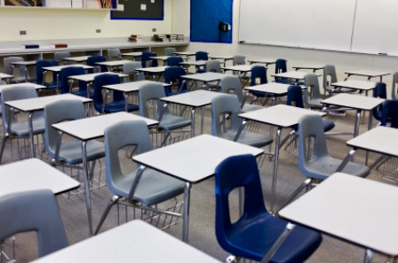 | 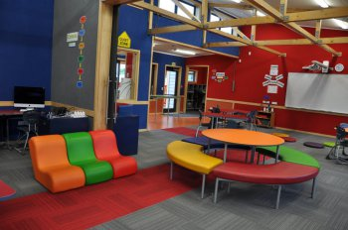
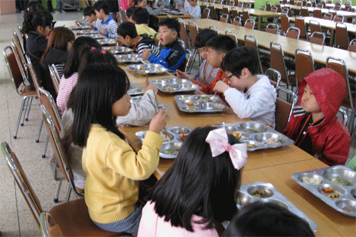
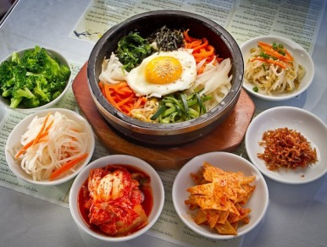 | 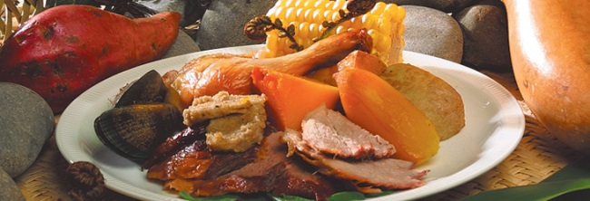
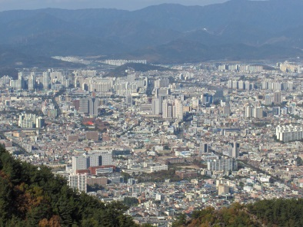 | 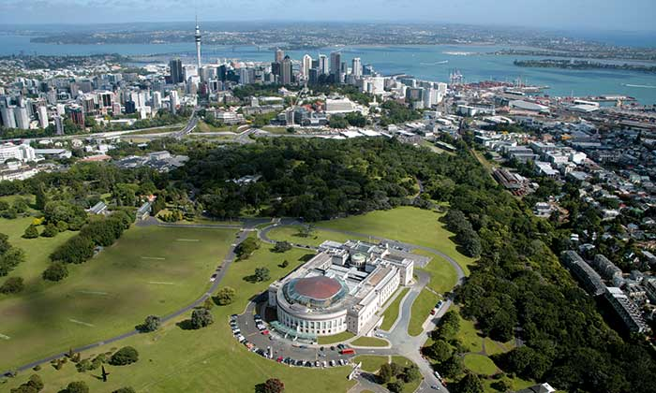
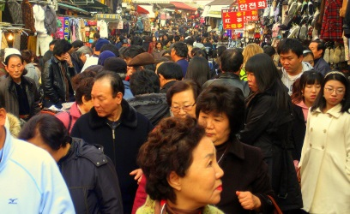 | 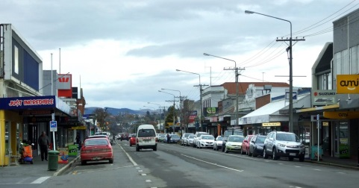

Copy Master 3: Korean Flag
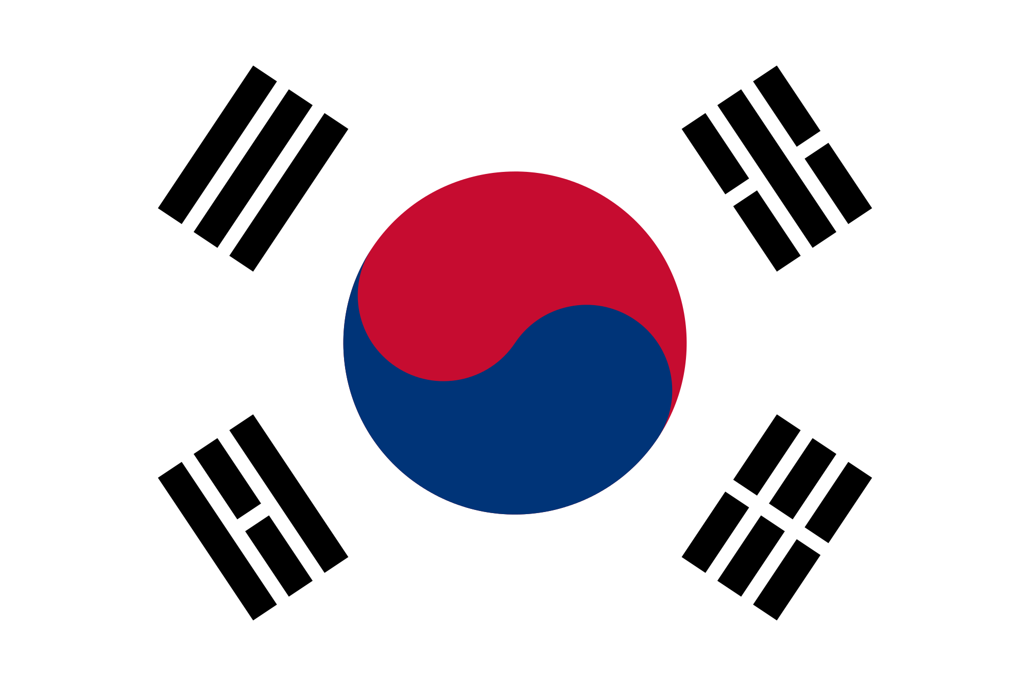

Copy Master 3: Labels to go on the Korean Flag
Heaven, fire, water and earth
Heaven, fire, water and earth
Heaven, fire, water and earth
The positive
The negative
Balance of the universe
Heaven, fire, water and earth
Peace and purity

Copy Master 4: Korean words

anyoung haseyo

kamsahamnida

juseyo

Copy Master 5: Past events in Korea
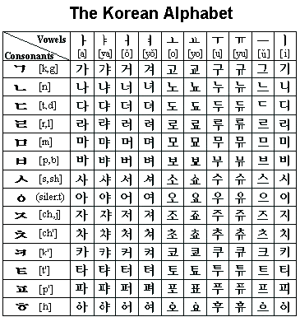
New writing system
Korean alphabet “Hanguel”
introduced

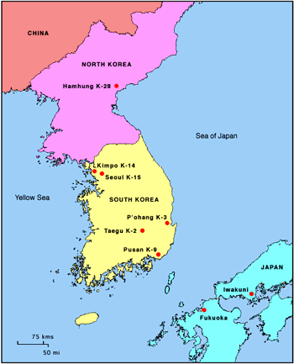
Korea is divided into
North and South Korea

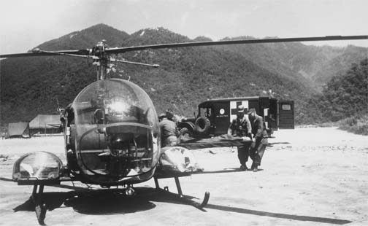
Korean War
Korean War
Korean War
Korean War

Seoul tower opened

Olympics in Seoul
Olympics in Seoul

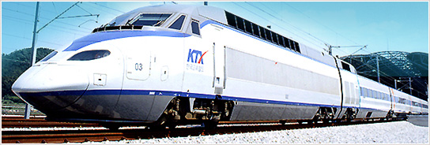
High speed train,
KTX, opened

Copy Master 6: Cycle of 12 animals

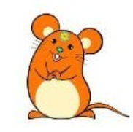
Mouse
Careful

Cow
Patient

Tiger
Passionate

Rabbit
Funny

Copy Master 6: Cycle of 12 animals

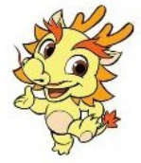
Dragon
Adventurous

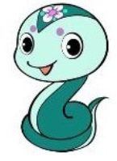
Snake
Hardworking

Horse
Reliable

Sheep
Kind

Copy Master 6: Cycle of 12 animals

Monkey
Cheerful

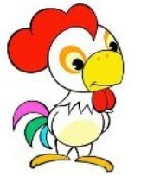
Chicken
Intelligent

Dog
Responsibility

Pig
Honest

Assessment Checklist
Names of Students | Children Day  I can talk about children’s day | Flag  I can recognise the Korean flag | Language  I can speak simple Korean words | Event  I can name a past Korean event | 12 Animals  I can talk about the 12 animals | Comments | Effort

STAGES OF INQUIRY
Name of Stage
Description of Stage

