DISCOVER KOREA
OBJECTIVES
Achievement Objective:  Students will gain knowledge, skills, and experience to:  - Understand that people have social, cultural, and economic roles, rights, and responsibilities.  - Understand how cultural practices reflect and express people’s customs, traditions, and values.  - Understand how places influence people and people influence places. |  | Year Level: Year 3 and 4  Curriculum level: 2  Unit Duration: 10 weeks
INTEGRATION INTO OTHER LEARNING AREA
MATHS
Achievement Objectives:
Students will
Statistical investigation
- Conduct investigations, using the statistical inquiry cycle:
- posing and answering questions;
- gathering, sorting, and displaying category and whole number data;
- communicating findings based on the data.
Statistical literacy
- Compare statements with the features of simple data displays from statistical investigations or probability activities undertaken by others.

ENGLISH – SPEAKING, WRITING, PRESENTING
Achievement Objectives:
Purposes and audiences
Students will:
- Show some understanding of how to shape texts for different purposes and audiences.

indicators:
- constructs texts that demonstrate a growing awareness of audience and purpose through appropriate choice of content, language, and text form;
- expects the texts they create to be understood, responded to, and appreciated by others;
- develops and conveys personal voice where appropriate.

HEALTH & PE
Achievement Objectives:

Students will:
Relationships
- Identify and demonstrate ways of maintaining and enhancing relationships between individuals and within groups.
Identity, sensitivity, and respect
- Describe how individuals and groups share characteristics and are also unique.

Interpersonal skills
- Express their ideas, needs, wants, and feelings appropriately and listen sensitively to other people and affirm them.
Societal attitudes and values
- Explore how people's attitudes, values, and actions contribute to healthy physical and social environments.
Community resources
- Identify and use local community resources and explain how these contribute to a healthy community.

VISUAL ART
Achievement Objectives:

Students will:
- Share ideas about how and why their own and others’ works are made and their purpose, value, and context.

DANCE
Achievement Objectives:

Students will:
- Identify and describe dance in their lives and in their communities.

MUSIC
Achievement Objectives:

Students will:
- Explore and share ideas about music from a range of sound environments and recognise that music serves a variety of purposes and functions in their lives and in their communities.

Values:  Excellence  Innovation, inquiry, and curiosity  Diversity  Equity  Community and participation  Ecological sustainability  Integrity  Respect | Key Competencies:  Thinking  Using language, symbols, and texts  Managing self  Relating to others  Participating and contributing |  | Principles:  High expectations  Treaty of Waitangi  Cultural diversity  Inclusion  Learning to learn  Community engagement  Coherence  Future focus
Assessment Opportunities:

The students assess their own learning as they complete their Korean Contract using the Self-Assessment of my Learning matrix. The teacher can use the design that students create along with their explanation of this as Summative Assessment opportunity.

Unit Focus:  The core learning in this unit consists of the students independently exploring an area of Korea which they are interested in. There are seven areas to choose from including; art, language, places, food, school, customs or Korean cars. The students complete a learning experience for each of the six levels of Blooms Taxonomy. Students will need to be supported and monitored throughout this process. |  | Context:  The unit begins with discussion about culture. Students will begin by examining their own culture. Next they will explore the Korean culture and will identify what makes it unique.  Students will then look at the Cheonggyecheon stream which runs through Seoul. They will discover its significance and relate it to their own lives living in New Zealand. Students will compare the importance of the Korean stream with New Zealand beaches.  Using the students’ knowledge and understanding they have gained about culture and significant places, they will then design a special place that could be built within their school.

Curriculum achievement objectives | Understand how cultural practices reflect and express people’s customs, traditions, and values.
Learning Intention | We are learning how to describe what ‘culture’ means
Key idea for the lesson:
A society’s culture is represented in the people’s language, customs, and in the material objects that people use every day.

Write the question “What are some ways that we express our own cultural identity?” Tell the students that they will need to consider this question throughout the lesson and that they will need to provide an answer at the end of the lesson.

Tell the students that you recently had a friend that went to Korea and they brought back some everyday items that provide us with clues about Korean culture.

Divide students into small groups and give each group a set of the items to study.
Copy Master 1: Korean items

Allow them time to discuss and then ask questions such as:
- What are these objects?
- Who would use these objects?
- When and where would these objects be used?
- Does everybody use them?
- Why is there English on some of them?
- How are these objects different from what you normally see or use?

Read “Family Treasures” from the School Journal Part 1 Number 3, 2007. Discuss each person in the story. What are each of their treasures and why are they important to them?

Ask the students to bring along a cultural or family treasure so that they can explore the cultures within the class. This could be anything that represents who they are, where they have come from, or what they identify themselves as (for example, they might bring a photo, an artefact, a symbol, a flag, an ornament, or a card).
Throughout the unit have the students share and describe their treasure to the class.

Take a photo of each student with their treasure and display. The student could write an explanation about why their treasure is important and what it tells us about their culture.

Revisit the initial question “What are some ways that we express our own cultural identity?” and formulate an answer. Display this on the wall so that students are able to add to this and refer back as necessary.

Curriculum achievement objectives | Understand how cultural practices reflect and express people’s customs, traditions, and values.
Learning Intention | We are learning about the different cultures in our community
Discuss with the class:

How many different cultures do we have in our class?
Where do we come from?
What languages do we speak?
Where were we born?

List the countries where each student was born.
List the languages that each child speaks. Display the results in the classroom

Look at a world map and have each student write their name and or photo beside their country.

Curriculum achievement objectives | Understand how cultural practices reflect and express people’s customs, traditions, and values.
Learning Intention | We are learning about the ways that Korean people express their culture in New Zealand
Tell the students that they have been asked to design a poster or create a TV advertisement for a Korean Festival that will be held in their town or city next month. In order to complete this task they will need to find out about what happens at these festivals.

Study the posters for the Duruje 2014; Annual Korean Cultural Festival and the 2015 K-Culture Festival. Copymaster 2

What do these tell us about Korean people in New Zealand?
How do the Koreans celebrate?
What is important to the Korean people?

Students to watch selected YouTube clips from various Korean Festivals around the world. In groups they identify the ways that Koreans express their culture.
Dance
Taekwondo
The Chicago Korean Festival
Korean Festival in Victoria

Imagine that there is a Korean Festival being held next month in your town/city. Your school has been asked to:
- design the poster for this.
- create a TV advertisement to promote this

In small groups or individually students choose to create an advertisement or design their own poster for this occasion.

Curriculum achievement objectives | Understand how cultural practices reflect and express people’s customs, traditions, and values.
Learning Intention | We are learning how to find out and use information to help us find out more about Korea
Introduce students to the Blooms Taxonomy Learning Experiences Sheet.

Discuss each of the key areas briefly and why they have been included. Explain that they will need to select one area that they are interested in to find out more about. They need to complete each of the six levels of Blooms Taxonomy, including remembering, understanding, applying, analysing, evaluating and creating.
At the completion of their work they will need to present something to the class to share what they have learnt.

Students independently work to complete a variety of activities exploring key cultural features about Korea such as;
- art
- language
- places
- food
- school
- customs
- Korean cars

Students are each given a Korea Contract where each learning experience needs to be checked off by either the teacher or a buddy before beginning the next learning experience.

Curriculum achievement objectives | Understand how places influence people and people influence places.
Learning Intention | We are learning how to identify Cheonggyecheon
Tell the students that a special guest from Korea is coming to talk about a very special place called “Cheonggyecheon” but that you are unsure about what this place is! The guest will be arriving in 15 minutes but they need to have an idea about what this place is so that they can ask really good questions.

Allow students 15 minutes to find about all that they can about Cheonggyecheon. Prompt them with questions such as:
Where is it?
How long has it been there for?
What is it for?

Encourage them to think about questions that they could ask someone who has been there.

Ask a Korean parent or someone from the community to come in and talk about what the stream means to them. Encourage the students to ask questions.

Display pictures from Copy Master 3: Cheonggyecheon stream for students

Curriculum achievement objectives | Understand how places influence people and people influence places.
Learning Intention | We are learning how to explain why the Cheonggyecheon stream is important to Koreans
Watch video about Cheonggyecheon

Using images from google or their own drawings, create a simple and brief slideshow that advertises a place that they identify with. Encourage students to consider and discuss why the place is important to them.

Choose a location (such as the beach) that is important to New Zealanders.
How do New Zealanders use the beach?
Why do New Zealanders use the beach?
How does it represent our culture and values?

Compare the beach, or another important place, to the Cheonggyecheon stream which is an important place for Koreans.

Complete a Venn Diagram using Copy Master 4 to show the similarities and differences between the stream and beach.

Curriculum achievement objectives | Understand how places influence people and people influence places.
Learning Intention | We are learning how to create a space within our school that could be an important place for students to visit
Survey other students within the school to find out …
What they would like in a special space?
What would they like to be able to do in this special space?
What things would they like to see in a special space?

Are there other things that they think need to be considered when designing a special space?

Using the ideas that other students have provided them with as well as their own, sketch a simple design of a special space within the school where students could go to do the things that they would like to be able to.

Present your design to other students to receive feedback about your ideas. The students make changes to their designs according to the feedback that they received.

Give students a collection of items such as paper, vivids, plasticine, material, large sheets of paper and cardboard and allow them to design a model of their space. Encourage them to consider how different cultures can be represented in their space.

Invite the Principal and BOT into the class and present these designs to them.

Curriculum achievement objectives | Understand how cultural practices reflect and express people’s customs, traditions, and values.
Learning Intention | We are learning how to share our knowledge about Korea with others
Students present their findings to the class from their independent work taken from the Blooms Taxonomy Learning Experiences Sheet.

They can choose what it is that they would like to share which may include a poster, video, slideshow, powerpoint, collage of pictures and or photos, draw a comic strip. It may be something they produced as part of their independent learning or it may be something else that they decide they would like to create.

Additional resources:
Copy masters 1-4

School Journal Part 1 Number 3, 2007

Blooms Taxonomy Learning Experiences Sheet

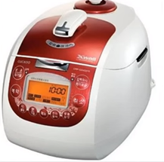
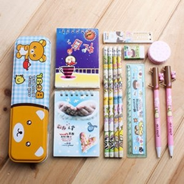
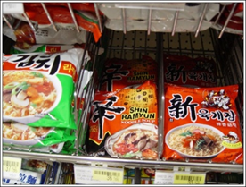
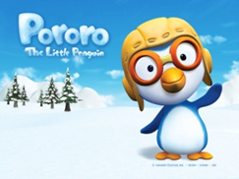
Copy Master 1: Korean items
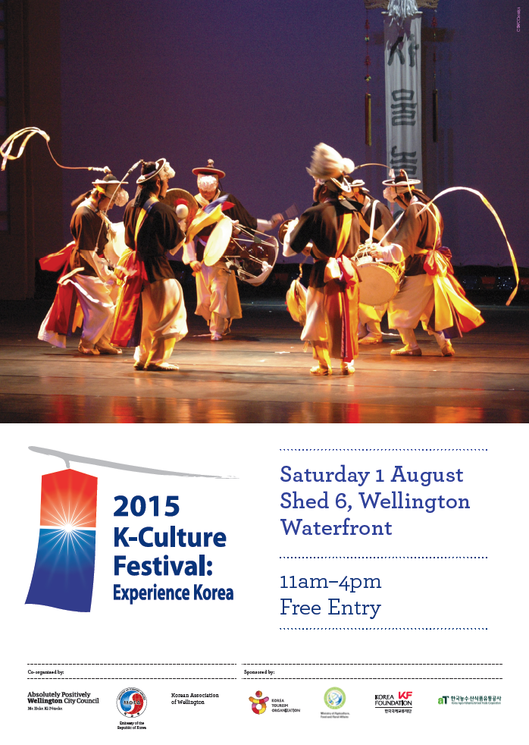
Copy Master 2:
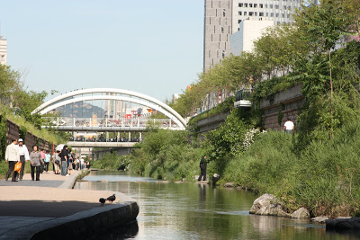
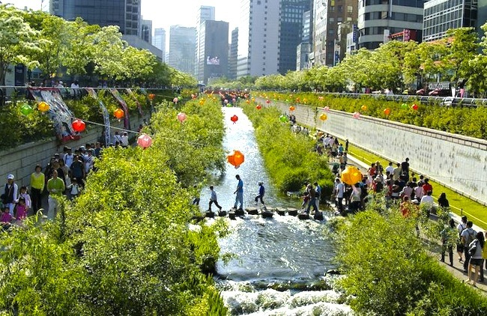
Copy Master 3: Cheonggyecheon stream

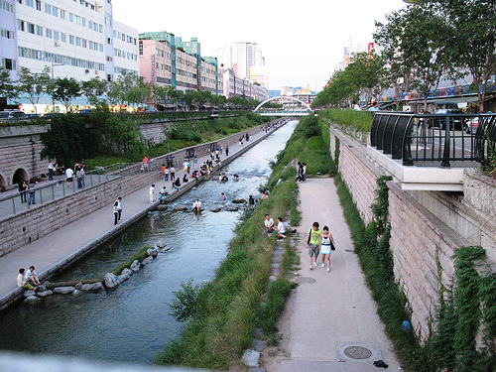
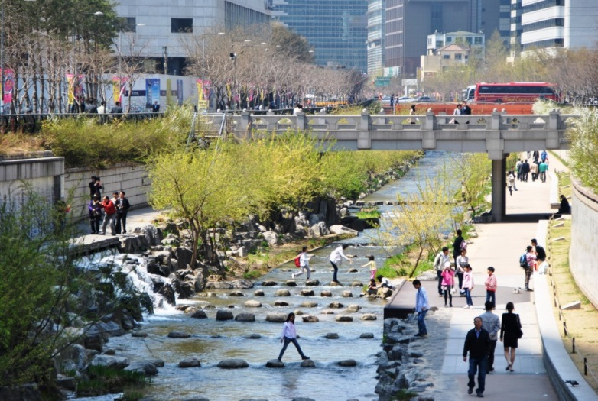
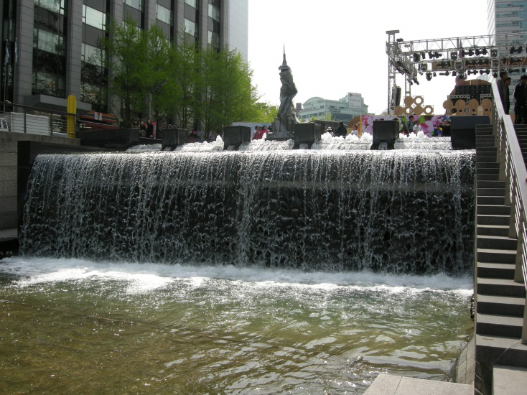
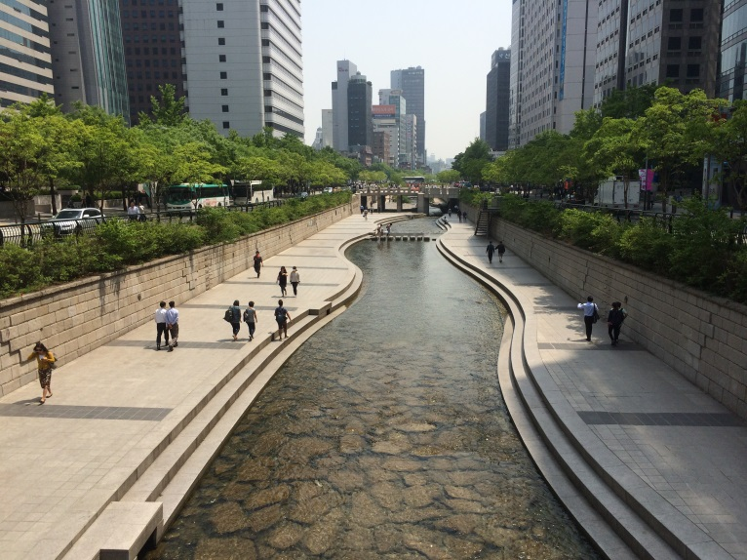
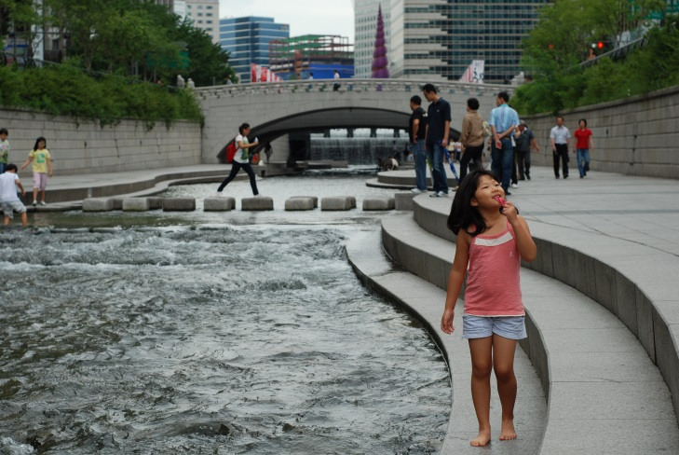
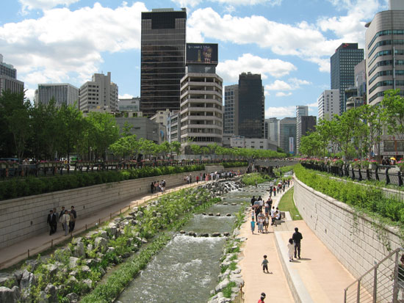

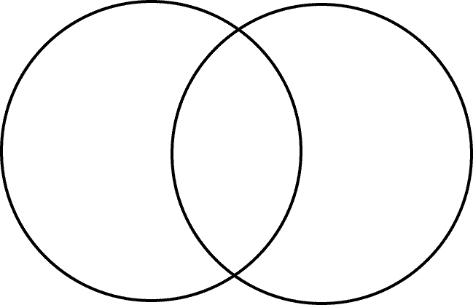
Copy Master 4: Venn diagram
Cheonggyecheon stream
New Zealand beach

