KOREAN KIWIS
OBJECTIVES
Achievement Objective:  Students will gain knowledge, skills, and experience to:  - Understand how cultural practices vary but reflect similar purposes.  - Understand how the movement of people affects cultural diversity and interaction in New Zealand. |  | Year Level: Year 5 and 6  Curriculum level: 3  Unit Duration: 10 weeks
INTEGRATION INTO OTHER LEARNING AREA
MATHS
Statistical investigation
- Conduct investigations using the statistical enquiry cycle:
- gathering, sorting, and displaying multivariate category and whole number data and simple time-series data to answer questions;
- identifying patterns and trends in context, within and between data sets;
- communicating findings, using data displays.

ENGLISH – SPEAKING, WRITING, PRESENTING
Purposes and audiences
- Show a developing understanding of how to shape texts for different purposes and audiences.

indicators:
- constructs texts that show a growing awareness of purpose and audience through careful choice of content, language, and text form;
- conveys and sustains personal voice where appropriate.
Ideas
- Select, form, and communicate ideas on a range of topics.

indicators:
- forms and expresses ideas and information with increased clarity, drawing on a range of sources;
- adds or changes details and comments to support ideas, showing some selectivity in the process;
- ideas suggest awareness of a range of dimensions or viewpoints.

HEALTH & PE
Achievement Objectives:

Students will:
Relationships
- Identify and compare ways of establishing relationships and managing changing relationships.
Identity, sensitivity, and respect
- Identify ways in which people discriminate and ways to act responsibly to support themselves and other people.
Interpersonal skills
- Identify the pressures that can influence interactions with other people and demonstrate basic assertiveness strategies to manage these.

VISUAL ART
Achievement Objectives:

Students will:
- Investigate the purpose of objects and images from past and present cultures and identify the contexts in which they were or are made, viewed, and valued.

DANCE
Achievement Objectives:

Students will:
- Explore and describe dances from a variety of cultures.

MUSIC
Achievement Objectives:

Students will:
- Identify and describe the characteristics of music associated with a range of sound environments, in relation to historical, social, and cultural contexts.
- Explore ideas about how music serves a variety of purposes and functions in their lives and in their communities.

Values:  Excellence  Innovation, inquiry, and curiosity  Diversity  Equity  Community and participation  Ecological sustainability  Integrity  Respect | Key Competencies:  Thinking  Using language, symbols, and texts  Managing self  Relating to others  Participating and contributing |  | Principles:  High expectations  Treaty of Waitangi  Cultural diversity  Inclusion  Learning to learn  Community engagement  Coherence  Future focus
Assessment Opportunities:
After each stage of the inquiry process, the teacher conferences with each student which provides the teacher with information for both formative and summative assessment.

Unit Focus:  In this unit the students work together in groups or individually to research a Korean celebration.  Throughout the unit the lessons are designed to provide students with a deeper understanding and appreciation of Korea and its culture.  This unit develops higher order thinking skills as it progresses and is intended to be taught as the students are also conducting their own inquiry about a Korean celebration. Some of the lessons may run over several learning sessions and as such there is no suggested timing included in the plan. |  | Context:  The unit covers two key learning ideas. Firstly students need to understand what cultural practices are and how these are similar across cultures. Secondly, students will gain an insight into immigration into New Zealand.  The unit concludes with students hosting multiple mini-festivals and celebrations. When the students are researching their inquiry they need to be continually reminded about the purpose and audience.  It is expected that the theme of Korea and celebrations will be integrated into other curriculum areas particularly in maths and literacy as this will make the learning more authentic for students.

Curriculum achievement objectives | Understand how cultural practices vary but reflect similar purposes.
Learning Intention | We are learning about Korean celebrations
HOOK INTO LEARNING

Distribute a ‘Discovery box’ (See Copy Master 1: Discovery Box) to groups of students, asking them to work out the stories behind each item and the country the items represent.
Allow students time to discuss each item; What it is and what it is used for?
Come back together as a class and ask each group to share what they discussed. If there are items that they are unsure about, ask students from other groups. If you have Korean students in the class, they can be used as experts to explain what they know about the objects. They may wish to share an experience with the class.
Create a “Wonder Wall” in your classroom. This wall is where students can write any questions that they have throughout the unit. Model how to compose a question and add it to the wall. Encourage any students that already have questions to add these to the wall. Possible prompts that could be used may be:
- I wonder why...
- I wonder if...
- I wonder what would/would not have happened if...
- I wonder who...
- I wonder how...

Using epals, http://www.epals.com/#/connections students can search for a Korean epal. Throughout the unit allow time for students to develop a relationship with their epal.
Encourage students to question their epal about their schooling, family etc to gain an insight into their lives. Students could also use their epals to ask them questions throughout their research.

Key idea to generate from the lesson: Celebrations reflect cultural practices which are important in all cultures

Curriculum achievement objectives | Understand how cultural practices vary but reflect similar purposes.
Learning Intention | We are learning how to express our ideas about what represents a festival or celebration
Using Copy Master 2: Korean Celebrations, print off each of the colour photos and spread these around the room. Have a piece of paper and some pens next to each photo. Students walk around the room and examine each of the photos and use the paper to note down their ideas about what they think the entire photo shows. Use the questions below to prompt their thinking:
- What do you think the people in this photo are doing?
- Where do you think this is?
- When do you think this photo was taken?
- What things in the photo give you clues about what the whole picture may show?

As a class uncover the photos. Ask questions such as:
- What are some of the things that are the same or nearly the same in all the photos?
- Are any of the things you see happening familiar?
- What would be a good name for this celebration?
- Do you think this celebration started in New Zealand or has it come from somewhere else?

The photos could be grouped and categorised by the students own criteria, and then displayed for future reference.
Curriculum achievement objectives | Understand how cultural practices vary but reflect similar purposes.
Learning Intention | We are learning how to identify Korean celebrations
THINKING SKILLS - REMEMBERING
Acting like an encyclopedia where one finds out facts, information and data -

Tell students that they are going to have the opportunity to get a small taste of a variety of festivals and celebrations that occur in Korea. Their aim is to find one festival or celebration that interests them as they will be doing further investigation and research into this festival and creating their own version of this in the last week of school for the Korean school community.
Students should gain an understanding about;
Lunar New Year’s Day (Seol or Seollal)
Chuseok
First Birthday
Weddings
Children’s Day

Provide students with a range of resources for them to investigate various Korean celebrations.
Allow students time to immerse themselves in the information. Use books from your school and community library

Set up a links page for them to access with:

Youtube clips such as;
https://www.youtube.com/watch?v=gzhlCjKgWss
https://www.youtube.com/watch?v=C3HRXlJHZWA
https://www.youtube.com/watch?v=OkySuOoQO_Q
https://www.youtube.com/watch?v=q35JmqvNzXs
https://www.youtube.com/watch?v=vUDYLjjaKg0

Informative websites such as;
Lunar New Year’s Day http://asiaenglish.visitkorea.or.kr/ena/SI/SI_EN_3_6.jsp?cid=505985
Chuseok http://english.visitkorea.or.kr/enu/SI/SI_EN_3_6.jsp?cid=811650
First Birthday http://www.lifeinkorea.com/culture/tol/tol.cfm
Weddings http://www.korea4expats.com/article-weddings.html
Children’s Day http://www.dodoland.com/childrenday3.php

Invite Korean parents or community members in to the class to share about their favourite Korean celebrations and or festivals

Students complete their Inquiry booklet - Stage One: Fact Finding
What is your research topic?
What prior knowledge do you already have about your topic?
Curriculum achievement objectives | Understand how the movement of people affects cultural diversity and interaction in New Zealand.
Learning Intention | We are learning how to discuss the patterns in Koreans arriving in New Zealand
THINKING SKILLS - REMEMBERING
Acting like an encyclopedia where one finds out facts, information and data -

Tell students they are going to take part in a quiz and that they will be supplied with a booklet that has all of the answers inside. Their task is to find the answers as quickly as possible.
Hand out the Visitors to Korea booklet and allow students to work together in groups or individually.
Ask them questions that ensure they must read and comprehend the content. You could ask questions such as (to make the quiz more challenging, ask the questions out of order!):

What is the exact number of how many visitors from Korea there were there in 1996?
What was the median age of visitors from in 2008?
On average, are there more male or female visitors from Korea?
What does VFR stand for?
What time of year are Koreans most likely to enter into New Zealand?
How many stay days were there in 2002?
In 2008, how many days did visiting Korean stay in New Zealand for?

A variation could be for students to ask each other questions using the document. As a class, discuss what these facts and figures tell us and why they are important. Brainstorm any questions that they still have and add to the Wonder Wall.

Curriculum achievement objectives | Understand how the movement of people affects cultural diversity and interaction in New Zealand.
Learning Intention | We are learning how to discuss the patterns in Koreans arriving in New Zealand
THINKING SKILLS - UNDERSTANDING
Acting like a Dictionary understanding words, concepts, cause-effect and reasons for

Read http://www.teara.govt.nz/en/koreans/page-2
Using quotes taken from this article, ask students to explore them further and discuss the implications of each of these.
“By 2001, in North Shore City, Korean was the second most common language after English.”
(eg, should schools should teach Korean, should the City Council have signs translated etc)

“Finding a suitable job was the greatest challenge.”
(What other factors may have contributed to this?)

Why might Koreans have been drawn to the North Shore?

Curriculum achievement objectives | Understand how cultural practices vary but reflect similar purposes.
Learning Intention | We are learning how to explain cultural stereotyping  We are learning how to identify needs that are common across cultures
THINKING SKILLS - UNDERSTANDING
Acting like a Dictionary understanding words, concepts, cause-effect and reasons for

Display Copy Master 3: Christmas in New Zealand, allow students time to talk to one another about what they can see.
Ask them, does this explain who a New Zealander is and what we stand for?
Discuss cultural stereotyping and how important it is not to make judgements about people in a culture. Who we are and what we stand for is very complex and is cannot be obtained through looking at photos or watching movies. Our culture, traditions, family values and environment all contribute to the complexity of who we are.

Display Copy Master 4: Christmas, and discuss how an image can be changed by cutting something out or adding something in.

However, we all have commonalities. Students complete Copy Master 5: Our Common Needs
Share and discuss as a class.

Students complete Stage 2: Questions
Curriculum achievement objectives | Understand how cultural practices vary but reflect similar purposes.
Learning Intention | We are learning how to compare how individuals and groups pass on and sustain their culture and heritage
THINKING SKILLS - APPLYING
Acting like a ‘How to Manual’ – applying previously learnt data in similar or novel situations

Read School Journal, Part 1, Number 2, 2006 “Becoming a Kiwi”
Discuss the value of New Zealanders who can speak more than one language and who have more than one culture

What is culture and heritage?
In pairs ask students to come up with their own definitions or each word.
Share definitions with another pair. Which words have you both used?
As a class find similar words that students have used to create a class definition of these words.

Key idea: it is important to value your own culture and heritage
Students complete Copy Master 6: My Own Culture and Heritage

Curriculum achievement objectives | Understand how cultural practices vary but reflect similar purposes.
Learning Intention | We are learning how to analyse common cultural values, practices and beliefs between NZ and Korean
THINKING SKILLS - ANALYSING
Acting like a ‘Sorting Tray’, examining and breaking up parts into its component parts

Ask students to select a New Zealand festival or celebration to compare to that which they have focused on in their independent research. Use a Venn diagram (Copy Master 7: Venn Diagram) to compare and contrast between a Korean celebration or festival with a New Zealand one. Share with a class member the similarities and differences between the two celebrations.

Connect back to the main idea that cultural practices are same but different.

Curriculum achievement objectives | Understand how cultural practices vary but reflect similar purposes.
Learning Intention | We are learning how to form an opinion and justify our decision
THINKING SKILLS - EVALUATING
Acting like a judge – making a decision based on the evidence

Compare and contrast knowledge of Korean culture and protocols with knowledge of own culture. Copy Master 8: Compare and contrast. Underneath, write a summary of what the diagram shows.

Key idea: We have commonalities but are also unique
Collect and use for assessment.

Have a class discussion and or debate about the advantages and disadvantages of having the Korean culture in New Zealand? Use Copy Master 8: Pros, cons and questions to help clarify thinking.

Curriculum achievement objectives | Understand how cultural practices vary but reflect similar purposes.
Learning Intention | We are learning how to present our findings to others
THINKING SKILLS - CREATING
Acting like Thomas Edison, always improving, designing and planning

Students complete their Inquiry booklet

Copy Master 1: Discovery Box
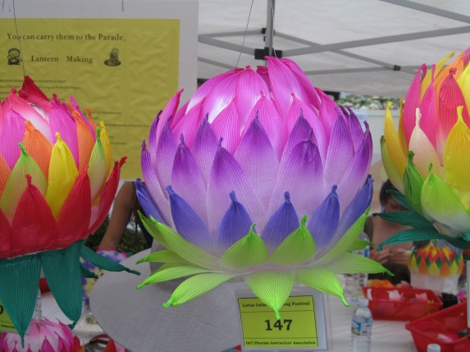
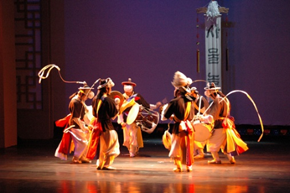
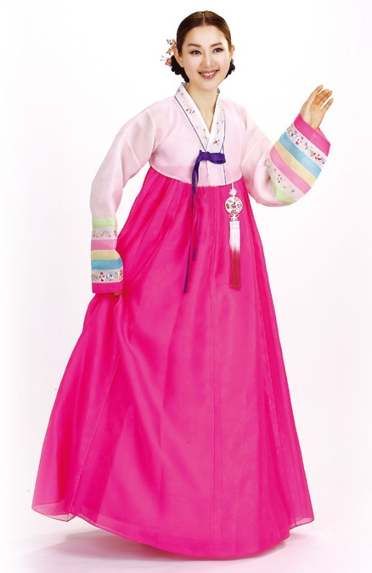
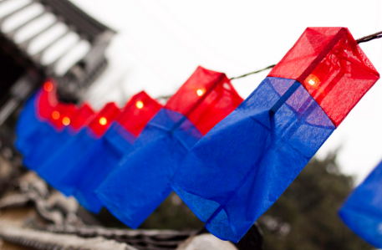
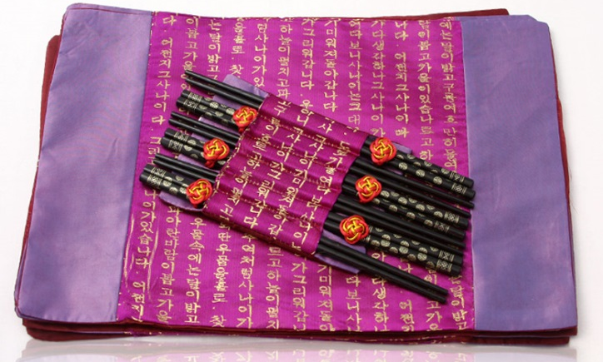
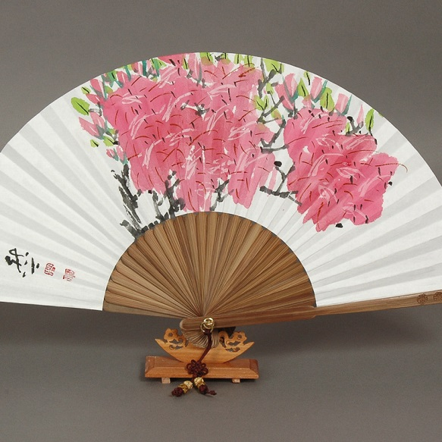
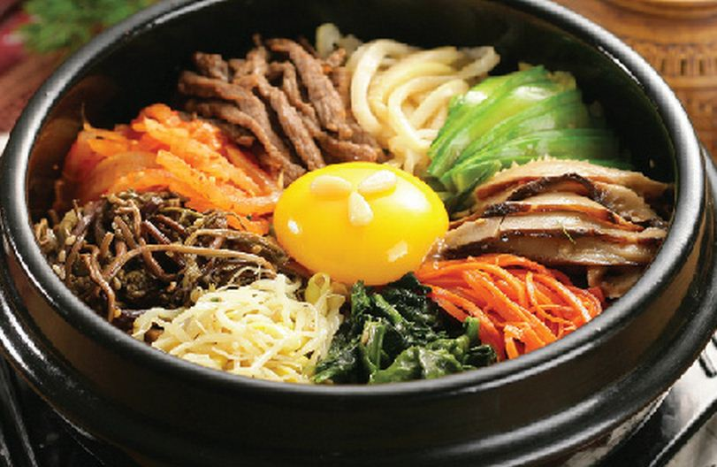
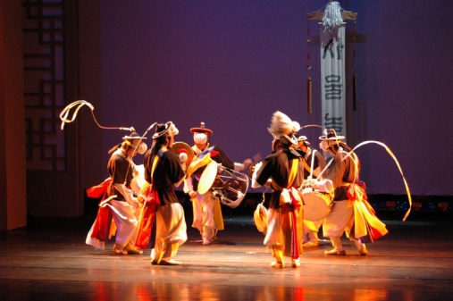
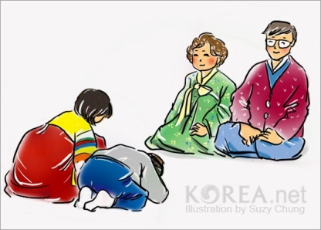
Copy Master 2: Korean Celebrations

Sebae: New Year’s bow on 1st of January of the lunar calendar can be considered as the most popular celebration in Korea.

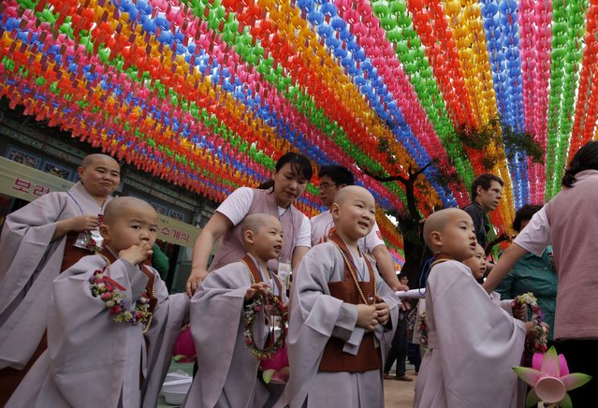
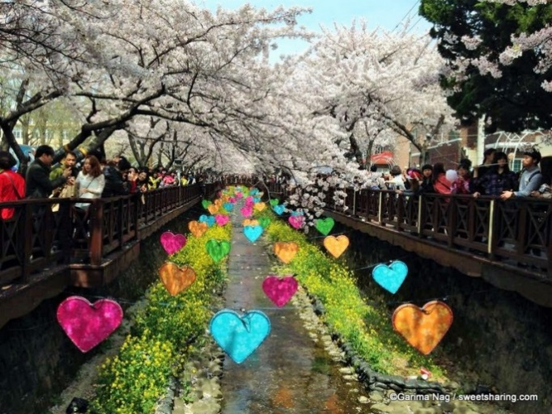
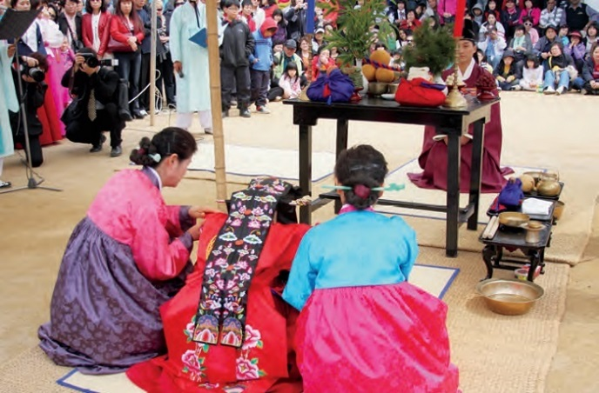
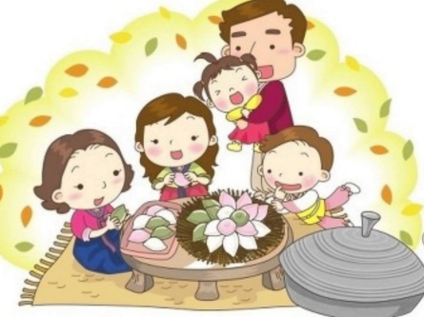
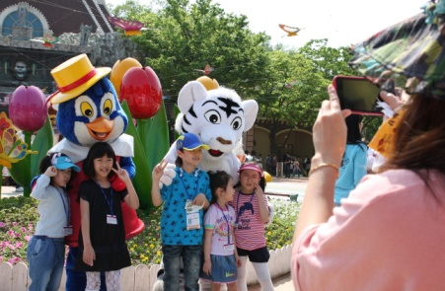
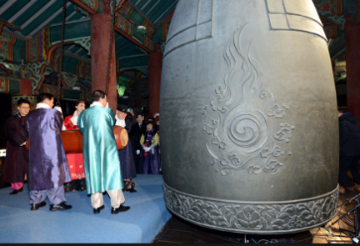
Buddha’s birthday: A young monk cries as his hair is shaved off during the “Children Becoming Buddhist Monks” ceremony. The children will stay at the temple to learn about Buddhism for 20 days. Korean Buddhists prepare to celebrate Buddha's upcoming birthday on 25 May.

Weddings are an important family celebration in Korea. Most Korean people choose their own partner. In pre-modern times, however, husbands and wives were given by their parents or matchmakers after an examination of their horoscopic data, called Saju (Four Pillars of Destiny), which are determined by the hour and date of their birth.

Jinhae Cherry Blossom Festival is the largest & most famous tourist attraction of South Korea. It is celebrated every year between late March to Early April in Jinhae in Changwon, Gyeongsangnam-do.
It marks the arrival of spring season

Chuseok is a major harvest festival and a three-day holiday in Korea celebrated on the 15th day of the 8th month of the lunar calendar. As a celebration of the good harvest, Koreans visit their ancestral hometowns and share a feast of Korean traditional food such as songpyeon and rice wines.
Children's Day: May 5 is officially recognized as Children's Day in Korea. Parents often give presents to their children, as well as spend time with them. The children are taken on excursions to zoos, museums, and various venues of children-oriented entertainment.
Bosingak Bell-Ringing Ceremony: The bell-ringing event on New Year’s Eve draws throngs of people from all over Seoul. The area around Bosingak is closed to traffic on this day and becomes packed with people. The bell ringing is preceded by various events like congratulatory performances by Korean stars. After that, all citizens participate in the countdown to the New Year. Then, as the New Year starts, celebrities, civil representatives, and senior members from various fields ring the bell 33 times in celebration of a good year, after which people shout with joy and firecrackers are launched into the sky. With people making wishes, hugging each other, shouting, or crying, the area is filled with an invigorating spirit for the New Year.
People gather with torches to celebrate the Jipyongsun (horizon) festival to experience the agricultural lifestyle in Korea.
Copy Master 3: Christmas in New Zealand

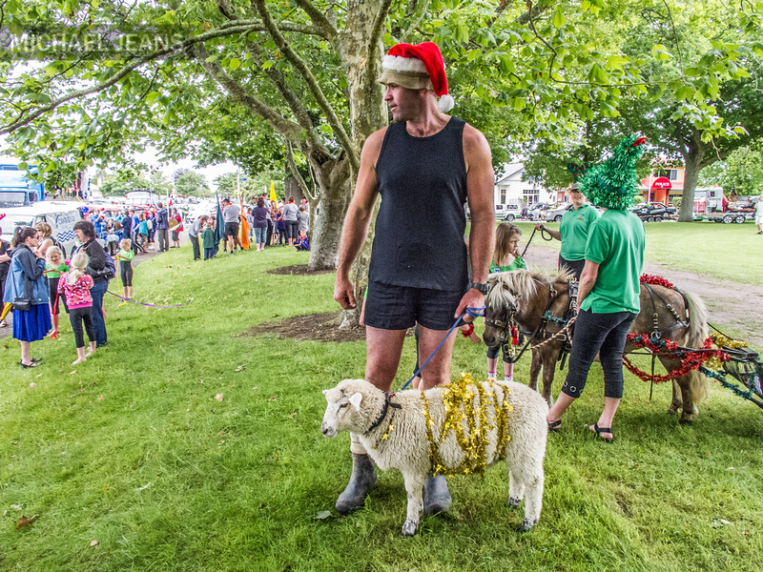

Copy Master 4:

Copy Master 5: Our Common Needs
Write the three basic needs of people
3.

2.

1.

These are not the only needs people have. People also need things such as entertainment and education. Different cultures satisfy these needs in various ways.
Use the table below to compare the needs of Koreans with New Zealanders.

Need | New Zealanders | Koreans
Transport

Clothing

Food

Employment

Shelter

Recreation

Write a sentence to describe the main differences between the two groups:
___________________________________________________________________
Copy Master 6: My Own Culture and Heritage
This is me
My name: _________________________
Date of Birth: _______________________
Place of Birth: ______________________
My family came from: ________________
Ethnic group: _______________________
The Language/s I speak
__________________________________
Favourite Food: _____________________

My caregivers name: ________________
My caregivers name: ________________
Place/s of Birth: _____________________
__________________________________
Ethnic group: _______________________
The Language/s they speak
__________________________________
Favourite Food: _____________________

This is my caregiver or caregivers
This is my grandparent or grandparents
My grandparents name: ______________
My grandparents name: ______________
Place/s of Birth: _____________________
__________________________________
Ethnic group: _______________________
The Language/s they speak
__________________________________
Favourite Food: _____________________

Copy Master 7: Venn Diagram
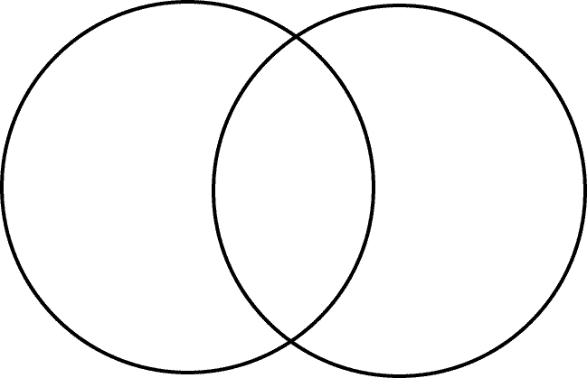

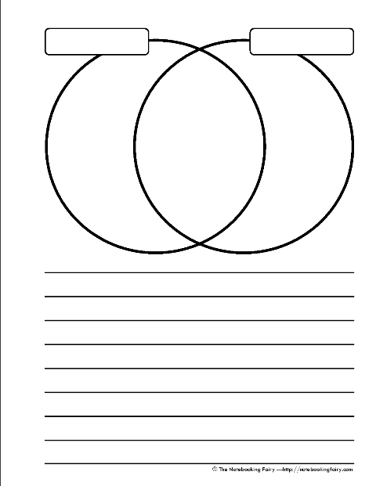Copy Master 8: Compare and contrast

Copy Master 8: Pros, cons and questions
Pros | Cons | Questions
In this column record all the benefits of having cultural diversity in New Zealand | In this column record all the disadvantages of having cultural diversity in New Zealand | In this column record all the ‘what if’ ideas of having cultural diversity in New Zealand

