|  |  |  |  |
| --- | --- | --- | --- |
| Have you had your rice yet? | | | |
| OBJECTIVES | | | |
| Achievement Objectives:  Students will gain knowledge, skills, and experience to:  Technological Practice:  Justify the nature of an intended outcome in relation to the need or opportunity. Describe specifications that reflect key stakeholder feedback and that will inform the development of an outcome and its evaluation.  Technological Knowledge :  Understand that technological products are made from materials that have performance properties.  Nature of technology:  Understand how people’s perceptions and acceptance of technology impact on technological developments and how and why technological knowledge becomes codified. | | Year Level: 10  Curriculum level: 5  Note: Completion of unit could provide evidence for achievement for NZ Curriculum Level 4/5 and with some modification it could be used for NCEA L1 and  AS 91046.  Unit Duration:  5 Weeks | |
| INTEGRATION INTO OTHER LEARNING AREAS | | | |
| Food Technology; Home Economics; Social Studies; Science; Health | | | |
| Values:  Excellence  Innovation, inquiry, and curiosity  Diversity  Equity  Community and participation  Ecological sustainability  Integrity  Respect | Key Competencies:  [Thinking](http://nzcurriculum.tki.org.nz/The-New-Zealand-Curriculum/Key-competencies#thinking)  [Using language, symbols, and texts](http://nzcurriculum.tki.org.nz/The-New-Zealand-Curriculum/Key-competencies#language)  [Managing self](http://nzcurriculum.tki.org.nz/The-New-Zealand-Curriculum/Key-competencies#managing)  [Relating to others](http://nzcurriculum.tki.org.nz/The-New-Zealand-Curriculum/Key-competencies#relating)  [Participating and contributing](http://nzcurriculum.tki.org.nz/The-New-Zealand-Curriculum/Key-competencies#participating) | | Principles:  [**High expectations**](http://nzcurriculum.tki.org.nz/Principles/High-expectations)   [**Treaty of Waitangi**](http://nzcurriculum.tki.org.nz/Principles/Treaty-of-Waitangi) [**Cultural diversity**](http://nzcurriculum.tki.org.nz/Principles/Cultural-diversity) [**Inclusion**](http://nzcurriculum.tki.org.nz/Principles/Inclusion)   [Learning to learn](http://nzcurriculum.tki.org.nz/Principles/Learning-to-learn) [Community engagement](http://nzcurriculum.tki.org.nz/Principles/Community-engagement) [Coherence](http://nzcurriculum.tki.org.nz/Principles/Coherence)  [**Future focus**](http://nzcurriculum.tki.org.nz/Principles/Future-focus) |
| Assessment Opportunities:  Completion of unit will provide evidence for achievement for NZ Curriculum Level 4/5 and with some modification it could be used for AS 91046: Use design ideas to produce a conceptual design for an outcome to address a brief.  This unit provides self-assessment followed by formative feedback opportunities as well as summative assessment.  SOLO Taxonomy is the suggested assessment tool. | | | |
| Unit Focus:  Celebrating food culture in Asian countries and investigating possibilities for combating malnutrition through meal development. | | Context:  The importance of rice as a staple food in Asian Countries. Understanding the impact of rice on the cultures of Japan and India in particular. Also of importance is the impact of technology on production in the face of growing demand. | |

|  |  |  |
| --- | --- | --- |
| Values; Key Competencies & Principles | | |
| [The WHS Learning Habits book](http://www.whs.school.nz/wp-content/uploads/Learning-Habits-Booklet-2013.pdf), [NZ Curriculum 2007](http://nzcurriculum.tki.org.nz/Curriculum-resources/NZC-resource-bank/Vision-values-and-principles) | | |
| Week 1: Introduction | | |
| As a learning community the teacher and students have defined responsibilities for securing a successful learning opportunity. When introducing the topic explain to students that:   * the teacher’s responsibility for the lesson requires planning, talking, listening, questioning and demonstrating * the students’ responsibilities would be listening, planning, concentrating, questioning, innovation and perseverance   Demonstrate the importance of listening by showing the following video demonstrating the [importance of listening](https://www.youtube.com/watch?v=TP8RB7UZHKI):  Discussion:   * Who in this video wants to be listened to? * Why is it impossible to solve the issue? * Who wins the argument? * Wrap up – why is it important to respect and to listen when you are being spoken to? | | |
| Values | Key competencies | Principles |
| Community and participation.  Students will be encouraged to value critical thinking. | Using language, symbols and texts:   * Make links – Make sure all students know how to use ‘Google Presentation’(have they used it before)? * Making links between business studies, health studies and food technology by considering needs and hauora * Students will find pleasure in seeing how food link to history and culture * Task given is an inquiry based activity * Listening to group members are important   Participating and contributing   * All students are actively involved in this activity * All need to take action; some will need to lead others * Students will work backwards to work out the thought process e.g. analysis of recipe and its relation to history and culture | High expectations   * Introducing key competencies and making explicit connections will raise an awareness with students about expectations * Co-operative strategies provides the inclusion of all |
| Week 2 | | |
| Values | Key competencies | Principles |
| Students will be encouraged to value creativity and diversity.  Poster activity will place value on participation for the common good.  Students will learn about their own values and those of others. These include moral, social, cultural and aesthetic. | Managing Self   * Encourage students to take a different role in group activities * Ask students to respect other people’s point of view * Emphasise the importance of being responsible, reliable, resourceful and resilient * For activities encourage the positive outcome of being supportive and co-operative | Community engagement   * Students are exposed to the wider society and its values * Stimulating activities encourages students to share with whahau |
| Week 3 | | |
| Values | Key competencies | Principles |
| By studying the production of rice and practices during each stage students will be encouraged to value ecological sustainability. | Using language symbols and text   * For production activity working effectively together as a team is important for a successful outcome of the lesson * Encourage active listening strategies e.g. making eye contact, being quiet and listen, nodding your head * Ask students to use self-evaluation at end of lesson * For chopstick challenge students will learn how to manage distractions and refocus if necessary | Coherence   * Relevant links between Health, Technology and Social sciences   Learning to learn   * Encourage students to be resilient and resourceful learners |
| Week 4 | | |
| Values | Key competencies | Principles |
| The investigation of needs and importance of balanced diets places a high value on integrity and the importance of due diligence (acting ethically) in the development of a solution.  The aim is to have students explore with empathy the values of others.  Development of a healthy recipe will require students to make ethical decisions and to act on them. | Thinking   * Concepts relevant in the learning activities encourages curiousness and reflection * Students will be required to describe what they have learnt * Encourage students to share what they have learnt at home * Problem solving is modelled by giving an example recipe   Participating and contributing   * Investigate * Understand that there are multiple paths that lead to understanding * Students need to explain and justify choices | Treaty of Waitangi   * Consider and value all cultures. Students have the opportunity to provide input based on cultural experiences   Cultural diversity   * Understand that not all have access to the same resources for a healthy life style * Values the history and traditions of other people   Coherence   * Relevant links between Health, Technology and Social sciences |
| Week 5 | | |
| Values | Key competencies | Principles |
| Students will be encouraged to value reflection. Reflection places huge value on self-respect. | Managing self   * In this unit students will need to think flexibly, evaluate and revise * Reflect; what have they done and how could they improve | Future focus   * Knowledge gained in this unit could empower students to consider sustainability, societal needs and enterprise |

|  |  |
| --- | --- |
| LESSON PLANS - Week 1 | |
| Lesson 1: Have you had your rice today? | |
| LEARNING INTENTION(S) | SUGGESTED ACTIVITIES/RESOURCES |
| Characteristics of Technological outcomes:  Students can explain why time and context are important criteria for judging the fitness for purpose of a technological outcome.  Technological Products:  Refresh students’ understanding of ‘Technological Products’.  Students will understand the cultural significance of rice in Asian countries.  Brainstorm students’ knowledge of rice based dishes.  Group activity: Through research students will develop and present the origin of a popular rice dish of their choice. | **Introduction:** Teacher has toprepare resources beforehand to successfully implement the game.  Play mapping game  **Aim:** The of this game is to locate India and Japan in relation to New Zealand    **Lesson 1**  Fun facts about rice: Show slides 1 – 5.    Before showing slide 6 allow students to do a class brainstorm on the white board.  Brainstorm: When the class had a try at brainstorming the names of popular rice dishes, then show slide 6 and keep displayed.  In groups of no more than four let groups pick a rice dish and on their own device find out about the dish. Each group then prepares a presentation about their dish of choice showing:   * Name of rice dish, explaining components * Country of origin * What is the history of the dish * What time of day is it served * How it is eaten   (Group activity)  Research and presentation. Use co-operative group strategies for group work. Each participant has an assigned role for the team activity, e.g.   * Researcher (fact finder) * Scribe (student making the presentation) * Team leader (student making sure that all are on task and are participating) * Presenter   Groups present to class  Literally, “Have you eaten rice yet?” is a common greeting, the equivalent of “how are you?” in English.  [Post Magazine, Lisa Lim 23 Oct 2016,](http://www.scmp.com/magazines/post-magazine/short-reads/article/2038651/why-have-you-eaten-means-how-are-you-hong-kong) Tony Han, 09·02·2014, |

|  |  |
| --- | --- |
| Lesson 2: Sushi, Japan’s first ‘Fast Food’ | |
| LEARNING INTENTION(S) | SUGGESTED ACTIVITIES/RESOURCES |

|  |  |
| --- | --- |
| Technological knowledge:  Students will understand that material can be formed, manipulated and/or transformed to enhance the fitness for purpose of a technological product.  Technological systems  Students can explain how transformation within a system are controlled | Discuss  How rice is formed, manipulated and/or transformed when making sushi.  This lesson is a pre-practical activity.  [Show/demonstrate how to cook perfect sushi rice.](https://www.youtube.com/watch?v=lEkSoYKhX2o)  Explain the control points in the system of cooking the perfect rice e.g.   * Rice to water ratio * Temperature and time measurement * Appropriate tools and equipment   Practical:  In pairs students prepare and cook rice for sushi making lesson.  Share with students the background of sushi as provided in  fact sheet  Allow for discussions on preservation: Conditions for bacterial growth and hurdles towards bacterial growth, e.g.   * Preservatives * Temperature * Time * Food * Moisture   Sushi as a fast food option could be a fun conversation point. Discuss the design of a sushi robot – Students’ interpretation of how it should work.  When cooled down rice can be bagged, labelled and stored in fridge for sushi making lesson.  Resources for practical lesson:   * Data show projector * Rice * Salt * Containers * Markers  Tokyo Best Sushi / The art of Sushi making [Tokyo Best Sushi](https://www.youtube.com/watch?v=skgsn2PKZ1w)  Worksheet 2: Making Japanese sushi – reflection.  This could be a written activity or a class discussion. |
| Lesson 3: Practical sushi making lesson | |
| Characteristics of Technological outcome  Students will understand that their technological outcome is fit for purpose in terms of time and context:   * Were able to complete within time frame * Outcome fits within the definition of ‘sushi’   Student will understand the concept of malfunction:   * What needs to be done to improve skill and outcome to make it fit for purpose | Video clip: [How To: Step-by-Step Sushi at Home](https://www.youtube.com/watch?v=yGG01tj9wi4)    Encourage students to try new or traditional Japanese ways for rolling or shaping sushi.  Recipe for sushi available in resource section.  At completion of the practical cooking lesson students need to do a sensory evaluation of the outcome and reflect on its fitness for purpose. |

|  |  |
| --- | --- |
| LESSON PLANS: Week 2 RICE FESTIVALS IN INDIA AND JAPAN | |
| Lesson 1: Introduction to Asian food festivals | |
| LEARNING INTENTION(S) | SUGGESTED ACTIVITIES/RESOURCES |
| Technological Practice:  The learning activities should allow students to reflect on needs and possible opportunities based on the context of rice festivals.  Encourage discussions on ‘what’ is done and ‘why’ it is done. | * Introduce Asian food festivals by using the Rice festival power point slides 1 – 5 (Slide 6 should be kept for poster activity at the end of the lesson). * Slide 2: For video links * [India](https://www.youtube.com/watch?v=LUkjiAgqjxY) * [Japan](https://www.youtube.com/watch?v=uNlrL383AhM) * Group discussions: Focus on * Reasons for festival – who are the festivals devoted to * Main themes, discuss the fireworks, decorations, performers, food, crowd   (Allow 5 minutes for groups to discuss, then do brainstorm on white board)  Leave space on white board for two brainstorms. A second video will be shown to compare Asian food festivals with NZ food festivals.  IMPORTANT: Rice is not the staple food of New Zealand. In NZ the celebration is about the freshness and availability of all food.       * Video: [Hokitika Wild food festival](https://www.youtube.com/watch?v=X5Q4ueW8QVk) * Complete second brainstorm around discussion completed for Rice festivals e.g. reasons and themes * Written activity: Compare and contrast the societal influence between the food festivals of Asia (Japan and India) versus New Zealand   Ref: The [true Japan](https://thetruejapan.com/9-cultural-mistakes-foreigners-make-japan-instead/), Livingston 2017. 9 Cultural mistakes foreigners make in Japan. |
| Lesson 2: Rice festivals in Japan and India - Rangoli | |
| LEARNING INTENTION(S) | SUGGESTED ACTIVITIES/RESOURCES |
| Characteristics of Technology:  Students will:  Understand how people’s perceptions and acceptance of technology impact on technological developments and how and why technological knowledge become codified. | Lesson introduction:   * Students share their view on the differences between cultural and societal influence for celebrating food in the different countries   Rangoli  Ask question: Can you remember which of the Indian festivals we looked at is popular for making rangoli?  Teacher explains the concept of rangoli?  It is an art form using geometric patterns and made with coloured rice, rice flour, coloured sand or flower petals, originated in India and is called rangoli. These patterns are made and displayed in living rooms or courtyards usually during Pongal and similar rice festivals in India. It is believed to bring good luck and the skills for making a rangoli are passed on from generation to generation.  Show video [Rangoli](https://www.youtube.com/watch?v=0IWabMtG_R8)  Make Your Own Rangoli  This is an optional activity if teacher wants to explore the art form of making a rangoli. A link on the picture will reveal an online website for purchasing coloured sand.    Poster Time   * Display rice festival power point p6 * Students will need their own device to make a poster of any one of the festivals listed on slide 6 * Poster page size is A3 * Include many relevant pictures * Information on poster need to show: * Name and region of the festival * Significance of the festival * Time of year of celebration * Activities that are related to the festival * Decorations and colours related to the festival * Dishes prepared and eaten during festival |
| Lesson 3: Festival food (Practical cooking lesson) | |
| LEARNING INTENTION(S) | SUGGESTED ACTIVITIES/RESOURCES |

|  |  |
| --- | --- |
| Technological products  Students will:  Understand how material is selected, based on desired performance criteria. | Three different recipes have been included for this lesson. The recipes could be divided between groups and at the end of the lesson all could share in festival food. (Suggestion only)  It could be a good idea to have posters and rangoli’s on display.  Recipes: See resource appendix  Three Colour Dango Dumplings  Quick Rice Kheer  Rice Fritters for two |

|  |  |
| --- | --- |
| LESSON PLANS: Week 3 Planting and Harvesting Rice | |
| Lesson 1: Rice planting and harvesting systems | |
| LEARNING INTENTION(S) | SUGGESTED ACTIVITIES/RESOURCES |
| Technological Knowledge:  Students will:  Understand technological systems and  the properties of sub-systems within technological systems.  Explain Systems working together for the production of rice.  Guide students to identify subsystems within the technological system of rice production and explain them in terms of their properties | Introduction:  Use diagram to guide students to identify sub-systems within the technological system of rice production and explain them in terms of their properties  Fact finding activity for students to learn about the planting and harvesting of rice. This activity will be done in pairs. Each pair will:   * Will be given a stage in the production of rice and paraphrase the information on a sticky note * Teacher will display rice planting and harvesting diagram on the white board * Students will then post their sticky notes in the correct order on the diagram on the whiteboard * When all stages are displayed on the board, teacher will talk students through the complete system. This is an interactive activity. At each stage teacher will stop and pair will read out to class the important facts of that stage.   White board  Finish lesson by showing the following video clips:  [Rice planting](https://www.youtube.com/watch?v=j8nGg-8qOGA)    [Rice harvesting systems](https://www.youtube.com/watch?v=5_PNm8d1gkQ) |
| Lesson 2: Know what you are eating | |
| LEARNING INTENTION(S) | SUGGESTED ACTIVITIES/RESOURCES |
| Technological products  Students will:  Understand how material is selected, based on desired performance criteria. | 1. Cook rice for next practical lesson. 2. Each pair has to cook a different type of rice  * Jasmin * Basmati * Brown rice  1. While rice is cooking get students to do the ‘chop stick challenge’. 2. Chop stick challenge:  * Divide class into teams of 5-6 * For each team provide 2 bowls of which one is empty and the other containing: * 1 cashew nut * 1 raisin * 1 rice grain * 1 pair of chop sticks * The challenge is for each team member to transfer each of the three items in the bowl over to empty bowl * The fastest team gets the prize ( Japanese lollies from your local Asian store)  1. Cooked rice should be portioned and allowed to cool before storing in fridge for next lesson.   Fact finding sheet provided for extension activity. See  ‘Student worksheet 3’ |

|  |
| --- |
| Lesson 3: Practical cooking session – Yakimeshi |

|  |  |
| --- | --- |
| Technological products  Students will:  Understand how material is selected, based on desired performance criteria. | Teacher could prepare sensory samples to select best rice. Divide all prepared ingredients into lots of 1/3 and make a Yakimeshi sample with each of the types of rice.  (a quick demonstration will re-enforce hygiene and knife handling skills).  Students need to complete a sensory evaluation.  Anatomy of rice grain – As an extension activity, students could draw their own version of the cross section of the rice grain. |

|  |  |
| --- | --- |
| LESSON PLANS: Week 4 Anatomy of rice grain | |
| Lesson 1: So how healthy is your rice? | |
| LEARNING INTENTION(S) | SUGGESTED ACTIVITIES/RESOURCES |
| Technological Products:  Students can discuss examples to illustrate how the composition of material determines performance properties:   * Can identify components of rice grain * Can identify nutritional value of different layers of rice grain * Understand the value on nutrients for human health | * Show power point for disassembling rice grain into components and nutrition * Discussion of nutritional value of layers – see slide 3 * Slide 4: Nutritional value of rice - investigation   Could be a group activity:   * + - Print copies of nutritional value of rice     - Allow students (groups) to point out or make a prioritised list of nutrients present and lacking in rice     - Feedback and discussion important (see slide 4) * [Slide 6](https://www.youtube.com/watch?v=sumKpYiLKFM) * Discuss terms regarding human nutrition * Use paraphrasing strategy to embed understanding and retain knowledge * Slide 8 is a result of outcome of discussion related to slide 7 Students can now visually see which food products are rich in the nutrients lacking in rice * Note: see Flash cards – Functions of Vitamin A, Vitamin B12, calcium and dietary Iron in the body. Students can make flash cards on their chrome books for printing after or they could make their own hard copies on paper. Resources needed would be: * Netbook * Paper * Health and Nutrition text books * Access to Internet   Note: This is an example for teacher’s information. Students will make their own flash cards.  **Paraphrasing strategy**  Teacher asks students to repeat what they have heard.  “Micah what have I said?”  “Jemima what did Micah say?”  “Isaac what did Jemima just say”? |
| Lesson 2: So how healthy is your rice? | |
| LEARNING INTENTION(S) | SUGGESTED ACTIVITIES/RESOURCES |
| Technological Products:  Students will: Understand how materials are selected, based on desired performance criteria.   * Explain the link between specifications of a product and the selection of suitable material for its construction * Students understand that nutrient deficiencies are one of the reasons for malnourished children in Rice eating countries (need and opportunity) | **Nutritional recipe design**   * Teacher given brief   **Conceptual statement:** Rice eating populations generally suffer from a lack of essential trace elements and vitamins.  **Opportunity/Need:** You have the opportunity to design a rice dish rich in the necessary nutrients you have identified as lacking in rice.   * In pairs students need to find a recipe for a rice dish   that includes calcium, vitamin A, vitamin B12 and iron   * Use google docs to copy and paste recipe. Recipe should be adapted to serve only 2 * Students will analyse recipe and indicate the nutritional significance of their chosen recipe. See resource sheet for example recipe * Teacher will give formative feedback about recipes on google docs * Complete shopping list * Finish flash cards |
| Lesson 3: So how healthy is your rice? | |
| LEARNING INTENTION(S) | SUGGESTED ACTIVITIES/RESOURCES |
| Technological practice:  Students will analyse their own and other’s outcomes to inform the development of ideas for a feasible outcome.  The outcome will be evaluated for its fitness for purpose. | Practical cooking lesson:  In pairs students will cook their own nutritional rice dish.  Take photos of completed dish.  Photos will be copied onto recipe on Google docs.  Peer assessment of final dishes. See peer assessment sheet in extra resources. |

|  |  |
| --- | --- |
| LESSON PLANS: Week 5 Have you had your rice? | |
| Lesson 1: Test my knowledge | |
| LEARNING INTENTION(S) | SUGGESTED ACTIVITIES/RESOURCES |
| Nature of Technology  Characteristics of Technology:  Understand how people’s perceptions and acceptance of technology impact on technological developments and how and why technological knowledge become codified. | Short video clips on dining etiquette will be the introduction to this lesson.  Dining etiquette in India and Japan  [India -Eating with your hands](https://www.youtube.com/watch?v=xiDtJuKoH8k)  [Japan](https://www.youtube.com/watch?v=J6ekU2ZGd28)  Dining etiquette presentations:   * In groups students will need to do a presentation (Google Doc) on dining etiquette for either India or Japan or rules for handling chop sticks * Presentations should not be longer than three minutes * Do presentations on Google Doc for easy sharing * All team members will participate in presentation   For India see:   * [Indian dining etiquette](https://thumbnails-visually.netdna-ssl.com/a-guide-to-indian-dining-etiquette_55f635aa74c61.png)   For Japan see:   * [Japanese dining etiquette](https://visual.ly/community/infographic/food/asian-dining-etiquette-series-dining-japan)   Etiquette rules for handling chop sticks: See list in resource section.  Flash cards:  Hand out flash cards for a quick revision session. |
| Lesson 2: Test my knowledge | |
| LEARNING INTENTION(S) | SUGGESTED ACTIVITIES/RESOURCES |
| Characteristics of Technology:  Students will:  Understand how people’s perceptions and acceptance of technology impact on technological developments and how and why technological knowledge become codified. | In this unit all three strands of the Technology curriculum have been covered. Assessment includes formal assessment of ‘The Nature of Technology’(Characteristics of Technology)  Assessment outcomes are based on SOLO assessment.  Hand out Assessment activity.  Students will complete assessment.  Read out answers to questions 1 and 2 - students mark own work.  Hand out solo assessment sheets.  Students self-evaluate their attempt to question 3.  Hand in for summative assessment. |

|  |  |
| --- | --- |
| Lesson 3 : Celebrate the end of the rice unit | |
| LEARNING INTENTION(S) | SUGGESTED ACTIVITIES/RESOURCES |
|  | Practical cooking lesson.  Butter chicken served with rice flour roti.  Activity designed for students to work in pairs.   * Rice flour roti * Butter chicken * Enjoy eating using only your right hand and no utensils. * Scoop chicken with roti when eating   “Have you had your rice today?” |

|  |
| --- |
| Additional Resources |
| Introduction |
| Mapping Game |
| Aim: To develop or revise students’ geographical knowledge of India and Japan in relation to NZ.  Divide class into co-operative groups using the jig-saw strategy.  Resources:   * Jig-saw pieces enough for 24 students. Jig-saw pieces are used as a fun tool for sorting groups. If there are more than 24 in the class extra students could serve as score keepers * Card for sticking to puzzle pieces (Strengthen) * Strip of blue tack per group * Data show projector   What to do:  Explain to students that this unit covers information about New Zealand, India and Japan. Mix up jig-saw pieces.  Students pick a random piece.  Students go around the room trying to find matching pieces from other students. Those students with matching pieces form a group.  Once students have moved into their new group the mapping game can begin.  Ask the questions – the first group who has all members put up their hand gets to answer the question. Important rule; the teacher picks a random member from the group to answer the question. (This encourages team work and inclusion) The correct answer scores the point.  Questions   1. Which of the three countries is an island? New Zealand and Japan 2. Which of the three countries forms part of a continent? India 3. Which of the three countries are in the northern hemisphere? India and Japan 4. Which country is in the southern hemisphere? New Zealand 5. Which of the three countries has the Pacific Ocean on its east coast? New Zealand and Japan 6. Which ocean surrounds the east and the west coast of India? Indian Ocean 7. Name the countries known for its volcanic activities. New Zealand and Japan 8. Which one of the three countries is the biggest? India 9. Which one of the two island countries have the most people? Japan 10. Which one of the three countries holds the record for having the most vegetarians? India 11. Where did the fortune cookie originate? Japan 12. Which of the three countries produce rice? Japan and India   Tally the scores and celebrate with the winning team.  Hand out blue tack. Students will need this to stick puzzle images onto white board.  Display world map on white board: each group gets the opportunity to stick puzzle pieces into position onto the world map displayed on white board.    Turn the following images into puzzles by pasting onto card and cut on lines. |

|  |
| --- |
| Fact sheet 1 |
| Sushi  Initially Sushi was the name for rice wrapped around fish in order to preserve it. When the time came to eat the fish, the rice was removed and thrown away and the fish consumed. Asian people needed to preserve raw fish and without modern-time technology they preserved the fish by salting it and wrapping it into rice. The rice would ferment and then help to preserve the fish.  When sushi was introduced to Japan in the 8th Century the Japanese started using vinegar instead of rice to preserve the sushi. This was the beginning of a unique Japanese version of sushi that is still consumed today.  In the 1800s sushi design experienced its next huge transformation and became a popular fast food option in the form of a rice ball topped with a slice of raw fish. This needed very little preparation and easy to eat-on-the-go. It is only in the 1970’s that sushi became the international super star that it is today. In New Zealand sushi has been identified as the most preferred meal choice for Kiwis. However Japanese sushi chefs in New Zealand including Mr Oizumi Fujiya are of the opinion that NZ consumers do not understand the art of eating sushi and according to them New Zealanders are killing the taste by the way we eat sushi. Japanese use pickled ginger as a palate cleanser and not a topping for eating sushi. They are astounded by the amount of soy sauce New Zealanders use when eating sushi. The chefs also do not want to classify sushi as a fast food. Sushi chefs insist that the sushi should be eaten when the rice is still warm and therefor they feel that buying sushi from a stall reduces the optimum quality of the product.  Rules for eating Sushi:  Do not dip the sushi or use too much soy sauce.  Only use chopsticks when eating raw fish sushi. Use your fingers for eating rice sushi with a topping.  Do not eat pickled ginger as a topping on the sushi as it should be eaten as a palate cleaner.  Real sushi is not a take-away food and is best eaten when the rice is still warm.  Blue fin tuna, which is a popular raw fish for sushi, is now becoming endangered. Therefor activists have been trying to stigmatise the use of Bluefin tuna, so much so that it is compared to ivory. To date they have not been successful and the demand for Bluefin tuna is so high that it sells for $200 per kilogram.  Fast Food  By definition Fast food e.g. pizza, fried chicken and hamburgers are food that is prepared in bulk. The quality is standardised because of standardised methods used in the preparation. It can be served quickly at inexpensive restaurants to be eaten on-the-go or at the restaurant. Sushi comfortably fits the profile of a fast food product. Due to the quest for standardised quality and production sushi restaurants can now buy a sushi robot for making the sushi rolls.  Problems that happen with man-made sushi are:   * Weight errors – different chefs using different amounts of rice * Time – depending on experience not all chefs take the same amount of time forming the rice mat, placing the filling and wrapping the roll * Shapes – it is easy to cut sushi into uneven sizes * Workload – managing orders in peak time can be a problem     Using sushi robots will reduce the employment of expensive personnel and the restaurant owner can be assured of having consistency in size, shape and weight at all times. The robot only uses 5 – 12 seconds to make a sushi roll, which in turn result in satisfied customers.  Sushi Bars in Japan  In Japan sushi is served at sushi only bars and very seldom in a sushi restaurant. At the bars consumers interact with the chef. The fillings on the menu will change with the season while the chef, which is a master of the profession, is there to explain this to the consumer. The chefs are trained to interact with the customers. This makes a visit to a sushi bar a socially interactive experience. To allow the chef to choose your sushi is paying him a complement as you respect him as the master of his trade.  Poochi sushi is now available for dogs at fast food sushi outlets Ref:Justin Bolois, Oct 2015. First we eat. The Great Divide: How Sushi Culture Differs in America Versus Japan. <https://firstwefeast.com/eat/2015/10/differences-between-sushi-in-america-and-japan>  NZ Herald.co.nz, 9 April 2016 Kiwi diners’ bad sushi are drowning real taste of Japan  <http://www.nzherald.co.nz/lifestyle/news/article.cfm?c_id=6&objectid=11619317>  Student work sheet 1   |  |  | | --- | --- | | Technology versus Human effort | | | Sushi Chef | Robot Sushi making machine |   **In a sushi fast food chain:**   1. What would be the difference between employing a sushi chef or buying a sushi making robot instead?   _____________________________________________________________________________  _____________________________________________________________________________  _____________________________________________________________________________  _____________________________________________________________________________     1. Explain the experience of buying and eating sushi at a sushi bar in Japan.   _____________________________________________________________________________  _____________________________________________________________________________  _____________________________________________________________________________   1. In your opinion how well would sushi making robots fare in the food industry?   _____________________________________________________________________________  _____________________________________________________________________________  ­­­____________________________________________________________________________   1. What is the character of the type of rice best suited for making Sushi? 2. What are the rules for eating sushi?     **Student Worksheet 2**  [Making Japanese sushi](https://www.youtube.com/watch?v=skgsn2PKZ1w) – reflection     1. Comment on the personal health and safety rules of the chef. 2. Record the safe food handling rules that the sushi chef is following in this video. 3. What are the two ways of shaping the rice for the sushi? 4. What makes this sushi special? (Two reasons) |

**Sushi Recipe for 2 (Gluten free)**

**Ingredients**

*Your effort here*

½ Avocado

1 Carrot

2 Nori sheets

1 Small wedge of red cabbage

200g Sushi rice

2.5ml Salt

30g Sugar

20ml Rice vinegar

* Wasabi
* Pickled ginger
* Soy sauce

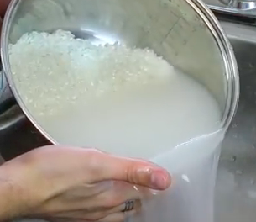

Method:

1. Rinse rice a couple of times to get rid of the most of its starch content.
2. Add 250ml of cold water and salt to rice. Bring to boil and cook for 12 minutes on medium heat. Turn off heat, place lid firmly on rice pot and let stand for 10 minutes.
3. 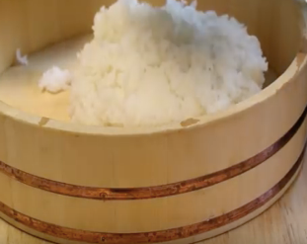When rice is cooked, gently turn out onto flat dish. Sprinkle with sugar and vinegar, spread out and leave to cool.
4. Peel and cut carrots into julienne strips.
5. Cut cabbage into thin slices.
6. Cut avocado also into thin slices.
7. 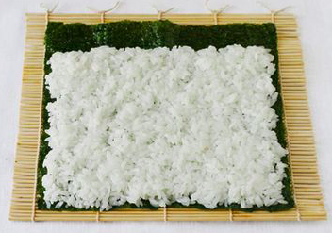Place Nori sheet onto bamboo mat. Make sure that the nori sheet is placed down with dull side up.
8. Wet hands and gently spread rice onto nori sheet, leaving 2cm of the far edge free.
9. In the middle place strips of vegetables.
10. 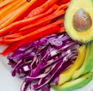To start rolling, lift the nori sheet with the bamboo mat just to flip it over for the start of the roll. Continue the rolling process.
11. Cut into even sized slices. Present with tiny dollop of wasabi, some pickled ginger and soy sauce.

**Sushi - Sensory Evaluation sheet**

Attribute: Appearance - shape



Attribute: Appearance - colourful



Attribute: Healthiness – range of food components included



Attribute: Presentation – plating and condiments



Comment on outcome’s fitness for purpose;

What can you do next time to make your sushi fit for purpose?

**RICE FESTIVAL FOOD**

[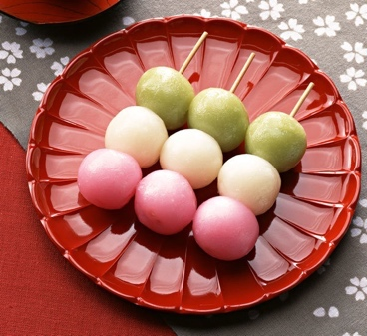](https://www.japancentre.com/en/recipes/693-three-colour-dango-dumplings)Three Colour Dango Dumplings [Japan Centre](https://www.japancentre.com/en/recipes/693-three-colour-dango-dumplings)

This is a chewy three colour dango recipe, a perfect finishing touch to a Japanese inspired afternoon tea.

**Ingredients**

160g Joshinko non-glutinous rice flour

40g Shiratamako glutinous rice flour

60g Sugar

200ml Hot water

5ml Matcha green tea powder

Red food Colouring

**Method**

1. Mix together the rice flour and sugar.
2. Add the hot water little by little, mixing well until the mixture takes on the consistency of play dough.
3. Cover the bowl and microwave for 3 minutes. Then knead the dough using a damp wooden spoon or damp hands.
4. Divide the dough into thirds.  Add the food colouring to one third and the matcha to another third.
5. This will leave you with three colours of dough. (If the matcha powder is too hard to combine, add a little water to the matcha powder to make a paste before mixing in).
6. Dampen your hands again and roll the dough into 6 evenly sized balls for each colour. Thread one of each colour onto a bamboo skewer and serve as a sweet treat.

**Tips and Information**

- If your mixture is a bit too crumbly after heating, just add extra hot water until becomes soft and bouncy again.

- You might be able to find the Joshinko non-glutinous rice flour in Asian groceries under the name of rice powder.

*Your effort here*

RICE FESTIVAL FOOD

Quick Rice Kheer (for two)

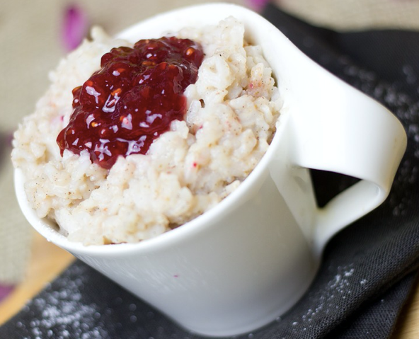**Ingredients:**

250ml Full milk

¼ cup cooked rice

50 ml condensed milk

2.5ml cardamom powder

1.25ml nutmeg powder

50g mixed roasted nuts (optional – used for garnishing)

**Method:**

1. Heat the milk in a non-stick frying pan.
2. Add the rice and mix well using a balloon whisk.
3. Add condensed milk and cardamom and cook for 2-3 minutes while stirring continuously.
4. Add the nutmeg and cook for another minute while stirring.
5. Scoop into two bowls and serve with roasted nuts. (Optional)

*Your effort here*

**RICE FESTIVAL FOOD**

[Rice Fritters for two](http://www.taste.com.au/recipes/rice-vegetable-fritters/d497d0e7-6a0e-4b2a-b44e-653372a4cf81)

**Ingredients**

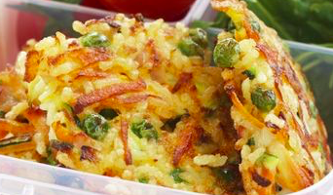100g Cooked rice

¼ Zucchini grated

¼ Carrot grated

50g Frozen peas

1 slice shaved ham, chopped

5ml Mint leaves, chopped

1 Egg, lightly beaten

**Dip**

10ml Light sour cream

5ml Sweet chilli sauce

**Method**

1. Combine eggs rice, zucchini, carrot, peas, ham and mint in a bowl. Season to taste with salt and pepper and mix well.
2. Heat oil in a frying pan and cook ¼ cup of mixture in batches for 2-3 minutes on each side until firm and golden. Repeat with remaining mixture. Drain on kitchen paper.
3. Meanwhile mix cream and chili sauce to serve as a topping or dip with the rice cakes.

*Your effort here*

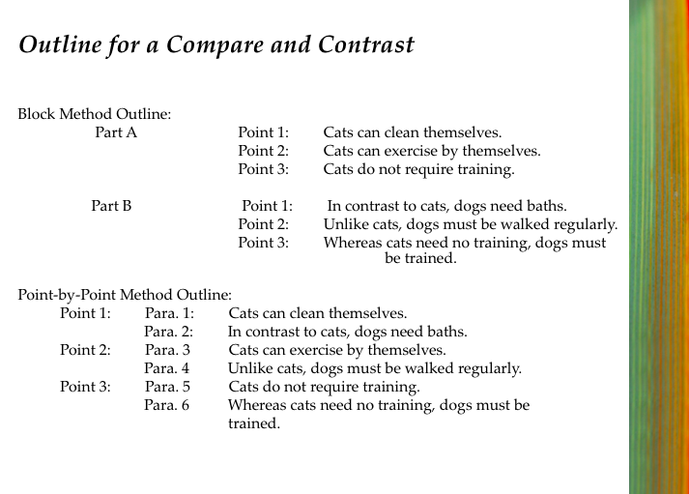Compare and contrast activity:

Use model to explain to students the strategy for writing compare and contrasting properly using either block method outline or point by point method outline.

Ref: CHERYL PYM, TESAC Conference October 2013, Scaffolding student thinking and learning Foods and Textiles Technology

**Poster instruction sheet: Possible rice festivals to investigate for making a poster**

**Japan:**

**Japanese moon festival:**

Is a time for introspection and gazing at the moon, a practice known as tsukimi. Again, rice-based dishes are a signature here, with tsukimi dango (rice-flour dumplings) enjoyed by one and all.

**O-Taue-Matsuri:**

Rice planting festival is held every June in the Taga Taisha shrine.

**India:**

**Makar Sankranti:**

This is the oldest and most colourful harvest festival in India. It is celebrated with bonfires, dances and snacks. The older woman cook food throughout the day. The people donate generously to the poor and needy. People take a dip in the Ganges River.

**Hindu’s Pongal festival:**

This festival is dedicated to the cycle of growing and harvesting rice. A sweet rice dish called ‘jaggery’ is served at breakfast.

**Nuakhai:**

Meaning ‘new food’. Popular for serving sweet pancakes.

**Nabanna:**

Celebrated in west Bengal. Rice is stocked in farmers’ homes. The first grains are offered to the goddess Lakshmi to thank her for all the blessings.

**Poster specifications**

* Pick a festival of your choice, then search information on the internet
* In pairs make a poster using your device. The size of the page should be A3
* Information on poster need to show:
* Name and region of the festival
* Significance of the festival
* Time of year of celebration
* Activities that are related to the festival
* Specific decorations and colours related to the festival
* Specific dishes prepared and eaten during festival
* Include many relevant pictures

Planting and Harvesting Rice

Three stages in the cultivation of rice

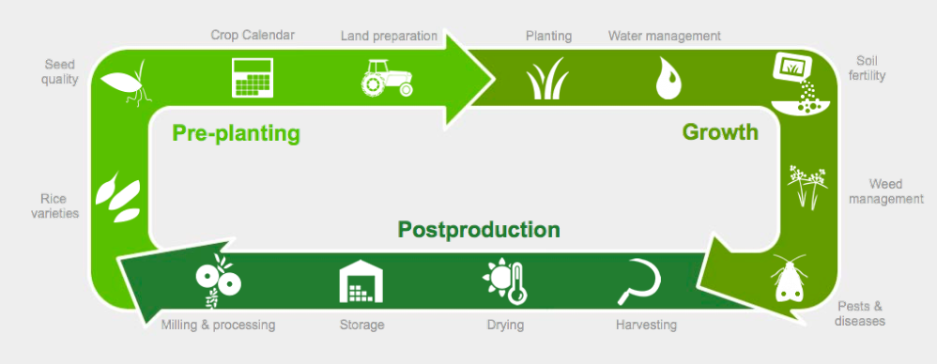

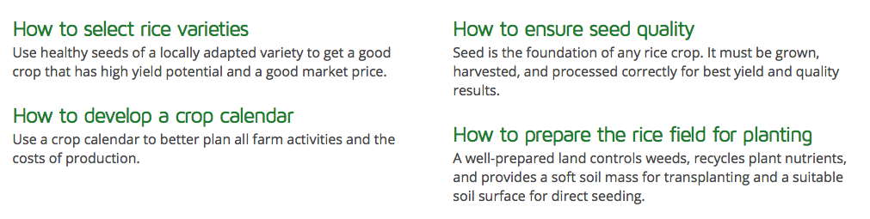Pre-planting

Growth

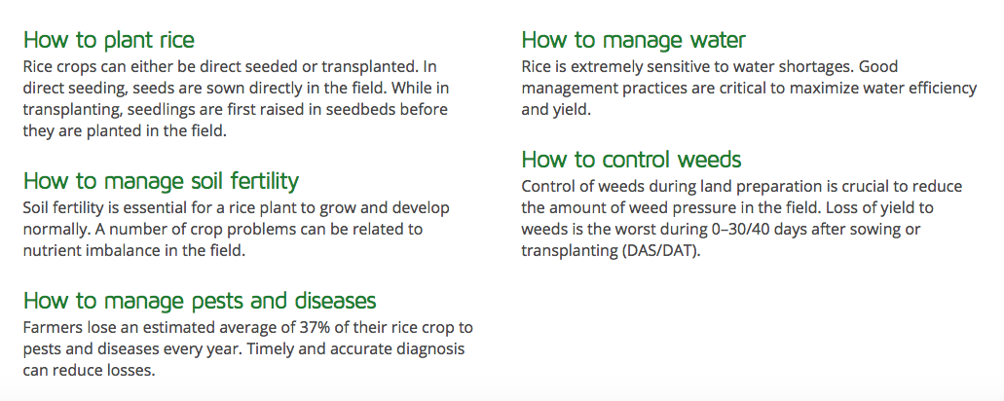

Postproduction

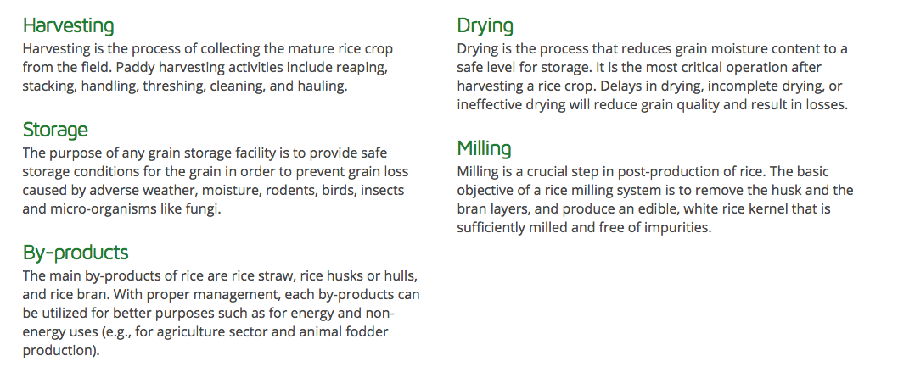

Ref: India Rice Knowledge bank, <http://knowledgebank.irri.org/rice-knowledge-for-india/india>

Student worksheet 3

Different types of rice

[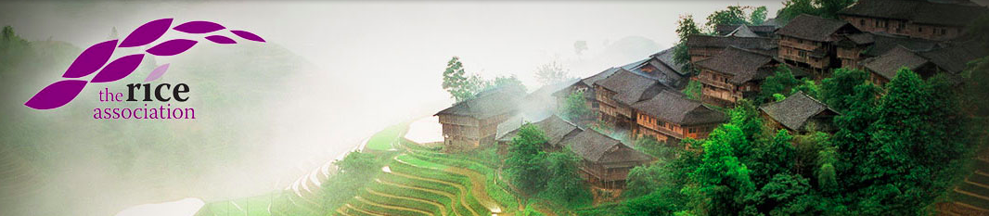](http://www.riceassociation.org.uk/content/1/10/varieties.html)

Facts about the different types of rice can be found on the website of the Rice Association. Click on the picture for the link.

**Rice varieties**

1. Which type of rice can be used for all types of cooking? ­­­­­­­­­­­­­­
2. Which type of rice is called ‘paddy’ or ‘rough’ rice?
3. Why is regular long white rice one of the most popular types of rice?
4. How is whole grain rice milled?
5. Why would brown rice be healthier than milled rice?
6. Name three types of speciality rice.
7. Which type of rice is known as the ‘prince of rice’ in India?
8. Which type of rice is slightly sticky when cooked?

Japanese Fried Rice for two

(Yakimeshi)

**Ingredients**

150g Cooked rice

30ml Mayonnaise

1 Slice Ham, diced

1 Egg

1 Spring onion

1.25ml Salt

15ml Oil

**Method**

1. Mix mayonnaise with cooked rice
2. Thinly slice spring onions and dice ham.
3. Heat oil in frying pan then add rice and fry for a few minutes.
4. Scoop out the rice and put aside.
5. Pour whisked egg into frying pan to make scrambled egg.
6. Add rice and ham and cook for another few minutes.
7. Add spring onion and salt, stir through and serve.

**Perfectly** **cooked rice**

**Ingredients**

200g Rice

2.5ml Salt

**Method:**

1. Rinse rice a couple of times to get rid of the most of its starch content.
2. Add 250ml of cold water and salt to rice. Bring to boil and cook for 12 minutes on medium heat.
3. Turn off heat, place lid firmly on rice pot and let stand for 10 minutes.

**Sensory evaluation for Yakimeshi**

Taste the yakimeshi made with three different types of rice:

Type of rice used for this dish

Evaluate the texture: too soft just about right too bouncy

Type of rice used for this dish

Evaluate the texture: too soft just about right too bouncy

Type of rice used for this dish

Evaluate the texture: too soft just about right too bouncy

Identify the rice variety of your choice:

Basmati Jasmin Brown rice

And the reason is?

Flash Cards

E.g.

|  |  |
| --- | --- |
| FRONT | BACK |
| IRON | Functions   1. Iron is an essential element for blood production. Red blood ‘Haemoglobin’ is essential for transferring oxygen in your blood from the lungs to the tissues. 2. Iron also is needed for proper immune function. 3. Prevents deficiency called anaemia. |

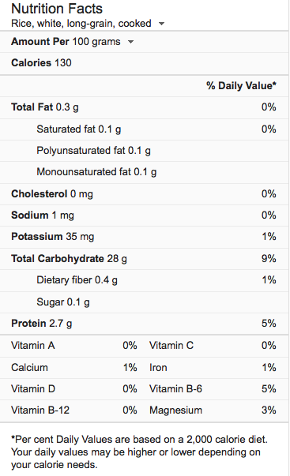Slide 4

Sample recipe for Nutritional recipe design:

**Masala Khichdi (****Rice and Moong Dal)**

This recipe will serve 2

Preparation time: 10 minutes.

Cooking time: 20 minutes.

**Ingredients**

80g Lentils (canned)

80g cup Rice

50g Green beans cut into about 1cm pieces

1 Carrot medium size washed peeled cubed

5ml Salt

1.25ml Turmeric (haldi)

40ml Clarified butter (ghee)

375ml Water for cooking

1 Tomato finely chopped

5ml Red curry paste

1.25ml Salt

5ml Ginger finely chopped

1 ½c water

¼c Natural yoghurt

**Method**

1. Wash rice changing water 3 to 4 times, drain the water.
2. In a medium sized saucepan add the rice, lentils, carrots, salt, turmeric, 20ml clarified butter and water. Bring to boil for 10 minutes. Put lid on saucepan, turn off the heat but leave on element for 10 more minutes.
3. In a second saucepan, heat the rest of the clarified butter over medium heat.
4. Add the ginger, chopped tomato, red curry paste and 62ml warm water. Season with salt and red pepper, stir.
5. Cook over medium heat until tomato is tender and mushy. This should take about 3 to 4 minutes. Turn down the heat to low.
6. Add cooked rice, mix gently, and add hot water slowly if needed because the khichdi should be like runny dough. Note: as khichdi cools it will become a little thicker.
7. Serve khichdi hot with yoghurt and Pampadam.

Nutritional code:

|  |  |
| --- | --- |
|  | Protein - Iron |
|  | Calcium, Vitamin B12 |
|  | Vitamin A |

**Peer assessment sheet**

Nutritional Rice Dish

Name of dish:

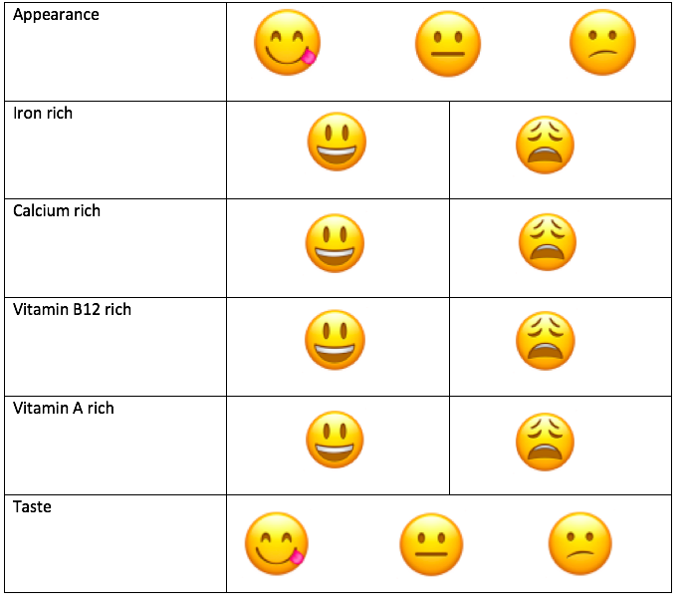

**Your guide to better** **chopstick etiquette**

* Do not stick your chopsticks upright in your rice. This is done when the spirit of a dead person is offered
* Do not leave your chopsticks crossed on your plate or bowl, or the table. This is seen as bad table manners
* Do not use one chopstick at a time, especially not to spear food
* Do not pass food from chopstick to chopstick because when people are cremated their bones are passed on from chop stick to chopstick
* Do not leave your chopsticks in your mouth while you do something else with your hands, like pick up plates or bowls
* Do not wash your chopsticks in your soup or in your beverage
* Do not use your chopsticks as toys, or pretend they are drumsticks and pound the table with them, or stick them in your mouth and pretend you are a funny vampire, or stick them up your nose
* Do not use chopsticks as hair accessories
* Do not rub your chopsticks together. Especially the wooden ones that you need to break apart
* Do not suck on your chopsticks
* Do not shovel food directly from your rice bowl into your mouth
* Do not take food from a communal plate with your own chopsticks
* Don't point at people or things with your chopsticks
* If you are supplied with chopstick rests, use them
* Don't let liquids drip from your chopsticks
* Don't stir your food around with your chopsticks

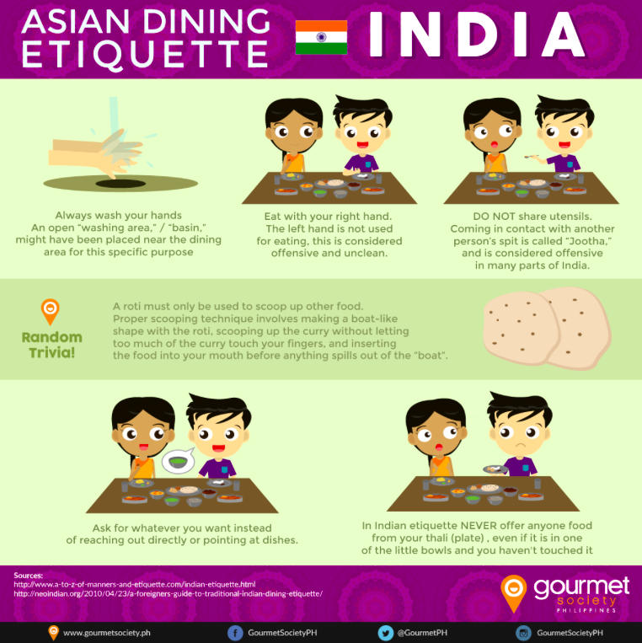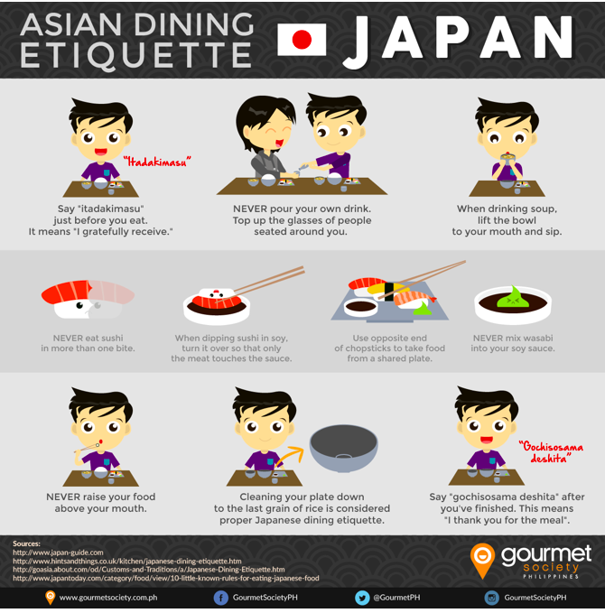

<http://justhungry.com/your-guide-better-chopstick-etiquette-mostly-japanese>

**Easy** **Butter Chicken (for two)**

* 200g Diced Chicken
* 25g Butter
* 1 Clove Garlic, crushed
* 2.5ml Turmeric
* 2.5ml Cumin
* 2.5ml Ground Nutmeg
* 1.25ml each Salt and Black Pepper
* 10ml Tomato Paste
* 2.5ml Garam Masala
* ½ Onion, chopped
* 62.5ml Cream
* 2.5ml Chilli Seasoning

### **Method:**

* 1. Mix together all the spices (except garam masala) and toss through the chicken.
  2. Melt the butter in a sauté pan.
  3. Add the onion and garlic and cook until soft.
  4. Add the chicken.
  5. Stir until golden.
  6. Add the tomato paste and garam masala.
  7. Stir in the cream.
  8. Season with salt and pepper and simmer for 5-8 minutes until rich and creamy.
  9. Serve with rice roti bread.

## [Rice flour roti](https://myheartbeets.com/rice-flour-roti/)

* 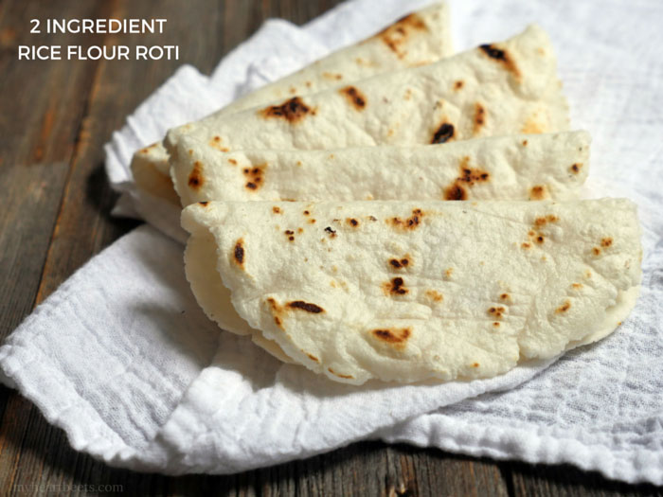Yield: 6 flatbreads

### **Ingredients**

* 250ml Water
* 200g Rice flour
* 1.25ml Salt
* Oil to grease hands

### **Instructions**

1. Bring the water to a boil in a medium sauce pan. Add salt, mix well, then add the rice flour and mix well. The mixture will look crumbly.
2. Turn off heat, cover the pot and let this sit for 10 minutes.
3. Add a little oil to your hands then knead the dough and form it into one large ball. Then break it off into 6 pieces.
4. Roll each piece of dough into a ball. Put a piece between two sheets of parchment paper. Roll it out using a rolling pin. Repeat with remaining dough.
5. Put the roti on a pre-heated non-stick skillet over medium heat.
6. Cook both sides until cooked through (a couple minutes per side).

|  |
| --- |
| ASSESSMENT |

Test Your Knowledge: Summative assessment

1. True or false

|  |  |  |
| --- | --- | --- |
|  | True | False |
| 1. Originally sushi rice was wrapped around raw fish for preservation purposes. |  |  |
| 1. Sushi restaurants are very popular in Japan. |  |  |
| 1. Brown rice is the healthiest type of rice. |  |  |
| 1. Vegetarian rice dishes are rich in Vitamin B12. |  |  |
| 1. In Asian countries it is common to greet people with the phrase “Have you eaten your rice today?” |  |  |
| Achieved | /5 | |

1. Paired comparison -

|  |  |  |
| --- | --- | --- |
| Column A | Write the answer here | Column B |
| Coloured rice |  | Fast food |
| Sushi |  | By- product |
| Rice straw |  | Good crop |
| Iron |  | Rangoli |
| Local healthy seeds |  | Anaemia |
| Merit | | /5 |

1. Discuss and explain the development of a mechanical sushi machine, focussing on the impact of society on the original design and future of the machine. (sushi robot)

Use the following guidelines to structure your discussion:

* Definitions
* History of sushi
* Traditions
* Fast food
* Speed and quality of product
* Future of this machine in the production of sushi

|  |
| --- |
| Answer question 3 here ‘Nature of Technology’ |
|  |
|  |
|  |
|  |
|  |
|  |
|  |
|  |
|  |
|  |
|  |
|  |
|  |
|  |
|  |
|  |
|  |
|  |
|  |
|  |
|  |
|  |
|  |
|  |
|  |
|  |
|  |
|  |
|  |
|  |
| Excellence /10 |

Test Total: /20

Solo marking sheet for assessing the ‘Nature of Technology’

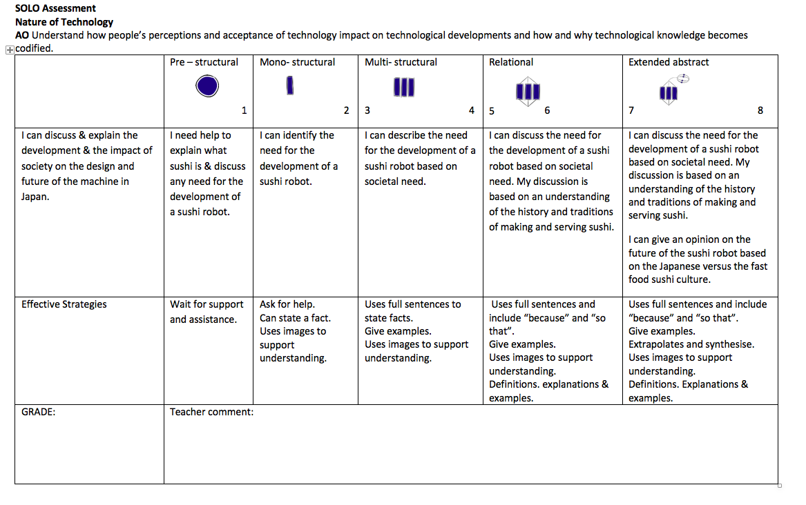

Answer to worksheets

Student worksheet 1

1. What would be the difference between employing a sushi chef or buying a sushi making robot instead?

Sushi made by the chef is custom in Japan and can be bought at sushi bars. This is a slow process and requires waiting. A sushi robot makes bulk amounts at a high speed. Sushi is displayed; customer chooses, picks up and pay. This makes for real fast food with no or little personal customer service.

1. Explain the experience of buying and eating sushi at a sushi bar in Japan.

Good customer/chef relationship; Feeling happy, content, appreciation; amazement at the skills of the chef. Learn more about sushi from the master e.g. the amount of soy sauce and wasabi to use.

1. In your opinion how well would sushi making robots fare in the food industry?

This depends on where the sushi is being sold. The bulk sushi we buy all look the same and this is what the mainstream consumer wants. Most new technology is trialled first as a prototype to see if it is fit for purpose. Sushi robots are now being sold world-wide so it is obviously effective as a tool that meets the need. However I do not think that it could be very popular in Japan because very little if any sushi restaurants exist in Japan. Here sushi is mostly sold in sushi bars, freshly made with seasonal produce by a highly qualified chef who takes pride in his work.

1. What is the character of the type of rice best suited for making Sushi?

It should be sticky.

Student worksheet 2

1. Comment on the personal health and safety rules of the chef.

He is wearing protective clothing.

1. Record the safe food handling rules that the sushi is following in this video.

* Knife blades pointing away from work area
* Food is kept in cooling cabinets. It is only taken out when needed then replaced immediately – no food left in the danger zone
* Chef wipes as he goes
* No rubbish left on workbench – discarded immediately

1. What are the two ways of shaping the rice for the sushi?

Rice is shaped with hands and some of the sushi have been rolled in nori sheets.

1. What makes this sushi special? (Two reasons)

Sushi is made by a chef.

Created with fresh seasonal produce.

Student worksheet 3

* 1. Which type of rice can be used for all types of cooking?

Long grain rice

* 1. Which type of rice is called ‘paddy’ or ‘rough’ rice?

Long grain rice

* 1. Why is regular long white rice one of the most popular types of rice?

It has a subtle flavour that perfectly complements most delicate and rich sauces.

* 1. How is whole grain rice milled?

It only undergoes minimal milling. In the process it is only the husk that is removed but not the bran layer.

* 1. Why would brown rice be healthier that milled rice?

Due to the low level of milling it has more vitamins, minerals and fibre than milled rice varieties.

* 1. Name three types of speciality rice.

Aromatics, risotto and glutinous rice varieties.

* 1. Which type of rice is known as the ‘prince of rice’ in India?

Basmati rice.

* 1. Which type of rice is slightly sticky when cooked?

Jasmine rice.

­­­­­­­­­­­Test your Knowledge

Question 1

Originally sushi rice was wrapped around raw fish for preservation purposes. T

Sushi restaurants are very popular in Japan. F

Brown rice is the healthiest type of rice. T

Vegetarian rice dishes are rich in Vitamin B12. F

In Asian countries it is common to greet people with the phrase “Have you eaten your rice today?” T

Question 2

Rangoli

Fast food

By product

Anaemia

Good crop

Question 3

Use guidelines and Solo criteria to assess question 3