Internal Assessment Resource

Subject Reference: Physics 2.2

Shinkansen of the
Next Generation:
SCMaglev

Supports internal assessment for:

Achievement Standard: 91169 version 2
Title: Demonstrate understanding of physics relevant to a selected context

Credits: 3

Teacher Guidelines
The following guidelines are designed so that teachers can carry out valid and consistent assessment.
A high level of familiarity with the outcome being assessed by Achievement Standard 91169 (Physics 2.2) is required. The achievement criteria and the explanatory notes along with the clarifications that can be found via nzqa.govt.nz contain information, definitions, and requirements that are necessary to understand when interpreting the standard and assessing students against it.
Context/Setting
This assessment is a guided research assignment. Students carry out research and using the information gathered and their knowledge of physics prepare a report describing the physics of the SCMaglev magnetic levitation transport system that is being built in Japan.
Conditions
Students carry out their own research and report writing (this must be performed individually). Research (suggested timeframe approximately 3 weeks) may take place outside the classroom but the conditions under which the report is to be written will depend on the resources available. Traditionally this has been carried out under supervised conditions during allocated class time of approximately 2 - 3 hours. However if appropriate check points throughout the research period are in place along with the use of a plagiarism checker such as turnitin.com it is possible that an electronic written report is completed out of class time.
The time allocated to the task will be decided by the individual assessor. It is crucial, regardless of the conditions under which the report is written, that the assessor can be sure of the authenticity of the students’ work.
The task requires a written report (which can include illustrations, diagrams, graphs etc) to be produced. The task could be modified to require other formats such as:
- poster presentation (including annotations or supporting notes)
- oral presentation (with written references)
- multi-media presentation (for example, a recorded video presentation or web page with embedded video, graphics, and text)
All sources of information, images, diagrams (anything not generated by the student) and data must be acknowledged and recorded in a traceable format (which means someone else could go straight to where the information came from). Non-text formats, for example, an oral presentation, must be supplemented by a written list of references.
Resource Requirements and Additional Information
Ensure students have access to a range of information sources, for example, physics textbooks, science magazines, science websites, Alpha resources, other Royal Society resources, and appropriate websites such as:
- https://en.wikipedia.org/wiki/Maglev
- http://www.explainthatstuff.com/linearmotor.html
- http://science.howstuffworks.com/transport/engines-equipment/maglev-train.htm
- http://www.circuitstoday.com/working-of-maglev-trains
- http://emt18.blogspot.co.nz/2008/10/maglev-propulsion.html
Note: Most websites do not teach physics and an understanding of the physics that is described is assumed. This means that the physics that the students will be expected to explain, in terms of this particular context, must either be taught by the teacher or self-taught by the student. This task assumes the physics has been taught.
If this is not the case, the student must be given adequate resources to enable them to teach themselves. The task would need to include specific instructions on how the student should acquire the appropriate learning.
Internal Assessment Resource
Achievement Standard Physics 91169 v2: Demonstrate understanding of physics relevant to a selected context
Resource reference: Physics 2.2 Credits: 3
Shinkansen of the
Next Generation:
SCMaglev

Achievement | Achievement with Merit | Achievement with Excellence
Demonstrate understanding of physics relevant to a selected context. | Demonstrate in-depth understanding of physics relevant to a selected context. | Demonstrate comprehensive understanding of physics relevant to a selected context.
Student Instructions
Introduction
Inadequate transportation capacity in the post WWII boom drove the development of Japan’s bullet trains, an integral part of the shinkansen system. Just before the 1964 Tokyo Olympics commercial operations began. Initially operating at a maximum speed of 200km h⁻¹ the 515km Tokyo to Osaka journey took 4 hours (previously 7 hours) but with subsequent speed increases this is consistently now a 2½ hour trip.

Constant improvement and innovation has led to the SCMaglev system- the next generation shinkansen. Relying on completely different technology it will eventually reduce the Tokyo to Osaka time to about 67 minutes.

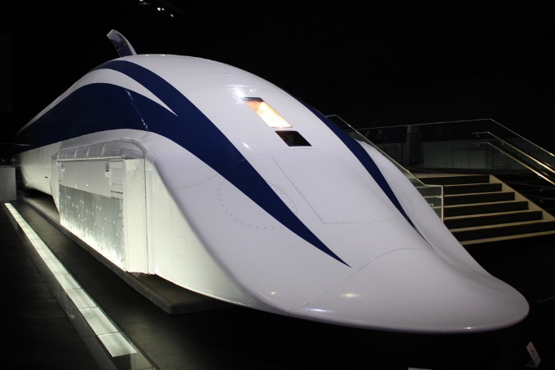
In 1821, the great English experimental physicist, Michael Faraday, first demonstrated the conversion of electrical energy into mechanical energy using the newly discovered concept of electromagnetism. Since then, Faraday’s electromagnetism experiments have revolutionised society and developed into the wide range of electric motors in use today.

The SCMaglev system is perhaps the most innovative application of Faraday’s discoveries and Japan’s latest contribution to a long history of science and innovation.
photozou.jp

Task
Working independently, you will gather information on the SCMaglev system. Using this along with your knowledge of the physics of electromagnetism you will produce a report that describes and explains the physics of the SCMaglev train system.
You will be given <insert details of the time that will be allowed for research> to carry out your research and produce your research materials (notes, photocopies, printouts, etc). You will then be given <insert number> periods of in-class supervised time to write your report <if applicable*>.
You may find it useful to use the template, Resource 1, which is given at the end of these instructions.
<if applicable*> All research materials should be brought to the report writing lesson and left with your teacher at the end of each session.
All sources of information, images, diagrams, and data must be acknowledged and referenced in a format that enables them to be easily traced.

The format of the report will be a written report. It must be written in your own words and should include the following information:
- The physics of the “motor effect”
- What a typical rotary electric motor is and how a linear motor differs from this (compare and contrast)
- The physics of the SCMaglev system and how it differs from traditional electric rail transport (the key differences)
- The advantages/disadvantages of the SCMaglev system
The report should be approximately three to four pages in length and may also include illustrations, diagrams and graphs, if appropriate.
All sources of information, images, diagrams, and data must be acknowledged and referenced in a format that enables them to be easily traced.
Your report will be assessed on how well you explain, integrate or link the relevant physics to the context of the SCMaglev transportation system.
The report will be written on <insert the dates of the supervised periods>. At the end of this time you should hand in your report and all research materials to your teacher.
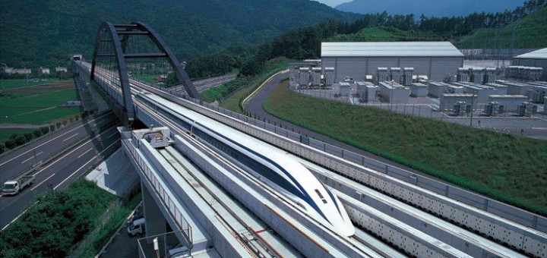
Resource 1: Research Processing Template
japantrends.com

Dot-Jot and Evaluate

Key Idea(s)/ Focus Question:
Source (website, newspaper, etc.):
Title:
Paste URL or write relevant bibliographic reference details here.
Author: Publisher:
Year of publication: Place of publication:
URL:
Dot-jot notes (highlight information in your research material, write the information as bullet points here, IN YOUR OWN WORDS):
Paste or write information from sources here. Try to include only what you need.

Write your summarised information here, in your own words, in paragraph form:
Summarise your new sentences here. Your summary should answer your question. If your planning template is multiple pages, it may be appropriate to write summaries of aspects of your research as you go or write your summary on the last page. When your summary is complete, ask your teacher for their feedback and signature. Keep this sheet as evidence of your research.

Dot-Jot and Evaluate

Key Idea(s)/ Focus Question:
Source (website, newspaper, etc.):
Title:
Author: Publisher:
Year of publication: Place of publication:
URL:
Dot-jot notes (highlight information in your research material, write the information as bullet points here, IN YOUR OWN WORDS):
Write your summarised information here, in your own words, in paragraph form:

Assessment Schedule AS91169 v2 (Physics 2.2): Shinkansen of the Next Generation: SCMaglev
Evidence/Judgements for Achievement | Evidence/Judgements for Achievement with Merit | Evidence/Judgments for Achievement with Excellence
The student correctly:  - Identifies and describes the characteristics of the physics related to SCMaglev  - describes how and/or why the physics applies to SCMaglev | The student correctly:  - identifies and describes in depth the characteristics of the physics related to SCMaglev  - provides reasons how and/or why the physics applies to SCMaglev | The student correctly:  - comprehensively identifies and describes the characteristics of the physics related to SCMaglev  - elaborates how and/or why the physics applies to SCMaglev  - justifies why the particular physics is well-suited to SCMaglev, and/or compares alternatives
For example, a student should: | For example, a student should: | For example, a student should:
Describe the physics of the motor effect | Explain the physics of the motor effect | Comprehensively explain the physics of the motor effect
Describe the difference between a linear motor and a rotary electric motor | Explain the difference between a linear motor and a rotary electric motor | Comprehensively explain the difference between a linear motor and a rotary electric motor
 | Discuss how the SCMaglev system differs from traditional electric rail | Discuss in detail how the SCMaglev system differs from traditional electric rail
 | Discuss the advantages and disadvantages of the SCMaglev system | Discuss in detail the advantages and disadvantages of the SCMaglev system
Identify and describe the main parts of the SCMaglev system:  - SCMaglev trains  - Superconducting Magnets  - Guideway Coils (for guidance, levitation & propulsion)  - Guideway Walls | Explain the function of the main parts of the SCMaglev system | Comprehensively explain the function of the main parts of the SCMaglev system

Final grades will be decided using professional judgement based on a holistic examination of the evidence provided against the criteria in the Achievement Standard

