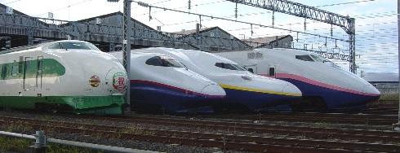
Momentum, Conservation of Momentum & Impulse Practice
Mechanics:
Japanese Rail & the Shinkansen
ρ _{before} = ρ _{after}
ρ = mv
Δρ = ρ_{f} - ρ_{i}

Δρ = FΔt

- Japan’s Shinkansen system includes several different versions of train. The 100-series trains consist of 16 steel cars that have a combined mass of 9.25 × 10⁵ kg. The top speed of a regular 100-series train is 220 km/h. What would be the momentum of one of these trains?

- A 15000 kg train engine traveling South at 13 m/s increases its velocity to 30 m/s. What is the trains:

  - initial momentum?
  - final momentum?
  - change in momentum?

- A freight train moves North with a speed of 8 m/s. The mass of the train is 6x10⁶ kg. How fast would a 1500 kg car have to be moving North to have the same momentum as the train?

- The high-speed 300-series Shinkansen trains consist of 16 aluminum cars with a combined mass of 7.10 × 10⁵ kg. The reduction in mass from the 100-series trains enables the 300-series trains to reach a top speed of 270 km/h. What is the magnitude of a 300-series train’s momentum at its top speed?

- A 42,000 kg train car travelling at 10 m/s toward another train car. After the two cars collide, they couple together and move along at 6 m/s. What is the mass of the second train car?

- At a test centre in Nagoya a 10,000 kg train car coasts at 10 m/s and collides with a 2000kg car which was coasting at 30 m/s in the opposite direction. If the stick together after the impact how fast and in what direction will they be moving?

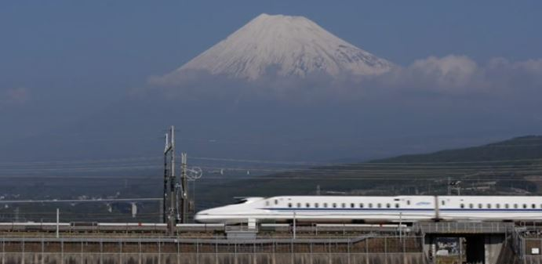
- Two train cars approach each other, one of mass 113 000 kg traveling at 1.20 m/s East, the other of mass 75 000 kg is traveling at 2.30 m/s West. After the collision, the two cars lock together. Calculate:
    - The momentum or each car
    - The total momentum of the cars before the collision
    - The total momentum of the cars after the collision
    - The velocity of the cars after the collision

- In a shunting yard a stationary flatcar of mass 4.0 x 10⁴ kg is rammed by an engine with a mass of 6.0 x 10⁴ kg and a velocity of 4.5 m/s. If they stick together, with what velocity will they continue to move at after the collision?

- A freight car with a mass of 6.0 x 10⁴ kg is rolling along a level track at 0.40 m/s, dragging a chain behind it. If the largest force that could be applied to the chain is 320.0 N, find:
  - How long would it take to stop the freight car
  - How far would the car move before it could be stopped (hint: use kinematics equations)

- Considering impulse discuss why it is more comfortable travelling in a train that takes longer to slow down and stop at a station compared to one that stops much more suddenly.

