Copy master 1 - Think, puzzle, explore
WALHT- Explore what we already know about Indonesia

What do you THINK you know about Indonesia? | What questions or PUZZLES do you have about Indonesia? | How can you EXPLORE this topic? Or what would you like to EXPLORE further?

Copy master 2 - World Map
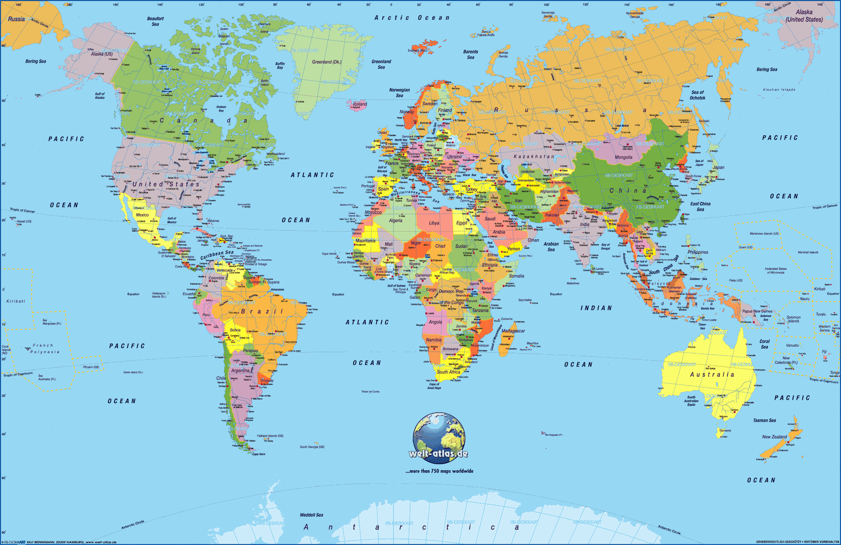
WALHT- Locate Indonesia on a map

Copy master 3 - Map of Indonesia
WALHT- Locate Indonesia on a map
Label: Bali, Banda Islands, Flores, Halmahera, Indian Ocean, Irian Java, Java, Kalimantan, Lombok, Pacific Ocean, South China Sea, Sumatra, Sumba, Sumbawa, Sulawesi, West Timor. Colour the land and the oceans.
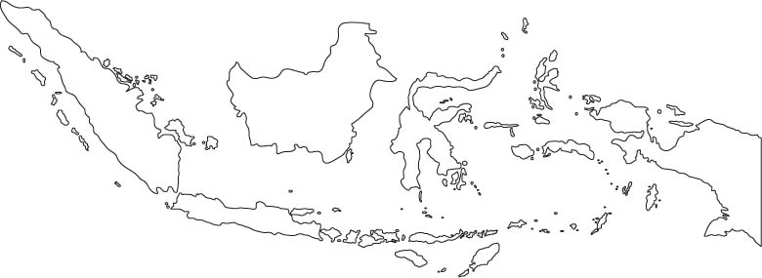

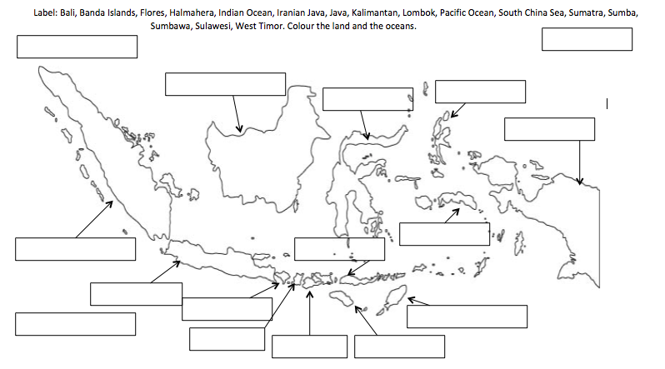
ANSWERS
West Timor
Sulawesi
Sumbawa
Sumba
Sumatra
South China Sea
Pacific Ocean
Lombok
Kalimantan
Java
Irian Jaya
Indian Ocean
Halmahera
Flores
Banda Islands
Bali

Copy master 4 - Island Life
WALHT- Compare how Island life is different to our daily life
Life in Indonesia
Children who live in the main cities in Indonesia lead very different lives that children who live in the rural or country areas. Those children who live in the main cities go to school, do homework, watch cartoons, go on holidays, play computer games, use smart phones and listen to music. However children from rural areas go to school then once they are home they help with numerous chores includes: Gathering water, helping on the farm and watching their younger siblings.
Two thirds of the Indonesian population are farmers, the farmers and most Indonesians live in villages called desas. Many of these villages have traditional houses, but they are raised on stilts about six feet off the ground. They use the space underneath to keep cattle or chicken and store firewood and farming tools. The houses are usually made of timber or bamboo. Some ethnic groups build large communal houses, which hundreds of people live in, kind of like a New Zealand marae but a bigger scale. Although most villagers still enjoy their traditional life they are also beginning to embrace some new modern practices for example: Listening to the radio, shopping in nearby towns and sending their children to schools.
Outside of the villagers in the cities, people live in western-style houses and apartment buildings, the larger cities like Java have busy streets, business districts, shopping areas and even skyscrapers! There are even movie theatres in larger cities and American and European movies are shown with subtitles in Bahasa Indonesian.
For day-to-day clothing women would usually wear long-sleeved shirts with a sarong or kalin, women also wear a shawl over their head or shoulders, but Muslim women do not have to cover their faces. A traditional Indonesian dress includes a colourful skirt which is called a sarong or kalin, it is made using a strip of cloth wrapped around the body, a sarong is not sewn in place but a kalin is. Men wear special hats. In the cities people usually dress similar to westerners.
Over 85% of Indonesians are Muslims, with a small percentage of Christians and Hindus. Although in the past Buddhism and Hinduism were once important religions on many islands, they are no longer practiced today. In comparison to other Muslims around the world, Indonesian Muslims tend to follow the religion less strictly than others as the combine the faith of Islam with ancestor worship or nature worship.
Another interesting fact is almost everyone in Bali has their teeth filed down, they believe that doing this can prevent anger, confusion, jealously, drunkenness, desire and greed.
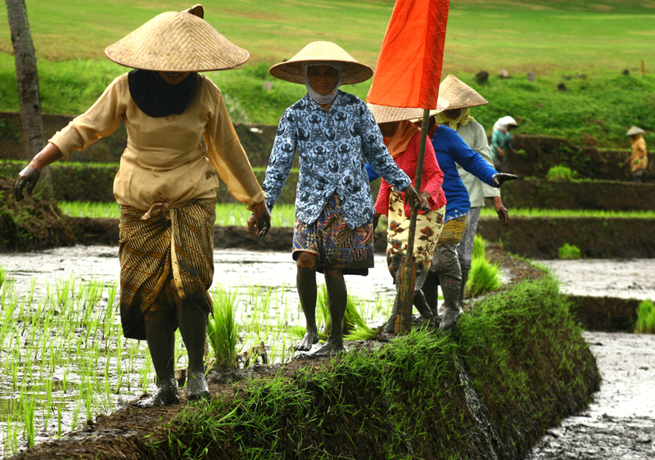
A great deal of the farmers in Indonesia grow rice, they began growing rice in the 7th century. On average every Indonesian eats more than 125kg of rice every year! That is more than 15 times as much as Americans eat and twice as much as Japanese people.
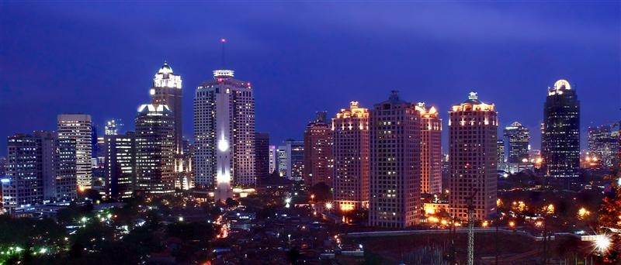

Copy master 6 - Island Life - Venn diagram
WALHT- Compare how Island life is different to our daily life. Using the information that you have read about island life in Indonesia, complete this Venn diagram to show how our life is similar and different. In the middle where the circles meet you will write the aspects that are the same, in the left circle you will write the aspects that Indonesians do differently and in the right circle you will write what we do that is different. You may need to do some further research.
New Zealand
Indonesia
Same
Copy master 4 - Identify Indonesian Animals
WALHT- Identify common animals found in Indonesia
WALHT- Describe simple facts about these common Indonesian animals

QR Code | Picture | Name | Question
 | 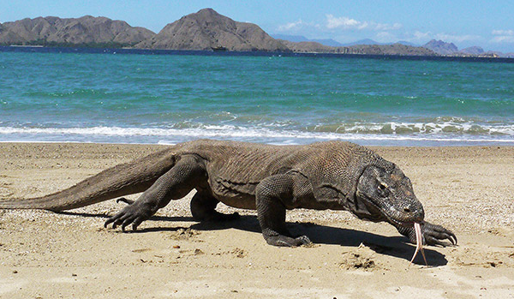 |  | How big can it grow to? Weight and Length  What movie did this creature inspire?
 | 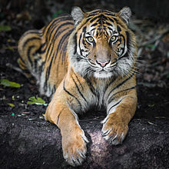 |  | How many approximately are left?  Name a park in Indonesia where you can see a large number of them
 | 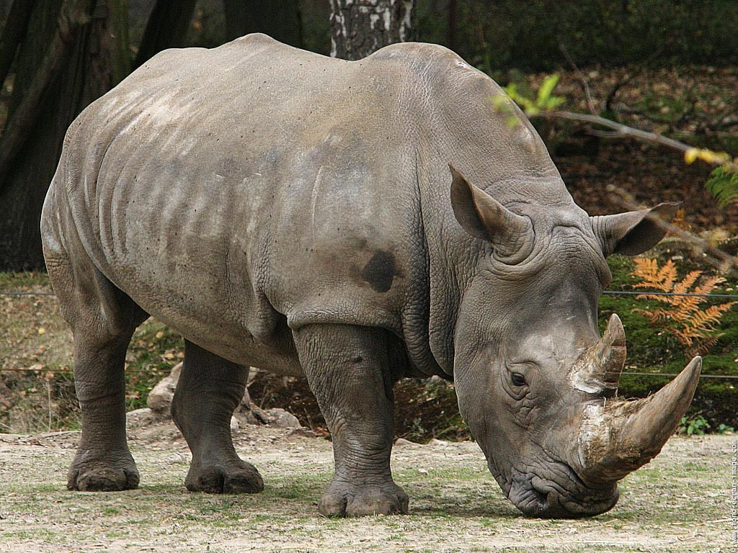 |  | How many approximately are left?  Where do they spend most of their day?
 | 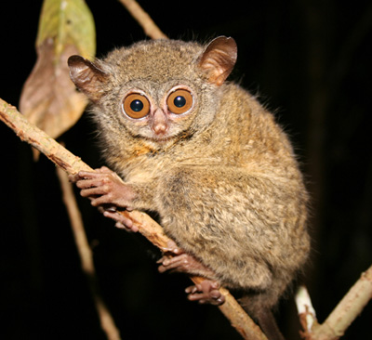 |  | How big can it grow to? Weight and Length  How far can their head rotate?
 | 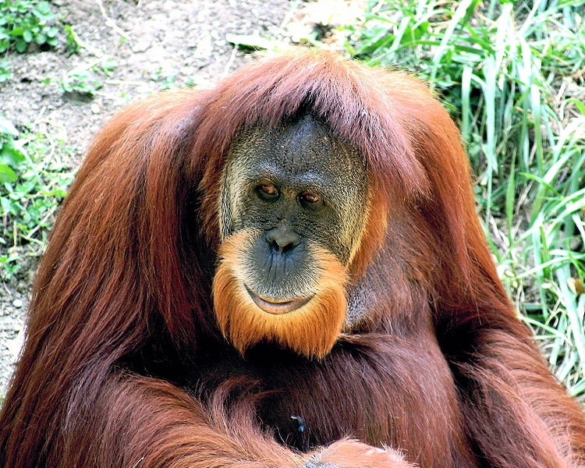 |  | What did some people used to do with these animals?  What is the name of the other orang-utan found in Indonesia?
 | 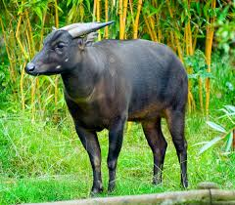 |  | What is this animal’s nickname?  What are they hunted for?

Copy master 4 - Identify Indonesian Animals ANSWERS
WALHT - Identify common animals found in Indonesia
WALHT- Describe simple facts about these common Indonesian animals

QR Code | Picture | Name | Question
 |  | Komodo Dragon | How big can it grow to? Weight and Length  L- Max 3m (10ft) W- 70kgs (150lb)  What movie did this creature inspire?  King Kong
 |  | Sumatran Tiger- The King of tigers | How many approximately are left?  As few as 400 today  Name a park in Indonesia where you can see a large number of them  Kerinci Seblat National Park or Gunung Leuser National Park
 |  | Sunda Rhinoceros or Javan Rhinoceros | How many approximately are left?  Between 37 and 44  Where do they spend most of their day?  Wallowing in mud holes
 |  | Tarsius Tarsier or Spectral Tarsier | How big can it grow to? Weight and Length  W- 102 and 114 grams L- 9.5-14cm  How much is their head able to rotate?  Almost 360 degrees!
 |  | Sumatran Orang-utan | What did some people used to do with these animals?  Captured in the wild and kept as pets in homes  What is the name of the other orang-utan found in Indonesia?  Bornean Orang-utan
 |  | Anoa | What is this animal’s nickname?  Midget buffalo  What are they hunted for?  Hunted for hide, horns and meat.

Copy master 7 - Festivals
WALHT- Express our ideas about what represents a festival or celebration
Waisak Day
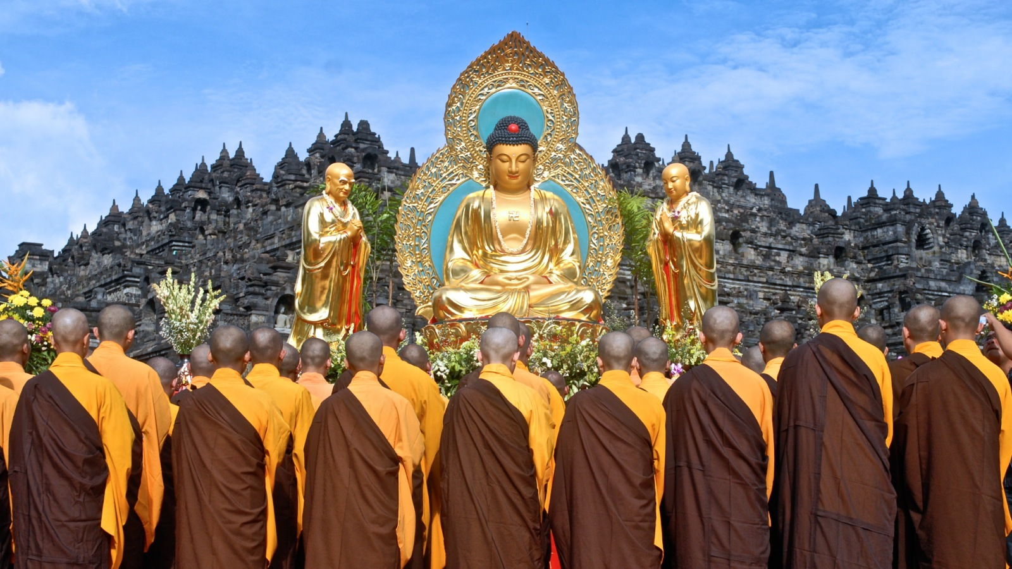

Independence Day

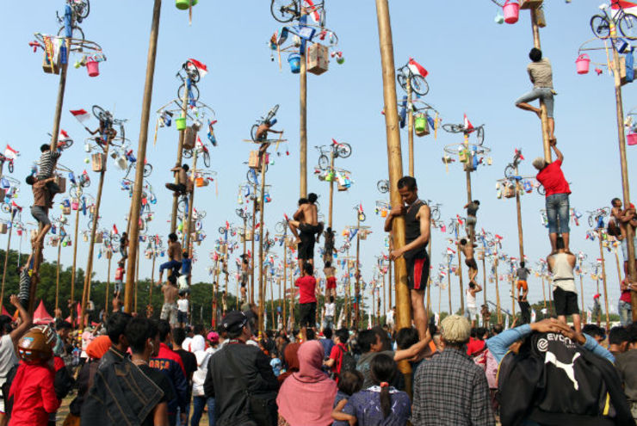
The Holy month of Ramadan
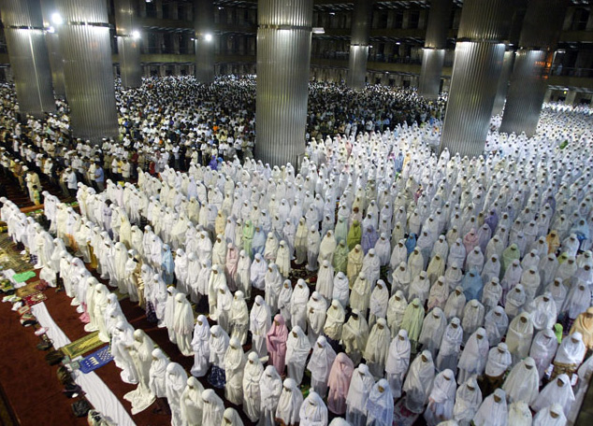
Islamic New Year
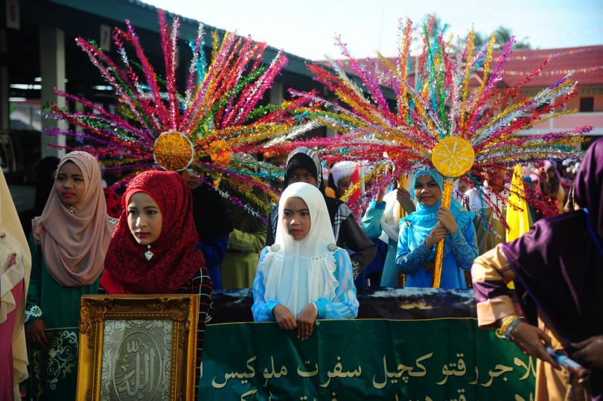

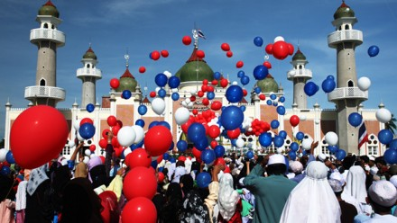
Eid-al-Fltr

Copy master 8 - Social etiquette
WALHT- Describe how culture effects the way we act.
Shake hands and give a slight nod when meeting for the first time. Shake an Indonesian’s womans hand only if she initiates the greeting.
Standing with hands on hips can signal anger or a threat.
The guest of honor or senior person begins the meal; this is a distinct honor. If you are asked to begin the meal, you should refuse twice and then begin.

Looking someone straight in the eyes is considered staring. Avoid prolonged eye contact, which may be viewed as a challenge and may cause anger.

The left hand is considered unclean. Do not touch food, pass, or receive anything, touch anyone or point with your left hand.
Never refuse food or drink, but never finish either completely. Compliments about food are appreciated.
Avoid showing the soles of your shoes while seated- it is considered an extreme offence. Keep both feet on floor when sitting and do not cross your legs. Sitting with good posture and both feet on the floor is a sign of respect.
The head is viewed as the most sacred body part, so avoid touching or passing any object over someone’s head. Do not touch a person’s head.
Taken from: http://www.ediplomat.com/np/cultural_etiquette/ce_id.htm

Copy master 9 - School life in Indonesia
WALHT- Discuss how schools in Indonesia are different and similar to New Zealand schools
In Indonesia children begin attending school at age seven and usually attend for 9 years until they are 16 years old.
Primary and intermediate schooling costs a small fee. Nearly all children attend primary school. About half of the children attend intermediate school and only a third go on to high school. Many children in rural areas will drop out to help their families on the family farms.
In the whole of Indonesia there are 50 public and private universities but only 4% of the population receives a college education.
Before 1947, public education did not exist. Up until that time, families that wanted their children to attend a school had to pay for private education.
School hours vary across schools but generally they must attend five or six days a week, from 6:30am until 2 or 3pm, with two breaks lasting fifteen minutes to half an hour each (about 40 hours in total across the week).
The teaching style is quite different in Indonesia, teachers usually do not ask individual students questions, they rather read something out and pause at an appropriate time for students to fill in the gap. For example, the capital of New Zealand is…. And students would call out responses rather than the teacher singling out a student.
The subject areas available at high schools reflect the huge agriculture and farming industry in Indonesia, the subjects taught come under these main areas: Technology and engineering, health, arts, craft and tourism, information and communication technologies, business management, agro-business and agro-technology.
In many remote areas of the Outer Islands, there is a severe shortage of qualified teachers, and some villages have school buildings but no teachers, books, or supplies.

Children stay at school and either take a lunch box or buy their lunch at the cafeteria. Food is also offered for children by vendors in front of many public schools. Private schools normally do not allow children to go out of the school area during lunch breaks. Children are not allowed to return home for lunch. Some international schools and other schools provide lunch for children.

Some Indonesian kids have to navigate across dangerous jungles rivers with giant barges, invisible logs, tricky currents, crocodiles and poisonous snakes to get to school. Reporting from Teluk Meranti, John M. Glionna wrote in the Los Angeles Times, “They're equatorial Huckleberry Finns, two wild-hearted boys guiding an old wooden fishing boat along a wide and mighty river." [Source: John M. Glionna, Los Angeles Times, October 31, 2009 <>]
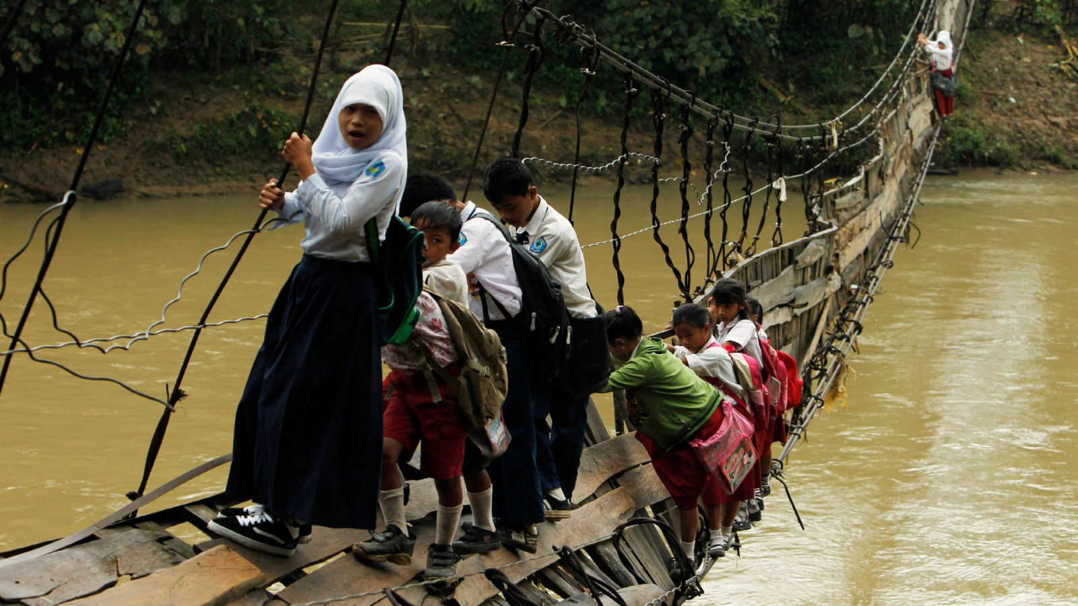
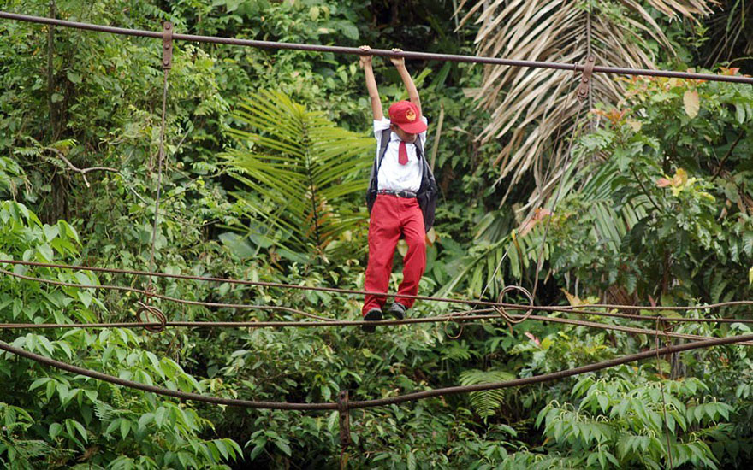

Copy master 10 - Same/Different
WALHT- Discuss how schools in Indonesia are different and similar to New Zealand schools
Complete this table to demonstrate what is the same in an Indonesian school and what is different, think about teachers, age you go to school, hours you attend, transportation to school, costs etc.
Same | Different

Copy master 11 - PMI

Positives  What are the aspects you have enjoyed learning about during this unit? | Minuses  What are the aspects you haven’t enjoyed so much, or could be done differently? | Interesting  What did you find interesting that you didn’t know?

Copy master 12 - Final Assessment
Using your knowledge of everything you have learnt about Indonesia in the unit so far, complete this Venn diagram to show what you recall that is the same and what is different to New Zealand. Remember to think about animals, climate, location, schooling, social etiquette and festivals.

Indonesia
New Zealand
Same

Copy master 13 - Assessment Rubric for Travel advertisement

Name of students:
CATEGORY | 3 | 2 | 1
Content- Accuracy | All facts in the advertisement are accurate. | 99-90% of the facts in the advertisement are accurate. | Less than 89% of the facts in the advertisement are accurate.
Attractiveness and organisation (print ad only) | The advertisement has exceptionally attractive formatting and well-organized information. | The advertisement has attractive formatting and well-organized information. | The advertisement's formatting and organization of material are confusing to the reader.
Posture and eye contact during presentation of advertisement | Stands up straight, looks relaxed and confident. Establishes eye contact with everyone in the room during the presentation. | Stands up straight and establishes eye contact with everyone in the room during the presentation. | Sometimes stands up straight and establishes eye contact.
Use of class time | Used time well during each class period. Focused on getting the project done. Never distracted others. | Used time well during each class period. Usually focused on getting the project done and never distracted others. | Did not use class time to focus on the project OR often distracted others.
Content | Shows a full understanding of the topic. | Shows a good understanding of the topic. | Does not seem to understand the topic very well.

Total: /15 for visual advertisement

Total: /12 for other advertisement

Copy master 14 - Travel advertisements
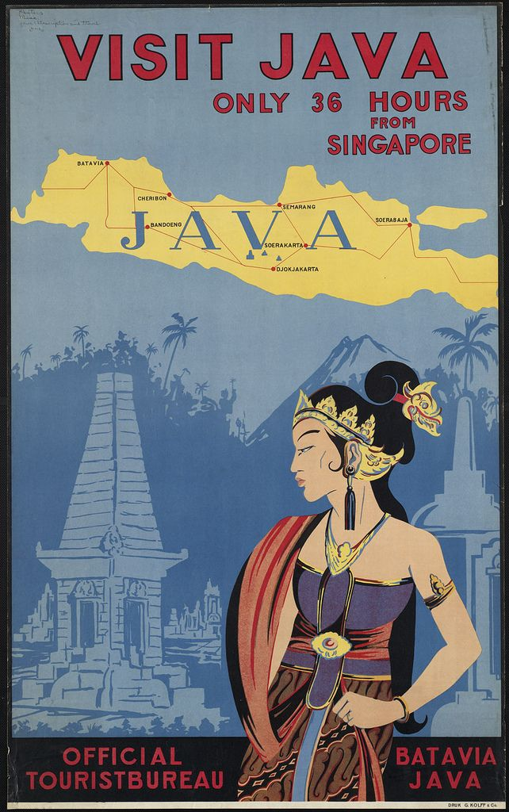

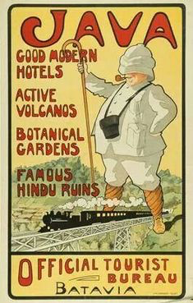

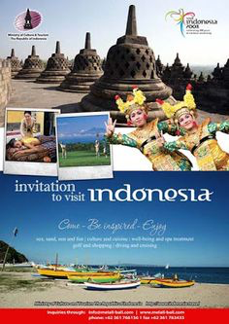

Copy master 15 – Pictures for hook into unit
