My Travel Advertisement for Indonesia

Name:

Task 1
WALHT- Identify features of different types of advertisements.

The first aspect you need to decide is what sort of advertisement you will do. There are usually 3 different types of advertisements, a print magazine/flyer ad, radio ad and a television ad. Weigh up the positives and negatives of each one. Think about what will suit you, your strengths and personality.

 | Positives | Negatives
Magazine/Flyer/Print ad | E.g. Bright coloured visually appealing | E.g. Not many people look at print these days
Radio ad
Television ad
Other E.g. Internet ad, Instagram post etc.

We have decided to do a………………………………….. Advertisement

We decided to do this type of advertisement because:

So far our ideas in our head are:
(Note down colours, themes, pictures, slogans etc.).

WALHT- Construct a slogan for your type of advertisement.
Task 2

Research what a slogan is and some examples of slogans. Try to include some examples related to travel. Include what you have found in the box below.

Now you need to come up with your own slogan, make sure it is suited to the type of advertisement you have chosen. You may need to do some further research on Indonesia to assist you with choosing a slogan. Write your slogan below.

WALHT- Examine Indonesian travel advertisements.
Task 3

Look online for example advertisements for your chosen product. What features do they include other than a slogan? What else do you need to consider that you haven’t already? How else will you encourage your audience to travel to Indonesia? Note down your findings in the box below. (Use copy master 14)
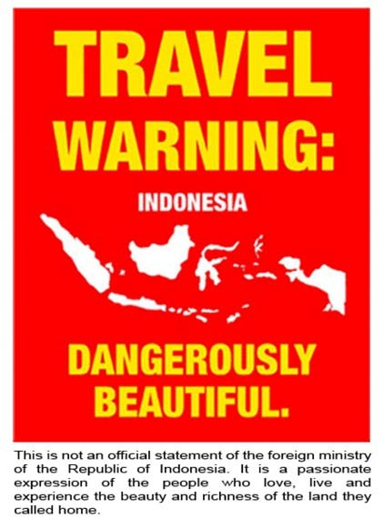
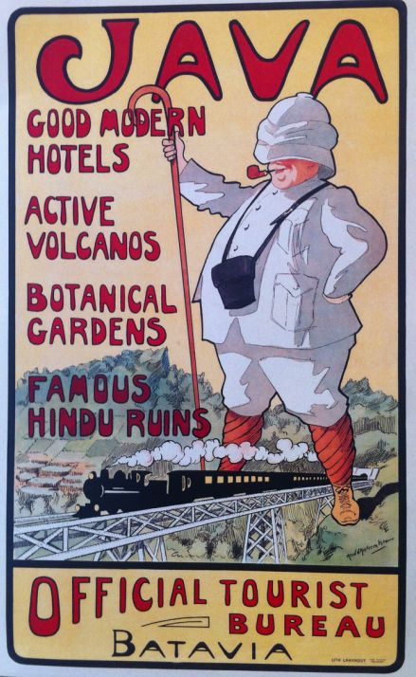

Task 4
Time to start drafting! Thinking about everything you have learnt about Indonesia so far, and what you would like to include in your advertisement, it’s time to start a draft. If doing a print advertisement you can draw up your draft below. If doing a radio or TV advertisement you can write your ideas for a script below.

Developing your final product.
Task 5

Now it is time over the next few lessons to make your final product, once your draft has been discussed with your teacher you can get started on the final product.

Some ideas for tools you can use if developing a print based advertisement are:
Microsoft Word, Microsoft Publisher, Microsoft PowerPoint, Google Docs, Google Slides or Online based- Canva.

If you are creating a radio or TV ad you may wish to use: iMovie, Garage band, Photo booth, or a camera-recording device and then edit in iMovie.

Remember you want to entice your audience to visit Indonesia, your audience is New Zealand residents. What will engage them to want to travel there?

Present your final product to the class, afterwards ask your classmates for some feedback on your product, what they liked and aspects you could improve further.
Task 6

Once you have presented, complete this self-reflection individually.

 | Faces | Comment
I worked well with my buddy
I learnt some new information about Indonesia that I hadn’t learnt with the teacher
I used my time effectively in class
I am happy with my final product
I learnt some new skills e.g. Using iMovie
My advertisement engages NZ residents to travel to Indonesia

Choose at least 3 of the reflection questions and write your answers in the space below:
Reflection
- How do you feel about your advertisement?
- What parts of it do you like/dislike?
- What did you find frustrating in the process?
- One thing I would like to improve upon is…..
- What was especially satisfying to you about either the process or the final product?
- What would you change/do differently if you had the chance to do this product again?
- What is one goal you would set yourself for next time?

