Name of researcher: _________________________

Your research brief …
You have been told that you will be going on a trip to China for three days and that all expenses will be paid for you.
You need to decide where you are going to go, what you are going to do there on each of the three days that you are there, how much it will cost and why it is the best go.

Stage One: Deciding
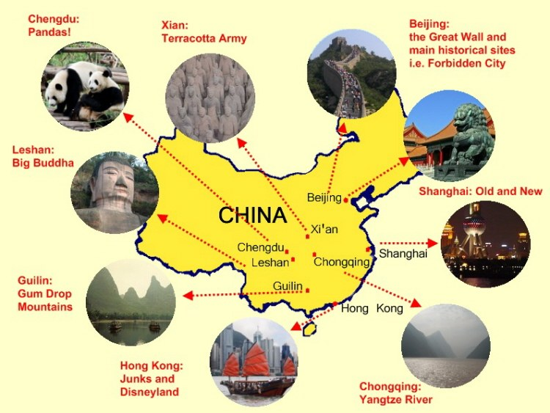

The two cities that I am most interested in are;

- _______________________________

- _______________________________

Comparing the two cities

City 1: | City 2:

I have chosen to investigate _______________ (name of city) because:

What prior knowledge do you already have about this city?

IALHT identify a specific area that I am interested in studying.

I will be successful when I can:
- Talk about the topic that I am going to be researching
- Can list at least three things that I already know (or think that I know) about my topic
After you have finished this stage, meet with your teacher BEFORE going to the next stage

Stage 2: Questions
Brainstorm possible questions that you will need to find out?

My research questions are:
- ______________________________________________________________________________________________________________________

- ______________________________________________________________________________________________________________________

- ______________________________________________________________________________________________________________________

- ______________________________________________________________________________________________________________________
IALHT write clear questions to guide my research

I will be successful when I can:
- Write four questions that I don’t already know the answer to
After you have finished this stage, meet with your teacher BEFORE going to the next stage

Stage 3: Things to do
Below list things that tourists can do in the city you have selected.

Which of these interest YOU the most and why?
- _______________________________________________ because

________________________________________________________

- _______________________________________________ because

________________________________________________________

- _______________________________________________ because

IALHT write find activities that interest me

I will be successful when I can:
- Talk about why I am interested in the activities I have selected
After you have finished this stage, meet with your teacher BEFORE going to the next stage

Stage 4: Investigating activity
Record relevant information about the first activity you have selected. You might want to think about how long it will take, the cost, the location, why it is interesting.

Activity 2
Record relevant information about the second activity you have selected. You might want to think about how long it will take, the cost, the location, why it is interesting.

Activity 3
Record relevant information about the third activity you have selected. You might want to think about how long it will take, the cost, the location, why it is interesting.

IALHT collect information that relates to my research

I will be successful when I can:
- Use the internet and at least one other source of information for my research
- Use my own words to take notes that I can read and understand
After you have finished this stage, meet with your teacher BEFORE going to the next stage
Stage 5: Flight information
Look at the flights and dates to your destination. Find out which flight you would take to China and then back to New Zealand. If it is more than one flight, you will have to work this out to.
Create your itinerary:

IALHT gather information from websites

I will be successful when I can:
- Find flights that will get me to and from my destination
- Record the total price for the flights
After you have finished this stage, meet with your teacher BEFORE going to the next stage

Stage 6: Making an itinerary
Decide on the order and timing of your three attractions.
Create your itinerary:

IALHT collate information I have found

I will be successful when I can:
- Find flights that will get me to and from my destination
- Record the total price for the flights
After you have finished this stage, meet with your teacher BEFORE going to the next stage

Stage 6: Reflecting

How do you feel about this piece of work?
What parts of it do you particularly like? Dislike? Why?
What was especially satisfying to you about either the process or the finished product?
What did you find frustrating about it?
Have you changed any ideas you used to have on this subject?
One thing I would like to improve upon is ...
What would you change if you had a chance to do this piece over again?
As you look at this piece, what's one thing that you would like to try to improve upon?
What's one goal you would like to set for yourself for next time?

Chooses at least three of the reflection questions above and write the answers to them in the space below

