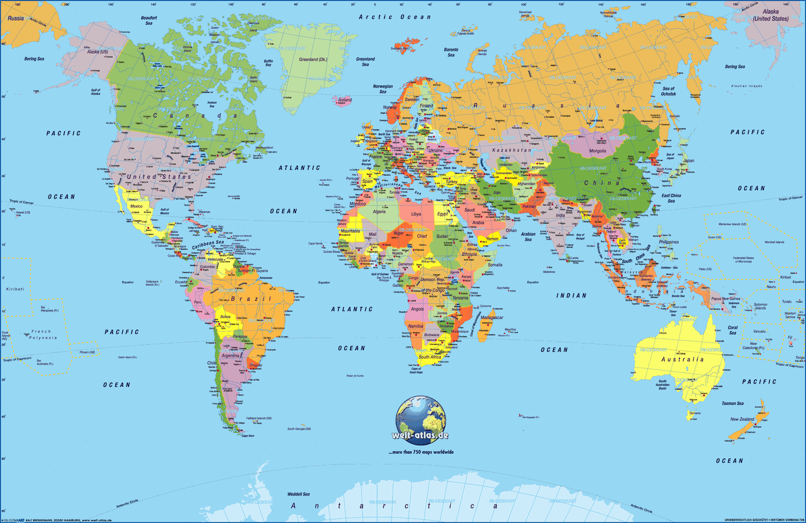
Copy Master 1: World Map
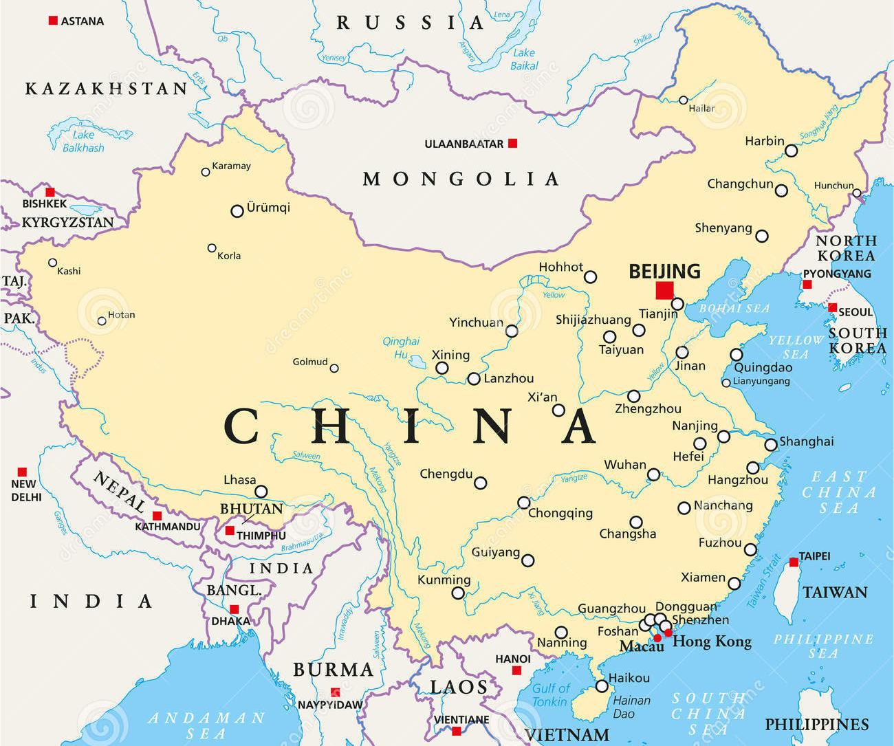
Copy Master 2: Map of China
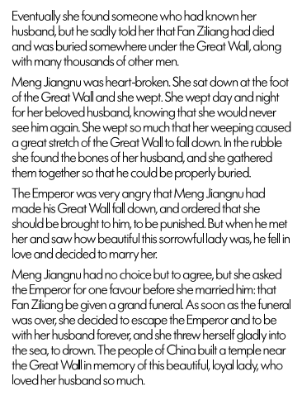
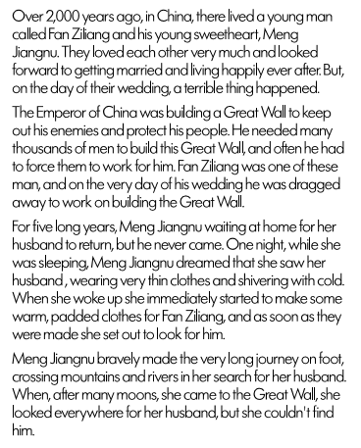
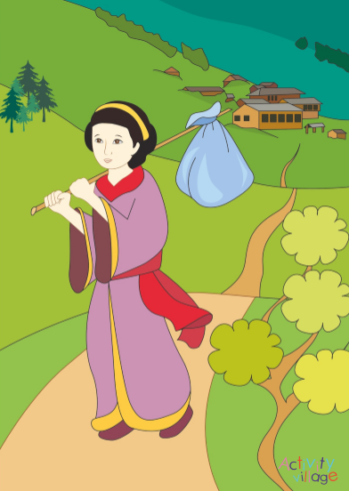
Copy Master 3: Meng Jiangnu Weeps

Copy Master 4: True or false
 | This is what I though before | This is what I found out after reading
It is the longest structure that was made with many expensive machines.
The Great Wall was built 500 years ago.
It remains as perfect as when it was first built.
The Great Wall was built to protect China from enemies.
It is visible from the moon.
The Great Wall stretches around all of the outside borders of China.
It is one of the seven new wonders of the world.
The Great Wall is one long continuous wall

Fun facts that could be true or could be false
 | My buddies name | Buddies decision; True or false? | Are they correct?

Copy Master 5: The Great Wall of China

The Great Wall of China
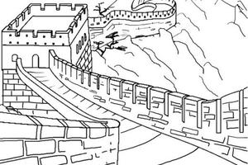

The Great Wall of China is a very old wall made of stone. It is the longest structure that people have ever built. The Great Wall is 4.5-9 meters wide and up to 7.5 meters high. At one point the wall may have measured more than 8,000 kilometres long but it is so old that many parts of the wall have broken and disappeared. The great wall was build more than 2,000 years ago to protect northern China from enemy attacks. It aimed to keep invaders from entering China. The Great Wall is not one long continuous wall, rather it is made up of a number of different sections. These sections were built by various dynasties over a long period of time. Watch towers and fortresses were built along the wall often on hilltops or other places with a long, clear view. These watch towers could be used to signal danger from a long way away. During the night, guards could light fires or lanterns that would shine brightly in the dark. During the say they could make smoke signals.
Today the Great Wall is no longer used to keep out enemies. Only about one-third of the original wall is still standing today. People come from all over the world to see it. Some people claim that The Great Wall is visible from the moon, however, this is not true. It is barely visible from 100 miles in space under perfect viewing conditions. It is one of the seven new wonders of the world.

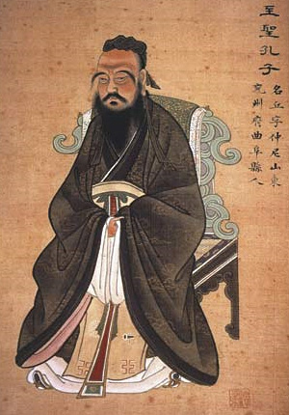
Copy Master 6: Portrait of Confucius

Copy Master 7: Information about Confucianism

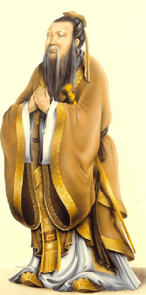
In 551 B.C., a man by the name of Kongzi was born to a poor family in the province of Shandong. Kongzi is known in the Western world as Confucius.
Confucius saw many problems in the world. He wanted to help to change the world for the better. In order to get into a position of influence, Confucius set out as a teacher.
The most important things to Confucius were peace and order. He felt that everyone had a proper role in society, and that if people were willing to accept their role and fulfil it, that peace and harmony would thrive.
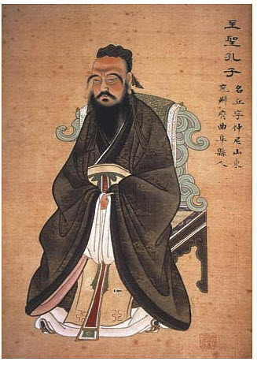
In order to help people accept their roles in society and establish order, Confucius laid out what he called ethics. These ethics outlined how individuals should treat one another. The most important of these ethics was the responsibilities of children to respect and listen to their parents and other elders.
He also shared ethics about how people should follow rulers, for how rulers should treat the people, how husbands and wives should treat one another, and how friends should treat each other.
During his own lifetime, Confucius’ teachings were not widely accepted. However, within a hundred years they were being used by the emperor to help him rule. Confucianism remains a powerful force in Chinese history.

Sourced from http://www.kidspast.com/world-history/0139-confucianism.php

Copy Master 8: What did Confucius teach people?
Confucius taught people five basic ideas:
Always be considerate to others.
Respect your ancestors.
Try for harmony and balance in all things.
Avoid extremes in behaviour and emotion.
If you live in peace and harmony, then you will be in contact with the spiritual forces of the universe, including nature.
Confucius taught five basic virtues:
1) kindness
2) righteousness
3) sobriety
4) wisdom
5) trustworthiness
Confucius also taught that your well-being depends directly on the well-being of others. This principle is called Jen. Jen stresses the importance of showing courtesy and loyalty to other people.
Those who practice Confucianism also believe the family and family values are very important. Children are taught to be very respectful of their parents and are taught to obey their parents.

Sourced from http://www.uri.org/kids/other_conf.htm

Copy Master 9: Festivals research guide
Name/s of researcher/s:

Name of Festival:

Date celebrated:

The festivals Chinese name:

Why is this celebrated?
This is what it looks like:

How is it celebrated?
What foods are eaten?

Copymaster 11: Traditional games
Catching Seven Pieces

You will need:
7 small inch-square bags filled with beans or rice.

How to play:
Take turns to play as follows:
Holds all seven pieces in one hand. Drop them onto the surface, trying to spread them out so that the pieces aren't touching.
Pick one of the pieces up and toss it in the air, grabbing another piece from the surface with the same hand before catching the original piece before it falls back to the surface. Still holding two pieces, throw one up in the air, grab another from the table, and catch the air-bound piece again. Continue until you hold all seven in your hand.
If at any time one of the pieces falls out of your hand, the air-bound piece falls back onto the surface, or any of the pieces not being grabbed are touched or moved, play passes to the next player.
When you get good at this level, try picking up 2 pieces at once, then 3 pieces, and so on - until you are throwing one piece up into the air and scooping all remaining 6 pieces into your hand before catching that first piece again

Catch the Dragons Tail
This traditional Chinese game is great fun for the playground. You will need a large group of children - at least 10, but the more the merrier!
The children all form a line with their hands on the shoulders of the child in front. The first in line is the dragon's head, the last in line is the dragon's tail.
The dragon's head then tries to catch the tail by manoeuvring the line around so that he can tag the last player. All the players in the middle do their best to hinder the dragon's head. Don't let the line break!
When the head catches the tail, the tail player takes the front position and becomes the new dragon's head. All the other players move back one position.

Hopping Chicken

Each player or team (of two) has 10 sticks, each about 12 inches long. They are laid on the ground like a ladder, about 10 inches apart, one ladder for each player or team.

How to play:
One player from each team starts, hopping over the sticks without touching any of them. If a stick is touched, the player is disqualified.
When the player has hopped over all the sticks he stops, still on one foot, and bends down to pick up the last stick. He then hops back over the remaining sticks.
Reaching the beginning again, he drops the stick and sets off again to hop over the nine remaining sticks, pick up the last one, and return.
Play continues until all of the sticks have been picked up.
Remember, a player is disqualified if both feet are on the ground at any point during one turn, or if a stick touches the player’s foot.

Chinese Ball
Children stand around in a circle with a ball as appropriate for the age group (such as a basketball).
The ball is thrown quickly around and across the circle. When a child caught the ball, the children on either side must raise one arm - the arm nearest the child with the ball - and hold it in the air until the ball is passed on to another child.
If a child fails to catch the ball, or fails to raise the correct arm when their neighbour catches the ball, or is too slow to pass the ball along, they drop out. When there are only 5 children left in the circle, they are all declared winners, and the game starts again.

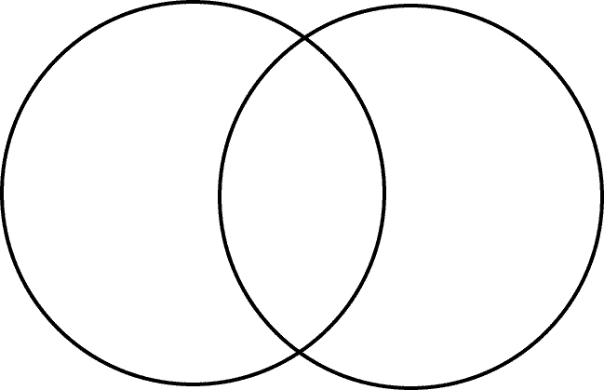
Copy Master 12: Venn diagram
Chinese games
New Zealand games

Copy Master 13: Social etiquette

Never write things in red ink. It symbolizes severe disapproval.

- When receiving a gift, it is polite to receive it with both hands.

- A handshake is the most common form of non-verbal greeting but you can also just a nod, though neither is necessary.

Do not back slap, hug or put your arm around someone’s shoulder. It will make a Chinese feel uncomfortable.

- When you greet a group of people, you need to welcome to the oldest person first.

- Do not place chopsticks upright in your bowl. This symbolizes death. It is also not polite to tap your bowl with chopsticks.

- When you are about to eat, wait to be told where to sit. The guest of honour will be given a seat facing the door.

- Many Chinese will look towards the ground when greeting someone.

Slurping or belching sounds while eating lets others know that you are enjoying your food.

- When eating rice hold the bowl close to your mouth.

Copy Master 14: PMI
Plus  What are the positive things about schools in China? | Minus  What are the negative things about schools in China? | Interesting  What are the interesting things about schools in China?

Copy Master 15:

Who is your favourite character and why?

What is the moral of the folk story?

Why was it written?

How could you apply this to your own life?

