Government response to the Lushan/Ya’an earthquake
Before | Emergency response | Recovery | Reconstruction

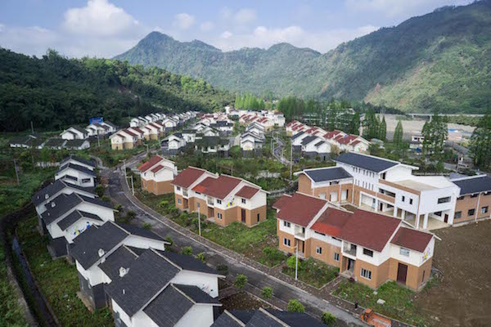

A village in Lushan County on April 3, 2015. Reconstruction work is mostly complete.

