Geographic inquiry: How have different groups or organisations responded to the Lushan/Ya’an earthquake?
Use this template to thoughtfully plan your inquiry.
Step One:
Carry out an online search to:
- Identify the groups and organisations that responded to the Lushan/Ya’an earthquake.
- Identify difference sources of information available to complete your inquiry.
Step two:
Name the group or organisation you are going to investigate.

Step three:
Plan your inquiry
What geographic concepts are relevant?

What are 2-3 inquiry questions worth investigating?

What do you expect to find out?

How will you present your findings?

Step Four:
Carry out research. Make sure to record notes relevant to your inquiry to help with your findings.

Step Five:
Answer each of your inquiry question using the notes you recorded in step four.

Step Six:
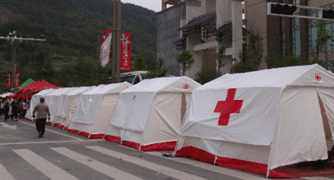
Present your findings. Ensure that your method of presentation is appropriate and engaging for the audience.

