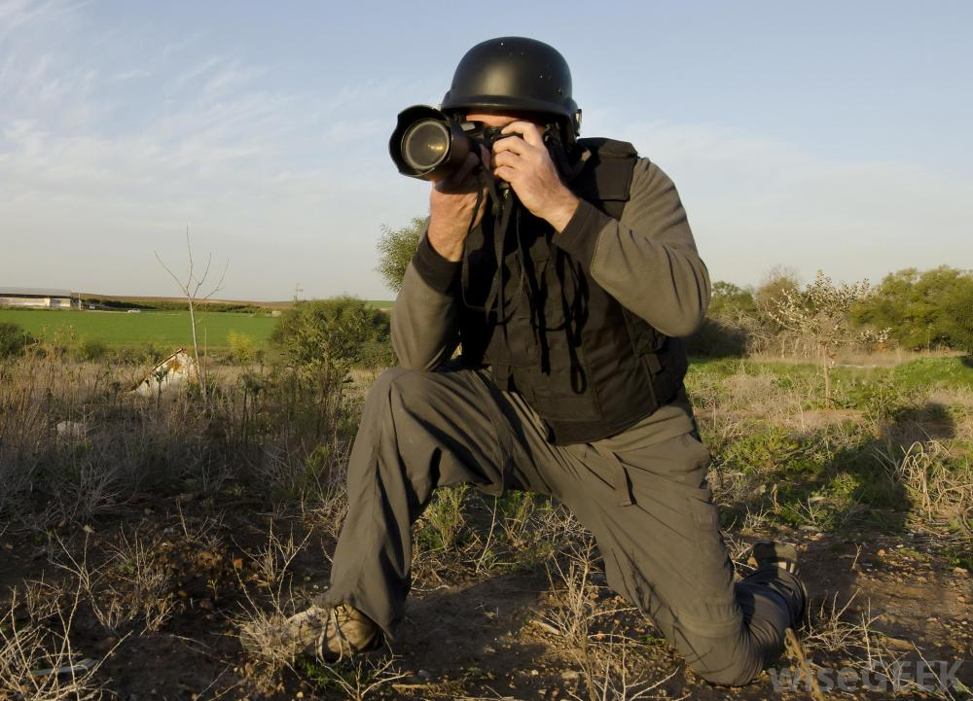
You have travelled to Lushan to take images of the situation in the area after the earthquake on 21 April 2013

Your images will be sold to and used by a range of global news agencies in print and online to inform people around the world on the event.

Your task is to find and select a range of images that you are willing to sell to these global news agencies.
Select no more than 5 images. Each image should come with a short description of what it shows and the significance of what it shows.
This link will give you some examples and ideas http://edition.cnn.com/2013/04/21/world/asia/china-sichuan-earthquake/

