Social factors: Hukou system
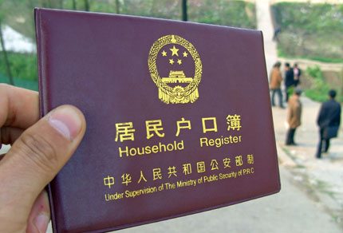
The Hukou system became law in 1958. In this system people are assigned a hukou location: urban or rural. It specifies the location where people receive benefits. Those with a rural hukou have access to farmland and perhaps rents or compensation for use of the land. Urban hukou gain access to jobs, housing, and education and state welfare benefits. The hukou is hereditary, very expensive and difficult to change.
Since the 1980s, when China started to make significant economic reform, migration from rural areas to urban areas has increased. This means there is an increasing amount of rural hukou holders living in urban areas where they are entitled to very little.
There have been some changes to the hukou system. In small towns and cities it is possible to get an urban hukou. The criteria requires a person to have a stable job and to have lived in the urban areas for more than two years in a permanent and legal place of stay.

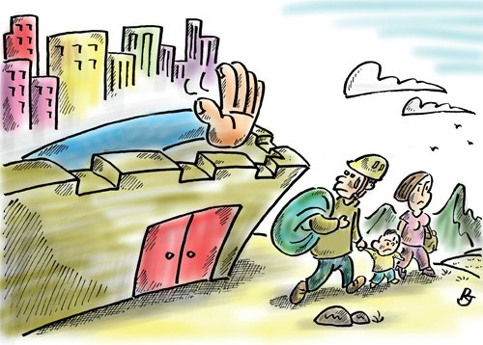
Larger cities have been more resistant and have very stringent criteria when awarding a new hukou. It includes a certain level of education attainments, skills, financial ability and health. Such cities include Beijing, Guangzhou and Shanghai. If you do not have an appropriate hukou your employment opportunities can become limited. For example, in Beijing if a university graduate wants to apply for Government jobs in Beijing they will need a Beijing city hukou. Many enterprises will restrict employment to those with a hukou. Local city governments are able to establish their own hukou criteria. In 2002 Guanqzhou reversed its hukou reform on grounds that migrants overloaded the urban infrastructure.

- Draw a diagram to highlight different aspects of the hukou system and changes that have occurred.
- Interpret the cartoon.

Inequalities due to the hukou system
As a result of limited access to sanitation and health care services, health status of migrants is not only inferior to that of urban residents but also to that of rural peers. Tetanus infection rate among migrant children in Suzhou is 38 times that of urban dweller children. Among children from the migrant population living in Zhongshan municipality, the incidence rates for low body-weight and slow growth were 18.2% and 26.5%, higher even than the 2000 national rural incidence rates for low body-weight and slow growth, which were 13% and 22% respectively.
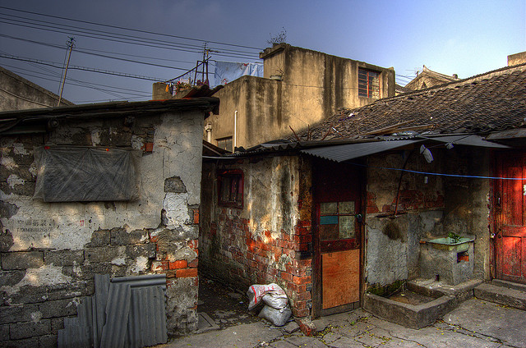
Children of migrant workers do not have equal access to education. They are encouraged to remain at their rural hometown no matter where their parents move to. If they do go to urban areas with their parents, children of interregional migrants are charged additional fees just for the right to attend regular schools, an amount that can be as much as 10% of family annual total income. As most migrants cannot afford this amount, their children have no choice but to attend primary and secondary schools designated for migrants that are segregated from regular educational institutions. In this context, schools for migrant children sprang out in most developed urban regions in China from the early 1990s on. Many migrant children cannot receive quality education.
There is still a two-tier labour market in urban areas where migrants suffer from occupational segregation and wage differentials. For instance, migrants are not allowed to work for official or public services, for public security or environmental protection services, or for the management of joint property in the city districts. Consequently, most migrants work in jobs that are deemed as inferior and undesirable, and make meagre wages despite their highly demanded labour and services.
Taken from: The Potential Causal Effect of Hukou on Health among Rural-to-Urban Migrants in China Meiping Sun ∗ November 27, 2015
- Identify the effects of the hukou system and sort them into four difference categories: health, education, employment and income.

Resource Link: Illiteracy rate in China by region
http://www.statista.com/statistics/278568/illiteracy-rate-in-china-by-region/
Construct a choropleth map to illustrate the differences in illiteracy between provinces in China.
Describe the pattern shown in your choropleth map

- On China: Hukou system
https://www.youtube.com/watch?v=re8MN2gbFJA
Views in a table.: what is the main problem, consequences and possible responses?
Use a perspective to comment on the inequalities created by hukou. The inequalities exist between rural and urban areas but also within urban areas between locals and migrants.

