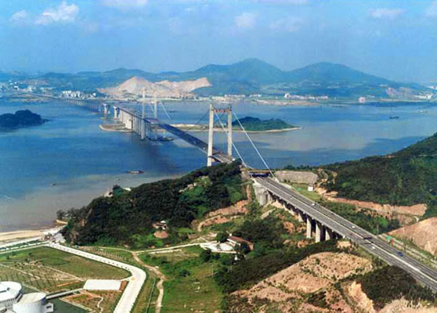
Natural features: Rivers
Pearl River
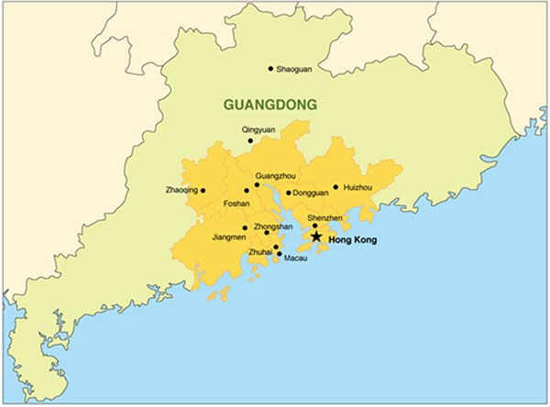
The Pearl River Delta area is one of the most economically vibrant zones in China. Large scale commercial activities and foreign trade occur in the area. The picture to the right shows the Pearl River.
After reform and opening up policies implemented in 1979 a number of cities in the delta - mostly in Guangdong province - have created one of the most developed areas of China in terms of GDP.
Guangzhou, capital city of Guangdong, saw its GDP hit 1.5 trillion yuan ($421 billion) last year (2013), a jump of 11.6 percent year-on-year, according to a local statistics agency. The municipal government is eyeing 10 percent growth this year, exceeding the national average.
Just to the northern border of Hong Kong, sits the young yet dynamic city of Shenzhen, created at the beginning of the reform and opening up. It is now the world's largest manufacturing base for consumer electronics such as smartphones and tablets.
The GDP for Shenzhen stood at 1.4 trillion yuan in 2013, a 10.5 percent increase compared to the previous year.
The three mega cities (Guangdong, Hong Kong and Shenzhen) are surrounded by a dozen smaller ones, such as Dongguan, Foshan, Huizhou and Zhaoqing, all with strong private capitals working in the manufacturing, trade and logistics sectors.
Source: http://www.chinadaily.com.cn/china/2014-04/11/content_17428605.htm

Yangtze River

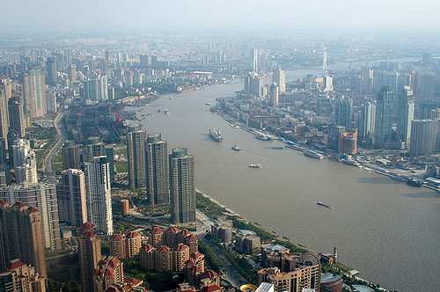
Shanghai is the largest city in the Yangtze River Delta economic zone and is also the financial centre for China. In late 2013, the central government set up the country's first free trade pilot zone trying to find new ways to boost domestic consumption. The Yangtze River at Shanghai is shown to the right.
Multinational corporations choose Shanghai as their East Asian headquarters. Global giants such as Exxon Mobil Corp, General Motors and Citigroup Inc have set their China HQs in Shanghai.
The GDP for Shanghai exceeded 2 trillion yuan last year, according to the municipal government. The city's economy has seen steady growth over the years, with an annual growth rate similar to the national average.
Thanks to Shanghai's economic power, cities in neighbouring provinces also showed rapid growth over the past decade or so. Hangzhou, roughly 150 kilometres southwest of Shanghai, is becoming the country's electronic-commerce capital as online shopping heats up. Hangzhou-based e-commerce giant Alibaba Group Holding Ltd commanded about 80 percent of customer-to-customer online shopping turnover in 2013, according to research firm Analysis International.
Cities in Jiangsu province are also included in the Yangtze River Delta economic zone. Suzhou, Wuxi and Nanjing are the largest culture and economy engines in Jiangsu thanks to industries such as electronic manufacturing, engineering, bio-technology and banking.
Source: http://www.chinadaily.com.cn/china/2014-04/11/content_17428605.htm

Use the texts on the Pearl and Yangtze Rivers to complete the three level guide.

Reading on the lines

Highlight the sentence in the text that supports each of the following statements.
- Guangzhou is the capital of Guangdong province.
- Shanghai is the financial hub of China.
- Shanghai is the largest city in the Yangtze River delta.
- Three cities are key to the Pearl River economic zone.

Reading between the lines

Find evidence in the text to support each of the following statements. Record the evidence below each statement.
- Most growth in the Pearl River delta has occurred in three mega cities.

- The Pearl River and Yangtze Delta specialise in different industries.

- Smaller cities have developed industries as a result of development in major cities.

- The Chinese government has been influential in supporting conditions for development

- The rivers are used as a means to transport products between coastal and inland provinces.

Reading beyond the lines

Respond to each statement by writing a small explanation that draws on information in the text and your learning so far. Write your answers in your book.
- GDP is a good measure when comparing development along the Pearl River delta and Yangtze River delta.

- Proximity to major rivers increases the standard of living for people.

- Development in large cities initiates growth in neighbouring cities.

- Development occurs evenly between cities in both river delta economic areas.
You have been asked to write an article for an online Geographic magazine on the importance of natural features of an environment for supporting development. China has been selected as your context due to the rapid growth in GDP in particular areas. You are to focus your investigation and article on the Pearl River delta and Yangtze River.
Use a variety of sources to collect information. Record the information in the table like the one below.
 | Pearl River Delta | Yangtze River
Provinces and key cities
Industries that have been developed
Infrastructure
How has the river been used
Impact on the river
Impact on eco develop
Impact on peoples standard of living

Your article should contain:
- Geographic terminology
- Geographic concepts: environment, change, interaction
- Evidence and examples from the case study areas
Below is a list of useful websites to begin your investigation:
Pearl and Yangtze River
http://www.chinadaily.com.cn/china/2014-04/11/content_17428605.htm
http://www.china.org.cn/english/BAT/94675.htm

Yangtze River
http://www.awotglobal.com/market_3.html
http://nextbigfuture.com/2015/07/shanghai-and-yangtze-river-delta.html
http://www.bjreview.com.cn/Business/201602/t20160214_800048679.html

Pearl River
http://china-trade-research.hktdc.com/business-news/article/Fast-Facts/PRD-Economic-Profile/ff/en/1/1X000000/1X06BW84.htm
http://www.awotglobal.com/market_4.html

