Economic and Political factors have influenced levels of development within China
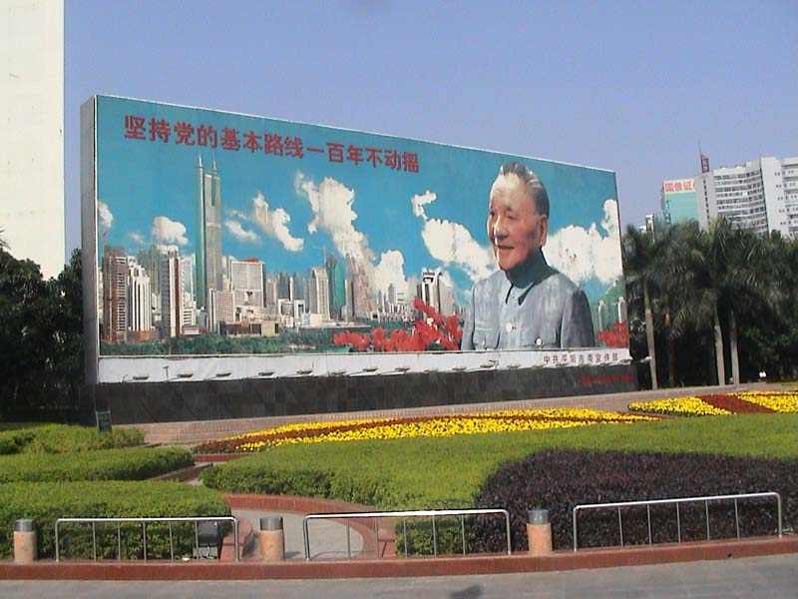
A change in leadership saw a different approach to development in China. Under Deng Xiaoping’s leadership China began a series of economic reforms based on market principles from 1978. The reforms saw changes in many areas of the economy.
In agricultural areas private plots were established. This had the effect of increased production as households now benefited from the rewards of their labour. This had the flow on effect of increased living standards for people in agricultural areas.
Early reforms included the encouragement of foreign investment and private enterprise. Later reforms included the privatisation and contracting out of some state owned enterprises (although many still remain). Price controls and protection policies that included trade barriers were reduced such as the lowering of tariffs and quotas. This saw the rapid growth of the private sector.
Special economic zones were created by the government. The Government of China gives these zones greater ability to be part of the free market through different economic policies and flexible government measures. The zones facilitate experimentation and innovation in many different industries.
The first Special economic zone was created in Shenzhen in 1980. It concentrated export orientated manufacturing industries in one geographical location. Other special economic zones followed and were created in coastal cities such as Zhangzhou to take advantage of location. Since then other areas have been developed as high tech development zones to capitalise on technology and talent and stimulate regional development. In 2014, there were 6 SEZs, 14 open coastal cities, 4 pilot free trade areas and five financial reform pilot areas.
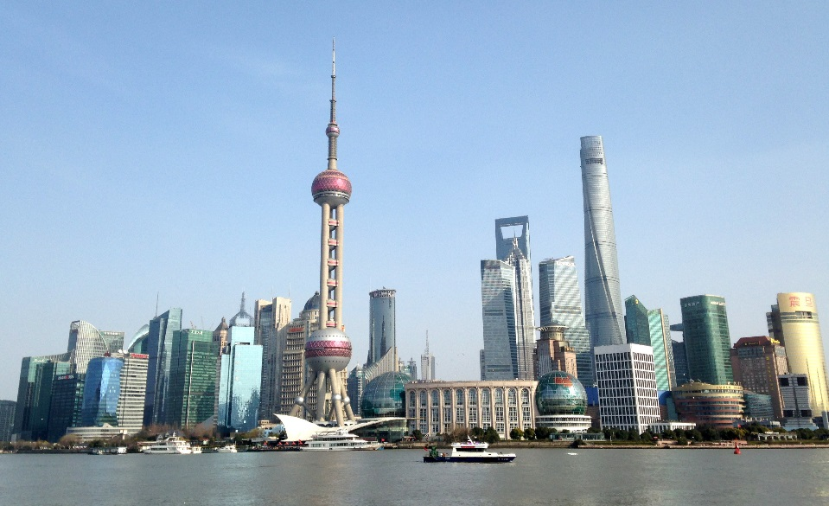
- Resource link: special economic zones.
http://understand-china.com/special-economic-zone-sez/
On an outline map of China locate each economic zone. Clearly annotate each zone to identify the population, GDP, average wage and function.
What are three comparisons that can be made between the zones? Make sure to use comparing words.
- Resource link: Visual representation of differences between provinces.
http://data.stats.gov.cn/english/mapdata.htm?cn=E0103&zb=A0301
In the left hand menu scroll down and select Employment and wages. Click on the Number of people employed in urban units.
- Identify the spatial pattern of employment in urban units.
- Refer back to your annotated map. What is the relationship between the locations of SEZs and employment?
Click on average wage of employed workers in urban units
- Identify the spatial pattern of average wage of employed workers in urban units.
- Refer back to your annotated map. What is the relationship between the locations of SEZs and wages?
Return to the main menu and select Education. Click on Graduates with degrees or diplomas in institutions of higher education.
- Identify the spatial pattern of graduates with degrees or diplomas in institutions of higher education.
- Refer back to your annotated map and previous answers. What is the relationship between education, employment, wages and SEZs.

- Elaborate on this statement with an explanation and evidence. Include the geographic concepts of accessibility and change.
Government economic policy has contributed to differences in development within China.
Resource link: China Statistical yearbook
http://www.stats.gov.cn/tjsj/ndsj/2014/indexeh.htm
In the left hand menu select Employment and wages. Click on - number of employed persons at year end in urban and rural areas.
Types of business
State-owned enterprise  A company or corporation that is owned by the government. | Limited liability company  A company in which the members cannot be held personally liable for the debts or liabilities.
Private enterprise  A business that is managed by independent companies or people rather than being controlled by the government | Self employed  A person generates their own income through commercial activities rather than as an employee of a company.

- Analyse the numbers in the table to identify patterns in: China total, urban areas and rural areas.
For China total:
- What is the overall change in employment?
- What years saw the biggest increase in employment?
- What years have seen the smallest change?
For urban areas:
- What is the overall change in employment?
- What years saw the biggest increase in employment?
- What change has occurred in the number of:
- State owned enterprises
- Limited liability companies
- Private companies
- Self-employed
For rural areas
- What is the overall change in employment?
- What years saw the biggest increase in employment?
- What change has occurred in the number of:
- Private companies
- Self-employed

- Describe three similarities and differences between urban and rural areas in China.
Consider: areas are experiencing greater growth and areas have seen greater change in the type of employment.
- Reflect and respond to this question using your learning.
To what extent has the changing type of employment change the standard of living of those in urban and rural areas?

