Natural conditions
Natural events effect people, their livelihoods and their environments. The impact of the natural event is related to the intensity, scale, location and level of development of the affected community. Depending on the level of development recovery may take shorter or longer.

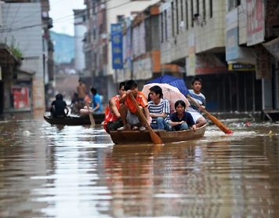

Over the past 20 years, natural disasters in China have affected 300 million people, destroyed more than 3 million houses and forced the evacuation of more than 9 million people on average annually, resulting in direct economic losses that have exceeded USD 36.2 billion per year. (http://www.cartiercharitablefoundation.org)

You have been employed as a consultant for a global non-governmental organisation to carry out an investigation into the impact natural events have had on the level of development in a specific province in China. Your report will help towards the NGO establishing a relationship with the Chinese central and provincial government to develop plans to minimise the impact these events have on the level of development.
Geographic concepts: environment, change
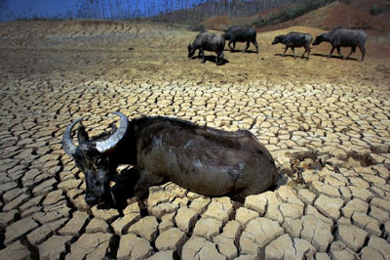
Your investigation should:
- Focus on one natural event. In the case of flooding or drought the event may take place over months.
- Describe the environment of the province. (environment)
- Describe the level of development before the event using quantitative and qualitative indicators.
- Describe the level of development after the event using quantitative and qualitative indicators. (change)
- Describe the length of time it took or may take for levels of development to return to pre-natural event levels.
- Describe why this natural event affected this province more than other provinces.
Make sure to include visuals to illustrate your findings.

Present your investigation in an engaging manner.

Useful links
http://www.circleofblue.org/2011/world/infographic-interactive-timeline-mapping-chinas-drought-ridden-provinces-since-2007/
http://content.time.com/time/photogallery/0,29307,1976923_2097553,00.html
http://floodlist.com/tag/china
http://www.telesurtv.net/english/multimedia/Massive-Floods-in-China-Affect-Over-250000-People-Kill-25-20151116-0013.html

Achieved | Merit | Excellence
Explain how a natural event has influenced levels of development | Explains in detail how a natural event has influenced levels of development | Fully explains how a natural event has influenced levels of development

