Natural features: Proximity to the coastline
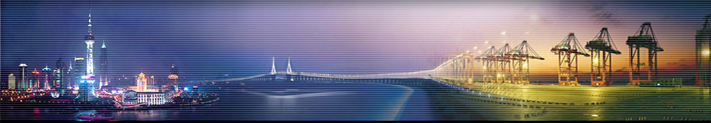

China's mainland coastline measures approximately 18,000 km, with a flat topography, and many excellent ports and harbours. The Chinese mainland is flanked to the east and south by the Bohai, Yellow, East China and South China seas, with a total maritime area of 4.73 million sq km.
Ports are important gateways for China's domestic and foreign trade. The Port of Shanghai is one of the top ports if not the top port in the world. It has posted a 3.5 per cent year-on-year increase in 2015 container volume to 36.54 million TEU. In December, Shanghai moved 3.07 million TEU, a year-on-year increase of 5.9 per cent. Shanghai International Port Group (SIPG) also posted a four per cent year on year net profit of decline of CNY6.5 billion (US$988.7 million) in 2015, against a profit of CNY6.77 billion the year before. But revenue was up 2.5 per cent year on year to CNY29.5 billion.
Shanghai port is considered by the Chinese central government to be an important international hub. The growth of this port also contributes to growth in its neighbouring regions and hinterland. The hinterland is connected by the Yangtze River. SIPG has also invested in nine ports along the river. The port stimulates growth in other industries increasing the standard of living of those in close proximity. Per capita disposable income in Shanghai, the nation's financial hub, hit 47,710 yuan ($7,611) last year (2104), eclipsing Beijing to secure the first place nationwide, the Guangming Daily reported on Thursday.

Map to show Mainland Chinese ports
http://www.chinaperformancegroup.com/wp-content/uploads/china-ports-e1359007388195.png
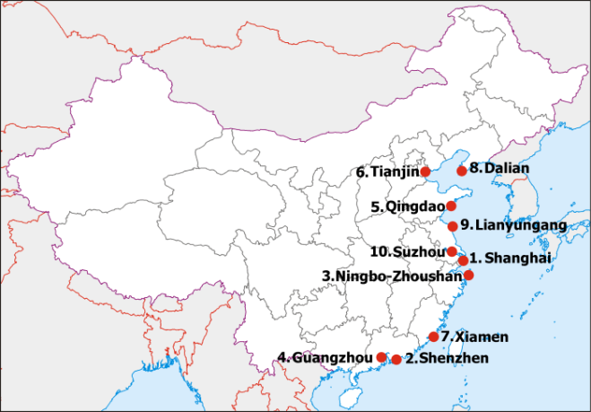
- Use the map above to describe the location and distribution of ports in Mainland China. Use natural and cultural features as reference points as well as compass directions to provide a more detailed description.

