汉堡 Fusion Burgers汉堡
OBJECTIVES
Achievement Objectives: Curriculum 2007  Technological practice  Outcome Development & Evaluation  Students will:  Analyse their own and others’ outcomes to inform the development of ideas for feasible outcomes. Undertake ongoing functional modelling and evaluation that takes account of key stakeholder feedback and trialling in the physical and social environments. Use the information gained to select and develop the outcome that best addresses the specifications. Evaluate the final outcome’s fitness for purpose against the brief.  Technological Knowledge  Technological Products  Students will:  Understand how materials are selected, based on desired performance criteria |  | Year Level: 9/10  Curriculum level: Technology level 5  Unit Duration: 4-5 weeks
INTEGRATION INTO OTHER LEARNING AREAS
Business studies, Social studies, Mathematics,
Values:  Excellence  Innovation, inquiry, and curiosity  Diversity  Equity  Community and participation  Ecological sustainability  Integrity  Respect | Key Competencies:  Thinking  Using language, symbols, and texts  Managing self  Relating to others  Participating and contributing |  | Principles:  High expectations  Treaty of Waitangi  Cultural diversity  Inclusion  Learning to learn  Community engagement  Coherence  Future focus
Unit Focus: Food technology:  The technological process is used to develop a suitable food product to a given brief and stakeholder.  The Unit is designed for group work, but assessment is based on the individual student’s submission of assessment activities. |  | Context:  Through the concept of a burger students are to demonstrate an understanding of Asian fusion food and plan the activity of making an Asian fusion burger. For a more in-depth understanding of the Asian culture students will investigate and apply the use of an Asian culinary tool as a technological outcome.
Conceptual Understandings:  Brief, Specifications, Attributes, Research, Concept analysis, Outcome evaluation  Within the definition of a burger students will develop a burger infused with Asian Culture and flavours. |  | Concepts: Culture, fusion food, Fast food, Values, Ethics, Food ingredients

LESSON 1:
Lesson focus: Chronology of Chinese Cuisine
Concepts: Chinese Food History Timeline
Suggested activities | Resources
Introduction:  In groups students use a timeline to make a lantern bunting.  Students can use all or a select group of events from the Time Line resource, as long as they can string them in a chronological order.  Use the Chinese Lantern to record and string on the bunting. These are put up in class to set the scene for the rest of the unit. | TASK 1: Students can use a set of Chinese lantern images to put together a timeline of important food events in China.  String Pegs  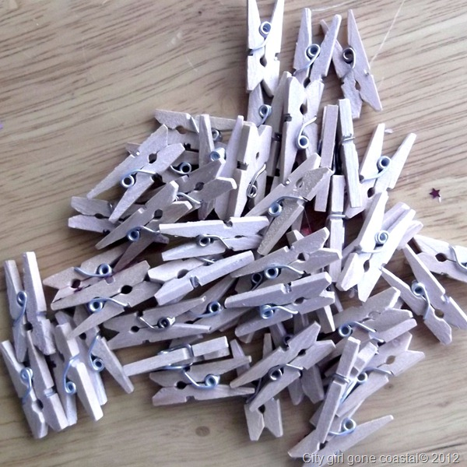

Chinese Food History Timeline: BC
0.5 million years ago | • Peking Man may have known cooking (roasting meat).
8000 BC | • First rice grown (Yuchanyan, Hunan).
7000 BC | • Millet grown in north China. • Wine making in Jiahu, Henan – world's oldest (fermented from rice, honey and fruit).
6000 BC | • Domestication of pigs.
4000 BC | • Widespread cultivation of several plant & animal species.
3000 BC | • Agriculture common in easily cultivated areas; social stratification; large villages; moves towards civilisation.
3000–2000 BC | • Wheat and barley introduced from the Middle East.
c. 2700 BC | • Shen Nong, the "Divine Farmer," father of agriculture, medicine, and discoverer of tea.
2000 BC | • Civilised society in North China & Manchuria.  • Noodles (made from millet flour)
1500 BC | • Fish Farming: carp in ponds.
1200 BC | • Wooden chopsticks dug from graves from this era.
c. 1050–256 BC | • Soybean cultivation.
1100 BC | • Strong ale (e.g. rice wine).
200 BC | • The rotary winnowing fan.  • The modern seed drill.  • Steel production from cast iron.  • Ice used for refrigeration.

600 BC | • The iron plough. • Row cultivation. • Intensive hoeing.
c. 551–c. 479 | • Life of Confucius.
400 BC | • Cast iron.
400 & 300 BC | • Efficient horse harnesses.
AD
25–220 | • Soy milk and tofu processing.
250 | • Tea drinking begins to spread throughout China.
300 | • The fishing reel. • Porcelain. • Biological pest control. • Understanding of deficiency diseases.
500–600 | • Ginger grown on ships. Ginger contains vitamin C, which guards against scurvy. (Whether Chinese understood this at the time or not, they gradually came to see a correlation between diet and shipboard health. The ships of Zheng He's voyages in the early 15th century had vegetable patches. Ginger is also effective against sea sickness).
605 | • Grand Canal completed (linking the Yangtze with the Yellow River), allowing mass shipment of food from the south to the north.
618-907(Tang Dynasty) | Vegetarianism • Tea drinking elevated to an art.
780 | • Publication of Lu Yu's Classic of Tea, the first comprehensive handbook on tea. It described the cultivation, processing, and use of tea.
960–1279 | • Soy sauce becomes a common flavouring.
1500– | • Gradual introduction of New World food: sweet potatoes, maize, potatoes, peanuts, peppers, tomatoes etc.
1555 | • Maize first mentioned in literature, after arriving sometime earlier in the century via the Philippines.
1610 | • Tea arrives in Europe.
1850 | • Chinese food arrives in America with the first Chinese gold prospectors.
1958–60 | • The Great Leap Forward, collectivisation of all agriculture into large communes – greatest human-made famine in human history.
1966–76 | • Cultural Revolution, many culinary traditions dispensed with.
1979 | • Coca-Cola re-enters China market after a 30-year enforced absence.
1987 | • American fast food arrives in China: KFC.

Reference:
Chronology of Chinese Cuisine Eating China http://www.eatingchina.com/articles/timeline.htm ;

LESSON 2:
Lesson focus: ASIAN FLAVOURS (BLIND TASTING)
Concepts: To familiarise and test their knowledge of Asian flavours students will identify typical Asian flavours by using their sense of smell.
Suggested activities | Resources
Teacher will set up this unit to help students become familiar with and be able to identify typical Asian food ingredients | Equipment:  Soy sauce  Fish sauce  Sweet chili sauce  Lime juice  Chopped ginger  Sesame oil  Crushed Nori sheets (sea weed)  Rice vinegar  Star Anise  Crushed coriander leaves  10 polystyrene cups  Aluminium Foil  10 rubber bands  Marker  Method:  Divide flavours into separate cups.  Cover each cup with foil and secure with rubber bands.  Poke small holes into foil for smelling purposes.  Number each cup.  Hand out sensory evaluation sheet to students and challenge students to identify each of the mystery flavours

Sensory Sheet
Sample | What is it? | Pick Me!
1 |  | 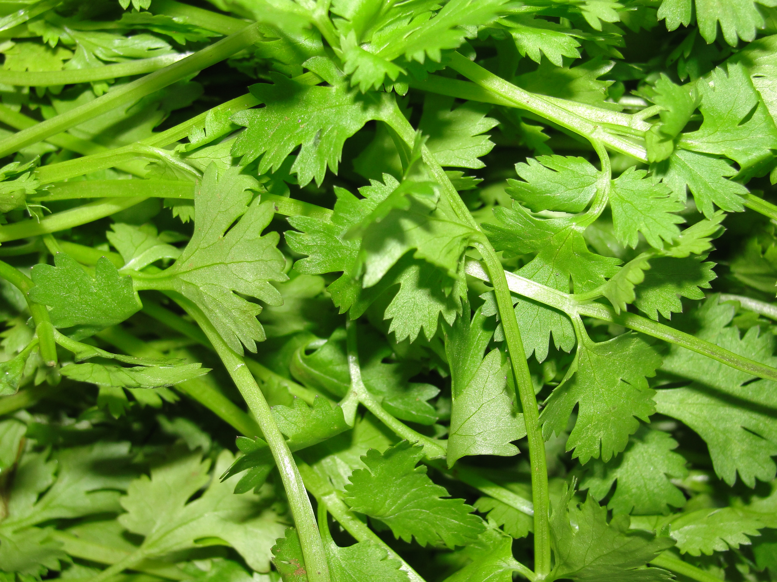  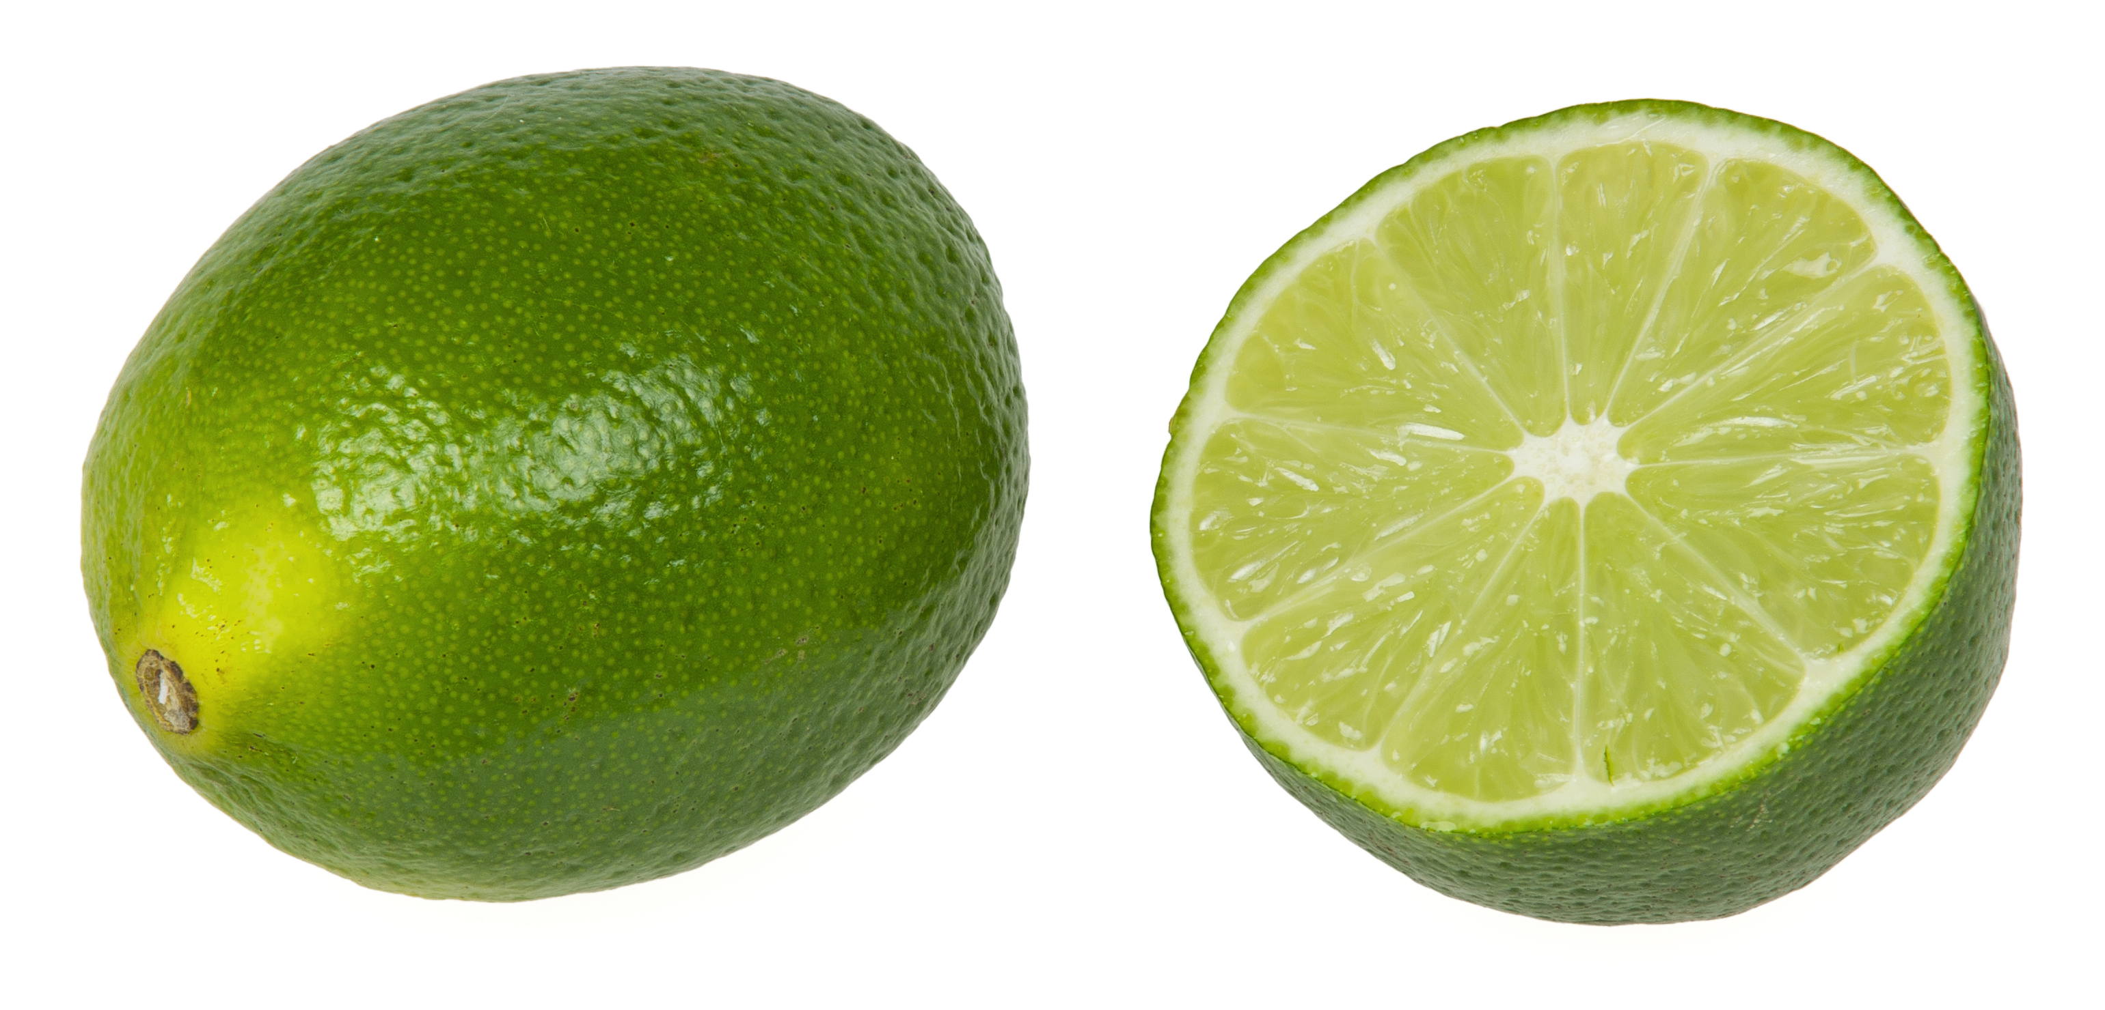  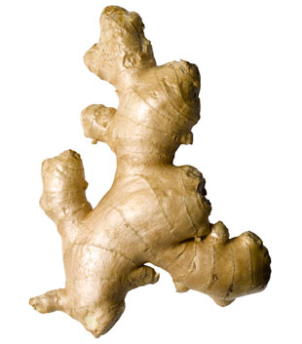  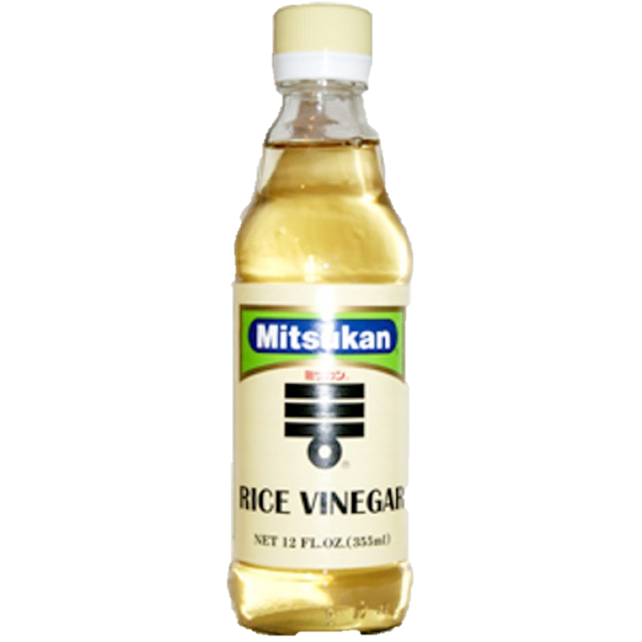  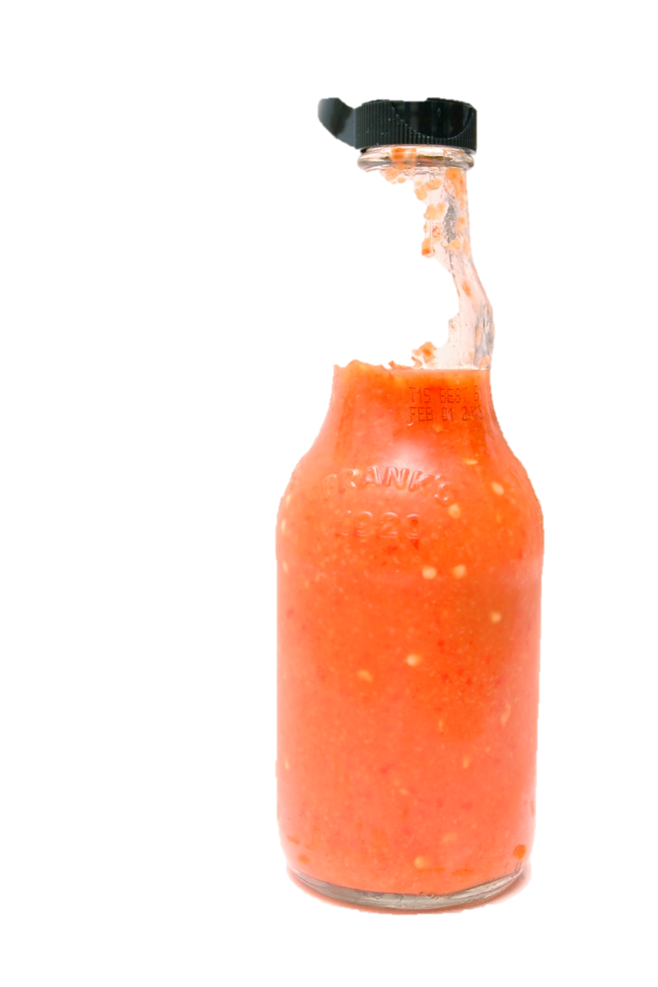  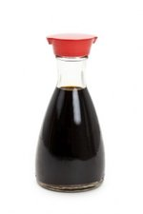  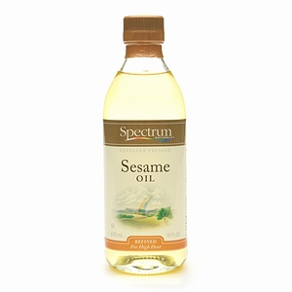  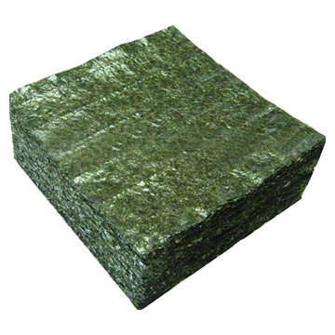  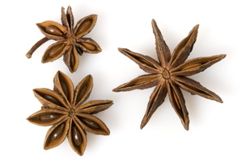  SOY SAUCE  FISH SAUCE  SEA WEED  SESAME OIL  STAR ANISE  GINGER  RICE VINEGAR  SWEET  CHILLI  SAUCE  LIME JUICE  CORIANDER  Soy  Fish  sauce
2
3
4
5
6
7
8
9
10

LESSON 3
Lesson focus: Product Disassembly
Concepts: Students will learn more about the composition and proportions of the ingredients going into a typical Asian meal. These are the flavours that could possibly be used in an Asian Burger Concept.
Suggested activities | Resources
Group activity: Teacher will have to purchase Asian flavoured “Heat ‘n Eat” meals.  (1 per group)  Groups will have to pre-heat their meal.  When done use forks/spoons/tongs to separate all ingredients onto baking paper squares.  Label and weigh the different ingredients. | Resources per group:  1 Bought Asian meal e.g.  1 Scale  1 pair of rubber gloves per student  1 A3 size sheet of paper/ or any other format suitable  1 marker  Stack of baking paper squares (20x20cm)  Camera to take photos of the product at different stages of disassembly  2 forks

- Record the:  Name  Weight of the product  How many portions it serves  Who is the target group for this product? | 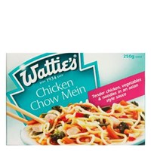
- Separate individual ingredients  on pieces of baking paper and weigh each component. E.g. | Noodles  g  Carrots ………..g  Chicken  g  Broccoli  g
- Describe the serving suggestions: | 4. List the Nutritional Value:

LESSON 4
Lesson focus: Asian Fusion Burgers
Concepts: Teacher given brief: The students in the Business study class have invited you to design an Asian fusion burger concept which they could make and sell at their annual Business study stall day.
Attributes:
- The burger has to be true to the definition of a “burger”
- It should look like a “burger”
- The flavours should be typical Asian
- The burger must be easy to make
- The burger should be easy to package
- The burger must be easy to eat
- The cost of the burger including the packaging should not exceed $2.00
- The Business Study students want to taste the burger before they accept your concept recipe.
- The burger must be fit for purpose

Suggested activities | Resources
‘Unpacking’ the Brief  Put word cards on white board  Ask students to explain the definition of each  Students can paraphrase  Finally to ensure all is familiar ‘brief’ handout worksheet to complete  (Individual activity) | Use word cards for each of the following terms:  BRIEF; SPECIFICATIONS; STAKEHOLDER; ATTRIBUTES; CONSTRAINTS; FIT FOR PURPOSE  Worksheet;  Understanding a brief  - What is the event for designing these Asian Fusion burgers?  - Who wants you to design an Asian Fusion burger?  - Who are your stakeholders?  - List the specifications
Concept idea Brainstorm  Group activity | Complete ‘Concept Idea brainstorm sheet’
ADDITIONAL RESOURCES
Concept Ideas:
Look at the ingredients used in the ‘frozen meals’ and come up with ideas for an ASIAN flavoured BURGER.

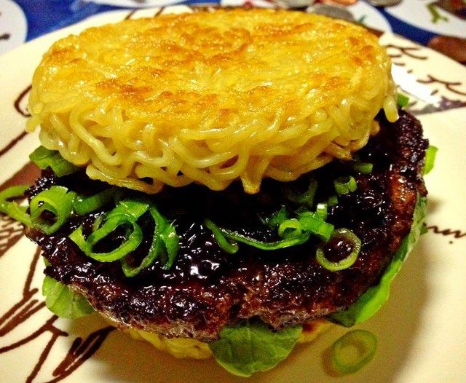

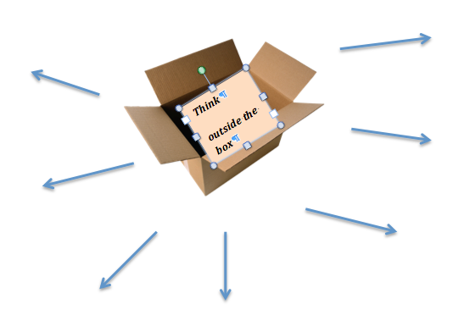

Words to support your creative thinking
Innovate FUSION FOOD Asian BURGERS Create Soy Sauce Flavour Steam buns Pork Beef Carrot Corn Vegetables GINGER Coriander fish sauce CHINESE Noodles Chicken pork buns lime juice

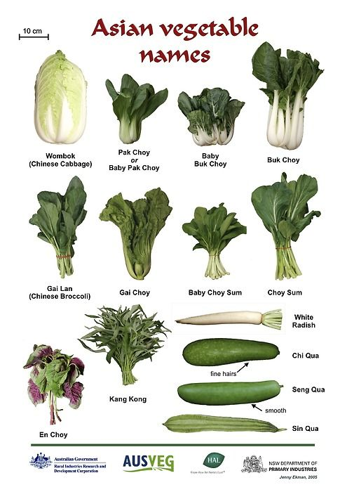

LESSON 5
Lesson focus: Components of a burger
Concepts: Practical activities to upskill students in making a suitable carbohydrate (Bread/Rice/Noodles) component for an Asian fusion burger
Suggested activities | Resources/ Recipes
Group activitiy:  Each group present a sample of the bread component of a burger they made:  Discussion questions:  - How easy is it to handle the bun?  - Which bun is the tastiest?  - Which bun will be most suitable for eating your burger out of a bag?  - Which burger is best suited for eating with chop sticks? | Group 1: Makes rice buns  http://mykoreankitchen.com/bulgogi-rice-burger/  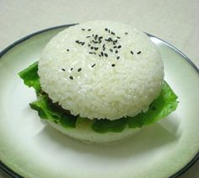  Group 2: Makes Steam buns (Man Tou)  http://thewoksoflife.com/2014/03/purpose-chinese-bun-dough-man-tou/  Group 3 : Makes Noodle buns  http://greatideas.people.com/2013/08/27/make-your-own-ramen-burger-recipe/  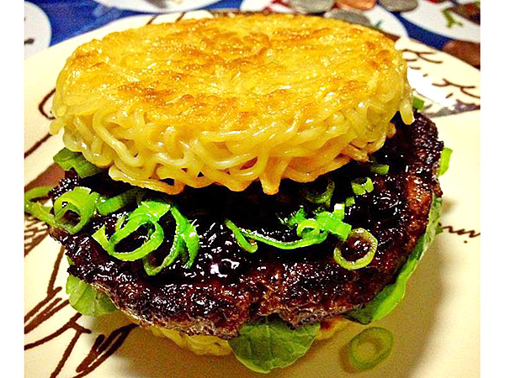  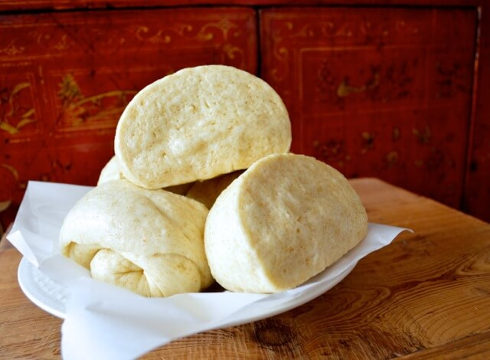

LESSON 6
Lesson focus: Concept analysis exercise
Concepts: Analyse various Asian fusion burgers
Suggested activities
Look at the following Concept Ideas and annotate each by completing the PMI boxes for each.
Resources
Asian Tuna Burger | Plus
 | Minus
 | Interesting (e.g. Creative)
Korean BBQ beef burger | Plus
 | Minus
 | Interesting (e.g. Creative)
Kimchi BBQ beef burger | Plus
 | Minus
 | Interesting (e.g. Creative)
Pork belly bun burgers | Plus
 | Minus
 | Interesting (e.g. Creative)

Key Ideas

Self assessment stop: (showing level of critical thinking skills)

Grade | Working towards Level 5 | Low A | A | M | E
Demonstrate understanding of concept analysis for the development of a fusion burger. | I need help understanding how to complete the PMI strategy to analyse recipe concept ideas for the development of a fusion burger. | I can analyse recipe concept ideas by completing a PMI strategy for the development of a fusion burger if I am prompted or directed. | I can analyse recipe concept ideas using a PMI strategy for the development of a fusion burger but I am not sure when and or why I need to use the PMI sheet. | I can analyse recipe concept ideas using a PMI strategy for the development of a fusion burger and I know when and why to use them. | I can analyse recipe concept ideas using a PMI strategy for the development of a fusion burger and I know when and why to use them.  I can teach others to analyse recipe concept ideas for the development of a fusion burger and I know when and why to use them  I act as a role model for others to help them analyse recipe concept ideas for the development of a fusion burger and I know when and why to use them.  I seek feedback on how to improve my analysis of recipe concept ideas for the development of a fusion burger and I know when and why to use them.
Formative feedback from teacher

LESSON 7
Lesson focus: Concept development
Concepts: To design concepts for a suitable Asian fusion burger
Suggested activities
Based on skills and knowledge gathered with this unit groups need to design 4 possible concept ideas.
List most important specifications given in the ‘Brief’ statement under the ‘Key Considerations”
(see product screening sheet.)

Rank each specification on its fitness for purpose.

RESOURCES
Student will need own laptops to find suitable recipes
Prepare four ‘Concept Sheets’ per group
Students will need to be able to print chosen recipes
Have scissors and glue available.
Recipe websites for possible recipes
Helpful websites:

http://italian-fusion.blogspot.co.nz/2012/01/favorite-chinese-fast-food.html
https://www.piedmontese.com/siteart/RecipePhotos/pin-asian-fusion-burger.jpg
http://www.thekitchenwitchblog.com/wp-content/uploads/2014/11/Asian-Apple-Pork-burger
http://mysecondbreakfast.com/wp-content/uploads/2014/04/asian-veggie-burger-slaw-.jpg
http://heatherchristo.com/2013/08/28/grilled-asian-pork-burger/
http://1.bp.blogspot.com/-XPIy3qbug84/TdWh4RHOjQI/AAAAAAAABJU/-iRZ49Vjc-4/s1600/100_8162+en+text+hb.jpg

Product Screening Sheet
Concept Idea 1:

Recipe here

PLUS | MINUS

PRODUCT SCREENING
CONCEPT:
PRODUCT PROFILE DIAGRAM | RATE EACH OF THE KEY CONSIDERATIONS
KEY CONSIDERATIONS | Very good | Good | Average | Poor | Very Poor
Key decision:

Self assessment stop

Demonstrate understanding: of concept analysis for the development of a fusion burger.
Grade | Working towards Level 5 | Low A | A | M | E
Demonstrate understanding of concept analysis for the development of a fusion burger. | I need help understanding how to complete the PMI strategy to analyse recipe concept ideas for the development of a fusion burger. | I can analyse recipe concept ideas by completing a PMI strategy for the development of a fusion burger if I am prompted or directed. | I can analyse recipe concept ideas using a PMI strategy for the development of a fusion burger but I am not sure when and or why I need to use the PMI sheet. | I can analyse recipe concept ideas using a PMI strategy for the development of a fusion burger and I know when and why to use them. | I can analyse recipe concept ideas using a PMI strategy for the development of a fusion burger and I know when and why to use them.  I can teach others to analyse recipe concept ideas for the development of a fusion burger and I know when and why to use them  I act as a role model for others to help them analyse recipe concept ideas for the development of a fusion burger and I know when and why to use them.  I seek feedback on how to improve my analysis of recipe concept ideas for the development of a fusion burger and I know when and why to use them.
Formative feedback from teacher

ADDITIONAL RESOURCES

Cross-country flavours
Mix and match these ingredients to create your own Asian adventure.

Thai
Coriander leaves and roots, fish sauce, galangal, kaffir lime leaves, lemon grass, palm sugar, dried shrimp, fried peanuts, shrimp paste, tamarind, coconut milk, chillies, Thai basil, mint and sweet chilli sauce.

Vietnamese
Thai basil, fish sauce, cinnamon, shrimp paste, Vietnamese mint, lemon balm (similar to mint in appearance but with a distinct citrus aroma), star anise, rice noodles, green papaya, chopped fried peanuts, rice-paper sheets and fried shallots.

Chinese
Soy sauce, bean curd, egg noodles, chilli sauce, green shallots, Sichuan pepper, chilli, hoisin sauce, star anise, oyster sauce, bean sprouts, water chestnuts, Shaoxing rice wine, black beans, garlic, ginger and eschalots.

Japanese
Seaweed (nori,konbu and wakame), pickled ginger, soy beans, sesame oil and sesame seeds, enoki and shiitake mushrooms, mirin, wasabi paste, daikon (white radish), dried bonito flakes, miso, shoyu sauce (Japanese soy), breadcrumbs, teriyaki sauce, tofu, and soba, udon and cellophane noodles.

Malaysian
Coconut milk, blachan (dried shrimp paste), chilli sauce, peanuts, satay sauce, sambal oelek (a paste of dried shrimp and chilli), rempah (spice pastes), coriander seeds, cinnamon, cloves, nutmeg, cumin, pepper, cardamom, star anise, fenugreek, candlenuts, laksa leaf, egg (hokkien) and rice noodles.

Indonesian
Tofu, egg, chicken, kecap manis, sambal oelek, coconut milk, satay, mie (noodles), ayam (chicken, nearly always fried), coconut cream, soto (chicken-stock broth) and avocado (even as a dessert served with chocolate syrup).

Source
Taste.com.au — November 2011 , Page 159

Author
Amanda Kelly

LESSON 8
Lesson focus: Key stakeholder interview
Concepts: To discuss concepts with stakeholder for finding the most suitable recipe
Suggested activities
Organise a meeting with Business studies students. Each group present their ideas to stakeholder team.
The best recipe per group will be the final concept for development.

Key Stakeholder interview (Key decisions):
(make sure that final ideas include specifications listed in the given brief).

Our stakeholders have decided that they like the ……………….burger, because

Changes we need to make so that the final burger meet their needs are:

LESSON 9
Lesson focus: Concept development
Concepts: Best recipe will be developed to meet the client needs. Functional modelling will be conducted to justify that the outcome is fit for purpose.
Suggested activities | Resources
Students rewrite the preferred recipe making changes as a result of stakeholder interview. | Recipes  Food lab  Aprons  Hair ties  Ingredients  Equipment  Sensory sheet  Pens  Camera
Prepare a sensory evaluation sheet for measuring attributes important to the stakeholder.
Day before practical students can measure out all ingredients, label, cover and store in fridge for next lesson.

Make and present fusion burger. Peer assess using the sensory tool. Invite Key stakeholders over. They need to evaluate if your burger will be suitable for sale in its intended environment.
(social and physical)
ADDITIONAL RESOURCES

Sensory Evaluation:

For: Hedonic Test, Ranking Test or Paired Comparison Test
- Decide on your aim and choose the best test to suit.
You will need:
- sticky labels and pen
- samples in cellophane bags
- paper towels
- glasses for water
- test sheets
- stakeholder/s or focus group
- sanitizer

Before testing:
- Decide on: What is your aim?
- Make the sample recipe e.g. variations which includes the control recipe.
- Set up the testing materials:
- Label the samples on each cellophane bag for each tester with numbers e.g. 709, 849, 134.
- Check you have enough copies of the test sheet.
- Make up a results chart for easy recording and evaluating of results.

Taste testing session:
- Check all is ready for the tasting session.
- Clean and sanitise the testing area.
- Set up each tester with randomly arranged samples on paper towels
- Place a pen and test sheet ready for the tester.
- Put out a glass of cold water for each tester.
- Get the testers to sit by their allocated test samples.
- Explain the instructions on the test sheet to them.
- Let the tasters sample in their own time.
- Do not give the tasters any indication or hints or information about a sample and how it should be evaluated.
- After each taster is finished tasting the samples, collect their test sheets. Check they have filled in their name and date and ask if they have any comments to add.
- Dispose of the samples in the food bin.
- Clean and sanitise tasting area.
After testing:
- Record the results of the test.
- Make up a conclusion which should include:
  - results of test (What happened)
  - link to your aim for the test (What did you learn)
  - improvements or changes to recommend (Where to from here)
  - link to your Technology Practice (Key Decision/s)

ADDITIONAL RESOURCES
Fusion Burger Sensory Sheet: Descriptive rating test
Please take a bite of the burger and rate the burger for each attribute that best describes your choice on the line scale
1 = Least acceptable 2= needs improvement 3 = OK 4 = acceptable 5 = very acceptable
Which attributes? – (See the brief specifications)
Attribute:___________________________
Attribute:___________________________
Attribute:___________________________
Attribute:___________________________
Attribute:__________________

Functional modelling: Prototyping (Fit for purpose)
Best ingredients:
Pick an ingredient from the list and explain why it was the best product to use in your fusion burger (Each group member can discuss modelling only one of the ingredients. This will allow for authentic assessment purposes).
RICE NOODLES MEAT VEGETABLES SAUCE

- Knowledge  What | The definition of (ingredient) is:
- Comprehension  Explain the process | There are many types of………………… to use but we decided to use…………….. because..
- Application  Use of facts  For example | (Ingredient)…………………………………….. can also be used for making, but in our fusion burger we decided that it…….
- Analysis  Debate/examine | It is true that the best way to cook ………… but we decided to best cook it by …………………….. (cooking method), because this is the best way ……………
- Synthesis  New ideas/plan  Solutions | When it was done our stakeholder suggested that we could change some aspects so that ……  It is also possible to
- Evaluation  Opinion/decisions | Use each specification and explain how the burger met each individual specification.

Assessment stop
Describe: most suitable ingredients for making a fusion burger.
Describe most suitable ingredients for making a fusion burger  (What are the most suitable ingredients like?) | Student needs help to describe most suitable ingredients for making a fusion burger | Student’s description of most suitable ingredients for making a fusion burger has one relevant attribute. | Student’s description of most suitable ingredients for making a fusion burger has several relevant attributes. | Student’s description of most suitable ingredients for making a fusion burger has several relevant attributes, and description links these attributes.  (link – sequence, classify, compare and contrast, explain causes, explain consequences, analyse (part whole)). | Student’s description of most suitable ingredients for making a fusion burger has several relevant attributes, links these attributes and description looks at these attributes in a new way.  (new way – generalise, evaluate, predict, create).
Evaluate: the final burger's fitness for purpose..
Evaluate the final burger's fitness for purpose.. | Student can make a claim about the final burger's fitness for purpose. but needs help to give relevant reasons and objections. | Student can make a claim about the final burger's fitness for purpose. and can give a relevant reason and objection. | Student can make a claim about the final burger's fitness for purpose. and give several relevant reasons and objections. | and student can explain why these reasons and objections are relevant to the claim. | and student can  - provide evidence.  - judge the overall support for the reasons and objections.  - make an overall evaluation of the claim.

