Impacts of rural-urban migration in China
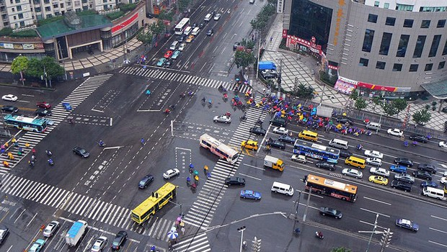

 | Province (rural area) | Urban area (city)
Social
Positive
Social
negative
Economic
positive
Economic
negative
Political
positive
Political
negative
Environmental
Positive
Environmental
negative

Responding to the challenges and impacts of urbanisation
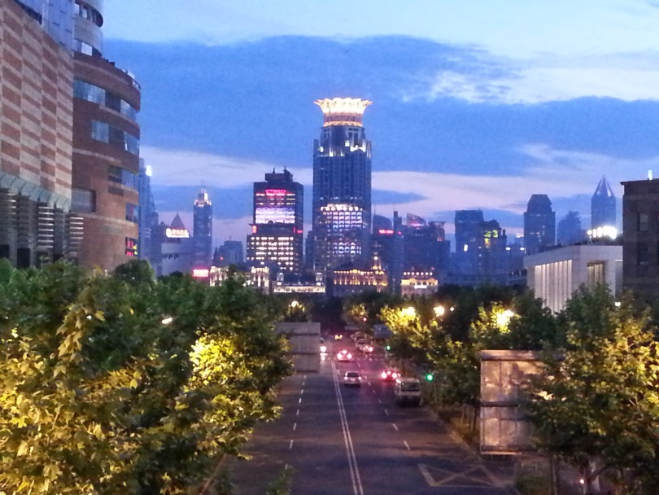
Response | Which challenges or impacts will it reduce? | How will it do this?

